**{*Treasure Hunt Game*}**

**THE White Paper**

**{*2021*}**

**{*NOT RAYYAN CO*}**

**{*We do things*}**

**Contents**

1. Introduction / Background 2

2. Abstract / Business Case 2

3. Problem Statement / Introduction 2

4. Proposed Solution(s) 2

a. Solution 2

b. 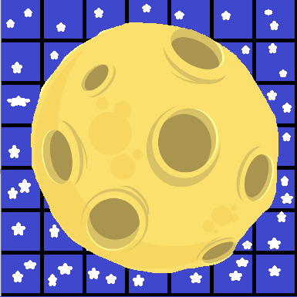Solution 2

5. Future Direction / Long-Term Focus 2

6. Results / Conclusion 2

Appendices 3

Appendix A – Scenarios 3

Appendix B – Options 3

Appendix C – Authors 3

Appendix D – References 3

# Introduction / Background

This game is for a GCSE computer science project. Both developers are complete novices and completely ineffective at everything.

# Abstract / Business Case

This is a simple game, where the player must find treasure under pressure from time and zombies.

# Problem Statement / Introduction

Developed in Python, we need to add a better UI and improve gameplay mechanics.

# Proposed Solution(s)

## Solution

Recode the current UI in a more efficient manner.

## Solution

Add a timer, no-go zones and bots.

# Future Direction / Long-Term Focus

Add some more splash screens, make gameboard larger with more features.

# Results / Conclusion

Need to make a feature list, implement, then troubleshoot.

# 

# Appendices

A: OPENING SPLASH SCREEN

## Appendix A – Scenarios

{*Add and remove stuff as we need. Will will send code later make it detailed* }

## Appendix B – Options

{*list of enhancements referenced in the proposed solution*}

## Appendix C – Authors

{*list of the primary author(s) and contributors*}

## Appendix D – References

B: GAME SPLASH SCREEN

{*bibliography of resources and references*}