1. 安装前准备
2. 创建两台虚拟机.
3. 关闭防火墙
4. 由于centOS7中默认安装了MariaDB,需要先进行卸载

rpm -qa | grep -i mariadb

rpm -e --nodeps mariadb-libs-5.5.64-1.el7.x86\_64

二开始部署

1.下载mysql5.7.21通用二进制版

wget [https://dev.mysql.com/get/Downloads/MySQL-5.7/mysql-5.7.21-linux-glibc2.12-x86\_64.tar.gz](https://dev.mysql.com/get/Downloads/MySQL-5.7/mysql-5.7.21-linux-glibc2.12-x86_64.tar.gz" \t "_blank)

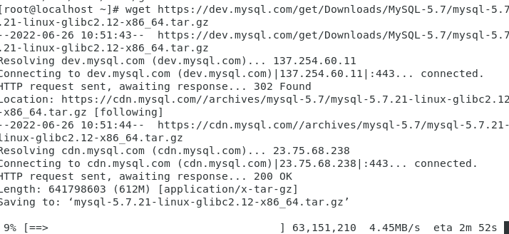

1. 创建mysql用户组和mysql用户

Useradd mysql



1. 解压安装包，并将解压好的文件夹重命名为mysql

tar -zxvf mysql-5.7.21-linux-glibc2.12-x86\_64.tar.gz

mv mysql-5.7.21-linux-glibc2.12-x86\_64 mysql

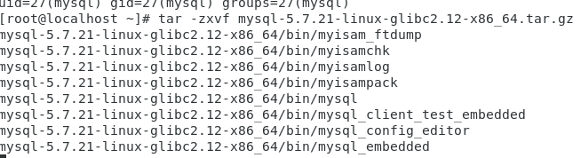



4.移动到/usr/local目录下

mv mysql /usr/local

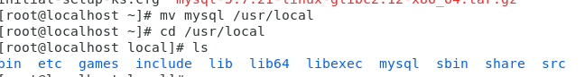

5.对配置/etc/my.cnf文件

Vim /etc/my.cnf

主库配置

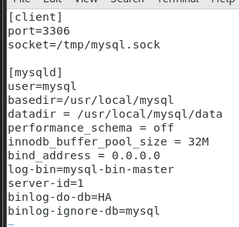

从库配置

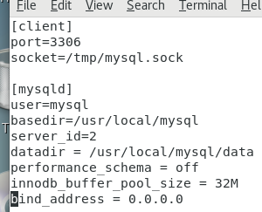

1. 初始化mysql

进入bin目录

cd /usr/lcoal/mysql/bin

主库

./mysqld --initialize --user=root --basedir=/usr/local/mysql/ --datadir=/usr/local/mysql/data

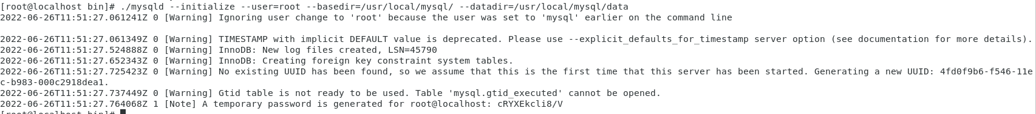

从库

./mysqld --initialize --user=root --basedir=/usr/local/mysql/ --datadir=/usr/local/mysql/data

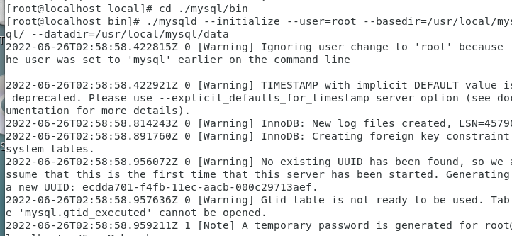

1. 复制启动脚本到/etc/init.d/mysql

cp /usr/local/mysql/support-files/mysql.server /etc/init.d/mysql



1. 将mysql启动文件写入到环境变量中

vim /etc/profile

PATH=$PATH:/usr/local/mysql/bin

export PATH

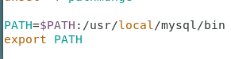

1. 刷新环境变量

source /etc/profile

1. 开启mysql

/etc/init.d/mysql start

Mysql -uroot -p



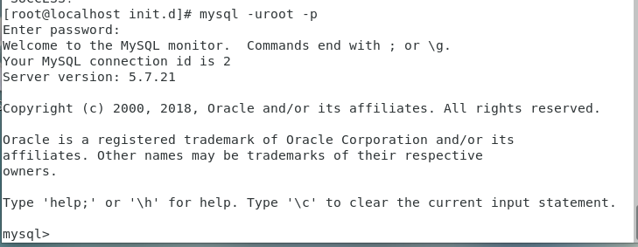

1. 重置mysql密码，并刷新

set password for root@'localhost'=password('123456');

flush privileges;

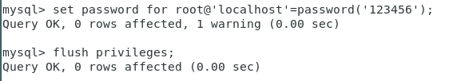

1. 主库授权

grant replication slave on \*.\* to 'test'@'192.168.178.116' identified by '123456';

刷新

flush privileges;

查看主库授权状态

show master status;

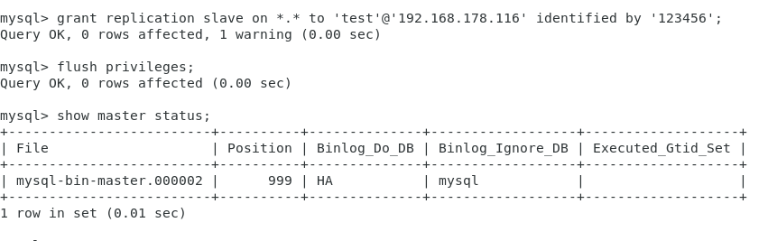

1. 从库授权

chang master to master\_host='192.168,178.117',master\_user='test',master\_password='123456';

start slave;

查看状态

 show slave status \G;

下面两个状态都是yes时，代表主从库配置成功了

Slave\_IO\_Running: Yes

Slave\_SQL\_Running: Yes

