Nginx部署

1. 解决依赖:yum install gcc gcc-c++ autoconf automake zlib zlib-devel openssl openssl-devel pcre\* pcre-devel  -y

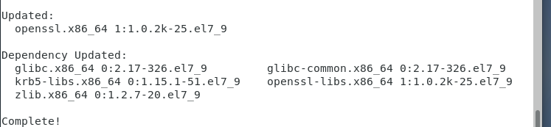

1. 下载nginx:wget <http://nginx.org/download/nginx-1.8.0.tar.gz>

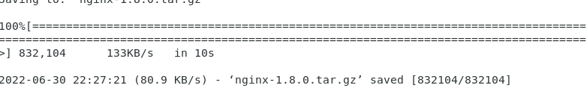

1. 下载pcre:

(1).wget

<http://downloads.sourceforge.net/project/pcre/pcre/>8.37/pcre-8.37.tar.gz

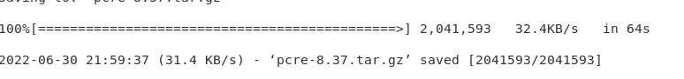

1. .解压:tar xf pcre-8.37.tar.gz -C /usr/local/src/

4.解压nginx安装包：tar xvf nginx-1.8.0.tar.gz -C /usr/local/src/ ; cd /usr/local/src/nginx-1.8.0

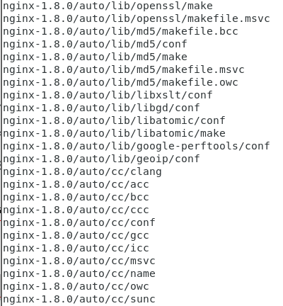

5生成makefile编译依赖文件:

./configure --prefix=/usr/local/nginx --with-http\_dav\_module --with-http\_stub\_status\_module --with-http\_addition\_module --with-http\_sub\_module --with-http\_flv\_module --with-http\_mp4\_module --with-pcre=/usr/local/src/pcre-8.37

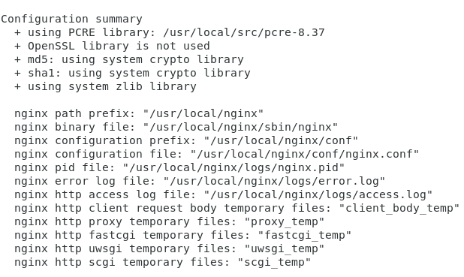

6.编译安装:make –j 3 ; make install

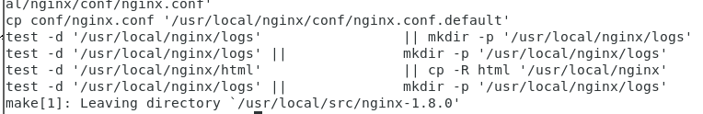

1. 创建nginx运行用户

8.启动nginx:

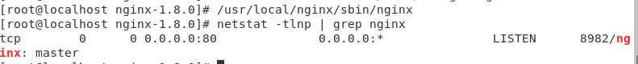

使用浏览器测试 [http://](http://192.168.1.63/" \t "_blank)你的IP

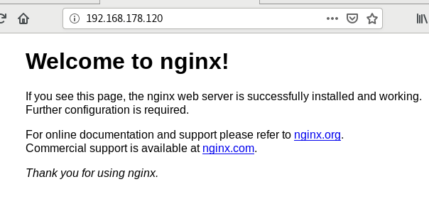

9.nginx维护命令

(1).检查配置文件语法是否有错误:/usr/local/nginx/sbin/nginx -t



(2).重新加载配置文而建（平滑重启）:

/usr/local/nginx/sbin/nginx -s reload

1. .停止Nginx:/usr/local/nginx/sbin/nginx -s stop
2. .开机启动:

echo "/usr/local/nginx/sbin/nginx &" >> /etc/rc.local