Lec07
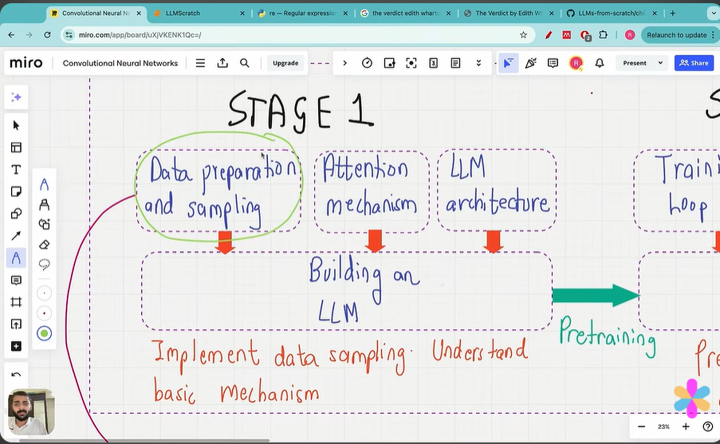
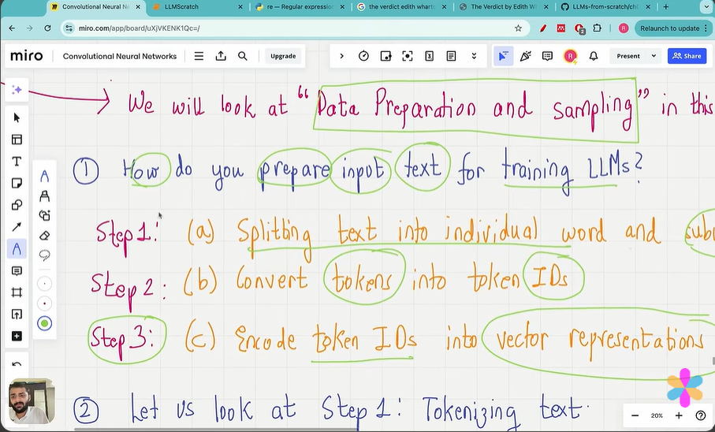
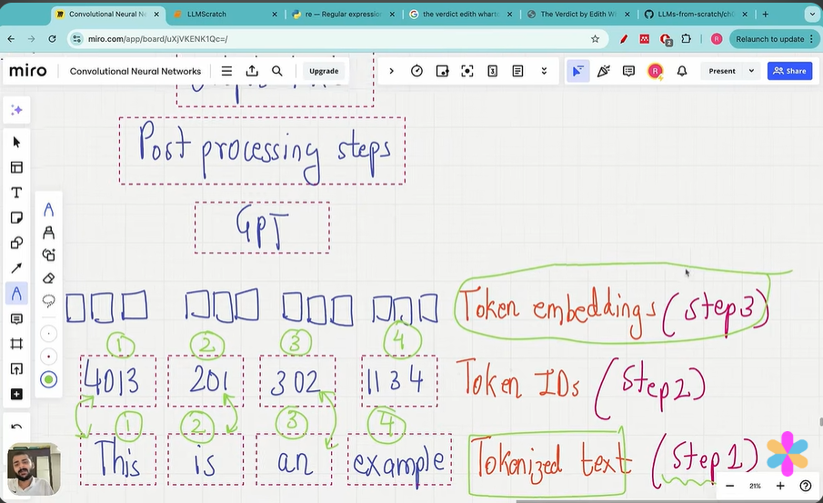

https://chatgpt.com/share/6ae2d06b-cc7c-83e8-9a38-793676ea5112 regex

