Visualization

**Contents**

Topic#1 - Convert from CAD STL ASCII format to MAT format 2

Topic#2 – Vehicle configuration in rectangle form 3

Topic#3 – Vehicle trajectory 4

Topic#4 – Animation of a vehicle motion 5

Topic#5 – Animation of a few vehicles motion 6

## Topic#1 - Convert from CAD STL ASCII format to MAT format

Description: …coming soon…

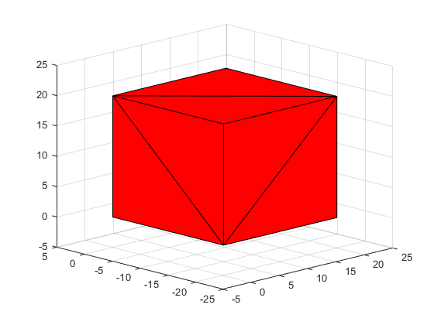

Fig.1.01. Visualization of the cube from CAD format in Matlab

## Topic#2 – Vehicle configuration in rectangle form

Description: …coming soon…

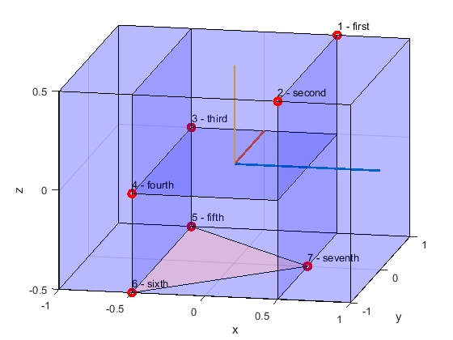

Fig.2.01. Visualization of the vehicle configuration in rectangle form

## Topic#3 – Vehicle trajectory

Description: …coming soon…

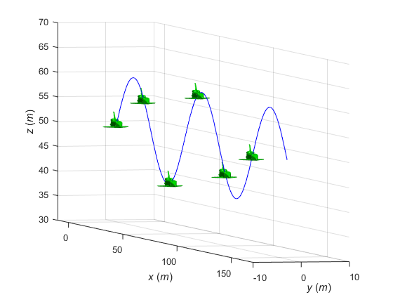

Fig.3.01. Visualization of the vehicle trajectory

## Topic#4 – Animation of a vehicle motion

Description: …coming soon…

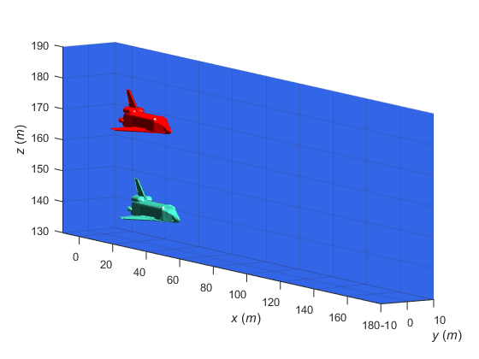

Fig.4.01. Visualization of the vehicle motion

## Topic#5 – Animation of a few vehicles motion

Description: …coming soon…

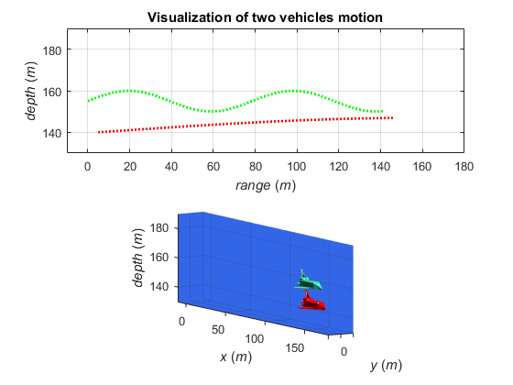

Fig.5.01. Visualization of two vehicles motion