********************************************************************************
Aufgabe 2.1
********************************************************************************

> b1 = [128, 64; 16, 32]
b1 =
128 64
16 32

> nb1 = normalizeAuto(b1)
nb1 =

1.00000 0.00000
-0.75000 -0.50000

> hb1 = h2 * nb1
hb1 =

0.17678 -0.35355
1.23744 0.35355

> hb1h = hb1 * h2
hb1h =

-0.12500 0.37500
1.12500 0.62500

> hhb1h = h2 * hb1h
hhb1h =

0.70711 0.70711
-0.88388 -0.17678

> hhb1hh = hhb1h * h2
hhb1hh =

1.0000e+00 7.8496e-17
-7.5000e-01 -5.0000e-01

> denormalize(hhb1hh, 128)
ans =

255 128
32 64
********************************************************************************
Aufgabe 2.2
********************************************************************************

> b2 = [17, 205; 205, 17]
b2 =

17 205
205 17

> nb2 = normalizeAuto (b2)
nb2 =

-0.83415 1.00000
1.00000 -0.83415

> hb2 = h2 * nb2
hb2 =

0.11728 0.11728
-1.29694 1.29694

> hb2h = hb2 * h2
hb2h =

0.16585 0.00000
0.00000 -1.83415

> hhb2h = h2 * hb2h
hhb2h =

0.11728 -1.29694
0.11728 1.29694

> hhb2hh = hhb2h * h2
hhb2hh =

-0.83415 1.00000
1.00000 -0.83415

> denormalize (hhb2hh, 205)
ans =

21 255
255 21
********************************************************************************
Aufgabe 2.3
********************************************************************************

> b3 = [0, 204, 102, 204; 204, 255, 51, 51; 204, 102, 153, 51; 153, 51, 51, 0]
b3 =

0 204 102 204
204 255 51 51
204 102 153 51
153 51 51 0

> nb3 = normalizeAuto (b3)
nb3 =

-1.00000 0.60000 -0.20000 0.60000
0.60000 1.00000 -0.60000 -0.60000
0.60000 -0.20000 0.20000 -0.60000
0.20000 -0.60000 -0.60000 -1.00000

> hb3 = h4 * nb3
hb3 =

2.0000e-01 4.0000e-01 -6.0000e-01 -8.0000e-01
-6.0000e-01 5.5484e-17 6.0000e-01 8.0000e-01
-6.0000e-01 1.2000e+00 -2.0000e-01 8.0000e-01
-1.0000e+00 -4.0000e-01 -2.0000e-01 4.0000e-01

> hb3h = hb3 * h4
hb3h =

-4.0000e-01 -5.5511e-17 1.0000e+00 -2.0000e-01
4.0000e-01 -4.0000e-01 -1.0000e+00 -2.0000e-01
6.0000e-01 -1.4000e+00 -2.7756e-17 -4.0000e-01
-6.0000e-01 -6.0000e-01 -8.0000e-01 -1.1101e-16

> hhb3h = h4 * hb3h
hhb3h =

8.3267e-17 -1.2000e+00 -4.0000e-01 -4.0000e-01
2.0000e-01 -2.0000e-01 1.4000e+00 -2.0000e-01
8.3267e-17 8.0000e-01 4.0000e-01 9.7138e-17
-1.0000e+00 6.0000e-01 6.0000e-01 2.0000e-01

> hhb3hh = hhb3h * h4
hhb3hh =

-1.00000 0.60000 -0.20000 0.60000
0.60000 1.00000 -0.60000 -0.60000
0.60000 -0.20000 0.20000 -0.60000
0.20000 -0.60000 -0.60000 -1.00000

> denormalize (hhb3hh, 255)
ans =

0 204 102 204
204 255 51 51
204 102 153 51
153 51 51 0
#********************************************************************************
#Aufgabe 3
#********************************************************************************
source ub1.m;

# Lesen des Bilds
#********************************************************************************
B = imread("lena-bw.png");

# I) normalisieren, transformieren mit Hadamard, rausschreiben nach "Bfreq.png"
#********************************************************************************
B_norm = normalizePicture(B);

B_freq = h512 * B_norm * h512;

imwrite(B_freq, "Bfreq.png")

# II) rücktransformieren, auf den Bereich 0..255 skalieren, schrebien nach "Bback.png"
#********************************************************************************
B_back = h512 * B_freq * h512;

B_back_den = denormalizeToPicture(B_back);

imwrite(B_back_den, "Bback.png")

# Das rücktransformierte Bild gleicht dem Original!

# spaßershalber ein Tiefpassfilter nach "Blow.png"
#********************************************************************************
B_low = h512 * lowpass(B_freq, 0) * h512;

B_low_den = denormalizeToPicture(B_low);

imwrite(B_low_den, "Blow.png")


Bfreq.png Bback.png

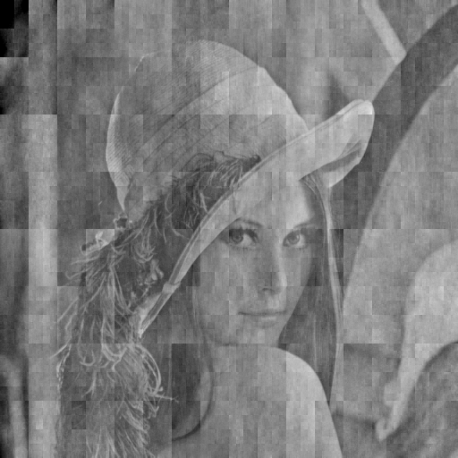
Blow.png
***************************************************************************
Definitionen, die im Vorhergehenden benutzt wurden ***************************************************************************

h2 = 1 / sqrt(2) * [1,1;1,-1];
h4 = 1 / sqrt(2) * [h2, h2; h2, -h2];
h8 = 1 / sqrt(2) * [h4, h4; h4, -h4];
h16 = 1 / sqrt(2) * [h8, h8; h8, -h8];
h32 = 1 / sqrt(2) * [h16, h16; h16, -h16];
h64 = 1 / sqrt(2) * [h32, h32; h32, -h32];
h128 = 1 / sqrt(2) * [h64, h64; h64, -h64];
h256 = 1 / sqrt(2) * [h128, h128; h128, -h128];
h512 = 1 / sqrt(2) * [h256, h256; h256, -h256];

b1 = [128, 64; 16, 32] ;
b2 = [17, 205; 205, 17];
b3 = [0, 204, 102, 204; 204, 255, 51, 51; 204, 102, 153, 51; 153, 51, 51, 0];

# nomalisiere Matrix x mit dem größten vorkommenden Wert
function result = normalizeAuto(x)
maximum = max(max(x));
result = double(x) / maximum * 2 - 1;
end;

# denomalisiere Matrix x mit dem Wert factor (Rückskalieren auf ursprünglichen Wertebereich)
function result = denormalize(x, factor)
result = (x + 1) / 2.0 * factor;
end;

function result = normalizePicture(x)
result = double(x) / 255.0 * 2 - 1;
end;

function result = denormalizeToPicture(x)
result = uint8((x + 1) / 2.0 * 255);
end;

# Werte einer Matrix auf den Bereich [0..1] skalieren
function result = normalize01(x)
minval = min(min(x))
maxval = max(max(x))
x = x - minval;
x = x / (maxval - minval)
result = x;
end;

function result = lowpass(x, threshold)
y = x;
y(find (y > threshold)) = 0;
result = y;
end;

