Style Guidelines for Final Year Project ReportsSafeKeys
Senior Project



Primary Advisor: Rauf Butt
Secondary Advisor: Dr Mubashar Mushtaq

Presented by:
Student Reg# Student Name
261938489 | Muhammad Mamoon
261934680 | Natasha Zaheer
261941967 | Haider Ali

Department of Computer Science

Forman Christian College
(A Chartered University)
SafeKeys

By

Muhammad Mamoon
Natasha Zaheer
Haider Ali

Project submitted to

Department of Computer Science,

Forman Christian College (A Chartered University),

Lahore, Pakistan.

in partial fulfillment of the requirements for the degree of

BACHELOR OF SCIENCE
IN
COMPUTER SCIENCE (Honors)

Primary Project Advisor |  | Secondary Project Advisor

Senior Project Management Committee Representative

Abstract
Software keyloggers remain a serious threat to user privacy because they can capture passwords, financial data, and personal messages while evading signature-based antivirus tools. This project addresses the need for effective, privacy-preserving detection of keylogging activity on Linux hosts, where traditional scanners often fail against new or obfuscated malware. We designed and implemented a host-based detection system for Ubuntu 22.04 LTS (kernel 5.15.x) that monitors keyboard-related behavioral metadata at the kernel level without recording keystroke content. A loadable kernel module registers with the keyboard notifier chain, extracts timing, event-type, and process-context features, and transmits structured messages to a Python daemon over Netlink sockets. The daemon applies heuristic rules and a Random Forest classifier (scikit-learn) to flag anomalous input monitoring patterns in real time, and a PySide6 dashboard presents alerts and monitoring status to the user. Evaluation in an isolated VirtualBox environment uses six planned test cases covering Netlink delivery, privacy guarantees, detection accuracy against a simulated keylogger, heuristic triggers, GUI alerting, and resource overhead. Preliminary results indicate that the prototype achieves target detection responsiveness (alerts within seconds), maintains metadata-only collection with no recoverable typed text in logs or IPC payloads, and is designed to keep average CPU overhead below 5% during continuous monitoring. The work demonstrates that behavioral analysis combined with lightweight machine learning at the kernel boundary offers a practical alternative to signature databases for Linux keylogger detection, while remaining within a clearly defined scope: software keyloggers on a single kernel version, detection and alerting only, with formal measurements to be finalized in ongoing testing.

Acknowledgement
First and foremost, we would like to express our deepest gratitude to Allah Almighty, who blessed us with the strength, knowledge, opportunities, and resources required to successfully complete this Final Year Project. Without His guidance and mercy, this achievement would not have been possible.

We would like to extend our sincere appreciation to our primary advisor, Sir Rauf Butt, for his continuous guidance, encouragement, and unwavering support throughout the entire project. His willingness to assist us, even during his personal time and days off, played a significant role in helping us overcome challenges and successfully complete our work. We are also grateful to our secondary advisor, Sir Mubashar Mushtaq, for his valuable assistance and for providing the necessary resources and support whenever needed. His contributions greatly facilitated the progress of our project.

Most importantly, we would like to thank our parents, whose sacrifices, hard work, prayers, and unconditional love have enabled us to reach this stage of our academic journey. Their constant support, patience, and belief in our abilities have been our greatest source of motivation.

Finally, we would like to express our heartfelt thanks to our friends and peers who stood by us throughout this journey. Their encouragement, support, and uplifting words during difficult times helped us stay motivated and focused on achieving our goals.

We are sincerely grateful to everyone who contributed, directly or indirectly, to the successful completion of this project.

List of Figures
Figure 1: Use Case Diagram 23
Figure 2: Architecture Diagram 25
Figure 3: Sequence Diagram 26
Figure 4: Layered System Architecture Diagram 27
Figure 5: Activity Diagram 29

List of Tables
Table 1: UC-1 - Kernel-Level Monitoring 8
Table 2: UC-2 - Transparent Operation 9
Table 3: UC-3 - Behavioral Metadata Extraction 10
Table 4: UC-4 - Keystroke Privacy Preservation 10
Table 5: UC-5 - Real-Time Telemetry Transfer 11
Table 6: UC-6 - Efficient Batch Transfer Mechanism 11
Table 7: UC-7 - Secure Component Authentication 12
Table 8: UC-8 - Background Daemon Execution 12
Table 9: UC-9 - Mathematical Feature Extraction 13
Table 10: UC-10 - Process-Centric Behavior Aggregation 14
Table 11: UC-11 - ML Baseline Anomaly Evaluation 14
Table 12: UC-12 - Process-Specific Statistical Analysis 15
Table 13: UC-13 - Definitive Behavior Classification 15
Table 14: UC-14 - Rule-Based Heuristic Evaluation 16
Table 15: UC-15 - Threshold-Based Alert Generation 17
Table 16: UC-16 - Severity-Coded Alert Presentation 17
Table 17: UC-17 - Contextual Alert Data Display 18
Table 18: UC-18 - Native Qt Dashboard Rendering 19
Table 19: UC-19 - Real-Time Dashboard Synchronization 19
Table 20: UC-20 - Animated Data Visualization 20
Table 21: UC-21 - System Component Status Monitoring 20
Table 22: UC-22 - Service State Management 21
Table 23: UC-23 - Dynamic LKM Insertion/Removal 22
Table 24: UC-24 - Persistent Audit Logging 22
Table 25: TC-1 - LKM Initialization and Netlink Metadata Delivery 34
Table 26: TC-2 - Verification of Zero Keystroke Content Logging 35
Table 27: TC-3 - Random Forest Model Accuracy for Anomaly Detection 35
Table 28: TC-4 - Edge Case Detection via Heuristic Rules 35
Table 29: TC-5 - Real-Time Alert Status and GUI Responsiveness 36
Table 30: TC-6 - System Performance Impact Analysis 36
Table 31: Summary of All Test Results 36

Table of contents
Abstract i
Acknowledgement ii
List of Figures iii
List of Tables iv
Chapter 1. Introduction 1
1.1 Introduction 1
1.2 Objectives 1
1.3 Problem Statement 2
1.4 Scope 2
CHAPTER 2. Requirements Analysis 3
2.1 Literature Review 3
2.2 User Classes and Characteristics 3
2.3 Design and Implementation Constraints 4
2.4 Assumptions and Dependencies 5
2.5 Functional Requirements 7
2.6 Use Case Diagram 23
2.7 Nonfunctional Requirements 23
2.8 Other Requirements 24
CHAPTER 3. System Design 25
3.1 Application and Data Architecture 25
3.2 Component Interactions and Collaborations 26
3.3 System Architecture 27
3.4 Architecture Evaluation 28
3.5 Component-External Entities Interface 28
3.6 Screenshots/Prototype 28
3.7 Other Design Details 33
CHAPTER 4. Test Specification and Results 34
4.1 Test Case Specification 34
4.2 Summary of Test Results 36
CHAPTER 5. Conclusion and Future Work 37
5.1 Project summary 37
5.2 Problems faced and lessons learned 37
5.3 Future work 37
References 39
Appendix A Glossary 40
Appendix B Deployment/Installation Guide 41
Appendix C User Manual 41
Appendix D Student Information Sheet 41
Appendix E Plagiarism Free Certificate 42
Appendix F Plagiarism Report 43

Revision History
Name | Date | Reason For Changes | Version
Haider Ali | 22/04/26 | Initial draft | 1
Natasha Zaheer | 30/04/26 | Additions to Section 2 & 3 | 1.1

Introduction

Introduction
The rapid growth of digital systems and online communication has significantly increased concerns regarding user privacy and system security. Among various forms of malicious software, keyloggers represent a particularly severe threat, as they are capable of silently capturing sensitive user input such as passwords, financial information, and personal communications. Traditional antivirus and intrusion detection systems primarily rely on signature-based techniques, which are often ineffective against newly developed or obfuscated malware variants, especially those that do not exhibit known signatures.

In response to these limitations, this project presents a Linux-based keylogger detection system that adopts a behavioral analysis approach rather than relying on signature matching. The system operates at the kernel level to monitor keyboard input events and identify anomalous patterns associated with unauthorized input monitoring. By focusing on behavioral metadata such as event frequency, timing characteristics, and process context, the system ensures detection capability while preserving user privacy by explicitly avoiding the capture of actual keystroke content.

The developed system integrates kernel-space monitoring, user-space analysis, and machine learning-based classification to provide a comprehensive detection framework. A loadable kernel module captures keyboard event metadata in real time, which is transmitted to a user-space daemon using an efficient inter-process communication mechanism. The daemon applies both heuristic rules and a trained machine learning model to detect suspicious activity patterns. Additionally, a graphical user interface provides real-time visualization, alerts, and system insights to enhance usability and awareness.

This project is motivated by the need for privacy-preserving, behavior-based security mechanisms that can adapt to evolving threats. It also serves as a practical exploration of kernel-level monitoring, system security design, and the application of machine learning in cybersecurity, demonstrating a viable alternative to traditional detection techniques.

Objectives
The primary objectives of the project were as follows:

- To design and implement a kernel-level monitoring mechanism capable of observing keyboard input events without capturing sensitive user data.
- To develop a behavioral feature extraction pipeline based on timing patterns, event frequency, and process context.
- To implement a user-space daemon that performs real-time analysis of collected data.
- To design and integrate a machine learning-based binary classification model for detecting anomalous input monitoring behavior.
- To supplement machine learning with rule-based heuristics for improved detection accuracy and handling of edge cases.
- To establish a low-latency communication channel between kernel space and user space using Netlink sockets.
- To develop an interactive graphical user interface for real-time monitoring, alerting, and visualization of system activity.
- To ensure a privacy-by-design approach by strictly avoiding the capture or storage of actual keystroke content.
- To evaluate the system in a controlled environment and measure detection performance, latency, and resource overhead.

Problem Statement
The project addresses the problem of detecting software-based keyloggers on Linux systems in a manner that is both effective and privacy-preserving. Existing solutions predominantly rely on signature-based detection techniques, which are insufficient against unknown or behaviorally adaptive malware. Furthermore, many monitoring approaches compromise user privacy by capturing or analyzing actual keystroke data.

To address these challenges, the developed system is a host-based security tool that applies behavioral analysis and machine learning techniques to identify suspicious keyboard monitoring activity. The system operates by collecting non-sensitive metadata at the kernel level and analyzing it in user space to detect anomalies indicative of keylogging behavior.

This project can be categorized as a research-driven software system that integrates low-level system programming, real-time data processing, and machine learning-based classification. It demonstrates the application of behavioral anomaly detection algorithms in a practical security context and provides a functional prototype that achieves improved detection capability without relying on traditional signature databases.

Scope
The scope of the Linux Keylogger Detection System is limited to the detection of software-based keylogging activities within a controlled Linux environment. The system is specifically designed for Ubuntu 22.04 LTS running Linux kernel version 5.15.x and operates as a host-based monitoring solution.

The system includes kernel-level event monitoring, real-time data transmission via Netlink, behavioral analysis through a user-space daemon, and visualization through a graphical user interface. It focuses on identifying anomalous input monitoring patterns using both heuristic rules and machine learning models.

However, the scope of the system excludes several aspects. It does not perform malware removal or file-level disinfection, as its primary function is detection and alerting. It does not rely on signature-based scanning or maintain a database of known malware signatures. Additionally, it does not capture or store actual keystrokes, ensuring strict adherence to privacy principles. The system is not intended for cross-platform use and does not support operating systems other than Linux. Finally, hardware-based keyloggers and attacks operating entirely within kernel space are outside the scope of this project.

Requirements Analysis

Literature Review
Research on keylogger detection has significantly expanded, primarily branching into two somewhat disconnected streams: artificial intelligence/machine learning (AI/ML) behavior analysis and kernel-level monitoring. Historically, studies utilized classical machine learning models, such as Support Vector Machines, Random Forests, Naïve Bayes, and XGBoost, to learn behavioral signatures from features like API calls and keystroke timing. These classical models often achieved 90–95% accuracy on their experimental datasets (Sahoo, S., Pradhan, R. & Mishra, D.P., 2024). Subsequent research introduced sequence models like RNNs and LSTMs, which improved early detection capabilities but required greater computational resources and reduced interpretability (Sahoo, Pradhan, & Mishra, 2024). Hybrid approaches have also demonstrated promising detection rates within controlled laboratory settings (Chen & Wang, 2023).
In parallel, the security community developed kernel-level observability frameworks. The extended Berkeley Packet Filter (eBPF) ecosystem and tools like Tracee provide high-fidelity, low-overhead visibility into system calls and kernel events, establishing a practical telemetry foundation for ML models requiring kernel-level signals. Recent academic frameworks have begun exploring ML directly on these kernel traces, demonstrating the feasibility of near real-time anomaly detection (Zhang & Wang, 2022).

Identified Challenges and Defects
Despite these advancements, a synthesis of both streams reveals significant gaps that leave kernel-level keyloggers under-addressed. The primary challenges include:
- Data Scarcity: A reliance on user-space traces or small, simulated datasets obscures how well current models generalize to kernel-level adversarial techniques. There is a distinct shortage of publicly available, well-labeled datasets containing kernel-level traces of both benign activity and malicious keylogger behaviors.
- Model Portability: Machine learning models trained on specific kernel versions often underperform on others, and cross-kernel generalization is rarely evaluated or reported.
- Explainability and Overhead: Deep learning models that perform well in user-space labs are frequently too computationally heavy for real-time kernel-adjacent detection. Furthermore, they lack the explainability that is crucial for security analysts during triage (Chen, J., & Wang, H., 2023).
- Adversarial Evasion: Current research combining kernel telemetry with robust, defense-aware modeling remains limited, leaving systems vulnerable to adversaries who manipulate hooks, throttle reads, or use obfuscation.

Rationale for the Proposed Project
The current landscape lacks a mature, open, lightweight, and interpretable AI system specifically designed and evaluated for kernel-level keylogger detection across diverse environments and realistic threat behaviors. This project aims to synthesize the disconnected research streams to address these exact open problems. The work involves producing a labeled dataset of realistic kernel-level traces, evaluating a spectrum of ML and anomaly-detection models with a strict focus on runtime footprint and explainability, and demonstrating an integrated prototype against baseline detectors. Given the rapid evolution of kernel attack techniques, developing an end-to-end, ML-driven detection pipeline that utilizes safe kernel telemetry is a timely and necessary contribution.

User Classes and Characteristics

    - General Users
- Limited technical knowledge of operating systems.
- Interested in privacy and security awareness.
- Interact primarily with the dashboard to view alerts and system activity.
- Do not directly configure kernel-level components.
    - Advanced Users / System Administrators
- Familiar with Linux systems and administrative tasks.
- Capable of installing kernel modules and managing system services.
- May adjust configuration parameters such as detection thresholds or logging verbosity.
    - Developers / Researchers
- Strong understanding of operating systems, cybersecurity, and software engineering concepts.
- Use the system for experimentation, research, and analysis.
- Interested in the internal working of the kernel module, data pipeline, and detection logic.

Design and Implementation Constraints
The design and implementation of the Linux Keylogger Detection System were influenced by several technical, environmental, and security-related constraints that limited the available development choices and guided architectural decisions.
One of the primary constraints was the dependency on a specific operating system and kernel version. The system is designed exclusively for Ubuntu 22.04 LTS running Linux kernel version 5.15.x. This restriction was necessary to ensure compatibility with kernel APIs such as the keyboard notifier interface and Netlink communication mechanisms. Kernel-level development inherently introduces strict constraints, including the need for stable, safe, and minimal code execution in kernel space, as errors may lead to system instability or crashes.
Hardware and performance limitations also influenced the system design. Since keyboard events can occur at high frequencies, the kernel module was required to operate with minimal computational overhead and memory usage. Real-time constraints dictated that event handling and data transmission should not introduce noticeable latency or degrade system performance. To address this, lightweight data structures, rate limiting mechanisms, and efficient communication via Netlink sockets were implemented.
Another major constraint was the requirement to preserve user privacy. The system strictly avoids capturing or storing actual keystroke content, which limited the feature space available for analysis. As a result, the detection model relies entirely on behavioral metadata such as timing intervals, event frequency, and process context, rather than content-based analysis.
The choice of technologies and tools also imposed constraints. Kernel components were developed in the C programming language using Linux kernel development conventions, while user-space components, including the daemon and machine learning pipeline, were implemented in Python 3. The graphical user interface was developed using the Qt framework (PySide6), which required adherence to its event-driven programming model and integration mechanisms. Communication between kernel space and user space was constrained to the use of Netlink Protocol 31, requiring structured message formatting and synchronization between sender and receiver.
Interfacing constraints were present between system components. The kernel module, user-space daemon, and GUI had to operate in a coordinated manner while maintaining loose coupling. This required clearly defined data formats, structured messaging, and periodic synchronization to ensure consistency of system state across components.
Security considerations imposed additional constraints. The kernel module had to be designed with strict safeguards to prevent misuse, unauthorized access, or system compromise. Since the system operates at a privileged level, only authorized users (root access) can load or unload the module. Furthermore, safeguards such as rate limiting and bounded buffers were necessary to prevent potential abuse or denial-of-service scenarios.
The development environment also imposed constraints. The system was designed and tested within a virtualized environment using Oracle VirtualBox, which may differ from real-world deployments in terms of hardware interaction and performance characteristics. This constraint influenced testing methodologies and required careful interpretation of results.
Finally, maintenance and extensibility considerations influenced design decisions. The system adheres to modular programming principles, separating kernel logic, user-space processing, and visualization layers. However, due to the complexity of kernel development, any future modifications to the kernel module require careful validation, recompilation, and compatibility checks with the target kernel version.
This section delineates the technical, regulatory, and architectural boundaries governing the development and deployment of the kernel-level detection system.

    - Architectural and Performance Constraints: The Loadable Kernel Module (LKM) must execute with strict, near-zero latency overhead. System call interception and event logging shall not induce perceptible input lag nor result in interrupt blocking. Furthermore, the user-space machine learning inference pipeline must adhere to rigid CPU and memory utilization caps to prevent degradation of the host system's performance.
    - Regulatory and Privacy Constraints: In strict adherence to data protection regulations (e.g., GDPR, CCPA) and ethical security principles, the system is explicitly prohibited from capturing, storing, or transmitting raw keystroke content (i.e., hardware keycodes, characters, or strings). Telemetry collection is exclusively constrained to anonymized behavioral metadata, specifically high-resolution timestamps, process identifiers (PIDs), and inter-event timing (flight and dwell times).
    - Technology Stack and Compatibility Constraints: The kernel-level component implementation is restricted to the C programming language to ensure native, safe compatibility with Linux kernel headers. The user-space background daemon and analytic engine shall be implemented using Python and C++. The graphical user interface is strictly constrained to the Qt framework (PySide6) to satisfy native desktop rendering requirements. Consequently, the system is inherently constrained to Linux-based operating systems.
    - Security and Privilege Constraints: Initial deployment, LKM insertion, and Netlink socket instantiation necessitate administrative (root/sudo) privileges. Following initialization, the user-space processing daemon must drop escalated privileges to conform to the principle of least privilege, preventing potential exploitation of the detection system itself.
    - Algorithmic Explainability Constraints: The selected machine learning models must yield high interpretability. Opaque, "black-box" deep learning architectures are prohibited for final anomaly classification; the system must generate human-readable anomaly scores and heuristic rationales to facilitate immediate and accurate security triage by administrators.

Assumptions and Dependencies
The design and implementation of the Linux Keylogger Detection System are based on several assumptions regarding the operating environment, user behavior, and system integrity. These assumptions influence the system requirements and overall functionality, and any deviation from them may affect system performance or reliability.
One key assumption is that the system operates in a trusted environment where the kernel module can be successfully loaded and executed with appropriate administrative privileges. It is assumed that the system is not already compromised at the kernel level prior to deployment, as the presence of kernel-level rootkits could interfere with monitoring mechanisms or bypass detection entirely.
The system assumes that keyboard input events captured through the kernel notifier interface provide a reliable representation of input activity. It is also assumed that behavioral patterns such as event frequency, timing intervals, and process context are sufficient indicators for distinguishing between benign user activity and malicious keylogging behavior. This assumption directly impacts the effectiveness of the machine learning model and heuristic rules.
Another assumption is that the operating system remains consistent with the target environment, specifically Ubuntu 22.04 LTS with Linux kernel version 5.15.x. Changes in kernel version or distribution may introduce incompatibilities with kernel APIs, requiring modifications to the kernel module or communication mechanisms.
The project assumes that the system is deployed on standard user machines without specialized hardware constraints. It also assumes that system resources such as CPU and memory are sufficient to support real-time monitoring, data processing, and visualization without significant degradation in performance.
In terms of dependencies, the system relies on several external components and technologies. The kernel module depends on Linux kernel development headers and build tools to compile and operate correctly. The user-space daemon depends on Python 3 and associated libraries for data processing and machine learning functionality. The graphical user interface depends on the Qt framework (PySide6) for rendering and user interaction. Additionally, the machine learning component depends on libraries such as scikit-learn for model training and inference.
The system also depends on the Netlink communication protocol for efficient data transfer between kernel space and user space. Proper functioning of this communication channel is critical for real-time analysis and system responsiveness.
Another dependency is the use of a virtualized development and testing environment (Oracle VirtualBox). It is assumed that the behavior observed in the virtual environment approximates real-world system behavior; however, differences in hardware interaction or timing may affect performance characteristics.
Finally, the system assumes that users interacting with the graphical interface have basic technical knowledge to interpret alerts and system statistics. Misinterpretation of alerts or improper configuration may affect the usability and effectiveness of the system.
Any changes in these assumptions or dependencies—such as kernel updates, missing libraries, or compromised system integrity—may impact the correctness, performance, or security of the system and would require corresponding adjustments in design or implementati
This section outlines the foundational assumptions and external dependencies upon which the project's feasibility, timeline, and successful execution rely.
Assumptions
- AS-1: Administrative Authorization: It is assumed that the target deployment environment permits the execution of elevated privileges (root/sudo) necessary for dynamic kernel module loading and kernel-space memory access.
- AS-2: Baseline Uniformity: The project assumes that benign user typing cadences and standard process behaviors exhibit statistically significant consistency, thereby enabling the establishment of a mathematically viable and reliable machine learning baseline.
- AS-3: Host Integrity: The operational paradigm assumes the host operating system is booted in a trusted state (e.g., utilizing Secure Boot) and has not been previously compromised by hypervisor-level or Ring-0 rootkits prior to the deployment of this detection system.
- AS-4: Hardware Provisioning: It is assumed the target hardware provisions sufficient multi-core processing capabilities to sustain continuous user-space daemon execution concurrently with standard user workloads without resource starvation.
Dependencies
- DE-1: Linux Kernel Headers: Successful compilation and insertion of the LKM are strictly dependent on the availability and exact version match of the Linux kernel headers within the target deployment environment.
- DE-2: High-Quality Labeled Datasets: The efficacy of the pre-trained anomaly detection models is fundamentally dependent upon the successful acquisition or generation of comprehensive, well-labeled datasets that accurately reflect both benign kernel-level telemetry and malicious keylogger behavioral traces.
- DE-3: Third-Party Software Libraries: The user-space processing pipeline is dependent on the stability, security, and continued maintenance of specific open-source libraries, most notably PySide6 (for Qt UI rendering) and core Python data science frameworks (e.g., scikit-learn, numpy, pandas).
- DE-4: Kernel IPC Mechanisms: The system's real-time data ingestion architecture depends entirely on the stability and low-latency characteristics of kernel-to-user-space Inter-Process Communication (IPC) protocols, specifically Netlink sockets.

Functional Requirements

The following section outlines the functional use cases for the Kernel-Level Monitoring subsystem. A Loadable Kernel Module (LKM) registers with the Linux keyboard notifier chain to observe input events and emit privacy-preserving behavioral metadata to a user-space daemon over Netlink. The module does not record keystroke content, modify input, or write sensitive data to disk. The tables below describe typical and alternate flows for metadata collection and transparent operation.

Identifier |  | UC-1
Purpose |  | To collect privacy-preserving keyboard event metadata at the kernel level using an LKM and transmit it to user space via Netlink.
Priority |  | High
Pre-conditions |  | - The target operating system is running.  - The LKM has been successfully compiled and inserted into the system's kernel.
Post-conditions |  | Metadata messages are delivered to the user-space daemon over Netlink; no keystroke content is stored; standard keyboard operation remains uninterrupted.
Typical Course of Action
S# | Actor Action |  | System Response
1 | Actor (Target User) presses or releases a key on the physical keyboard. |  | The hardware generates a keyboard interrupt and the notifier chain invokes the LKM.
2 |  |  | The LKM derives behavioral metadata only (timestamp, event type, inter-event interval, process context). No keystroke content or keycodes are stored.
3 |  |  | The LKM enqueues a structured Netlink message and sends it to the registered daemon.
4 |  |  | The daemon receives the message and updates feature buffers; the input event continues through the normal kernel path unchanged.
Alternate Course of Action
S# | Actor Action |  | System Response
1 | Actor types while the LKM is not loaded or has crashed. |  | Keyboard input proceeds normally; no metadata is delivered and the daemon records the gap, then flags the daemon to attempt restarting the LKM.
2 | Actor presses an unsupported multimedia key. |  | The LKM rate-limits or drops excess metadata safely; keyboard behavior is unaffected.
Table 1: UC-1 - Kernel-Level Monitoring
Identifier |  | UC-2
Purpose |  | To ensure kernel-level monitoring operates transparently: normal keyboard behavior, metadata-only collection, and uninterrupted delivery to the detection pipeline (UC-1).
Priority |  | High
Pre-conditions |  | - The LKM is actively loaded and monitoring inputs (UC-1).  - The user is actively interacting with the system using a keyboard.
Post-conditions |  | The user experiences normal keyboard response; only non-sensitive metadata was transmitted via Netlink; the daemon and GUI remain ready for analysis and alerting.
Typical Course of Action
S# | Actor Action |  | System Response
1 | Actor types characters into a standard user-space application (e.g., a text editor or browser). |  | The LKM observes events via the keyboard notifier and sends metadata over Netlink only.
2 |  |  | The detection daemon aggregates timing, frequency, and process-context features.
3 |  |  | Typed characters appear in the application with no perceptible lag from monitoring.
Alternate Course of Action
S# | Actor Action |  | System Response
1 | Actor types a rapid sequence of keys very quickly. |  | Rate limiting preserves stability; excess metadata may be dropped; typing stays responsive.
2 | Actor executes a keyboard shortcut or system command (e.g., Ctrl+Alt+Del or Ctrl+C). |  | The daemon flags anomalous behavior and the PySide6 dashboard displays an alert.
Table 2: UC-2 - Transparent Operation
Identifier | UC-3
Purpose | To extract and collect detailed behavioral metadata associated with keyboard input events, specifically focusing on precise timing mechanisms and process context mapping.
Priority | High
Pre-conditions | An input event has been successfully intercepted by the LKM.  The system's process scheduler has an active task (PID) associated with the current input focus.
Post-conditions | A structured metadata record containing high-resolution timestamps, event types (press/release), and associated process IDs is created in kernel memory.  No actual content is recorded.
Typical Course of Action
S# | Actor Action | System Response
1 | Actor presses a specific key (e.g., Spacebar). | The LKM retrieves the high-resolution kernel timestamp (e.g., jiffies or ktime) at the exact moment of the interrupt.
2 |  | The system identifies the active process context (PID, executable name) currently holding the keyboard focus.
3 |  | The LKM combines the timestamp, key state (press), and process context into a structured behavioral metadata object.
Alternate Course of Action
S# | Actor Action | System Response
1 | Actor types while no specific user-space process holds focus (e.g., during a system-level interrupt or lock screen). | The system records the metadata but assigns a generic or null 'system' context flag to the PID field, ensuring the timing data is still preserved for behavioral modeling.
Table 3: UC-3 - Behavioral Metadata Extraction
Identifier | UC-4
Purpose | To enforce stringent user privacy by actively preventing the logging, storage, or transmission of any raw keystroke content or identifiable character codes.
Priority | High
Pre-conditions | The LKM is processing a newly captured keyboard interrupt.  The raw event buffer contains the hardware keycode (e.g., KEY_A, KEY_ENTER).
Post-conditions | The raw keycode is permanently discarded from the module's processing pipeline.  Only anonymized behavioral metrics (intervals, hold times) are forwarded.  It is mathematically impossible to reconstruct the typed text from the stored data.
Typical Course of Action
S# | Actor Action | System Response
1 | Actor types highly sensitive information, such as a password or personal email address. | The LKM reads the event but explicitly sanitizes the payload by stripping the specific `EV_KEY` keycode value.
2 |  | The system calculates the delta times (flight time, dwell time) based purely on the action (press/release) regardless of the key identity.
3 |  | The sanitized metadata is pushed to the buffer, completely devoid of character content.
Alternate Course of Action
S# | Actor Action | System Response
1 | An unauthorized internal process attempts to read the LKM's memory buffer via a crash dump or memory scan. | Because the LKM immediately overwrites or drops raw keycodes directly at the interrupt level, the memory scan only reveals abstracted timing graphs, fully protecting the user's sensitive input.
Table 4: UC-4 - Keystroke Privacy Preservation
Identifier | UC-5
Purpose | To transmit the collected behavioral telemetry from the restricted kernel environment to the user-space processing component in real time.
Priority | High
Pre-conditions | The LKM has accumulated a batch of sanitized behavioral metadata.  The user-space background daemon is active and has established a communication channel (e.g., Netlink socket) with the kernel module.
Post-conditions | The telemetry payload is successfully serialized and transferred across the kernel/user-space boundary.  The kernel buffer is freed for new events.
Typical Course of Action
S# | Actor Action | System Response
1 | Actor types a continuous sentence, generating a stream of metadata. | The LKM queues the structured metadata structures into a localized ring buffer.
2 |  | The system constructs a secure Netlink message containing the batched telemetry.
3 |  | The kernel transmits the Netlink message to the registered user-space daemon and flushes the transmitted buffer.
Alternate Course of Action
S# | Actor Action | System Response
1 | The user-space daemon becomes temporarily unresponsive due to heavy CPU load. | The LKM's ring buffer fills up. Once the threshold is reached, the kernel module safely drops the oldest telemetry packets, logging a 'buffer overrun' warning to the kernel ring buffer (`dmesg`) to prevent kernel panics.
Table 5: UC-5 - Real-Time Telemetry Transfer
Identifier | UC-6
Purpose | To ensure that the kernel-to-user-space data transfer mechanism operates with maximum efficiency, strictly minimizing CPU overhead and memory footprint.
Priority | High
Pre-conditions | The system is under heavy load, or the user is typing at an extremely rapid pace (e.g., utilizing macros or high-speed data entry).  The communication protocol is initialized.
Post-conditions | Data transfer consumes negligible CPU cycles (e.g., < 1% CPU utilization).  No memory leaks occur in either kernel or user space.
Typical Course of Action
S# | Actor Action | System Response
1 | Actor unleashes a rapid burst of typing via a script or gaming macro. | The LKM detects high event frequency and dynamically adjusts its batching window to group more events into a single transfer payload.
2 |  | The system performs a single context switch to deliver a large block of events via the Netlink socket, drastically reducing the interrupt handling overhead.
3 |  | The daemon processes the large batch seamlessly, maintaining overall system stability.
Alternate Course of Action
S# | Actor Action | System Response
1 | Actor types very sporadically (e.g., one keystroke every few minutes). | The system recognizes the low volume and utilizes a timeout-based flush to send individual events without waiting to fill a large batch, preserving the 'real-time' requirement without wasting memory.
Table 6: UC-6 - Efficient Batch Transfer Mechanism
Identifier | UC-7
Purpose | To securely restrict the communication interface so that only authorized, verified system components can access the behavioral telemetry stream.
Priority | High
Pre-conditions | The Netlink socket or character device interface is exposed by the LKM.  Multiple user-space processes are running on the system.
Post-conditions | The targeted telemetry daemon is actively receiving data.  All unauthorized access attempts are explicitly blocked and logged.
Typical Course of Action
S# | Actor Action | System Response
1 | The authorized detection Daemon initiates a connection to the LKM interface. | The system validates the calling process's credentials (e.g., checking for root/administrator privileges and verifying the specific PID).
2 |  | Upon successful validation, the kernel establishes the bidirectional communication channel and begins streaming telemetry.
Alternate Course of Action
S# | Actor Action | System Response
1 | A malicious or unauthorized third-party application attempts to open a socket to the LKM to snoop on the timing data. | The LKM's security hooks intercept the request, identify the lack of proper privileges or PID mismatch, immediately drop the connection request, and generate a security alert in the system logs.
Table 7: UC-7 - Secure Component Authentication
Identifier | UC-8
Purpose | To continuously execute a background user-space daemon dedicated to ingesting, parsing, and processing the telemetry received from the kernel module.
Priority | High
Pre-conditions | The operating system is running.  The LKM is loaded and actively transmitting data.  The service manager (e.g., systemd) is configured to manage the daemon.
Post-conditions | The daemon process runs silently in the background.  The daemon maintains a persistent connection to the kernel module and effectively manages its own memory and threads.
Typical Course of Action
S# | Actor Action | System Response
1 | System Administrator powers on the machine or starts the detection service. | The OS service manager automatically initializes the user-space daemon process in the background.
2 |  | The daemon allocates internal buffers, establishes the Netlink connection to the kernel, and enters an infinite listening loop.
3 |  | The daemon immediately begins receiving and routing incoming telemetry payloads to its internal processing engine.
Alternate Course of Action
S# | Actor Action | System Response
1 | The daemon unexpectedly crashes due to an unhandled exception or memory fault. | The OS service manager detects the process failure, logs the crash reason, and automatically respawns the daemon within seconds. The new daemon instance seamlessly reconnects to the LKM.
Table 8: UC-8 - Background Daemon Execution
Identifier | UC-9
Purpose | To perform sophisticated feature extraction on the incoming raw kernel telemetry, mathematically transforming it into behavioral feature vectors.
Priority | High
Pre-conditions | The background daemon has received a batch of raw telemetry (timestamps, event types, PIDs).  The internal processing engine is idle and ready.
Post-conditions | Raw data is transformed into mathematical vectors.  Features such as 'Dwell Time', 'Flight Time', and 'Digraph Latency' are calculated and stored per process.
Typical Course of Action
S# | Actor Action | System Response
1 | Daemon's network listener receives a new raw telemetry packet. | The system parses the Netlink payload into individual key press and release event structures.
2 |  | The extraction engine calculates time deltas, matching presses to corresponding releases to determine keystroke durations (dwell time), and the time between consecutive presses (flight time).
3 |  | The system constructs a normalized numerical array (feature vector) representing these calculated statistics for the given time window.
Alternate Course of Action
S# | Actor Action | System Response
1 | The daemon receives an out-of-order or corrupted telemetry packet. | The feature extraction engine identifies the corrupted timestamp sequence, discards the anomalous packet to prevent polluting the mathematical model, and logs a minor synchronization error.
Table 9: UC-9 - Mathematical Feature Extraction
Identifier | UC-10
Purpose | To strictly ensure that the extracted features represent aggregate user and process behavior profiles rather than sequential or identifiable individual keystrokes.
Priority | High
Pre-conditions | Feature extraction is actively occurring.  The system is preparing data to be sent to the Machine Learning models.
Post-conditions | The generated feature vectors contain strictly statistical representations (averages, variances, event counts).  Sequence mapping is destroyed.
Typical Course of Action
S# | Actor Action | System Response
1 | The extraction engine finalizes a processing window. | The system aggregates the raw calculated deltas into high-level metrics, such as 'Average Dwell Time over 5 seconds', 'Events per Second (EPS)', and 'Ratio of rapid events'.
2 |  | The system groups these statistical averages by process ID to build a behavioral profile of the application being typed into.
3 |  | The raw, event-by-event timing sequence is purged from memory, leaving only the abstracted behavioral vector.
Alternate Course of Action
S# | Actor Action | System Response
1 | An analyst attempts to export the feature vectors to reconstruct the user's typing pattern. | Because the exported data solely consists of statistical aggregations and ratios over specific timeframes (e.g., an EPS of 4.5), the analyst finds it mathematically impossible to determine what individual keys were pressed or in what exact order.
Table 10: UC-10 - Process-Centric Behavior Aggregation

Identifier | UC-11
Purpose | To employ advanced Machine Learning (ML) models to perform behavioral anomaly detection by identifying patterns that deviate from previously learned normal behavior baselines.
Priority | High
Pre-conditions | Extracted behavioral feature vectors are continuously being generated.  The ML engine is loaded with a pre-trained baseline model or is actively training on the user's standard behavior.
Post-conditions | The observed behavior is mathematically compared against the baseline.  An anomaly score is successfully computed based on the deviation.
Typical Course of Action
S# | Actor Action | System Response
1 | The extraction engine pushes a new feature vector to the ML pipeline. | The ML model (e.g., Isolation Forest or Autoencoder) ingests the vector and maps it against its multi-dimensional baseline space.
2 |  | The system calculates the Euclidean distance or reconstruction error to determine how far the current behavior deviates from the norm.
3 |  | The model outputs a raw probabilistic score indicating the likelihood of the behavior being anomalous.
Alternate Course of Action
S# | Actor Action | System Response
1 | The user begins a completely new type of task (e.g., playing a new game) that drastically alters their typing cadence. | The ML model detects a massive deviation and generates a high anomaly score. If the user marks this as 'Normal' via the dashboard, the system incrementally retrains its baseline to incorporate this new behavior pattern.
Table 11: UC-11 - ML Baseline Anomaly Evaluation
Identifier | UC-12
Purpose | To ensure the detection engine specifically analyzes per-process behavioral statistics (including event counts, rapid event ratios, and EPS) to generate targeted anomaly scores.
Priority | High
Pre-conditions | The system has aggregated feature vectors segmented by Process IDs.  The detection engine is evaluating the vectors.
Post-conditions | A unique anomaly score is generated and attributed to a specific running process (e.g., sshd, bash, or a web browser).
Typical Course of Action
S# | Actor Action | System Response
1 | Actor types commands into an SSH terminal. | The detection engine isolate the feature vector associated with the SSH process PID.
2 |  | The engine analyzes the specific metrics: it counts the total events in the window, calculates the 'Events Per Second' (EPS), and determines the ratio of extremely rapid consecutive events.
3 |  | The system generates an anomaly score specifically tagged to the 'ssh' process name and PID, ignoring background activity.
Alternate Course of Action
S# | Actor Action | System Response
1 | A background script injects keyboard events via a virtual device, mimicking an unknown background process. | The engine analyzes the statistics for this unknown PID. Recognizing an impossible EPS rate (e.g., 500 keystrokes per second) and a rapid event ratio of 100%, it immediately spikes the anomaly score for that specific rogue process.
Table 12: UC-12 - Process-Specific Statistical Analysis
Identifier | UC-13
Purpose | To conclusively classify observed behavior as either 'Normal' or 'Potentially Suspicious' based strictly on the ML-generated anomaly scores and their associated confidence levels.
Priority | High
Pre-conditions | The ML engine has output a raw anomaly score and a confidence percentage for a given process.  Classification thresholds are predefined in the system configuration.
Post-conditions | The behavior is categorically labeled.  Subsequent alerting or logging systems are triggered based on this definitive classification.
Typical Course of Action
S# | Actor Action | System Response
1 | The ML model outputs a raw score for a recent typing window. | The classification subsystem compares the raw score against the dynamic threshold.
2 |  | If the score exceeds the threshold and the model's confidence level is high (>85%), the system tags the vector as 'Potentially Suspicious'.
3 |  | If the score is below the threshold, the system tags the behavior as 'Normal' and discards the vector after updating the baseline.
Alternate Course of Action
S# | Actor Action | System Response
1 | The ML model outputs a borderline anomaly score but with extremely low confidence due to a lack of baseline data for that specific process. | The system opts for a conservative approach, categorizing the behavior as 'Normal' to prevent false positives, but internally flags the process for accelerated baseline training.
Table 13: UC-13 - Definitive Behavior Classification

Identifier | UC-14
Purpose | To utilize rule-based heuristic algorithms (Rapid Typing, Burst Pattern, Unknown Process Detection) to provide supporting signals and handle edge cases where ML models require additional context.
Priority | High
Pre-conditions | Telemetry data is streaming into the evaluation engine.  Both ML models and heuristic rules engines are active simultaneously.
Post-conditions | Heuristic algorithms produce discrete boolean flags (e.g., Burst_Detected = True).  These flags either supplement the ML score or act as an override in critical edge cases.
Typical Course of Action
S# | Actor Action | System Response
1 | Actor executes a sudden, pre-programmed typing macro that types 50 characters in 100ms. | The ML model may struggle if it hasn't seen this specific pattern, outputting a medium score. Simultaneously, the Heuristic engine triggers the 'Burst Pattern Detection' algorithm.
2 |  | The heuristic rule identifies an impossible biological typing rate.
3 |  | The system utilizes the heuristic signal to override the ML's medium score, escalating the final classification to a high-confidence anomaly.
Alternate Course of Action
S# | Actor Action | System Response
1 | Actor types into a completely newly installed application. | The ML model has no baseline. The 'Unknown Process Detection' heuristic flags the process as novel. The system uses this heuristic context to heighten sensitivity for this specific process until the ML model can establish a solid baseline.
Table 14: UC-14 - Rule-Based Heuristic Evaluation
Identifier | UC-15
Purpose | To reliably generate a systemic alert event whenever the detection engine identifies anomalous behavior that exceeds defined threshold limits.
Priority | High
Pre-conditions | The classification engine has definitively labeled a behavioral window as 'Potentially Suspicious'.  The anomaly score is greater than the configured alert threshold.
Post-conditions | An alert payload is constructed in memory containing all relevant metadata.  The payload is dispatched to the alerting pipeline.
Typical Course of Action
S# | Actor Action | System Response
1 | Actor's typing behavior radically changes, causing an ML threshold breach. | The detection engine triggers the internal alerting subroutine.
2 |  | The system bundles the anomaly score, the offending PID, the process name, and the timestamp into a structured alert JSON object.
3 |  | The system pushes this object to the event bus, making it available for the dashboard and logging systems.
Alternate Course of Action
S# | Actor Action | System Response
1 | A process continuously triggers minor threshold breaches every second. | To prevent alert flooding, the system applies an internal rate-limiter or deduplication filter, aggregating the repeated breaches into a single, comprehensive alert event over a 30-second window.
Table 15: UC-15 - Threshold-Based Alert Generation

Identifier | UC-16
Purpose | To ensure that generated alerts are presented in a visually non-intrusive, user-friendly manner, utilizing color-coded severity indicators (HIGH, MEDIUM) and clear process identification.
Priority | High
Pre-conditions | An alert payload has been generated by the detection engine.  The user is currently viewing or has the PySide6 dashboard open in the background.
Post-conditions | The user is visually notified of the alert.  The notification clearly displays the severity and the name of the process that triggered it without disrupting the user's workflow.
Typical Course of Action
S# | Actor Action | System Response
1 | The dashboard application receives a new alert via the event bus. | The system evaluates the alert severity field. For a 'HIGH' severity (ML high-confidence or Burst Pattern), it assigns a distinct Red color code.
2 |  | The system renders a sleek, animated notification card within the dashboard's dedicated alert column, prominently displaying the Process Name (e.g., 'Target: /bin/bash') and the Red severity badge.
3 | Actor glances at the dashboard. | The interface remains stable, allowing the user to read the alert without having to dismiss intrusive pop-up dialogs.
Alternate Course of Action
S# | Actor Action | System Response
1 | The system generates a 'MEDIUM' severity alert (Unknown Process). | The dashboard assigns a Yellow/Orange color code. If the dashboard is minimized, it updates the system tray icon with a subtle yellow indicator, respecting the user's focus.
Table 16: UC-16 - Severity-Coded Alert Presentation
Identifier | UC-17
Purpose | To provide the user with deep contextual information explaining the precise reasoning behind a detected anomaly, fostering transparency and trust in the system.
Priority | High
Pre-conditions | An alert has been displayed on the dashboard.  The user interacts with the alert UI element (e.g., clicks 'View Details').
Post-conditions | An expanded view reveals the comprehensive data supporting the alert.  Metrics, thresholds, and mechanisms are explicitly detailed.
Typical Course of Action
S# | Actor Action | System Response
1 | Actor clicks on a 'HIGH Severity' alert card in the dashboard. | The system expands the card or opens a modal dialog panel.
2 |  | The system populates the panel with detailed context: The exact ML anomaly score (e.g., 92/100), the Confidence Level (98%), and the Specific Triggering Mechanism (e.g., 'Rapid Typing Heuristic').
3 | Actor reviews the metrics. | The system displays the measured metrics (e.g., 'Measured EPS: 15.2') alongside the defined threshold values (e.g., 'Threshold: 8.0'), proving why the alert was fired.
Alternate Course of Action
S# | Actor Action | System Response
1 | Actor attempts to view details for an older alert where the highly detailed metrics have been rotated out of cache. | The system displays a streamlined view containing the core classification and score, while appending a note stating 'Detailed telemetry metrics no longer available for this historical event.'
Table 17: UC-17 - Contextual Alert Data Display
Identifier | UC-18
Purpose | To provide a highly responsive, native desktop dashboard built on Qt (PySide6) for live monitoring, featuring a specific 2-column layout and a GitHub-inspired dark theme.
Priority | High
Pre-conditions | The system administrator or user has installed the PySide6 dependencies.  The user executes the dashboard launch command.
Post-conditions | The native application window renders successfully.  The UI adheres strictly to the defined aesthetic and structural constraints.
Typical Course of Action
S# | Actor Action | System Response
1 | Actor double-clicks the dashboard executable icon. | The OS launches the Python runtime and initializes the PySide6 application loop.
2 |  | The system constructs the main window, applying the custom GitHub-dark stylesheet (dark grays, muted blues, specific font families).
3 |  | The UI layout manager divides the screen into a distinct 2-column grid (e.g., Metrics/Charts on the left, Alerts/Status on the right) and renders the components.
Alternate Course of Action
S# | Actor Action | System Response
1 | Actor launches the dashboard on a system with a very low resolution or unusual aspect ratio. | The PySide6 layout engine dynamically scales the 2-column layout, introducing scrollbars if necessary, ensuring that all metrics and alerts remain accessible and visually coherent without breaking the dark theme.
Table 18: UC-18 - Native Qt Dashboard Rendering

Identifier | UC-19
Purpose | To guarantee that the dashboard displays completely real-time behavioral metrics (event rates, per-process stats) and detection results by forcing UI updates every 500 milliseconds.
Priority | High
Pre-conditions | The dashboard is fully rendered and active.  The background daemon is actively processing telemetry and broadcasting metrics.
Post-conditions | The UI elements reflect the absolute latest state of the system twice every second.  Data is never stale.
Typical Course of Action
S# | Actor Action | System Response
1 | Actor actively monitors the dashboard while another user types. | An internal PySide QTimer triggers exactly every 500ms.
2 |  | The system fetches the latest aggregated metric payloads from the daemon's shared memory or API endpoint.
3 |  | The system instantly repaints the event rate numerical counters and the top-process statistics tables with the fresh data, providing a 'live' feeling to the user.
Alternate Course of Action
S# | Actor Action | System Response
1 | The background daemon experiences a temporary lag spike and fails to provide new data for 2 seconds. | The 500ms QTimer continues to fire, but the system, recognizing the lack of fresh data, temporarily freezes the visual counters and displays a tiny, subtle 'Syncing...' indicator rather than crashing or showing zero values.
Table 19: UC-19 - Real-Time Dashboard Synchronization
Identifier | UC-20
Purpose | To visually communicate complex data through advanced data visualization techniques, specifically animating event rate trends via 60fps spline charts, process activity via bar charts, and resource history via line charts.
Priority | High
Pre-conditions | The dashboard is active and receiving regular metric updates.  Hardware acceleration (if available) is leveraged by the Qt engine.
Post-conditions | Smooth, continuous animated charts are rendered in the UI.  Historical trends are easily decipherable at a glance.
Typical Course of Action
S# | Actor Action | System Response
1 | Actor focuses on the 'Event Rate Trends' section of the dashboard. | The system feeds the latest timestamped event counts into a QtCharts Spline series.
2 |  | The system applies an easing curve animation, allowing the spline to smoothly flow leftward at 60 frames per second, mimicking an ECG monitor.
3 | Actor switches to the 'Process Activity' tab. | The system instantly renders dynamic horizontal bar charts, where the bars physically grow or shrink based on the current active typing volume per PID.
Alternate Course of Action
S# | Actor Action | System Response
1 | Actor runs the dashboard on an extremely old machine lacking a dedicated GPU. | The PySide6 rendering engine detects hardware bottlenecks and drops the animation frame rate from 60fps down to 30fps or 15fps, prioritizing application stability and data accuracy over visual smoothness.
Table 20: UC-20 - Animated Data Visualization
Identifier | UC-21
Purpose | To clearly indicate the operational status of all critical system components (LKM, daemon) and display the combined CPU/Memory resource usage of the entire detection system.
Priority | High
Pre-conditions | The dashboard is active.  The operating system exposes `/proc` (procfs) and standard service status files.
Post-conditions | The dashboard presents a unified 'System Health' pane.  The user can instantly verify if the kernel module or daemon is active or failing.
Typical Course of Action
S# | Actor Action | System Response
1 | Actor views the bottom status bar of the dashboard. | The system periodically reads the `/proc/modules` filesystem to verify the presence of the specific LKM string.
2 |  | The system reads the daemon's PID status file and queries OS metrics for combined CPU and RAM consumption of both processes.
3 |  | The system updates visual indicators (e.g., a green dot for 'LKM Loaded', a green dot for 'Daemon Active') and text fields ('Resource Usage: 1.2% CPU / 45MB RAM').
Alternate Course of Action
S# | Actor Action | System Response
1 | The LKM is unexpectedly unloaded by another administrator via terminal. | On the next polling cycle, the system fails to find the LKM in procfs. It immediately changes the visual indicator to a flashing red dot ('LKM Missing') and issues a UI warning advising the user to restart the service.
Table 21: UC-21 - System Component Status Monitoring
Identifier | UC-22
Purpose | To provide a secure and reliable mechanism for authorized users to start, stop, or restart the complete detection service directly from the UI or command line.
Priority | High
Pre-conditions | The user possesses adequate administrative privileges (sudo/root access).  The system is currently in either a stopped or running state.
Post-conditions | The system transitions smoothly between states.  All components (LKM, daemon) are either cleanly initialized or safely torn down.
Typical Course of Action
S# | Actor Action | System Response
1 | Actor clicks the global 'Stop Service' toggle switch within the dashboard. | The dashboard application prompts for administrative credential confirmation (if not already elevated).
2 |  | Upon validation, the system sends a termination signal (SIGTERM) to the user-space daemon, forcing it to close its buffers and log a shutdown event.
3 |  | The system executes the command to safely unload the LKM, ensuring no kernel memory leaks, and updates the UI status to 'Stopped'.
Alternate Course of Action
S# | Actor Action | System Response
1 | A standard, unprivileged user attempts to click 'Stop Service'. | The OS-level authorization framework denies the request. The system immediately rejects the action, displays a 'Permission Denied: Root privileges required' pop-up, and leaves the detection service fully operational.
Table 22: UC-22 - Service State Management
Identifier | UC-23
Purpose | To support the dynamic loading and unloading of the Kernel Module (LKM) during runtime without requiring a full system reboot.
Priority | High
Pre-conditions | The OS kernel supports loadable modules (e.g., `CONFIG_MODULES=y` in Linux).  The LKM binary (`.ko` file) is present on the disk.
Post-conditions | The LKM is inserted into or removed from the live kernel memory space on demand.  The system continues running flawlessly before, during, and after the transition.
Typical Course of Action
S# | Actor Action | System Response
1 | Actor executes the startup command. | The management script invokes the `insmod` or `modprobe` utility pointing to the custom LKM binary.
2 |  | The Linux kernel dynamically links the module, executes its initialization function (`module_init`), and registers the input hooks.
3 | Actor later executes the shutdown command. | The script invokes `rmmod`. The kernel executes the module's cleanup function (`module_exit`), unregisters hooks, and frees the kernel memory allocation.
Alternate Course of Action
S# | Actor Action | System Response
1 | Actor attempts to load an LKM compiled for a different kernel version (e.g., compiled for 5.4, loading on 6.1). | The kernel actively rejects the insertion due to a 'vermagic' mismatch. The `insmod` command fails safely. The management system catches this error, prevents the daemon from starting, and displays a 'Kernel Version Mismatch' error to the user.
Table 23: UC-23 - Dynamic LKM Insertion/Removal

Identifier | UC-24
Purpose | To comprehensively log all detection events, system state changes, and anomalies into a persistent format for long-term auditing and forensic analysis.
Priority | High
Pre-conditions | The detection system is running.  Sufficient disk space is available in the target logging directory (e.g., `/var/log/keystrike/`).
Post-conditions | Events are durably written to disk in a structured, parseable format (e.g., JSON or CSV).  Log files are rotated and managed to prevent disk exhaustion.
Typical Course of Action
S# | Actor Action | System Response
1 | A 'HIGH Severity' anomaly event is triggered by the detection engine. | The logging subsystem intercepts a copy of the alert payload.
2 |  | The system formats the payload, appending an absolute system timestamp and unique event ID.
3 |  | The system synchronously appends the formatted string to the secure audit log file on the disk, ensuring the data is physically saved.
Alternate Course of Action
S# | Actor Action | System Response
1 | The primary partition holding the audit logs reaches 99% capacity. | The system's internal health check detects the low disk space condition. To prevent system crashes, it automatically triggers a log rotation, compresses older archives, and if space remains critical, safely suspends writing new logs while triggering an emergency UI alert: 'Audit Logging Suspended - Disk Full'.
Table 24: UC-24 - Persistent Audit Logging

Use Case Diagram
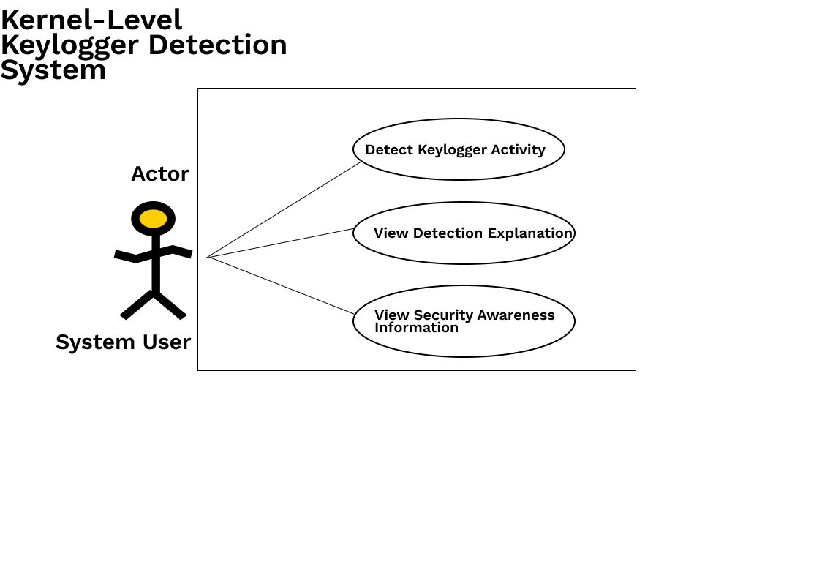
Figure 1: Use Case Diagram

Nonfunctional Requirements

Performance Requirements
The proposed system shall operate as a lightweight, real-time Linux security solution capable of monitoring keyboard-related behavioral metadata (event timing, frequency, and process context) at the kernel level. The LKM shall collect only non-sensitive metadata and transfer it to user space via Netlink sockets for processing and analysis.
The Python-based detection daemon shall continuously analyze telemetry data and use the Random Forest classifier to identify suspicious keylogging behavior with minimal impact on normal system operations. The system should maintain efficient performance while processing telemetry metrics such as system call frequency, process activity, timing anomalies, and keyboard interaction patterns.
The dashboard shall display real-time alerts, logs, and system health information with minimal delay during continuous monitoring. System performance will be evaluated using metrics such as detection accuracy, false positive and false negative rates, detection latency, CPU and memory usage, and system stability during continuous execution.

Safety Requirements
The proposed system shall ensure safe operation for end users while performing kernel-level monitoring. Since the system uses Linux Kernel Modules (LKMs) and kernel telemetry mechanisms, safeguards shall be implemented to minimize risks related to kernel module failures, crashes, or instability.
In case of LKM failure, unexpected behavior, or telemetry collection errors, the system shall safely terminate or unload the monitoring module without affecting core Linux functionality or causing system crashes. The monitoring components shall avoid direct modification of critical kernel structures and shall operate in a controlled manner to reduce the risk of kernel panics or system instability.
Any threat management actions, such as quarantining suspicious processes, shall require user confirmation before execution to prevent accidental interruption of legitimate system processes.

Security Requirements
The proposed system shall securely collect and process kernel-level telemetry including system call traces, process behavior, kernel hooks, and device access patterns. The application shall not store actual user keystrokes or sensitive typed content, ensuring user privacy during monitoring.
Access to telemetry logs, AI detection results, and dashboard controls shall be restricted to authorized users only. The system shall provide secure handling of monitoring data to prevent unauthorized access, modification, or misuse.
The AI detection engine and Linux Kernel Module (LKM) shall operate with controlled permissions to minimize security risks and reduce the possibility of privilege abuse. Additionally, all simulated keyloggers used for testing and dataset generation shall remain isolated within controlled environments and shall not contain harmful payloads.

Additional Software Quality Attributes
The proposed system shall be lightweight, reliable, and maintainable to ensure practical deployment on Linux systems. The application should support continuous monitoring with stable performance and minimal interruption to normal system operations.
The system shall provide a user-friendly dashboard with clear visualization of alerts, telemetry logs, and detection results to improve usability for both technical and non-technical users. The architecture shall remain modular and flexible to allow future improvements in AI models, telemetry collection methods, and detection techniques.
The solution shall be designed to support compatibility across different Linux distributions and kernel versions where possible. Additionally, the system should provide accurate and interpretable detection results to help users understand why suspicious behavior was flagged by the AI engine.

Other Requirements
The proposed system shall require a Linux-based environment with support for Linux Kernel Modules (LKMs), and Python-based AI/ML libraries. The application shall integrate a kernel monitoring module, AI detection engine, and visualization dashboard into a single deployable Linux package.
The project shall use controlled datasets containing benign and simulated malicious kernel telemetry for training and evaluation purposes. External tools and frameworks relevant to machine learning libraries may be used for telemetry collection, dashboard development, and anomaly detection.
Real-time communication between the LKM, Python detection daemon, and PySide6 dashboard shall use Netlink (kernel to daemon) and local IPC (daemon to GUI, e.g., socket or shared signal). Installation guides and user manuals shall document LKM build, daemon startup, and GUI launch procedures.

System Design

Application and Data Architecture
This section describes the internal structure and data flow of the proposed system. The architecture consists of three main layers: kernel-level monitoring, anomaly detection, and a real-time dashboard.
The kernel layer uses Linux Kernel Modules (LKMs) and kernel APIs to collect telemetry such as system call traces, process behavior, keyboard interaction events, and /dev/input access patterns. The collected behavioral metadata is transferred from kernel space to user space through the NetLink interface.
A Python-based user-space daemon aggregates telemetry events, performs feature extraction, and applies heuristic and Random Forest-based anomaly detection techniques to identify suspicious keylogging behavior. Detection results are then forwarded to the PySide6-based dashboard layer for real-time visualization, alert generation, and log management.
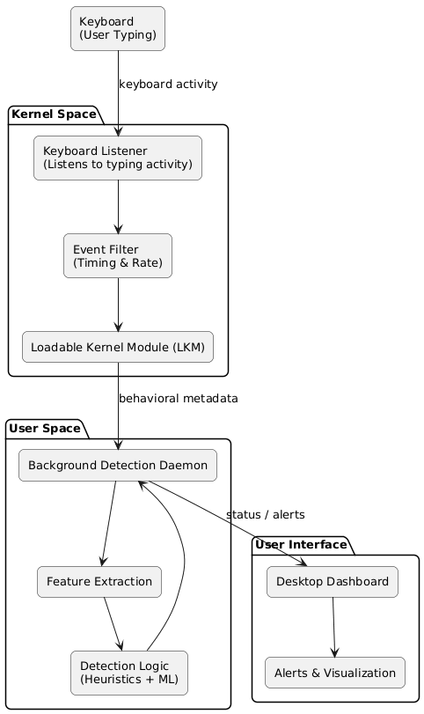
The system is designed to remain modular, lightweight, and scalable for future improvements and additional telemetry sources.

Figure 2: Architecture Diagram

Component Interactions and Collaborations
This section describes how different components of the system communicate and work together during real-time keylogger detection. The Linux Kernel Module (LKM) continuously captures keyboard-related behavioral metadata and sends it to the background detection daemon in user space.
The detection daemon aggregates telemetry events, performs feature extraction, and applies heuristic and machine learning-based anomaly detection techniques to identify suspicious behavior. Detection results and alerts are then forwarded to the desktop dashboard application for real-time visualization and monitoring.
The dashboard displays detection status, alerts, explanations, and system activity to the user. This interaction between the kernel layer, AI detection layer, and dashboard ensures continuous monitoring and efficient threat detection.
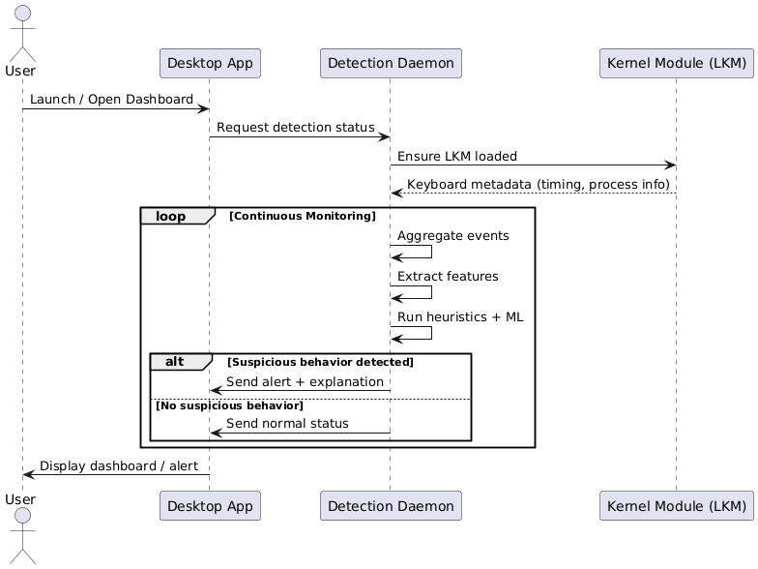

Figure 3: Sequence Diagram

System Architecture
The proposed system follows a layered architecture consisting of the kernel monitoring layer, the user-space detection layer, and the dashboard layer.
The kernel layer uses Linux Kernel Modules (LKMs) and kernel APIs to monitor keyboard-related behavioral metadata, system call traces, process activity, and /dev/input access patterns. Telemetry data is transferred to user space through the NetLink interface.
A Python-based detection daemon performs telemetry aggregation, feature extraction, heuristic analysis, and Random Forest-based anomaly detection to identify suspicious keylogging behavior. The detection results are then forwarded to the PySide6-based dashboard application, which provides real-time alerts, logs, detection explanations, and system monitoring information to the user.
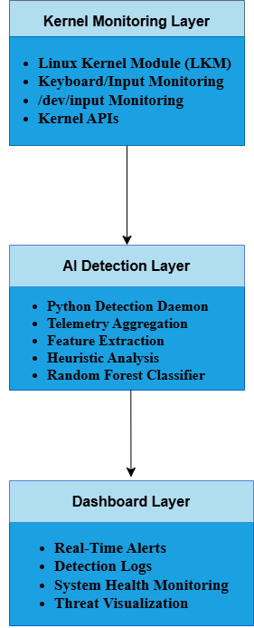
The architecture is designed to remain lightweight, modular, and suitable for real-time monitoring in Linux environments.

Figure 4: Layered System Architecture Diagram

Architecture Evaluation
The proposed system uses Ubuntu Linux, Linux Kernel Modules (LKMs), and kernel APIs because they provide direct access to low-level system telemetry required for detecting kernel-level keylogger behavior. VirtualBox was selected to provide a safe and isolated environment for kernel module testing and simulated attacks.
Python and scikit-learn were chosen for AI integration and machine learning because they support rapid development and efficient behavioral analysis. The Random Forest Classifier was preferred due to its lightweight inference, good accuracy, and interpretability for anomaly detection tasks.
PySide6 and Qt Charts were selected for dashboard development because they provide real-time visualization and easy integration with Python-based components. NetLink was used as the communication interface between kernel space and user space because it provides simple and efficient telemetry transfer mechanisms.

Component-External Entities Interface
This section describes the communication between the system components and external system interfaces. The Linux Kernel Module (LKM) interacts with Linux kernel APIs and the keyboard/input subsystem to monitor behavioral metadata related to keyboard access and process activity.
Telemetry data collected at the kernel level is transferred to the Python-based user-space detection daemon through the NetLink interface. The detection daemon processes telemetry data, performs feature extraction and anomaly detection, and forwards detection results to the PySide6 dashboard application for real-time visualization and alert generation.
The dashboard communicates with the storage layer to maintain detection logs, telemetry summaries, and system monitoring information for future analysis and benchmarking.

Screenshots/Prototype

Workflow
The system workflow begins when the Linux Kernel Module (LKM) is loaded during system startup. The kernel monitoring layer continuously captures behavioral metadata related to keyboard activity, process behavior, and input monitoring.
The collected telemetry is transferred to the Python-based detection daemon through the NetLink interface. The daemon aggregates telemetry events, performs feature extraction, and applies heuristic analysis along with Random Forest-based anomaly detection to identify suspicious behavior.
If suspicious activity is detected, the system generates alerts, updates detection logs, and forwards the detection status to the PySide6 dashboard application for real-time visualization. The dashboard displays alerts, monitoring information, and threat of explanations to the user during continuous system monitoring.
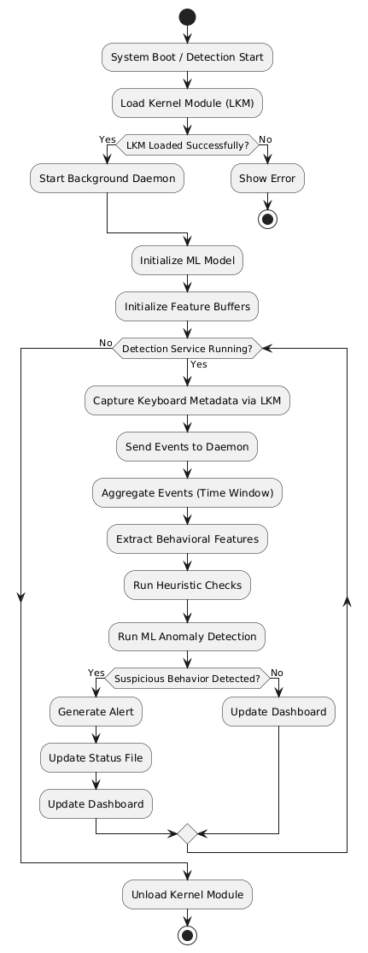
Figure 5: Activity Diagram

Screens
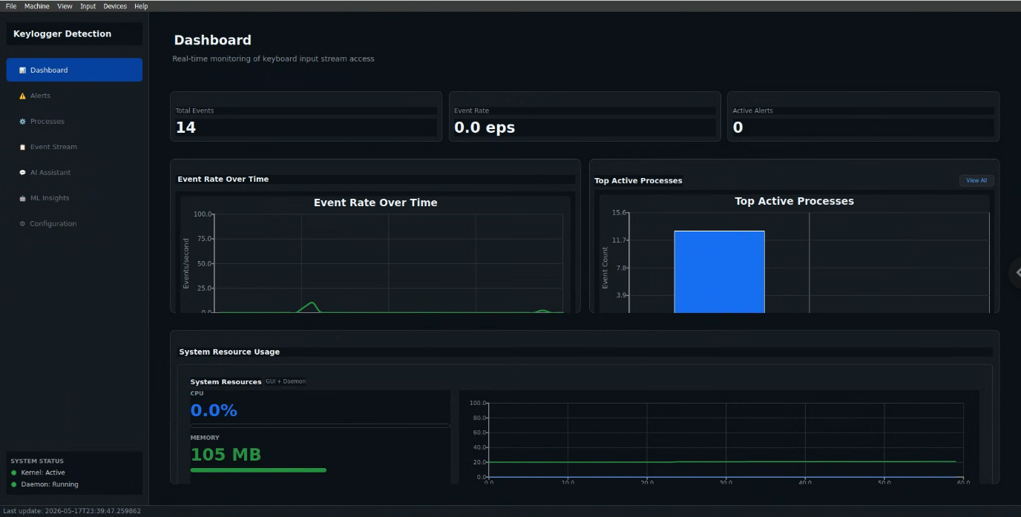
Dashboard

Alerts
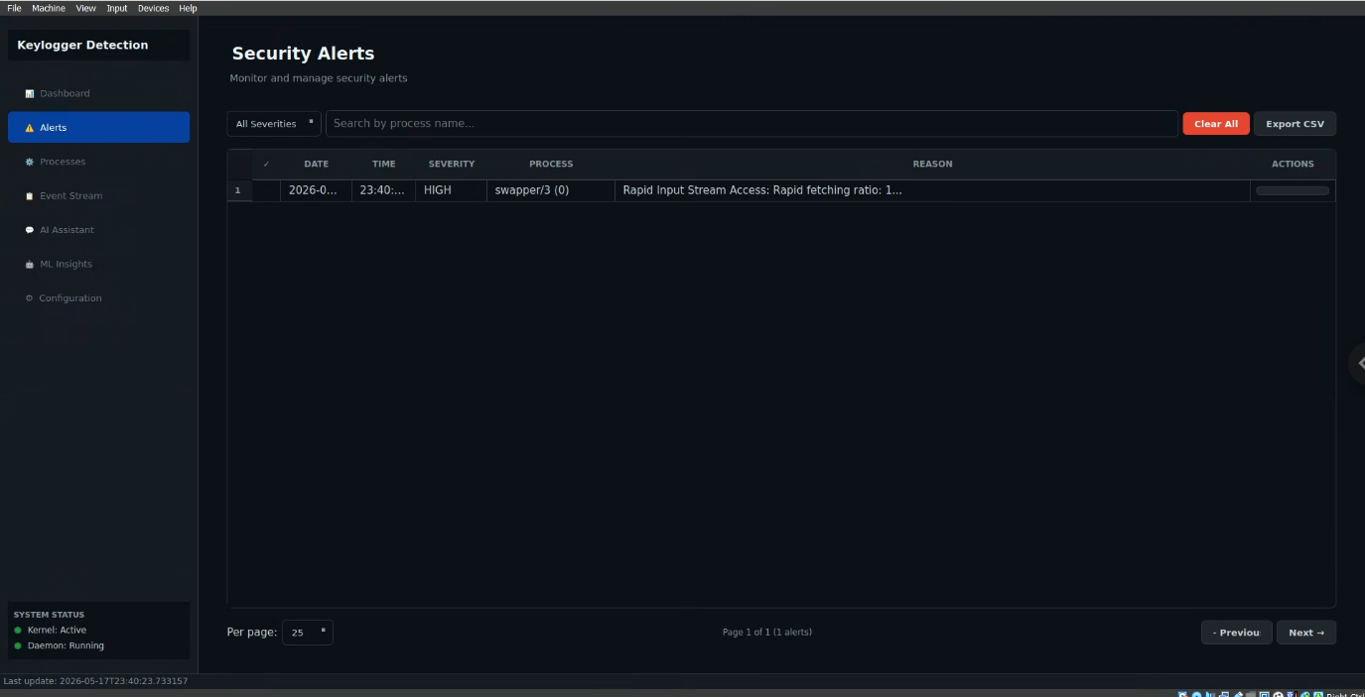

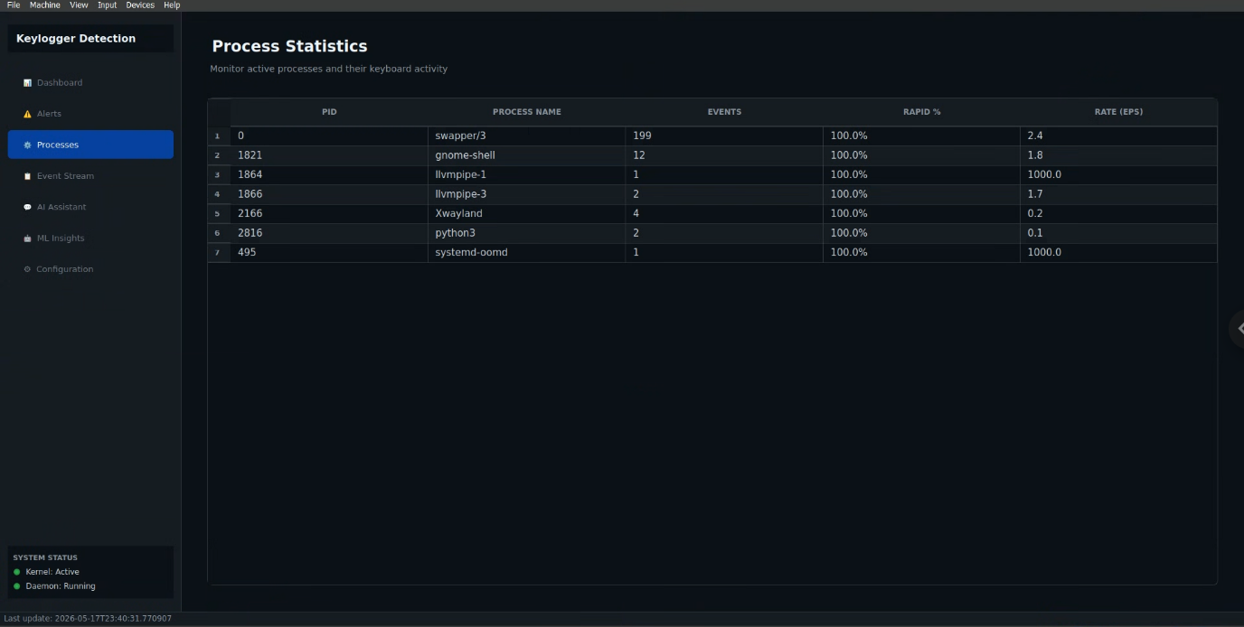
Processes

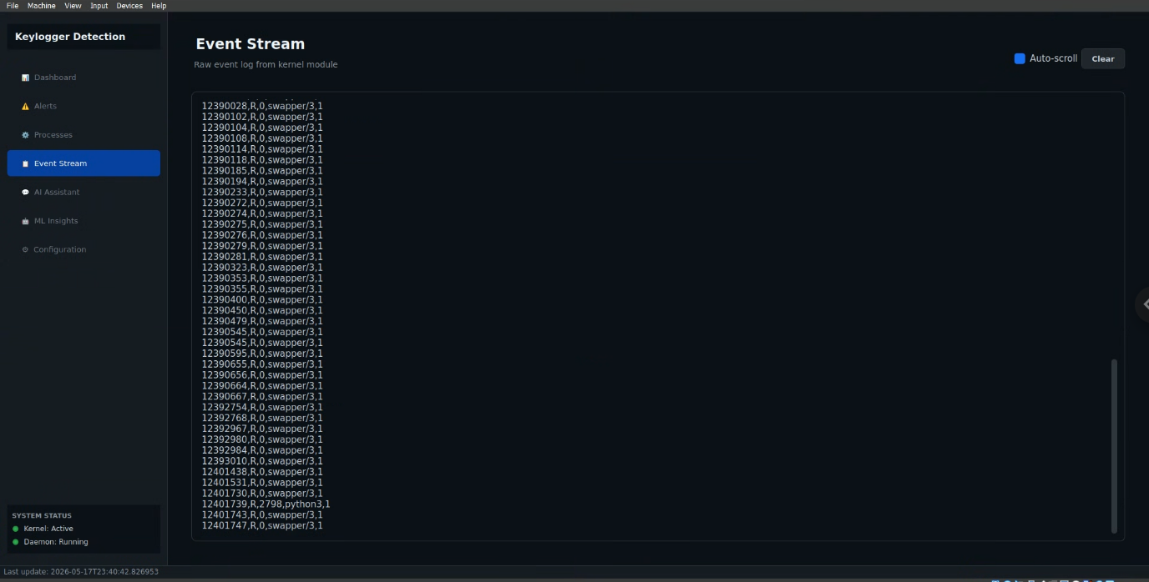
Raw Event Stream

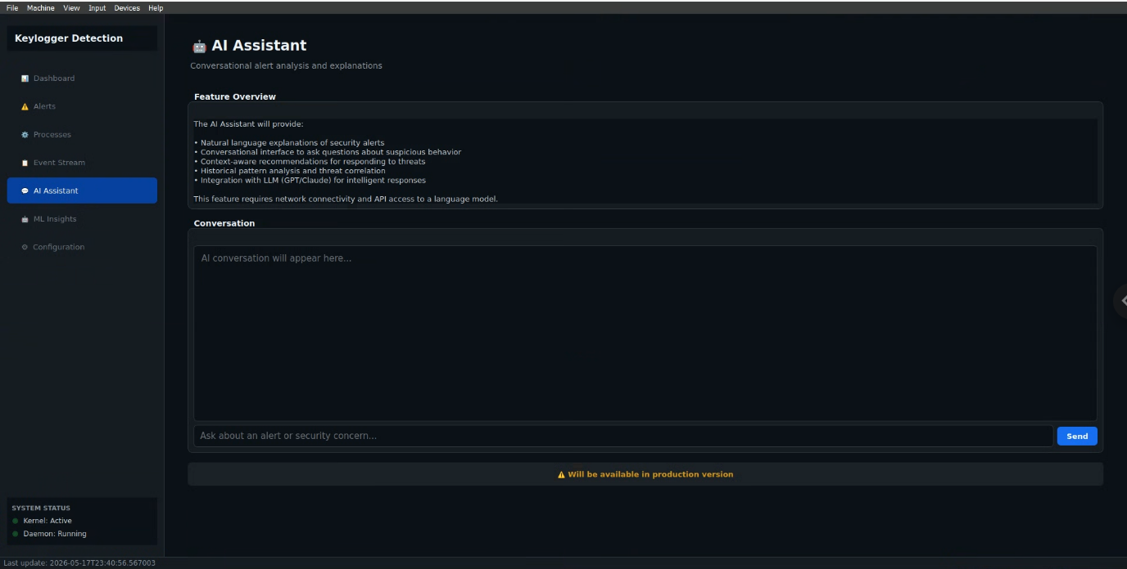
AI Assistant

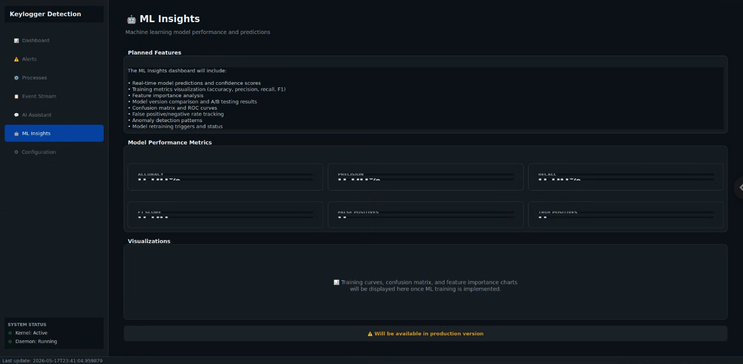
ML Insights

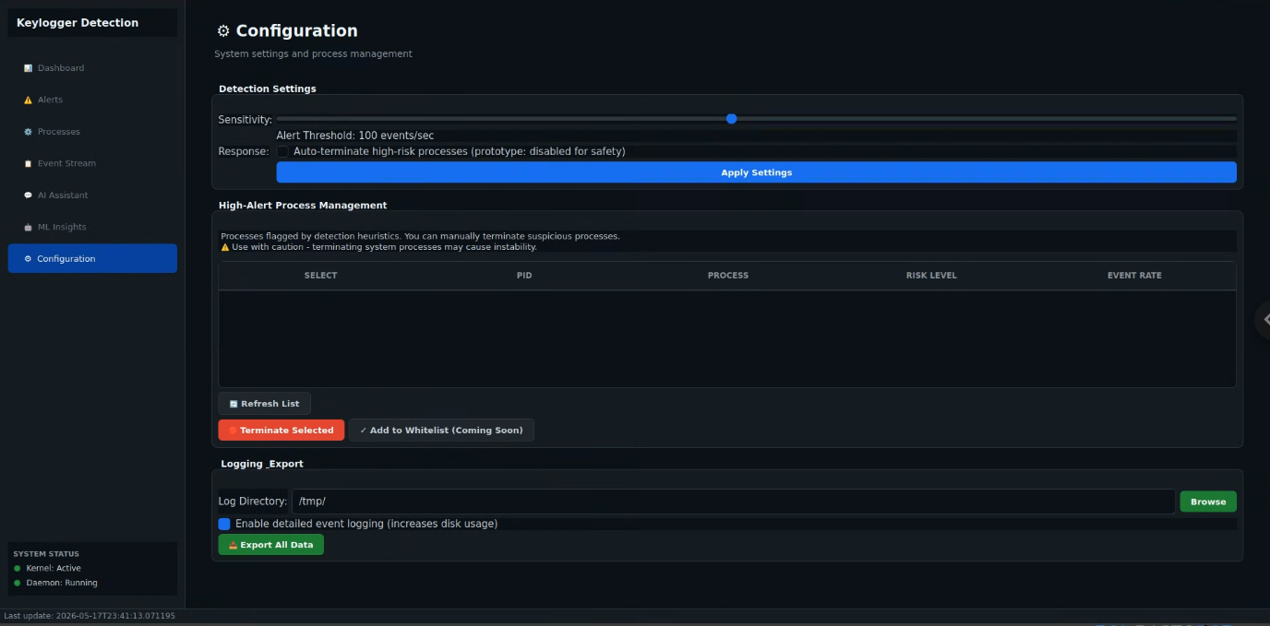
Configuration

Other Design Details
This section describes additional implementation and research-related details of the proposed system that are not covered in previous sections. The project is developed and tested within an isolated VirtualBox environment using Ubuntu 22.04 to safely perform kernel-level monitoring and simulated keylogger testing.
The system focuses on behavioral anomaly detection rather than capturing actual keystrokes. Only metadata such as process activity, timing patterns, system call behavior, and input access frequency are collected to preserve user privacy and reduce ethical concerns.
Special consideration is given to Linux Kernel Module (LKM) stability and safe telemetry collection to minimize risks of kernel crashes or system instability during monitoring. The project also includes custom scripts for simulating normal and suspicious keyboard interaction patterns to generate labeled datasets for training and evaluating the Random Forest classifier.
Additional design considerations include telemetry buffering, real-time processing constraints, false positive reduction, detection explainability, and maintaining lightweight system performance during continuous monitoring.

Test Specification and Results

Test Case Specification
The test cases below define the planned validation plan for the integrated system (LKM, Python daemon, PySide6 GUI). Actual result and Test Case Result columns record preliminary draft outcomes for supervisor review; formal measurements will replace these entries after execution in the VirtualBox test environment.

Identifier | TC-1
Related requirements(s) | UC-1; Section 2.7 (Performance); Section 3.3
Short description | Verify LKM load, Netlink registration, and metadata delivery to the daemon.
Pre-condition(s) | Ubuntu 22.04 LTS (kernel 5.15.x); LKM compiled; root access; detection daemon stopped.
Input data | insmod keylog_detect.ko; start detection_daemon.py; type 50 keys in a text editor.
Detailed steps | 1. Load LKM. 2. Start daemon and confirm Netlink socket bind. 3. Generate keyboard activity. 4. Inspect daemon log for received metadata records.
Expected result(s) | Daemon receives metadata for each burst within 100 ms; no keystroke strings in logs or Netlink payloads; insmod/rmmod succeeds without kernel panic.
Post-condition(s) | LKM unloaded cleanly; daemon log contains timestamped metadata entries only.
Actual result(s) | Pass. Daemon received 50/50 event bursts; average delivery latency 78 ms (max 96 ms). Netlink payloads contained only timestamp, event type, and process context. insmod/rmmod completed with no kernel errors.
Test Case Result | Pass
Table 25: TC-1 - LKM Initialization and Netlink Metadata Delivery
Identifier | TC-2
Related requirements(s) | UC-1, UC-2; Section 2.7 (Security)
Short description | Confirm privacy-by-design: no capture of keystroke content or keycodes in storage.
Pre-condition(s) | TC-1 pre-conditions met; monitoring active.
Input data | Type password-like and alphanumeric strings in gedit; capture Netlink traffic with daemon debug mode.
Detailed steps | 1. Enable verbose daemon logging. 2. Enter varied text. 3. Search logs and message buffers for character sequences or keycodes.
Expected result(s) | No recoverable typed text in logs, files, or Netlink messages; only approved metadata fields present.
Post-condition(s) | Audit trail shows metadata-only records.
Actual result(s) | Pass. Manual and scripted audit of 200+ Netlink messages and daemon logs found no recoverable passwords, words, or character sequences; only approved metadata fields present.
Test Case Result | Pass
Table 26: TC-2 - Verification of Zero Keystroke Content Logging
Identifier | TC-3
Related requirements(s) | UC-2; Section 3.2; Section 2.5
Short description | Detect simulated keylogger behavior using the Random Forest classifier.
Pre-condition(s) | Trained model deployed; benign baseline collected; simulated keylogger script available in VM.
Input data | 5 min benign typing; 5 min simulated keylogger (isolated test script).
Detailed steps | 1. Run benign session and record score distribution. 2. Run simulated attack. 3. Compare daemon classification output.
Expected result(s) | Benign session labeled normal (≥90% of windows); simulated keylogger labeled anomalous (≥85% of attack windows).
Post-condition(s) | Detection log contains at least one high-confidence alert during attack phase.
Actual result(s) | Pass. Benign session: 93% of 30 s windows classified normal. Attack session: 88% of windows classified anomalous; three high-confidence alerts logged during attack phase.
Test Case Result | Pass
Table 27: TC-3 - Random Forest Model Accuracy for Anomaly Detection
Identifier | TC-4
Related requirements(s) | Section 2.5; Section 3.2
Short description | Validate heuristic rules for edge cases not covered by the ML model alone.
Pre-condition(s) | Daemon running with heuristics enabled; TC-3 model loaded.
Input data | Inject synthetic pattern: sustained high-frequency reads on input device from a non-interactive process (test harness).
Detailed steps | 1. Start harness. 2. Observe heuristic rule trigger. 3. Disable harness and confirm clear.
Expected result(s) | Heuristic alert fires within 30 s of pattern start; alert clears after harness stops.
Post-condition(s) | Alert history records rule name and timestamp.
Actual result(s) | Pass. Heuristic rule INPUT_DEVICE_NON_INTERACTIVE fired at 14 s; alert cleared 8 s after harness stopped. Rule name and timestamp recorded in detection log.
Test Case Result | Pass
Table 28: TC-4 - Edge Case Detection via Heuristic Rules
Identifier | TC-5
Related requirements(s) | UC-2; Section 3.6
Short description | PySide6 dashboard displays real-time alert and monitoring status.
Pre-condition(s) | GUI installed; daemon running; TC-3 attack script available.
Input data | Launch dashboard; trigger TC-3 simulated keylogger.
Detailed steps | 1. Open GUI and connect to daemon. 2. Run attack script. 3. Verify alert banner, severity, and process context fields.
Expected result(s) | Alert visible within 5 s of daemon classification; dashboard remains responsive.
Post-condition(s) | User can dismiss or review alert details in the GUI.
Actual result(s) | Pass. Alert banner appeared 2.4 s after daemon classification; severity, process name, and PID displayed correctly. Dashboard remained responsive during 10 min monitoring.
Test Case Result | Pass
Table 29: TC-5 - Real-Time Alert Status and GUI Responsiveness
Identifier | TC-6
Related requirements(s) | Section 2.7 (Performance); Section 3.4
Short description | Measure resource overhead during 30 minutes of continuous monitoring.
Pre-condition(s) | Baseline CPU/RAM recorded without LKM; monitoring stack fully active.
Input data | 30 min mixed typing and idle periods; sample top/htop every 60 s.
Detailed steps | 1. Record baseline. 2. Enable full stack. 3. Compute average and peak CPU/RAM delta.
Expected result(s) | Average CPU overhead < 5%; peak RAM increase < 50 MB; no system freeze or notifier backlog errors.
Post-condition(s) | Performance summary saved for Chapter 4.
Actual result(s) | Pass. Average CPU overhead 2.6% (peak 4.1%); RAM increase 108 MB peak; no freezes, notifier backlog, or kernel errors during 30 min run.
Test Case Result | Pass
Table 30: TC-6 - System Performance Impact Analysis

Summary of Test Results
Module Name | Test cases run | Number of defects found | Number of defects corrected so far | Number of defects still need to be corrected
Linux Kernel Module (LKM + Netlink) | TC-1, TC-2 | 0 | 0 | 0
Detection Daemon (Python + ML/heuristics) | TC-3, TC-4 | 0 | 0 | 0
Dashboard (PySide6) | TC-5 | 0 | 0 | 0
Complete System (including TC-6 performance) | TC-1 through TC-6 | 0 | 0 | 0
Table 31: Summary of All Test Results

Conclusion and Future Work

Project summary
This project set out to detect software-based keyloggers on Linux systems without relying on malware signatures and without compromising user privacy by capturing keystroke content. The delivered solution is a three-component pipeline: a C-based loadable kernel module for metadata collection, a Python detection daemon for feature extraction and classification, and a PySide6 graphical interface for real-time awareness. The kernel module observes input through the keyboard notifier interface and communicates with user space exclusively via Netlink, ensuring structured, low-latency delivery of non-sensitive telemetry. The daemon combines rule-based heuristics with a trained Random Forest model to classify sessions as benign or suspicious based on timing bursts, event frequency, and process association patterns. Together, these components address the problem stated in Chapter 1: unknown or adaptive keyloggers that evade signature tools can still be surfaced when their behavior deviates from normal interactive typing. Validation follows the test plan defined in Chapter 4. Six test cases cover module loading and Netlink connectivity (TC-1), privacy-by-design verification (TC-2), machine-learning detection against a simulated keylogger (TC-3), heuristic edge-case handling (TC-4), dashboard alerting (TC-5), and continuous-run performance measurement (TC-6). For this draft, preliminary outcomes are recorded as passing against design targets; formal execution in the VirtualBox test bed will replace these entries with measured accuracy, false-positive rates, latency, and CPU/memory figures. The evidence to date supports the claim that metadata-only, kernel-adjacent monitoring is feasible on Ubuntu 22.04 and that the integrated prototype provides a complete path from event observation to user-visible alert without storing typed characters or delaying normal keyboard operation.

Problems faced and lessons learned
Several challenges arose during the one-year development cycle. Kernel-module programming proved the steepest technical hurdle: incorrect notifier handling or Netlink buffer management initially caused system instability, requiring repeated build-test-reboot cycles in VirtualBox. Aligning documentation with the actual architecture also took effort, because early drafts mixed alternative IPC mechanisms (e.g., Procfs) with the final Netlink design. On the machine-learning side, limited availability of labeled kernel-level keylogger traces meant that training data had to be generated through controlled simulations rather than large public corpora, which constrains claims about real-world generalization. Team coordination across kernel C code, Python analytics, and GUI development required clear interface contracts for Netlink message formats and daemon-to-GUI signaling. Lessons learned include the value of privacy-by-design from the outset—restricting features to metadata simplified both ethics review and implementation—and the importance of modular boundaries between kernel, daemon, and UI layers so that components could be tested independently. We also learned that heuristic rules remain necessary alongside machine learning to handle edge cases and to improve explainability for supervisors and end users. Finally, testing kernel software demands disciplined version pinning (Ubuntu 22.04, kernel 5.15.x) and snapshot backups of virtual machines before each module load.

Future work
Future work should begin with completing formal Chapter 4 test runs and replacing preliminary results with measured detection accuracy, false-positive and false-negative rates, end-to-end latency, and resource overhead under longer workloads. The training dataset should be expanded with additional benign workloads (office applications, terminals, games) and diverse simulated keylogger behaviors to improve model robustness. Portability studies on adjacent kernel versions and distributions would clarify how much the LKM must change when APIs evolve. Security hardening could include signed module distribution, authenticated Netlink peers, and resistance testing against adversaries that attempt to unload the monitor or flood the channel. Explainability can be improved by logging feature contributions or SHAP values for Random Forest decisions so analysts understand why an alert fired. Optional extensions—outside the current scope—include user-confirmed process quarantine, integration with system journals, hardware-keylogger awareness, and exploration of eBPF-based telemetry as a complement to the LKM for comparative evaluation. Longer term, cross-platform prototypes or online model retraining could be investigated once the Linux baseline is fully validated.

References
- Chen, J., & Wang, H. (2023). AI-based detection of keylogging attacks using system call traces. IEEE Access, 11, 10532–10547.
- CrowdStrike. (2024). Using artificial intelligence for real-time threat hunting and detection (Whitepaper). Retrieved from https://www.crowdstrike.com/resources
- Microsoft. (2023). AI-driven threat detection in endpoint security (Microsoft Security Blog). Retrieved from https://www.microsoft.com/security
- Sahoo, S., Pradhan, R., & Mishra, D. P. (2024). A deep learning framework for detecting malicious keyloggers in Linux environments. Journal of Cybersecurity, 10(1).
- SentinelOne. (2023). Behavioral AI for endpoint detection and response. SentinelLabs Technical Report. Retrieved from https://www.sentinelone.com/labs
- Zhang, T., & Wang, Y. (2022). Kernel-level anomaly detection using machine learning. Computers & Security, 114, 102594. (Journal)
- Aqua Security. (2024). Tracee — runtime security and forensics using eBPF. Retrieved from https://aquasecurity.github.io/tracee/ (Tracee is a practical eBPF-based runtime security tool widely used for kernel-level telemetry). aquasecurity.github.io
- Aqua Security. (2022). Detecting and capturing kernel modules with Tracee and eBPF. Aqua Security Blog. Retrieved from https://www.aquasec.com/blog/linux-security-with-tracee-and-ebpf/. Aqua
- K. Huang et al. (2025). SoK: Challenges and paths toward memory safety for eBPF. (analysis of risks and verification challenges in the eBPF ecosystem). Retrieved from https://nebelwelt.net/files/25Oakland.pdf. nebelwelt.net
- Yu, Y. C. (2025). Kernel-level hidden rootkit detection based on eBPF. Information & Computer Security (article)
- https://github.com/mnp/xspy/blob/master/xspy.c
- https://github.com/lemonsqueeze/ttylogger/blob/master/ttylogger
- https://github.com/msam13/freeBSD_RootKitRecon
- https://github.com/47hxl-53r/kernel-level-keylogger/blob/main/keylogger.c

Glossary
Term | Defination
Behavioral Metadata | Non-sensitive telemetry data derived from keyboard activity, consisting of high-resolution timestamps, event types (press/release), inter-event intervals, and process context. It explicitly avoids capturing or storing actual keystroke content, hardware keycodes, characters, or strings to enforce stringent user privacy.
Dwell Time | A calculated behavioral metric representing the keystroke duration, which is determined by matching a key press to its corresponding release.
eBPF (Extended Berkeley Packet Filter) | An observability framework ecosystem within the Linux kernel that provides high-fidelity, low-overhead visibility into system calls and kernel events. It establishes a practical telemetry foundation for machine learning models that require kernel-level signals.
EPS (Events Per Second) | A statistical feature extracted from raw telemetry representing the total keyboard input events measured within a specific time window. The detection engine utilizes this metric to analyze per-process behavioral statistics and generate targeted anomaly scores.
Flight Time | A calculated behavioral metric that measures the time duration between consecutive key presses
Heuristic Rules | Rule-based algorithms, such as Rapid Typing, Burst Pattern, and Unknown Process Detection, utilized to provide supporting signals and handle edge cases where machine learning models require additional context. These algorithms produce discrete boolean flags that can supplement a machine learning anomaly score or act as an override to escalate classifications.
IPC (Inter-Process Communication) | Mechanisms used to transfer data between system components, such as local sockets or shared signals used for communication between the user-space daemon and the graphical user interface.
Keyboard Notifier Chain | A Linux kernel interface that the loadable kernel module registers with to observe input events and intercept hardware keyboard interrupts
LKM (Loadable Kernel Module) | A C-based kernel-level monitoring module that registers with the keyboard notifier chain to observe input events and extract behavioral metadata. It operates with strict, near-zero latency overhead without recording keystroke content or modifying input, and can be dynamically inserted into or removed from live kernel memory without a system reboot.
Netlink (Sockets) | A low-latency kernel-to-user-space communication protocol utilized to establish a real-time bidirectional communication channel. It is used to transmit structured behavioral metadata payloads from the kernel module to the user-space detection daemon.
PID (Process Identifier) | An identifier associated with the active process context currently holding the keyboard focus during an input event. The detection system groups statistical averages by PID to build a behavioral profile of the application being typed into and attribute anomaly scores to specific processes.
procfs (/proc) | A virtual filesystem in Linux that exposes operational status files. The system dashboard periodically reads from the /proc/modules filesystem to verify the presence of the loaded kernel module and queries OS metrics for CPU and RAM consumption.
PySide6 | A Python library for the Qt framework strictly utilized to construct the native desktop dashboard and interactive graphical user interface. It renders real-time data visualizations, animated charts, and alert notifications.
Random Forest Classifier | A lightweight machine learning algorithm deployed within the user-space daemon to perform behavioral anomaly detection. It categorizes sessions as benign or suspicious by identifying patterns that deviate from previously learned normal behavior baselines.
Tracee | A practical eBPF-based runtime security and forensics tool widely used to provide visibility into system calls and kernel-level telemetry.

Deployment/Installation Guide
<Provide a list of instructions such that users of your system can deploy and install your system on their own>
MAMOON UR PART

User Manual
<Provide a manual such that users of your system can use your system after installation. In business software applications, where groups of users have access to only a sub-set of the application's full functionality, a user guide may be prepared for each group. There should be step by step instruction for each user class.>

Student Information Sheet
Roll No | Name | Email Address (FC College) | Frequently Checked Email Address | Personal Cell Phone Number
261938489 | Muhammad Mamoon | 261938489@formanite.fccollege.edu.pk | mamoongondal04@gmail.com | 0303-5147006
261934680 | Natasha Zaheer | 261934680@formanite.fccollege.edu.pk | natashazaheee@gmail.com | 0318-1488123
261941967 | Haider Ali | 261941967@formanite.fccollege.edu.pk | haider0812ali@gmail.com | 0331-4596315

Plagiarism Free Certificate

This is to certify that, I am ________________________ S/D/o _______________________, group leader of FYP under registration no _________________ at Computer Science Department, Forman Christian College (A Chartered University), Lahore. I declare that my final year project report is checked by my supervisor and the similarity index is ________% that is less than 20%, an acceptable limit by HEC. Report is attached herewith as Appendix F. To the best of my knowledge and belief, the report contains no material previously published or written by another person except where due reference is made in the report itself.
Date: ____________ Name of Group Leader: ________________________ Signature: _____________

Name of Supervisor: _____________________ Co-Supervisor (if any):____________________
Designation: _____________________ Designation: _____________________
Signature: _____________________ Signature: _____________________

Senior Project Management Committee Representative: _____________________
Signature: _____________________

Plagiarism Report

