**Group Name: DAN/EXT 28**

**Group Members:**

**FATEEN RAHMAN - s387983**

**HENDRICK DANG - s395598**

**KEVIN ZHU - s387035**

**MEHRAAB FERDOUSE - s393148**

*Question 2:*

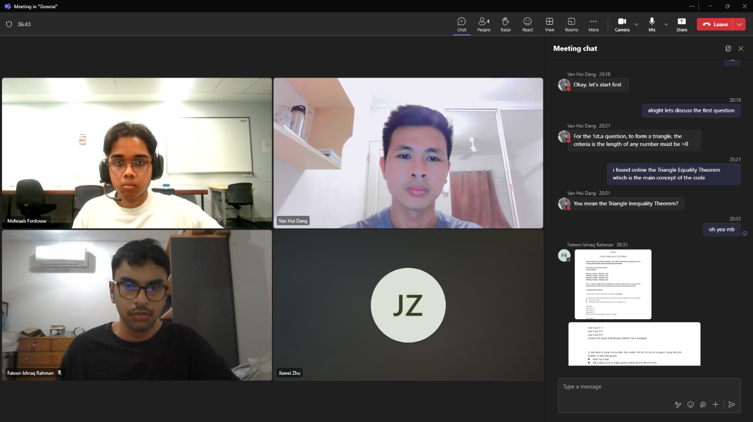

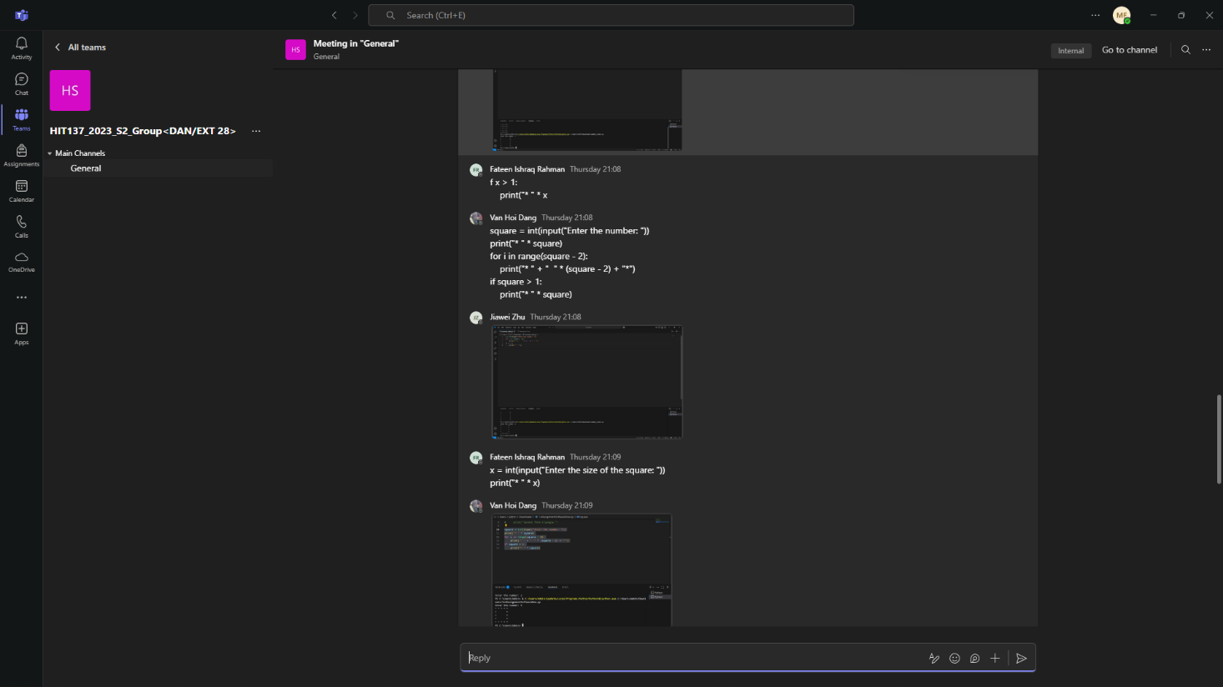

*Question 3:*

**The Imperative of Collaboration in Programming Projects**

As the world progresses further technologically, the need for solutions to up-and-coming problems within our programs and software becomes a higher imperative. Modern day software development incentivizes collaboration among developers in the industry to come together and solve these problems more efficiently instead of making individualized efforts. Such collaboration has become a defining feature of successful programming projects, even on a more fundamental level in an academic setting. Group work offers students an opportunity to better understand their work, sharpen their practical skills and prepare for the collaborative nature of real-world software development. While individual assignments test coding knowledge, group-based programming projects foster a broader range of competencies that are essential for thriving in the tech industry.

Notably the most beneficial aspect of peer-to-peer learning environments is the ability to teach and learn from each other. Topping (2005) explains that peer tutoring allows for reciprocal learning, where both tutor and tutee benefit from the interaction. In an academic programming context, this might involve one student helping another understand the concept of Object-Oriented Programming or debug a complex algorithm, leading to stronger retention and comprehension for both. These interactions enable abstract concepts to be clarified in the moment and accelerate the learning process.

As stated previously, modern day programming encourages group work, and this is evident in present day software development tools. Tools like Git, GitHub and Kaggle are industry-standard platforms for project management and actively discourage development in isolation. Academic programming projects that adopt these tools expose students to key workflows they will encounter in the workplace. Williams and Kessler (2002) advocate for collaborative techniques like pair programming and regular code reviews, highlighting that these practices improve code quality and foster shared understanding. As students experience these workflows, they gain familiarity with managing branches, reviewing pull requests, and integrating code collaboratively which are all critical aspects of modern development.

Moreover, diverse group settings can lead to more innovative and effective solutions than coming up with a solution as an individual. Differing perspectives, shaped by varying educational, cultural or technical backgrounds, can be a positive aspect of working with peers that further enriches the group’s approach to problem-solving. When these diverse skill sets are combined, the overall quality and breadth of the project are improved (Tushman & O’Reilly, 1996).

In programming groups, students must coordinate timelines, assign roles, give constructive feedback, and manage differences in work style or motivation. These interactions help build trust and improve the overall team dynamic (Wheelan, 2005) and help develop soft skills that are critical for success not just in the tech industry, but in the professional workspace in general. The ability to articulate one’s thought process and collaborate respectfully with others is as valuable as writing efficient code.

However, group work is not without its challenges. Differences in ability, commitment, or communication styles can hinder progress. Yet, these difficulties are also learning opportunities. Establishing clear expectations, maintaining regular communication, and developing a team agreement at the beginning of a project are effective strategies for reducing conflict and ensuring accountability (Topping, 2005). As teams learn to navigate these issues, they build resilience and grow more capable of handling collaborative work in professional settings.

To conclude, working in groups on programming projects provides opportunities to grow academically and develop strong professional skills. In such environments, students gain the ability to learn industry-relevant tools, develop innovative solutions through collaboration and become proficient in their field of study. Despite challenges inevitably arising, the experience not only leads to better project outcomes but ultimately also prepares team members for future professional roles in the software development industry.

**References**

Topping, K., 2005. Trends in peer learning. *Educational Psychology*, 25(6), pp.631–645.

Williams, L. and Kessler, R., 2002. *Pair Programming Illuminated*. Boston: Addison-Wesley.

Tushman, M.L. and O’Reilly, C.A., 1996. Ambidextrous organizations: Managing evolutionary and revolutionary change. *California Management Review*, 38(4), pp.8–30.

Wheelan, S.A., 2005. *The handbook of group research and practice*. Thousand Oaks, CA: Sage Publications.

**Group Agreement:**

Team Vision:   
Our vision as a team is to automate the learning process by working together in a friendly space. We have agreed to practice equality and ensure that each member is treated fairly. We aim to complete all assignments in this unit as a team and work through all challenges with everyone’s input.

Goals:

* Become proficient in fundamentals of the Python programming language
* Build strong skills and relations by working together as a team
* Gain the ability to work on larger and more complex projects and participate in community events
* Ensure that the workspace for assignments is always comfortable and friendly for all members
* Work toward achieving a high grade as well as understanding the core concepts of the unit
* Strive to continue to learn and improve