Example to show the procedures of calculating dynamic stability
Local dynamic stability was determined³ based on the maximum finite-time Lyapunov exponent, λ_{max}. The procedures to calculate the λ_{max} are shown below using Lorenz attractor as an example. The Lorenz equations are,
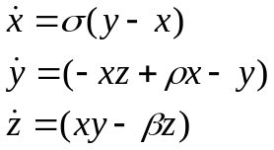
where σ = 16.0, ρ = 45.92 and β = 4.0 in this example. Figure 1 is the traditional Lorenz attractor with these parameters, initial conditions [x,y,z] = [20,20,20] and time range from 0 to 10 seconds (timestep = 1 msec).
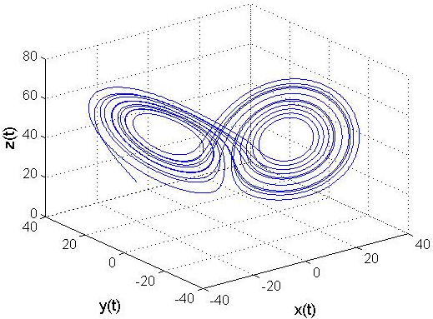
Figure 1. Lorenz attractor
Norm of vectors:
It is unreasonable to assume that one can measure all of the dynamic states of the biomechanical system. Therefore, in this example we will demonstrate how a measurable subset of the dynamic states can be used to estimate the nonlinear behavior¹ The stability analyses were performed on the Euclidean norm of the three variables determining the dynamics at each time interval,
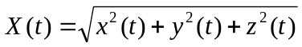
The norm of the example Lorenz attractor is illustrated in Figure 2 plotted X(t) as a function of time. This can be used to represent the measured experimental data.
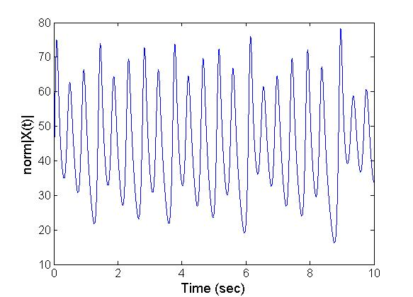
Figure 2. Norm of the Lorenz attractor. This represents a sample measurable state.

Since the measured time-series data, X(t), is a one dimensional column vectors it is necessary to reconstruct an n-dimensional state-space out of the data in order to accurately represent the nonlinear dynamics. One typical method of creating an n-dimensional state-space from scalar data is by method of delays (equation 2)⁴. Two critical parameters are necessary including the constant time delay T_{d} and the number of reconstructed embedding dimensions, n.
Time Delay:
The time delay T_{d} was estimated from the Average Mutual Information Function². T_{d} was taken as the first minimum of the Average Mutual Informatio(AMI) function. Figure 3 shows that in this case (norm of the Lorenz attractor) the minimum AMI occurred at 90 samples i.e. 0.09sec.
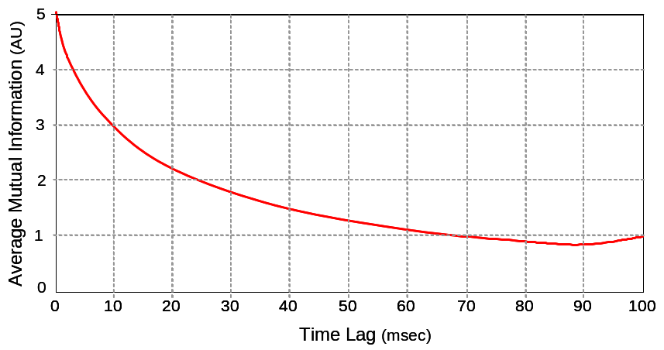
Figure 3. Time delay from AMI
Embedding Dimension:
Embedding dimension was based on a global false nearest neighbor analysis. Figure 4 shows the percentage of false neighbors is minimum at embedding dimension n = 3. Therefore for this example the embedding dimension n = 3 was used to reconstruct the state-space.
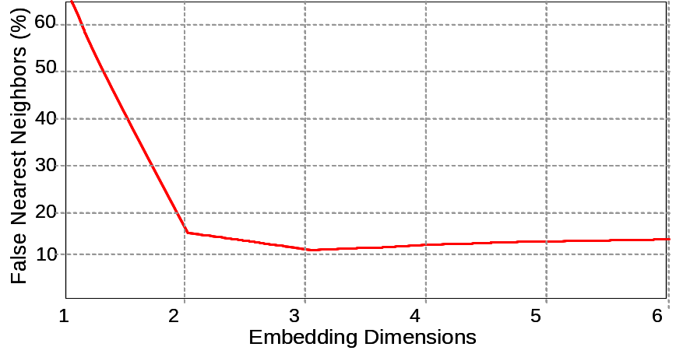
Figure 4. Embedding dimension from false nearest neighbors analysis
Reconstructed State-Space:
Figure 5.A below is the reconstructed state space of X(t) with an embedding dimension of n = 3. Figure 5.B shows the Euclidean distance between the nearest neighbors. The Euclidean distance between nearest neighbors, d_{i}(t), was computed for each data point, i, in the reconstructed state-space. The nearest neighbor of a data point was found by selecting a point on a separate trajectory such that the distance between the two points was minimum compared to the distance between the reference point and any other point on a different trajectory in the state-space.
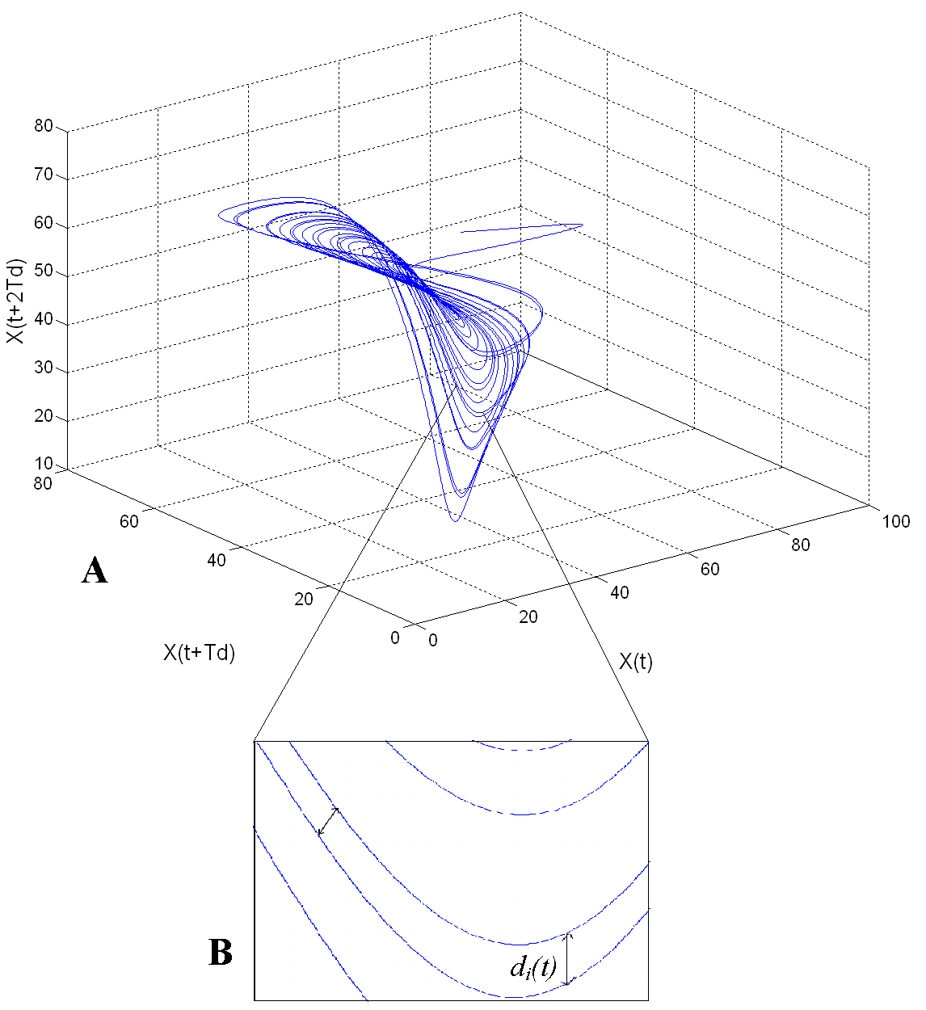
Figure 5. (A) Reconstructed state-space with 3 embedded dimensions. (B) Euclidean distance between nearest neighbors
Calculating Maximum Finite Time Lyapunov Exponent λ_{max} :
The average logarithmic divergence of all pairs of nearest neighbors, i are calculated from the reconstructed state space. The maximum finite-time Lyapunov exponent, λ_{max} was calculated as the slope of the logarithm of average divergence across the span of o to 1 cycle as shown in the Figure 6.
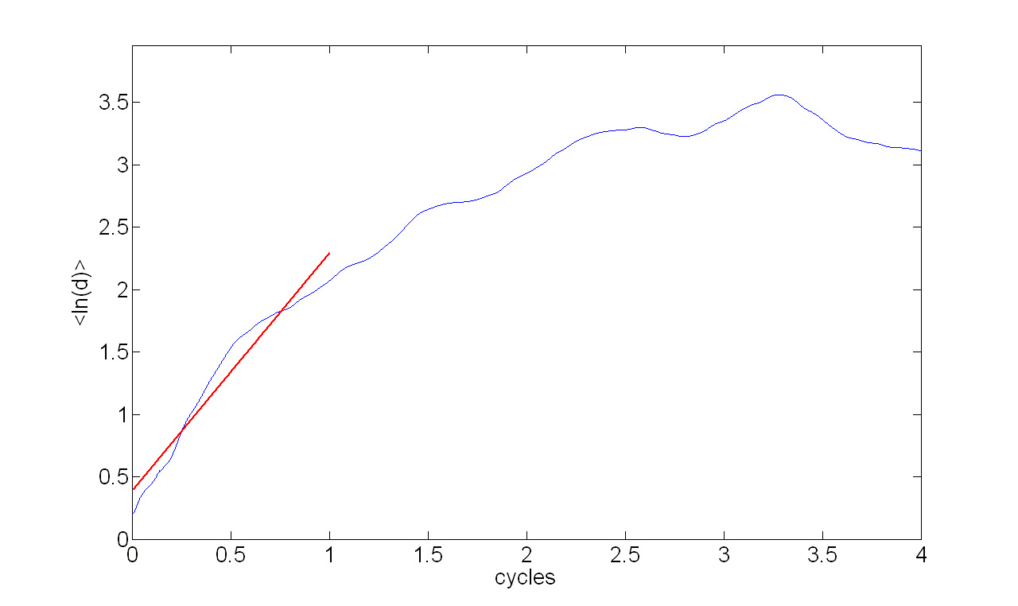
Figure 6. Average logarithmic divergence vs. time

Reference List
1. F.Takens. Detecting Strange Attractors in Turbulence. In: L.-S.Young, ed. Dynamical Systems and Turbulence. New York: Springer, 1981:366-81.
2. Fraser AM and Swinney HL. Independent coordinates for strange attractors from mutual information. Phys.Rev.A 1986;33:1134-40.
3. Rosenstein MT, Collins JJ, and Deluca CJ. A Practical Method for Calculating Largest Lyapunov Exponents from Small Data Sets. Physica D 1993;65:117-34.
4. Rosenstein MT, Collins JJ, and Deluca CJ. Reconstruction Expansion As A Geometry-Based Framework for Choosing Proper Delay Times. Physica D 1994;73:82-98.

