**University Graduate School Development Needs Analysis Form (GRS1A)**

Successful and timely completion of your research degree will depend on developing a mixture of subject-specific skills, intellectual skills, such as critical thinking, and more generic skills, like communication and enterprise. Many of these skills will also be important in your future life, whatever career or life choices you make.

The Development Needs Analysis (DNA) form uses Vitae’s Researcher Development Framework (RDF) to help you think about your current skills, pinpoint gaps in your knowledge, and identify areas for future development. The RDF articulates the knowledge, behaviours and attitudes of researchers, from postgraduates to established academic leaders and is endorsed by Research Councils UK.

There are four sections to the form, based on the RDF domains. The domains are shown below. For more information see here <https://www.vitae.ac.uk/researchers-professional-development/about-the-vitae-researcher-development-framework/developing-the-vitae-researcher-development-framework/> (you will need to register). Use the sections to outline your development goals for this year in each domain. At the end of the form is a summary sheet to outline your specific plans.

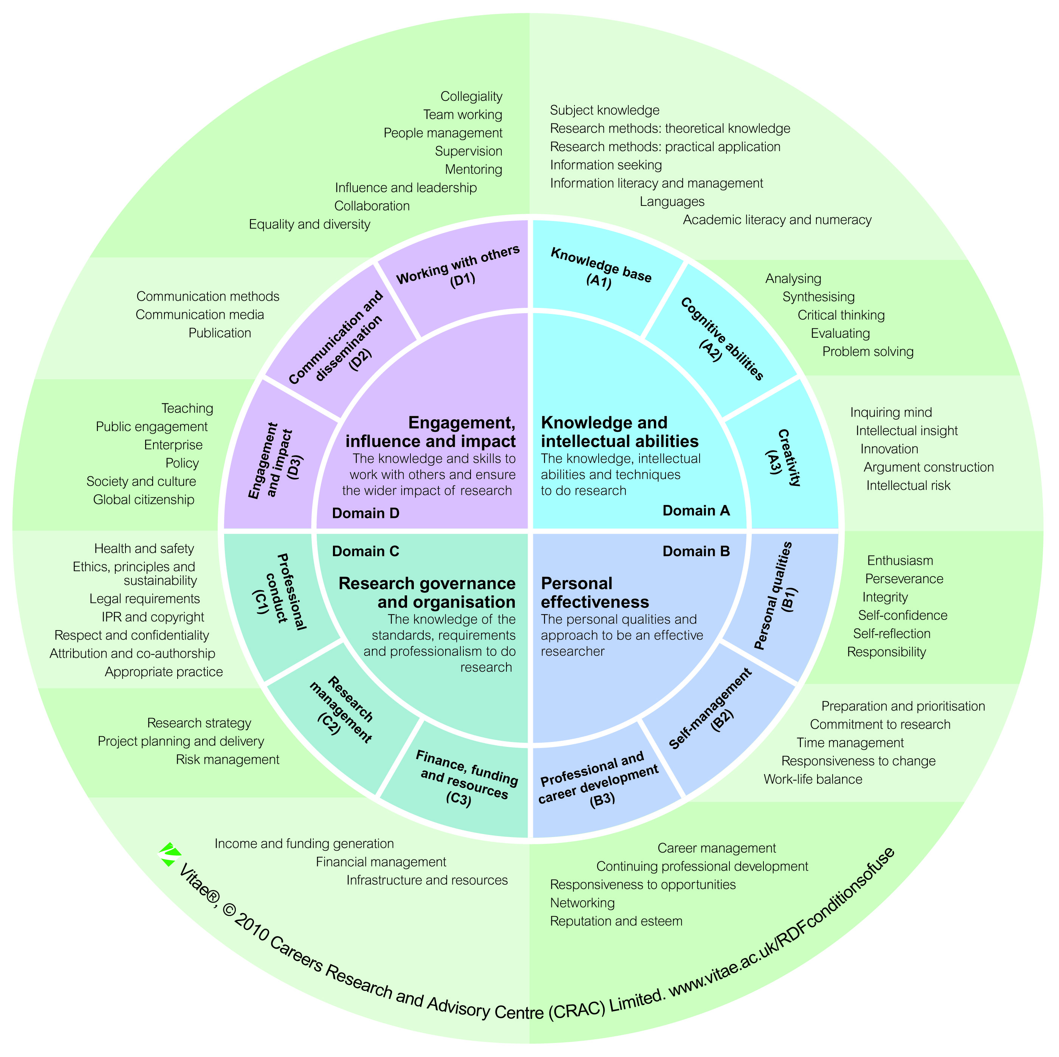

**Domain A: Knowledge and Intellectual Abilities**

The knowledge, intellectual abilities, and techniques used in research

(Knowledge Base, Cognitive Abilities, Creativity)

**Domain B: Personal Effectiveness**

The personal qualities and approach to be an effective researcher

(Professional and Career Development, Self-Management, Personal Qualities)

**Domain C: Research Governance and Organisation**

The knowledge of standards, requirements, and professionalism to do research

(Professional Conduct, Research Management, Finance, Funding and Resources)

**Domain D: Engagement, influence and impact**

The knowledge and skills to work with others and ensure the wider impact of research

(Working with Others, Communication and Dissemination, Engagement and Impact)

**Personal Development Plan Summary**

You can use this section to identify a small number of specific prioritised goals for your development this year. This should be revisited at the end of the year to assess progress. Please visit [www.graduateschool.bham.ac.uk](http://www.graduateschool.bham.ac.uk) for information, workshops and events that can help you meet your development objectives. Once the form is completed and signed please hand into your school, or upload electronically via the BIRMS PGR management system.

|  |  |  |  |
| --- | --- | --- | --- |
| **Identified skill area for development** | **Planned Activity** | **Success criteria (i.e. how will you know you’ve achieved your goal)** | **Deadline (when do you want to achieve it by?)** |
|  |  |  |  |
|  |  |  |  |
|  |  |  |  |
|  |  |  |  |
|  |  |  |  |

Signature (PG Researcher)

……………………………………………………………………………….. Date……………………………………………………

Signature (Supervisor)

………………………………………………………………………………….. Date…………………………………………………..

Signature (Second or co-Supervisor)

…………………………………………………………………………………. Date………………………………………………………