Understanding Movement Variability of Simplistic Gestures Using an Inertial Sensor

| Miguel Xochicale  University of Birmingham, UK  map479@bham.ac.uk | Chris Baber  University of Birmingham, UK  c.baber@bham.ac.uk | Mourad Oussalah  University of Oulu, Finland  [moussala@ee.oulu.fi](mailto:moussala@ee.oulu.fi) |
| --- | --- | --- |

# ABSTRACT

Paste the appropriate copyright/license statement here. ACM now supports three different publication options:

* ACM copyright: ACM holds the copyright on the work. This is the historical approach.
* License: The author(s) retain copyright, but ACM receives an exclusive publication license.
* Open Access: The author(s) wish to pay for the work to be open access. The additional fee must be paid to ACM.

This text field is large enough to hold the appropriate release statement assuming it is single-spaced in Times New Roman 8-point font. Please do not change or modify the size of this text box.

Each submission will be assigned a DOI string to be included here.

We present a preliminary experiment to understand the movement variability of six simple movements. Six participants, wearing inertial measurement units on their wrist, performed six actions. The data collected were analysed using time-delay embedding theorem, PCA and percentage of cumulative energy to characterise variability in these movements. Of these movements, the static, circular and 8-shape movements show a constant trend between participants; however, such trend is not evident for horizontal, vertical and diagonal movements. Such analysis can be useful in determining different states of interactions with the display of user’s behavior (enthusiasm, boredom, tiredness or confusion) which might allow the displays to respond accordingly and also in diagnosing performance in rehabilitation applications. *...150 words and are required…*

## Author Keywords

Time delay embedding; activity recognition; dimensionality reduction; phase space reconstruction

## ACM Classification Keywords

I.5 Pattern Recognition: general; G.3 Probability and statics: statistical computing, time series analysis.

# INTRODUCTION

Variability is an inherent characteristic of human movement [1] and could provide useful diagnostic information in activity recognition, e.g. in terms of detecting changes in the way in which activities are performed over the course of training, practice or rehabilitation. Movement variability is, however, a common problem in activity recognition. For instance, users usually perform the same action slightly differently trial by trial. One approach would be to remove variability by normalizing the data so that the movements conform to defined models. Another is to find a way to preserve the variability in the movement while also supporting activity recognition. For these reason we are interested in the analysis of the variability of simple movement that can give insight into understanding variably between individuals and between repetitions of the same movement. Variability is presented when users interact with displays. For instance, Zaiţi et al. [2] explored kinematic variations of leap gestures such as gesture volume, gesture length, finger-to-palm distance and articulation speed.

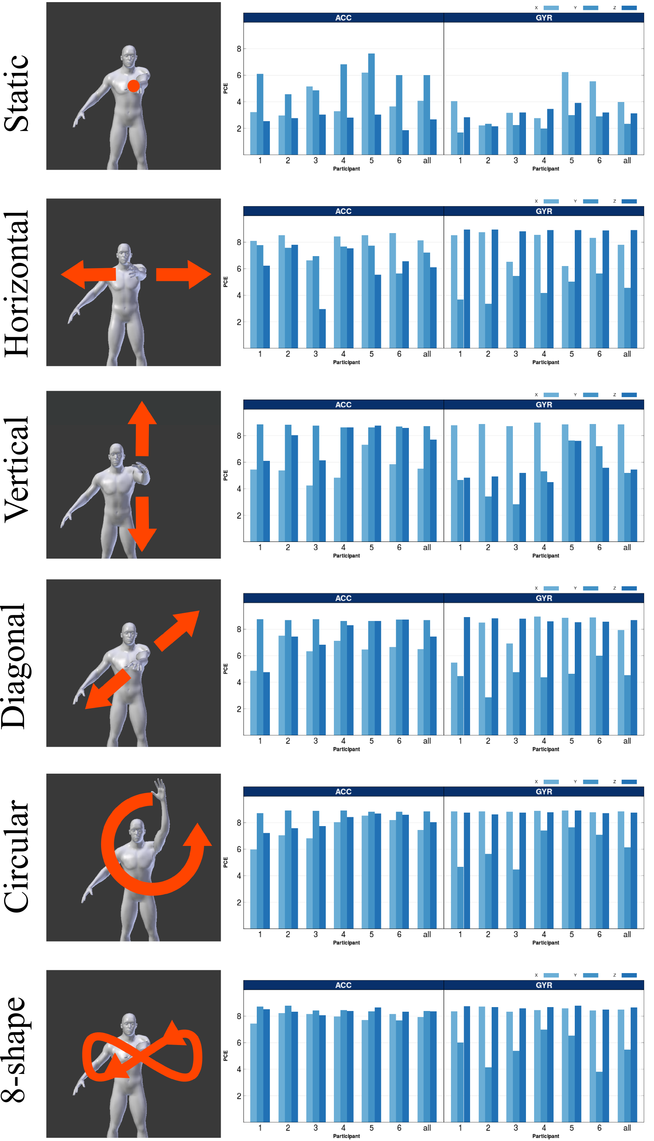

Figure 1. The first column shows the six gestures. The second and third columns present the cumulative energy (accelerometer and gyropscope) for each movement accross partipants and their average denoted by all.

We therefore consider that the freedom that wearable sensors (inertial sensors) offer is ideal for both comfortable and unconstrained interaction with displays.

# PHASE SPACE REPRESENTATION OF THE TIME-DELAY EMBEDDED SERIES DATA

In this work we follow the notation employed in [5]. The purpose of time-delay embedding, also known as Takens’s Theorem, is to reconstruct a D−dimensional manifold *M s(t)* of an unknown dynamical system from time series *x(t)* of that system. Time-delay embedding assumes that the time series is a sequence *x(t) = h(s(t))*, where *h : M → RD* is a measurement function on the unknown dynamical system, being *x(t)* observable (Figure 2). The time delay reconstruction in *m* dimensions with time delay *τ* is deﬁned as: *x(t) = (x(t),x(t − τ),...,x(t − (m − 1)τ))* which deﬁnes a map *Φ : M → Rm* such that *x(t) = Φ(s)*. *Ψ : Rm → Rn* is a further transformation that is considered as a more general transformation, for our case we apply Principal Component Analysis (PCA).

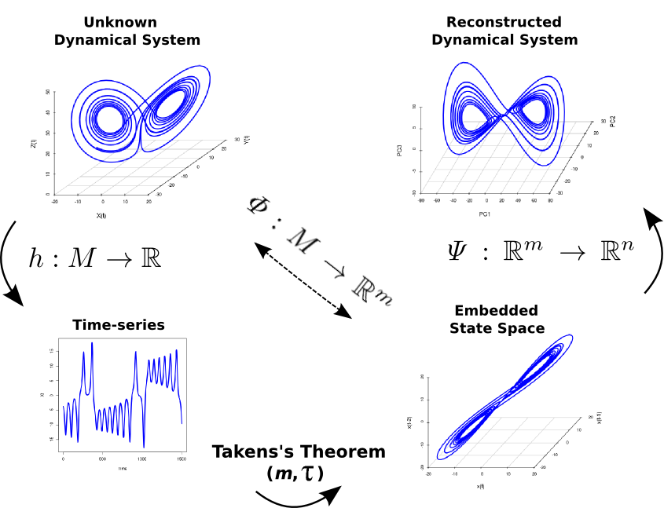Figure 2. The reconstruction problem.

# FRAMEWORK FOR THE EXPERIMENT

To analyse the data from six individuals who performed each action for 20 seconds, we use the time-delay embedding and PCA techniques. To do this, the raw data is collected from triaxial accelerometer and triaxial gyroscope sensors. Then, the time-series, for instance, ***ax***, with a length of ***N*** samples is used to obtain the time-delay embedded matrix, ***E****{* ***ax*** *}* [3], with *m* rows and *N − (m − 1)τ* columns. PCA algorithm is applied to obtain, via eigenvalues (*λ1,…,λm*) of eigenvectors (*v1,…,vm*), the principal components (*PC1,…,PCm*) of the time-delay embedded phase space. Finally, the percentage of cumulative energy is computed [4].

# RESULTS

Figure 1 show the percentage of energy for both participants and movements. It can be seen that static, circular and 8-shape movements show a constant trend between participants; however, such trend is not evident for horizontal, vertical and diagonal movements for both sensors. We assume that the variability for the horizontal, vertical and diagonal movements is due to the no well constrained experiment in which participants were only asked to perform the movements at a confortable speed, besides that, the anthropomorphic features of the participants might have an effect on the similarity or variation of the movement. The averages of PCE for all participants show statistical evidence for different movements for each sensor.

# Conclusion and Future work

Although the Time-delay embedding technique is subject to different values of embedded parameters (*m* and *τ*) according to the length and complexity of the time-series, the technique is useful to statistically present the inherent features of variability between 6 participants for six different gestures (Fig. 1). Appreciating variability in human activity can not only provide useful diagnostic information but also offers an approach to considering the manner in which people interact with pervasive displays.  For example, each of the gestures described in this study could be performed in ways which signifies different states of enthusiasm, boredom, tiredness or confusion. Rather than generating individual models of each of the actions performed in each of these states, being able to detect the variability in the action could help determine how the user is interacting with the display, possibly allowing the displays to respond accordingly. We are planning to collect data from female and male participants of different ages attaching more sensors. We are also going to apply some classification algorithms to automatically measure the variability of participants.

# ACKNOWLEDGMENTS

Miguel Xochicale is supported by National Council of Science and Technology (CONACyT) Mexico  
<http://www.conacyt.mx/>. The support is gratefully acknowledged.

# REFERENCES

1. K. M. Newell. a. D. M. Corcos, Variability and motor control, United States of America: Human Kinetics Publishers, 1993.
2. I.-A. Zaiţi, P. Ştefan-Gheorghe and R.-D. Vatavu, "On free-hand TV control: experimental results on user-elicited gestures with Leap Motion," *Personal and Ubiquitous Computing,* vol. 19, pp. 821--838, 2015.
3. J. Frank, S. Mannor and D. Precup, "Activity and Gait Recognition with Time-Delay Embeddings," in *Proceedings of the Twenty-Fourth AAAI Conference on Artificial Intelligence*, 2010.
4. N. Y. Hammerla, T. Plötz, P. Andras and P. Olivier, "Assessing motor performance with pca," in *Proceedings of the IWFAR*, 2011.
5. Uzal, L. C., Grinblat, G. L., and Verdes, P. F. Optimal reconstruction of dynamical systems: A noise ampliﬁcation approach. Physical Review E - Statistical, Nonlinear, and Soft Matter Physics 84, 1 (2011).