Understanding Movement Variability of Simplistic Gestures Using an Inertial Sensor

| Miguel Xochicale  University of Birmingham, UK  map479@bham.ac.uk | Chris Baber  University of Birmingham, UK  c.baber@bham.ac.uk | Mourad Oussalah  University of Oulu, Finland  [moussala@ee.oulu.fi](mailto:moussala@ee.oulu.fi) |
| --- | --- | --- |

# ABSTRACT

Permission to make digital or hard copies of part or all of this work for personal or classroom use is granted without fee provided that copies are not made or distributed for profit or commercial advantage and that copies bear this notice and the full citation on the first page. Copyrights for third-party components of this work must be honored. For all other uses, contact the Owner/Author.   
Copyright is held by the owner/author(s).  
*PerDis '16*, June 20-22, 2016, Oulu, Finland  
ACM 978-1-4503-4366-4/16/06.  
http://dx.doi.org/10.1145/2914920.2940337

We present a preliminary experiment to understand the variability of six simple movements. Six participants, wearing inertial measurement units on their wrist, performed six actions. The data collected were analysed using time-delay embedding theorem, PCA and percentage of cumulative energy to characterise variability in these movements. Of these movements, circular and 8-shape movements show a constant trend between participants; however, such a trend is not evident for static, horizontal, vertical and diagonal movements. Such analysis can be useful in determining different states of interactions with the display of user’s behavior (enthusiasm, boredom, tiredness or confusion) over the course of training, practice or rehabilitation.

## Author Keywords

Time-delay embedding; activity recognition; dimensionality reduction; phase space reconstruction

## ACM Classification Keywords

I.5 Pattern Recognition: general; G.3 Probability and statics: statistical computing, time series analysis.

# INTRODUCTION

Variability is an inherent characteristic of human movement [3] and could provide useful diagnostic information in activity recognition, e.g. in terms of detecting changes in the way in which activities are performed over the course of training, practice or rehabilitation. Movement variability is, however, a common problem in activity recognition. For instance, users usually perform the same action slightly differently trial by trial. One approach would be to remove variability by normalizing the data so that the movements conform to a defined set of models. Another is to find a way to preserve the variability in the movement(s) while also supporting activity recognition. For these reason, we are interested in the analysis of the variability of a simple set of movements that can give insight into understanding variably across individuals and repetitions within the same movement. Variability is presented when users interact with displays. For instance, Zaiţi et al. [6] explored kinematic variations of the leap gestures such as gesture volume, gesture length and articulation speed. We therefore consider that the freedom that inertial sensors offer is ideal for both comfortable and unconstrained interaction with displays.

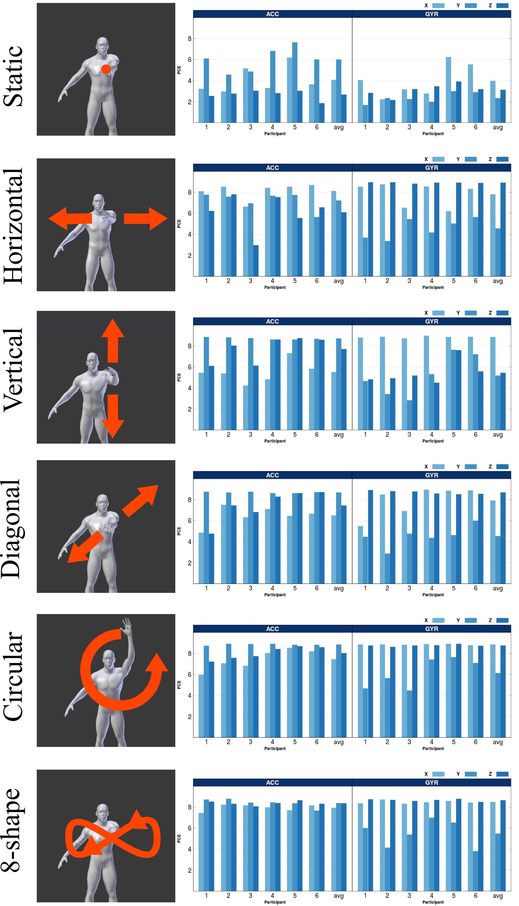 Figure 1. The first column shows the six simple gestures. The second and third columns present the cumulative energy (accelerometer and gyroscope) for each movement across participants and their average denoted by “avg”.

# TIME-DELAY EMBEDDING THEOREM

In this work we follow the notation employed in [5]. The purpose of time-delay embedding, also known as Takens’s Theorem, is to reconstruct a $D$-dimensional manifold $M$ of an unknown dynamical system $s\left(t\right)$ from its time-series $x\left(t\right)$. Time-delay embedding assumes that the time series is a sequence $x\left(t\right)=h(s(t))$, where $h:M→R^{D}$ is a measurement function on the unknown dynamical system, being $x(t)$ observable. The time delay reconstruction in $m$ dimensions with time delay $τ$ is deﬁned as: $x\left(t\right)=(x\left(t\right),x\left(t-τ\right),x\left(t-2τ\right),…,x\left(t-(m-1)τ\right))$ which deﬁnes a map $Φ:M→R^{m}$ such that $x\left(t\right)=Φ(s)$. $Ψ:R^{m}→R^{n}$ is a further transformation that is considered as a more general transformation (Figure 2). For our case $Ψ$ coincides with Principal Component Analysis (PCA).

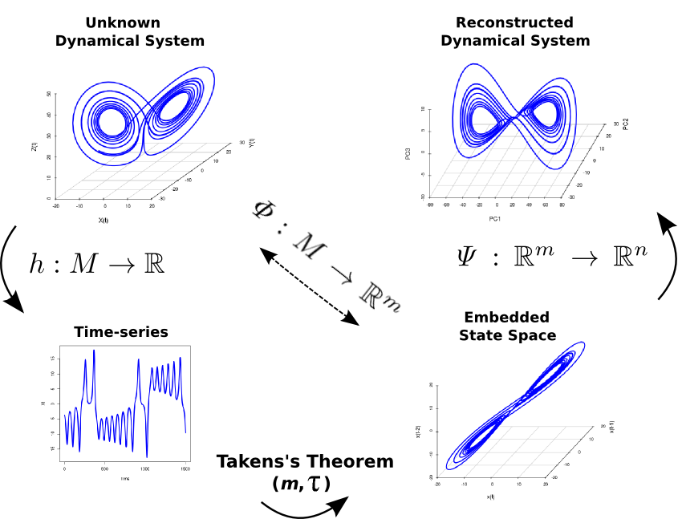Figure 2. Time-delay embedding representation.

# FRAMEWORK FOR THE EXPERIMENT

To analyse the data from six individuals who performed each action for 20 seconds, we used the time-delay embedding and PCA techniques. To do this, the raw data is collected from triaxial accelerometer and triaxial gyroscope sensors. The time-series, $a_{x}$, with a length of *N* samples, is used to obtain the time-delay embedded matrix, $E\left\{a_{x}\right\}$ with $m=20$ and $τ=6$ [1, 4]. PCA is applied to obtain, via eigenvalues ($λ_{1},…,λ_{m}$) of eigenvectors ($v_{1},…,v_{m}$), the principal components ( ${PC}_{1},…,{PC}_{m})$ of the time-delay embedded phase space. Finally, the percentage of cumulative energy is computed [2].

# RESULTS

Figure 1 shows the percentage of energy across participants and movements. It can be seen that circular and 8-shape movements show a constant trend between participants; however, such a trend is not evident for static, horizontal, vertical and diagonal movements. The average of PCE denoted by “avg” present evidence for the identification of the six movements. We assume that the variability for the horizontal, vertical and diagonal movements is due to the flexibility in the experimental constraints where participants were only asked to perform the movements at a comfortable speed. Moreover, the anthropomorphic features of the participants might have an effect on the similarity or variation of the movement.

# Conclusion and Future work

Although the Time-delay embedding technique is subject to different values of embedded parameters ( $m$ and $τ$) according to the length and complexity of the time-series, the technique is useful to present the inherent features of variability between six participants for six different gestures. Appreciating variability in human activity can not only provide useful diagnostic information but also offers an approach to considering the manner in which people interact with pervasive displays.  For example, each of the gestures described in this study could be performed in ways which trigger different states of enthusiasm, boredom, tiredness or confusion. Rather than generating individual models of each of the actions performed in each of these states, being able to detect the variability in the action could help determine how the user is interacting with the display, possibly allowing the displays to respond accordingly. For future work, we will collect data from a wider range of individuals (gender and age) and from extra sensors. Also, different classification techniques will be explored for automatic recognition of the variability of participants.

# ACKNOWLEDGMENTS

Miguel Xochicale is supported by National Council of Science and Technology Mexico (CONACyT). The support is gratefully acknowledged.

# REFERENCES

1. Jordan Frank, Shie Mannor and Doina Precup. 2010. Activity and Gait Recognition with Time-Delay Embeddings. In *Proceedings of the Twenty-Fourth AAAI Conference on Artificial Intelligence*, 1581-1586.
2. Nils Y Hammerla, Thomas Plötz, Peter Andras and Patrick Olivier. 2011. Assessing motor performance with pca. In *Proceedings of the International Workshop on Frontiers in Activity Recognition using Pervasive Sensing*, 18-23.
3. Karl M. Newell and Daniel M. Corcos. 1993. *Variability and motor control*. United States of America: Human Kinetics Publishers.
4. Albert Samà, Francisco J. Ruiz, Núria Agell, Carlos Pérez-López, Andreu Català and Joan Cabestany. 2013. Gait identification by means of box approximation geometry of reconstructed attractors in latent space. In *Neurocomputing*, 121, 79-88.
5. Lucas C. Uzal, Guillermo L. Grinblat, and Pablo F. Verdes. 2011. Optimal reconstruction of dynamical systems: A noise ampliﬁcation approach. In *Phyical Review*, 84, 016223.
6. Ionuţ-Alexandru Zaiţi, Ştefan-Gheorghe Pentiuc, Radu-Daniel Vatavu. 2015. On free-hand TV control: experimental results on user-elicited gestures with Leap Motion. In *Personal and Ubiquitous Computing,* 19, 821-838.