[1]

Analysis the Movement Variability in Dance Activities using Wearable Sensors

Miguel Xochicale, Chris Baber and Mourad Oussalah

*Abstract*— Variability is an inherent feature of human movement, however little research has been done to measure such characteristic. Therefore the aim of this preliminary study is to investigate the assessment of human movement variability in dance activities using inertial measurement units (wearable sensors). We asked thirteen participants to repeatedly dance two salsa steps for 20 seconds. We then used a technique from nonlinear dynamics (time-delay embedding) to obtain the reconstructed state space for visual assessment of the variability of dancers. Such reconstructed state space is graphically linked with their level of skillfulness of the participants.

# INTRODUCTION

V

ARIABILITY is an inherent feature that occurs not only within individual but also between individual systems of movement. Newell and Corcos stated that the movement variability (MV) increases or decreases as a function of practice which is linked with the increment or diminution of skill [1]. For instance, in sport biomechanics, Preatoni *et al.* stated two important facts about the MV: i) MV should not be treated as a noise that needs to be removed and ii) conventional approaches can only quantify the overall variability. Hence, Preatoni *et al.* examined non-linear methodologies (entropy measures, dynamical systems theory approaches, and principal component analysis) that are able to deal with and measure variability. It is however concluded that analysis to be use for a particular movement is dependent on the movement in question [2]. Despite the previous efforts of researchers in biomechanics and sport science in measuring the MV, little research has been done with wearable sensors to both quantify the MV and link the MV with the skill assessment of users. For instance, Velloso *et al.* [3], assessed automatically the quality of weight-lifting activity to quantify how good the repetition of weight-lifting. Further examples of skill assessment using wearable sensors were investigated on music violin players [4] or medical students doing surgical activities [5].

We believe that the use of nonlinear tools will provide better measurements and further understanding of the variability and skill assessment of activities. For instance, Liao *et al.* used the Empirical Mode Decomposition for activity recognition using accelerometer data [6]. The works of Sama *et al.* [7] and Frank *et al*. [8] used the time-delay embedding technique for gait recognition using inertial sensors. For the current work, we are interested in the question of how the time-delay embedding and PCA techniques can provide insights into the variability and dexterity of dancers. To this end, we consider the performance of a set of steps from Salsa dance and compare non-dancers in one cohort with experienced dancers in another.

# Methods

## Time-delay embedding

## The aim of the time-delay embedding is to reconstruct a $D$-dimensional manifold $M$ of an unknown dynamical system $s(t)$ from a time series $x(t)$. The time-delay reconstruction, time delayed copies of the available time series $x(t)$, is define as: $\overline{x}\left(t\right)=\left(x\left(t\right),x\left(t-τ\right),x\left(t-2τ\right),…,x\left(t-\left(m-1\right)τ\right)\right)$, where $m$ is the embedding dimension and $τ$ is the embedding time-delay. To determine the embedded values ( $m$ and $τ$) we respectively follow a modified version of the False Nearest Neighbors and the mutual information algorithms [9].

## Framework for the experiment

The raw data is collected from triaxial accelerometer, gyroscope and magnetometer sensors. For instance, the time series, $a_{x}$, with a length of $N$ samples is used to obtain the time-delay embedded matrix, $E\{a_{x}\}$, with $m$ rows and $N-(m-1)τ$ columns. Then, the PCA is applied to obtain, via eigenvalues ($λ_{1},…,λ_{m}$) of eigenvectors ($υ_{1},…,υ_{m}$), the principal components (${PC}_{1},…,{PC}_{m}$) of the time-delay embedded phase space.

## Participants

Thirteen participants with different years of experience in dancing were invited to dance basic salsa steps: one (male) expert dancer (14 years of experience), one intermediate (male) dancer (4 years of experience) and eleven non-dancers. The non-dancers were engineering students (4 female, 7 male). The design of the experiment was approved by the University of Birmingham ethics approval process. All participants provided informed consent prior to participation.

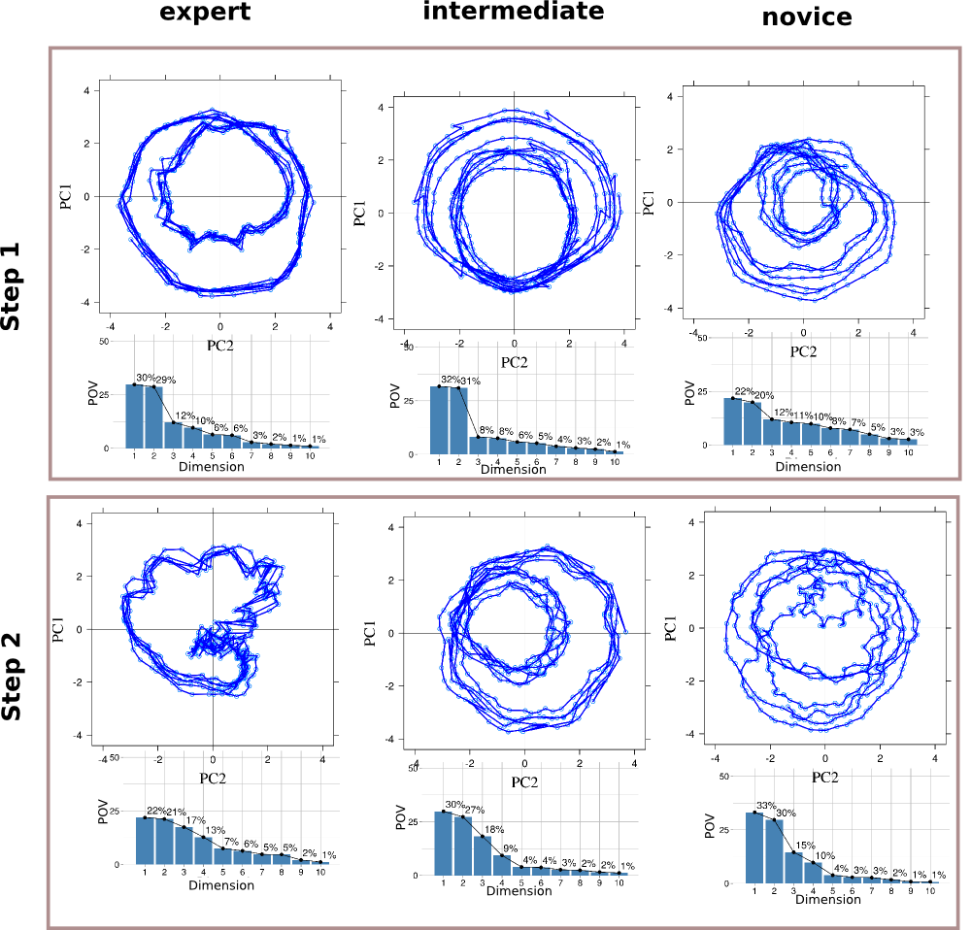

Fig. 2. 2-D reconstructed state spaces for the expert, intermediate and non-dancer participants for step 1 ( $m_{z}$ data) and step 2 ( $m_{y}$ data). 2-D plots presents the first two component of the PCA with embedding parameters (m = 10 and τ = 6).

## Experiment design

Each participant was shown a series of video clips (recorded by the expert dancer) demonstrating basic salsa steps. Each video clip showed one step repeated several times for 20 seconds. For the analysis in this work, we report two Salsa step patterns: step 1 which is mambo and step 2 which is side crossover. Participants watched the video clip and were then asked to copy the steps in time to music. The video was played during the data collection (so that participants did not have to rely on their memory of the steps). Data were collected from the IMUs and recorded. For this work, the analysis reported will focus on data taken from the sensor mounted on the left ankle.

## Data collection

Data from triaxial accelerometer, gyroscope and magnetometer sensors were collected at a sampling rate of 50Hz using a Razor 9DOF IMU with Bluetooth (Adeunis ARF7044). The IMUs were attached to custom-made bracelets worn by participants.

# Results

Fig. 2 illustrates the 2-D reconstructed state space for the non-dancer, intermediate and expert dancers. The reconstructed state spaces visually help us to distinguish different levels of dexterity. It is immediately noticeable that the shape of the state spaces for each level (novice, intermediate, expert) appears visually similar across step 1. As the participants are meant to be performing the same action, this similarity is to be expected. However, the state spaces also show a tighter and less varied pattern for the expert than for the other dexterity levels. This suggests that the expert is producing more repeatable and more consistent actions than the other dexterity levels. While this is to be expected, the reconstructed state spaces provide interesting illustrations of this phenomenon. For step 2, which is a more complicated sequence of movements, one can see a marked contrast across dexterity levels. Again, the expert is showing a consistent and repeatable action. The intermediate participant is showing a consistent action but this is different to that of the expert, and the novice is showing a pattern which appears disjointed and noisy. Indeed, for the novice dancer, the state space reconstruction of step 2 seems to have more in common with their state space for step 1 than it does with the other dancers performing step 2.

# Conclusion and Future work

Although the time-delay embedding technique is subject to the embedded parameters ( $m$ and $τ$), the technique is useful to visually present the differences among levels of skillfulness. We believe that MV is an ongoing trend towards extending the understanding of human movement with potentially promising applications in the field of human-robot interaction. For future work, we are planning to collect data from a wider range of individuals (gender and age) and from additional sensors. We are going to review nonlinear techniques that can be used for the assessment of MV using wearable sensors.

References

1. K. M. Newell and D. M. Corcos, Eds. *Variability and motor control*, 1st ed. United States of America: Human Kinetics Publishers Inc., 1993
2. E. Preatoni, J. Hamill, A. J. Harrison, K. Hayes, R. E. A. V. Emmerik, C. Wilson, and R. Rodado, “Movement variability and skills monitoring in sports,” *Sports Biomechanics*, vol. 12. no.2 pp. 62-92, 2013.
3. E. Velloso, A. Bulling, H. Gellersen, W. Ugulino, H. Fuks, “Qualitative activity recognition of weight lifting exercises,” *Proceeding AH '13 Proceedings of the 4th Augmented Human International Conference*, pp 116-123, 2013.
4. J. Van Der Linden, E. Schoonderwaldt, J. Bird, R. Johnson, “MusicJacket - Combining motion capture and vibrotactile feedback to teach violin bowing*,” IEEE Transactions on Instrumentation and Measurement*, vol. 60, pp 104-113, 2011.
5. A. Khan, S. Mellor, E. Berlin, R. Thompson, R. McNaney, P. Olivier, T. Plotz, “Beyond Activity Recognition: Skill Assessment from Accelerometer Data,” *UBICOMP*, 2015.
6. M. Liao, Y. Guo, Y. Qin, Y. Wang, “The application of EMD in activity recognition based on a single triaxial accelerometer,” *Bio-Medical Materials and Engineering*, vol. 6, 2015.
7. A. Sama, F. J. Ruiz, A. Nuria and C. Perez-Lopez, A. Catala, J. Cabestany, “Gait identification by means of box approximation geometry of reconstructed attractors in latent space,” *Neurocomputing*, vol. 121, pp 77-88, 2013
8. J. Frank, S. Mannor, D. Precup, “Activity and Gait Recognition with Time-Delay Embeddings,” *AAAI Conference on Artificial Intelligence*, pp 1581-1586, 2010.
9. L. Cao, Practical method for determining the minimum embedding dimension of a scalar time series, *Physica D*, 110, 43-50. 1997.

1. M. Xochicale is supported by the National Council of Science and Technology – CONACyT Mexico. The support is gratefully acknowledged.

   M. Xochicale and C. Baber Authors are with the School of Electronic, Electrical and System Engineering at the University of Birmingham, UK. (map479@bham.ac.uk and c.baber@bham.ac.uk).

   M. Oussalah Author is with the Center for Ubiquitous Computing at the University of Oulu, Finland (moussala@ee.oulu.fi).