CS 340 Project Two: Grazioso Salvare Web Dashboard
Description
This project is an interactive dashboard developed for Grazioso Salvare, an animal rescue training company. It uses data from animal shelters in the Austin, Texas area to help identify dogs that may be suitable for different types of search-and-rescue training, including water rescue, mountain and wilderness rescue, and disaster or individual tracking.
The application uses the Model-View-Controller (MVC) design pattern and provides an easy-to-use interface for exploring the Austin Animal Center Outcomes dataset. Users can filter the animal data and view the results in an interactive table, a map showing animal locations, and a chart displaying breed distribution.
Visuals
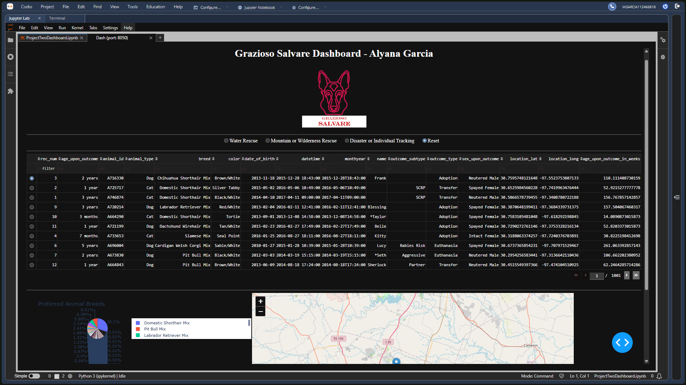
- Figure 1: Dashboard Reset / Starting State (Unfiltered Data)
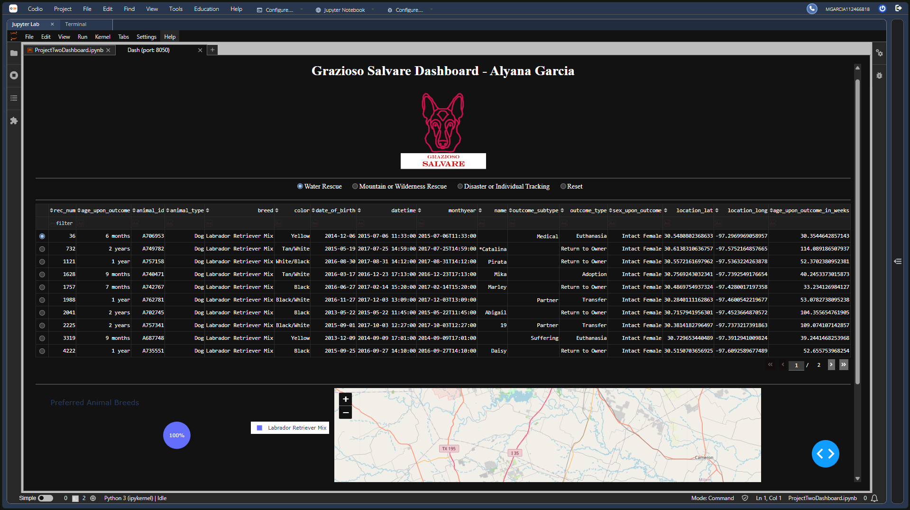
- Figure 2: Water Rescue Filter Applied

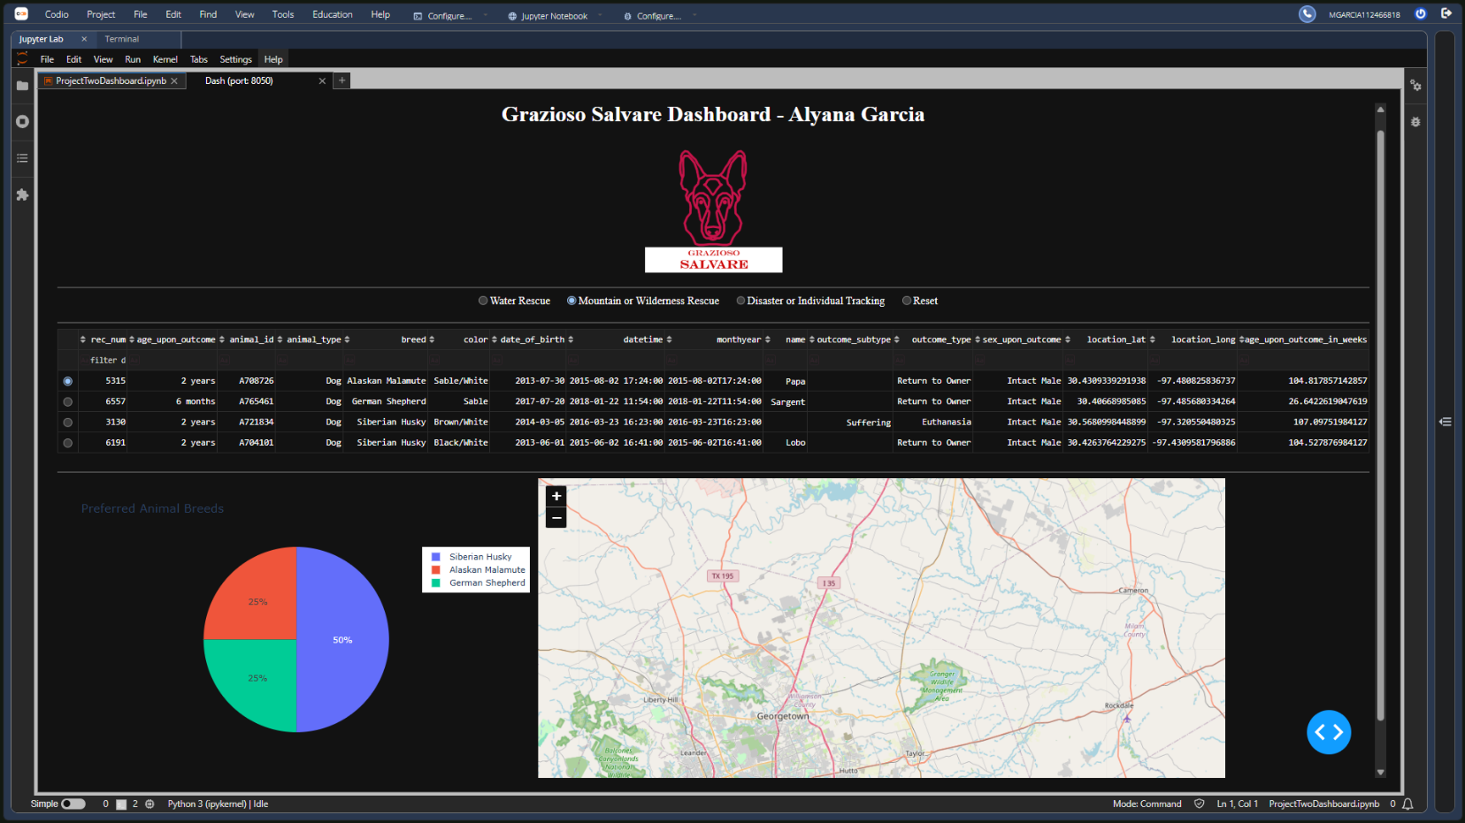
- Figure 3: Mountain or Wilderness Rescue Filter Applied

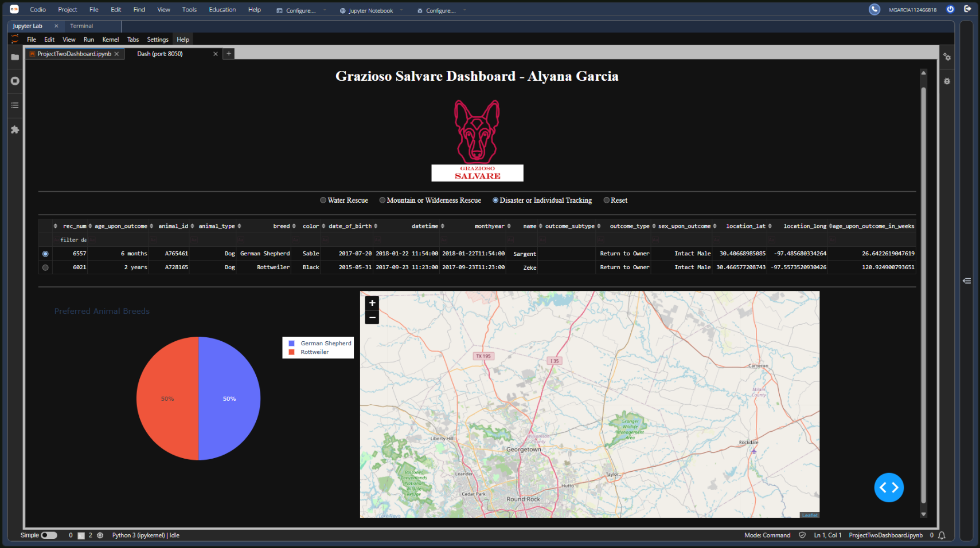
- Figure 4: Disaster or Individual Tracking Filter Applied

Installation & Requirements
The following technologies and libraries are required to run this project:
- MongoDB: Used as the database to store animal shelter records. Its flexible document structure makes it suitable for storing animal data.
- Dash by Plotly: Used to build the interactive web dashboard, including the data table, map, and breed distribution chart.
- PyMongo: A Python library that connects the application to MongoDB and allows it to retrieve and work with the stored data.
- JupyterDash: Used to run and test the dashboard in the Codio JupyterLab environment.
Usage & Implementation Steps
- Backend Development: Created the AnimalShelter Python class to perform Create, Read, Update, and Delete (CRUD) operations using PyMongo.
- Dashboard Layout: Built the dashboard interface using Dash HTML and Core components. Added the Grazioso Salvare logo, developer information, radio buttons, data table, and charts.
- Database Queries: Created MongoDB queries to filter animal records based on the required training profiles, including specific breeds, intact gender, and ages between 26 and 156 weeks.
- Callbacks and Interactivity: Created callback functions that respond to changes in the radio buttons and update the data table with the matching results. Additional callbacks use the table data to update the Plotly pie chart and Dash Leaflet map markers.

How to Run the Application
Open ProjectTwoDashboard.ipynb in the CS 340 workspace and make sure CRUD_Python_Module.py is in the same directory. Configure the database connection with valid credentials, then run all notebook cells to launch the dashboard locally.
Roadmap & Challenges
One challenge I encountered was a TypeError: 'NoneType' object is not iterable that caused the dashboard to crash during its initial loading. The error occurred because a Dash callback tried to process selected rows before any rows had been selected. I fixed this by checking whether selected_columns was None and returning an empty list when necessary. This allowed the dashboard to load without triggering the error.
A possible future improvement would be adding an option to export filtered animal records to a CSV file.
Authors and Acknowledgment
- Developer: Alyana Garcia
- Dataset: Austin Animal Center (AAC) Outcomes Data
- Course: CS 340 – Client/Server Development

