Sample Console Application

Purpose
The intent of this application is to demonstrate how you can test for code coverage on a console application. The application will exercise a series of methods based on the parameters passed in. The code coverage percentages will vary based on the parameter that is passed in. The purpose of this is to show different code coverage scenarios and also explain how the trends functionality works in NCover.

Included Files
Bin\debug: A compiled version of the source. The sample batch files target these files.
BusinessObjects: Example business objects that are exercised.
SampleLogic: Sample code that uses the business objects and performs actions on the objects for code coverage.
Numerous batch files: These files are explained in the quick start section.

Quick Start
Note for 64-bit machines: If your tests exercise a 32-bit application, then you need to select "NCover Path" in the left-hand menu and choose the NCover.Console.exe that is located in "C:\Program Files (x86)\NCover\". Setting this option is discussed in our Startup Guide.

Command Line:
We have included a series of batch files that will get you up and running in less than 30 seconds. We have included a sample batch file for each of the switches that are accepted by the application:
Runlowtest.cmd – run low coverage tests
Runmediumtest.cmd – run medium tests
Runhightest.cmd – run high coverage tests
Runcompletetest.cmd – run tests to obtain 100% coverage on the business logic and objects
Runtests.cmd – run all four sets of tests
Runreports.cmd – run eight different reports showing the different report types that are available from NCover.
If you pick a command to run, runlowtests.cmd for example, a coverage file will be created with very low coverage. Running the runreports.cmd command after running coverage will provide 8 different sample reports based on this coverage data.
Once you run coverage, you can drag and drop the coverage file onto NCover explorer to view the coverage information.

NCover Explorer:
Load NCover Explorer and click on the big green “Run Coverage” button.
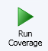
The following dialog will be displayed.
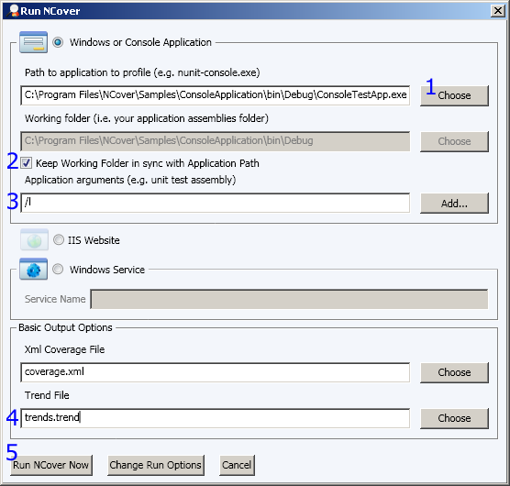
1. Choose the Console Test Application located in the Sample Projects\Sample Console Application\bid\debug folder as seen above.
2. Check the “Keep working folder in sync with Application Path” checkbox or provide a path to save the coverage files. If you do not provide a path, the files will be placed in the NCover folder.
3. Pass in /l (L as in Larry) to simulate Low coverage. You may also pass in /m for medium, /h for high coverage and /c for complete coverage (100%).
4. You may optionally provide a trend file path.
5. Click on the “Run NCover Now” button.
You now have a sample coverage file.
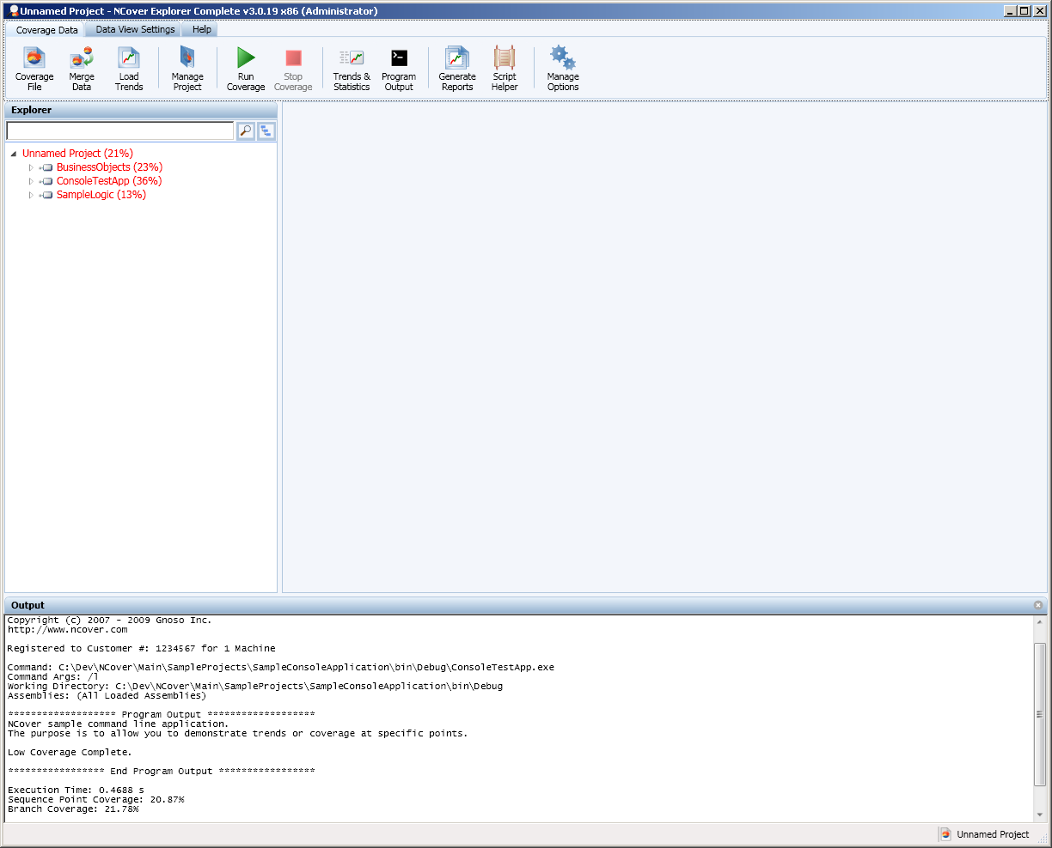
If you would like to change the run settings, click on the manage options button as seen below.
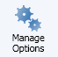
And choose the “Project Configuration” tab
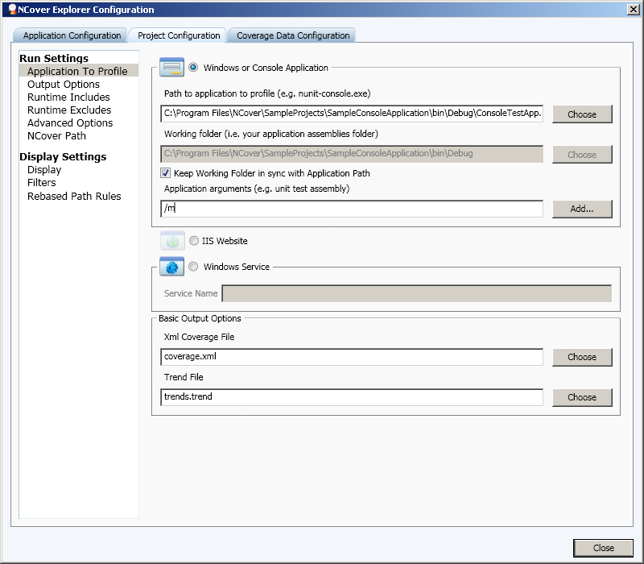
You may then change the application arguments as needed. See step 3.

