MSTest and MSBuild Samples

Purpose
The intent of this application is to demonstrate how you can test for code coverage using MSTest and MSBuild. The unit tests will exercise a series of methods based on the targets passed in. The code coverage percentages will vary based on the targets that are passed in. The purpose of this is to show different code coverage scenarios and also explain how the trends functionality works in NCover.

Included Files
Bin\debug: A compiled version of the source. The sample batch files target these files.
BusinessObjects: Example business objects that are exercised.
SampleLogicMSTest: Sample code that uses the business objects and performs actions on the objects for code coverage.
Numerous batch files: These files are explained in the quick start section.

Quick Start
Unless you run in /noisolation mode, you must cover MSTest's test host process instead of MSTest itself. NCover will cover the test host process instead of MSTest if you add “//pm vstesthost.exe” to the NCover command line. This instructs NCover to cover the child process of MSTest named vstesthost.exe. If you are using the /noisolation MSTest argument, do not use the //pm option if you want to get test coverage. When calling MSTest from NCover, we pass in the /testcontainer (the dll containing the unit tests), and an optional list of /test (s) in the test container to execute.

Command Line:
We have included a series of batch files that will get you up and running in less than 30 seconds. We have included a sample batch file for each of the switches that are accepted by the application:
lowtests.cmd – calls mstest.exe from ncover, passing in the tests to run low coverage.
mediumtests.cmd – calls mstest.exe from ncover, passing in the tests to run medium coverage.
hightests.cmd – calls mstest.exe from ncover, passing in the tests to run high coverage.
completetests.cmd – calls mstest.exe from ncover, passing in the tests to run complete coverage.
msbuildlowtests.cmd – calls msbuild.exe passing the lowcoverage target.
msbuildmediumtests.cmd – calls msbuild.exe passing the mediumcoverage target.
msbuildhightests.cmd – calls msbuild.exe passing the highcoverage target.
msbuildcompletetests.cmd – calls msbuild.exe passing the completecoverage target.
msbuildrunreport.cmd – calls msbuild.exe passing in the reporting target.

NCover Explorer:
MSTest Example:
Load NCover Explorer and click on the big green “Run Coverage” button.
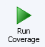
The following dialog will be displayed.
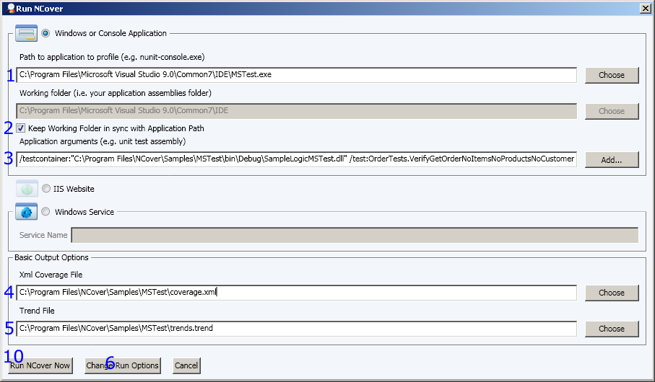
1. Choose the MSTest.exe. This is normally found at “C:\Program Files\Microsoft Visual Studio 9.0\Common7\IDE\MSTest.exe”.
2. Check the “Keep working folder in sync with Application Path” checkbox or provide a path to save the coverage files. If you do not provide a path, the files will be placed in the NCover folder.
3. Place the test container and test command options. For this example, the value is “/testcontainer:" C:\Program Files\NCover\Samples\MSTest\bin\Debug\SampleLogicMSTest.dll" /test:OrderTests.VerifyGetOrderNoItemsNoProductsNoCustomer”. Because of the working directory being set to the mstest folder, you must fully qualify the path to the test container. DO NOT place the //pm option on this line, it will not be recognized.
4. You may optionally provide a trend file path. This must be fully qualified or it will end up in the mstest folder.
5. You must fully qualify the path for the coverage file.
6. You must click on “Change Run Options”, since we must specify the //pm option.
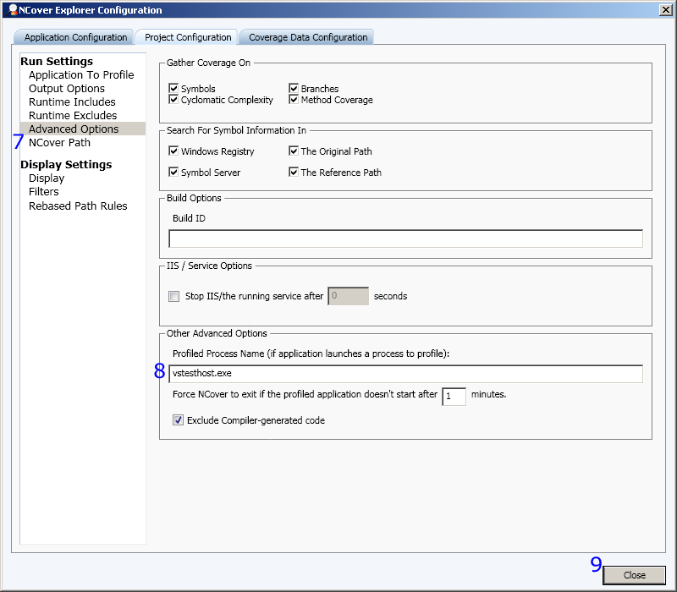
7. Choose the Advanced options section under “Project Configuration”.
8. Place vstesthost.exe in the “Profiled Process Name” text box.
9. Choose close to return the main run form.
10. Choose Run Coverage Now.
You now have a sample coverage file.
MSBuild Example:
Load NCover Explorer and click on the big green “Run Coverage” button.
The following dialog will be displayed.
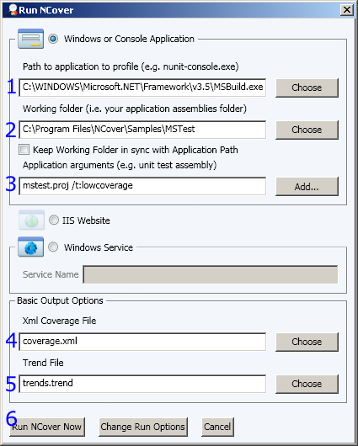
1. Choose the MSBuild application. This is normally located in the “C:\WINDOWS\Microsoft.NET\Framework\v3.5\MSBuild.exe”
2. Set the path to the root of the mstest project, and do NOT check the checkbox
3. Pass the parameters containing the msbuild script and the targets.
4. Set the coverage file. It will default to the working folder.
5. Optionally set the trend file path. It will default to the working folder.
6. Run NCover
You now have a sample coverage file.

