NUnit Samples

Purpose
The intent of this application is to demonstrate how you can test for code coverage using NUnit. The unit tests will exercise a series of methods based on the targets passed in. The code coverage percentages will vary based on the targets that are passed in. The purpose of this is to show different code coverage scenarios and also explain how the trends functionality works in NCover.

Included Files
Bin\debug: A compiled version of the source. The sample batch files target these files.
BusinessObjects: Example business objects that are exercised.
SampleLogicNUnit: Sample code that uses the business objects and performs actions on the objects for code coverage.
Numerous batch files: These files are explained in the quick start section.

Quick Start
We also strongly recommend using the "/noshadow" option when covering NUnit tests with NCover, since getting coverage on tests without using it sometimes prevents NCover from finding several assemblies that it relies on. Note for 64-bit machines: If your tests exercise a 32-bit application, then you should enter the full path to "nunit-console-x86.exe". Note for 64-bit machines: If your tests exercise a 32-bit application, then you need to select "NCover Path" in the left-hand menu and choose the NCover.Console.exe that is located in "C:\Program Files (x86)\NCover\". Setting this option is discussed in our Startup Guide.

Command Line:
We have included a series of batch files that will get you up and running in less than 30 seconds. We have included a sample batch file for each of the switches that are accepted by the application:
lowtests.cmd – calls nunit-console.exe from ncover, passing in the tests to run low coverage.
mediumtests.cmd – calls nunit-console.exe from ncover, passing in the tests to run medium coverage.
hightests.cmd – calls nunit-console.exe from ncover, passing in the tests to run high coverage.
completetests.cmd – calls nunit-console.exe from ncover, passing in the tests to run complete coverage.

NCover Explorer:
Load NCover Explorer and click on the big green “Run Coverage” button.
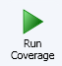
The following dialog will be displayed.
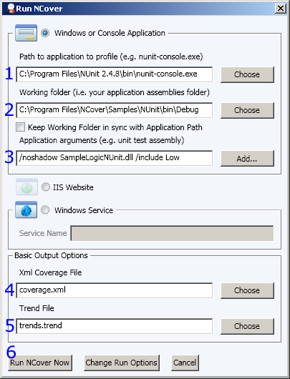
1. Choose nunit-console.exe. Note for 64-bit machines: If your tests exercise a 32-bit application, then you should enter the full path to "nunit-console-x86.exe"
2. Set the working folder to the directory containing your test assemblies. This will simplify the path for the coverage file and trend file.
3. Pass the parameters required for the tests. You would include the dlls that you wish to test, this can be as many dlls as you wish to test and is not limited to one. In the example above, we only want to test items that are part of a category called Low. This is a step we are using for this sample. If you are not using categories for your tests, you would not include this switch. We also strongly recommend using the "/noshadow" option when covering NUnit tests with NCover, since getting coverage on tests without using it sometimes prevents NCover from finding several assemblies that it relies on.
4. Set the coverage file. It will default to the working folder.
5. Optionally set the trend file path. It will default to the working folder.
6. Run NCover
You now have a sample coverage file.

