Sample WPF Application

Purpose
The intent of this application is to demonstrate how you can test for code coverage on a WPF application. The application will exercise a series of methods based on the buttons pressed. The code coverage percentages will vary based on the button pressed. The purpose of this is to show different code coverage scenarios and also explain how the trends functionality works in NCover.

Included Files
Bin\debug: A compiled version of the source.
SampleWPFApp: The sample application.
References have been made to the BusinessObjects and SampleLogic as seen in the Sample Console Application.

Quick Start
Please follow the steps under “Command Line” or “NCover Explorer” to run the application and obtain coverage. Note for 64-bit machines: If your tests exercise a 32-bit application, then you need to select "NCover Path" in the left-hand menu and choose the NCover.Console.exe that is located in "C:\Program Files (x86)\NCover\". Setting this option is discussed in our Startup Guide.
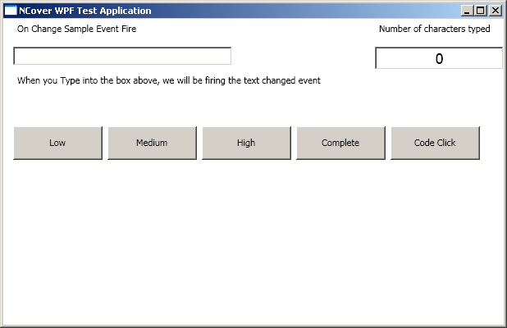
In either the command line or NCover explorer version of the application, you are going to want to run the test a few times. Each time you run it, you should click on one of the buttons and see how the code coverage is collected. If you click on all of the buttons, you will always have 100% coverage.
A sample run of the application would be the following.
By running the application and performing the following steps:
- Type in 10 characters into the on change sample event text box.
- Click on “Low” Button
- Click on the “Code Click” button
You will obtain a coverage file that looks similar to this in NCover Explorer
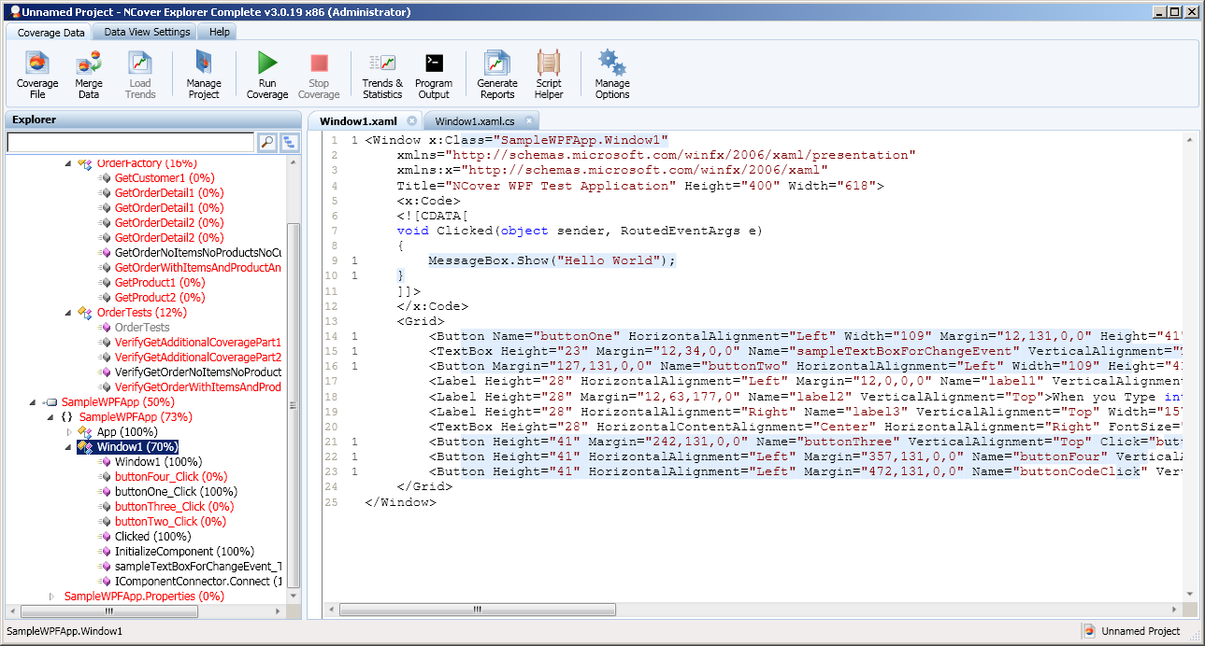
As you can see from the source code, the inline C# code is covered. You may also notice that the Xaml appears to be covered and highlighted. This is a side effect of the auto generated code that is created by the compiler. The Xaml is processed at run time once, causing the code to appear as if it has been covered once. Even if you do nothing, the code will still show code coverage. This is a side effect of the compiler and is not a bug in NCover. There is no work around for this.

Command Line:
This application needs to be launched by ncover.console.exe to obtain code coverage. This can be done by one of two ways.
1. Run the “RunApplication.cmd” script. This will call ncover.console.exe along with the sample application.
2. Type in the following command from the “C:\Dev\NCover\Main\SampleProjects\SampleWPFApplication” folder:
ncover.console.exe //x coverage.xml //at trends.trend bin\debug\SampleWPFApp.exe
3. Run through the example given above or click on many buttons to demonstrate code coverage being collected for a windows application.
4. Exit the application.
You now have a sample coverage file.

NCover Explorer:
Load NCover Explorer and click on the big green “Run Coverage” button.
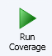
The following dialog will be displayed.
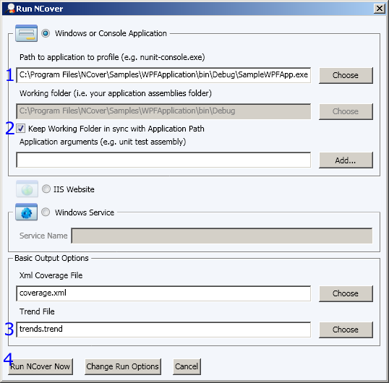
1. Choose the Console Test Application located in the Sample Projects\Sample Console Application\bid\debug folder as seen above.
2. Check the “Keep working folder in sync with Application Path” checkbox or provide a path to save the coverage files. If you do not provide a path, the files will be placed in the NCover folder.
3. You may optionally provide a trend file path.
4. Click on the “Run NCover Now” button.
5. Perform the actions described at the beginning of the Getting Started section.
6. Exit the application.
You now have a sample coverage file.
If you would like to change the run settings, click on the manage options button as seen below.
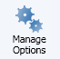
And choose the “Project Configuration” tab

