Министерство образования Республики Беларусь

Учреждение образования
БЕЛОРУССКИЙ ГОСУДАРСТВЕННЫЙ УНИВЕРСИТЕТ
ИНФОРМАТИКИ И РАДИОЭЛЕКТРОНИКИ

Факультет компьютерных систем и сетей

Кафедра электронных вычислительных машин

ОТЧЕТ
по лабораторной работе №5
Вариант №212

Студент: П. Е. Казаченко
Проверил: В. А. Марцинкевич

МИНСК 2025
1. Практическая часть

1.1. Топология

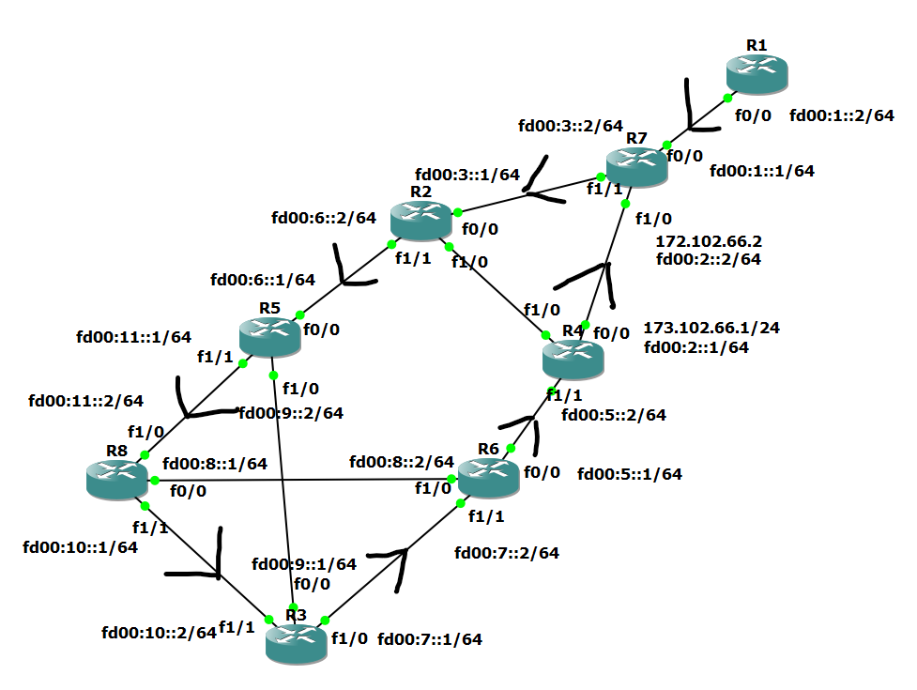

1.2. Рабочие конфигурации

R1:
ipv6 unicast-routing
interface f0/0
ipv6 address fd00:1::2/64
ipv6 nd reachable-time 60000
no shutdown
exit
interface Loopback0
ipv6 address fd00:12::1/64
ipv6 address 2a00:1760:52:8000::1/128
exit
ipv6 route ::/0 fd00:1::1

R2:
ipv6 unicast-routing
interface f1/1
ipv6 address fd00:6::2/64
no shutdown
exit
interface f1/0
ipv6 address fd00:4::1/64
no shutdown
exit
interface f0/0
ipv6 address fd00:3::1/64
no shutdown
exit
ipv6 route ::/0 fd00:6::1

R3:
ipv6 unicast-routing
interface f0/0
ipv6 address fd00:9::1/64
no shutdown
exit
interface f1/0
ipv6 address fd00:7::1/64
no shutdown
exit
interface f1/1
ipv6 address fd00:10::2/64
no shutdown
exit
interface Loopback0
ipv6 address fd00:13::1/64
ipv6 address 2a00:1760:51::1/128
exit
ipv6 route ::/0 fd00:7::2

R4:
ipv6 unicast-routing
interface f0/0
ip address 173.102.66.1 255.255.255.0
no shutdown
exit
interface f1/0
ipv6 address fd00:4::2/64
no shutdown
exit
interface f1/1
ipv6 address fd00:5::2/64
no shutdown
exit
interface Tunnel0
ipv6 address fd00:2::1/64
tunnel source 173.102.66.1
tunnel destination 173.102.66.2
tunnel mode ipv6ip
no shutdown
exit
ipv6 route ::/0 fd00:2::2

R5:
ipv6 unicast-routing
interface f0/0
ipv6 address fd00:6::1/64
no shutdown
exit
interface f1/0
ipv6 address fd00:9::2/64
no shutdown
exit
interface f1/1
ipv6 address fd00:11::1/64
no shutdown
exit
ipv6 route ::/0 fd00:11::2

R6:
ipv6 unicast-routing
interface f0/0
ipv6 address fd00:5::1/64
no shutdown
exit
interface f1/0
ipv6 address fd00:8::2/64
no shutdown
exit
interface f1/1
ipv6 address fd00:7::2/64
no shutdown
exit
ipv6 route ::/0 fd00:5::2

R7:
ipv6 unicast-routing
interface f0/0
ipv6 address fd00:1::1/64
no shutdown
exit
interface f1/1
ipv6 address fd00:3::2/64
no shutdown
exit
interface f1/0
ip address 173.102.66.2 255.255.255.0
no shutdown
exit
interface Tunnel0
ipv6 address fd00:2::2/64
tunnel source 173.102.66.2
tunnel destination 173.102.66.1
tunnel mode ipv6ip
no shutdown
exit
ipv6 route ::/0 fd00:3::1
ipv6 route fd00:1::/64 fd00:8::2

R8:
ipv6 unicast-routing
interface f0/0
ipv6 address fd00:8::1/64
no shutdown
exit
interface f1/0
ipv6 address fd00:11::2/64
no shutdown
exit
interface f1/1
ipv6 address fd00:10::1/64
no shutdown
exit
ipv6 route ::/0 fd00:10::2

