Министерство образования Республики Беларусь

Учреждение образования
«Белорусский государственный университет информатики и радиоэлектроники»

Кафедра электронных вычислительных машин

ОТЧЕТ
по лабораторной работе №2

Вариант № 212

Выполнил Проверил:
студент группы 250504: Марцинкевич В.А.
Казаченко П.Е.

Минск 2025
Цель работы: сконфигурировать VLAN и настроить STP в топологии.

Рабочие конфигурации устройств:

all switches:
vlan 10
vlan 20
vlan 99
vlan 100
spanning-tree vlan 1,10,20,99,100

N3:
int fa0/4
switchport mode access
switchport access vlan 100
switchport port-security
switchport port-security mac-address 0001.C766.CE17

int fa0/5
switchport mode access
switchport access vlan 20

int fa0/6
switchport mode access
switchport access vlan 10

int range fa0/4-6
spanning-tree bpduguard enable
spanning-tree portfast

int fa0/1-3
switchport mode trunk
switchport trunk allowed vlan 1,10,20,99,100
switchport trunk native vlan 99
no shut

N1:
int range fa0/2-3
switchport mode access
switchport access vlan 10

int fa0/4
switchport mode access
switchport access vlan 20

int range fa0/2-4
spanning-tree bpduguard enable
spanning-tree portfast

int fa0/1
switchport mode trunk
switchport trunk allowed vlan 1,10,20,99,100
switchport trunk native vlan 99
no shut

N6:
int range fa0/1-4
switchport mode trunk
switchport trunk allowed vlan 1,10,20,99,100
switchport trunk native vlan 99

int range fa0/1,fa0/4
switchport mode trunk
channel-group 1 mode on
no shutdown

int port-channel 1
switchport mode trunk
switchport trunk allowed vlan 1,10,20,99,100
switchport trunk native vlan 99
no shutdown

N2:
int range fa0/1-4
switchport mode trunk
switchport trunk allowed vlan 1,10,20,99,100
switchport trunk native vlan 99

int range fa0/2,fa0/4
switchport mode trunk
channel-group 2 mode on
no shutdown

int port-channel 2
switchport mode trunk
switchport trunk allowed vlan 1,10,20,99,100
switchport trunk native vlan 99
no shutdown

N7:
int range fa0/1-4
switchport mode trunk
switchport trunk allowed vlan 1,10,20,99,100
switchport trunk native vlan 99

int range fa0/3,fa0/4
switchport mode trunk
channel-group 3 mode on
no shutdown

int port-channel 3
switchport mode trunk
switchport trunk allowed vlan 1,10,20,99,100
switchport trunk native vlan 99
no shutdown

N4:
spanning-tree vlan 10 priority 4096
spanning-tree vlan 20 priority 4096
spanning-tree vlan 99 priority 4096
spanning-tree vlan 100 priority 4096

default interface fa0/1
default interface fa0/2
int range fa0/1-2
switchport mode trunk
switchport trunk allowed vlan 1,10,20,99,100
switchport trunk native vlan 99
channel-group 1 mode on
no shutdown

int port-channel 1
switchport mode trunk
switchport trunk allowed vlan 1,10,20,99,100
switchport trunk native vlan 99
no shutdown

default interface fa0/3
default interface fa0/4
int range fa0/3-4
switchport mode trunk
switchport trunk allowed vlan 1,10,20,99,100
switchport trunk native vlan 99
channel-group 2 mode on
no shutdown

int port-channel 2
switchport mode trunk
switchport trunk allowed vlan 1,10,20,99,100
switchport trunk native vlan 99
no shutdown

default interface fa0/5
default interface fa0/6
int range fa0/5-6
switchport mode trunk
switchport trunk allowed vlan 1,10,20,99,100
switchport trunk native vlan 99
channel-group 3 mode on
no shutdown

int port-channel 3
switchport mode trunk
switchport trunk allowed vlan 1,10,20,99,100
switchport trunk native vlan 99
no shutdown

int fa0/7
switchport mode trunk
switchport trunk allowed vlan 1,10,20,99,100
switchport trunk native vlan 99
no shutdown

R1:
spanning-tree vlan 1,10,20,99,100

int fa0/0.10
encapsulation dot1q 10
ip address 192.168.10.1 255.255.255.0
no shut

int fa0/0.20
encapsulation dot1q 20
ip address 192.168.20.1 255.255.255.0
no shut

int fa0/0.100
encapsulation dot1q 100
ip address 192.168.100.1 255.255.255.0
no shut

int fa0/0
no shutdown

N5:
int fa0/1-3
switchport mode trunk
switchport trunk allowed vlan 1,10,20,99,100
switchport trunk native vlan 99

N8:
int fa0/1-3
switchport mode trunk
switchport trunk allowed vlan 1,10,20,99,100
switchport trunk native vlan 99

PC0:
IP: 192.168.100.2
MASK: 255.255.255.0
GATE: 192.168.100.1

PC1:
IP: 192.168.20.2
MASK: 255.255.255.0
GATE: 192.168.20.1

PC2:
IP: 192.168.10.2
MASK: 255.255.255.0
GATE: 192.168.10.1

PC3:
IP: 192.168.20.3
MASK: 255.255.255.0
GATE: 192.168.20.1

PC4:
IP: 192.168.10.4
MASK: 255.255.255.0
GATE: 192.168.10.1

PC5:
IP: 192.168.10.3
MASK: 255.255.255.0
GATE: 192.168.10.1

Практическая часть (скриншот реализованной топологии):

Вывод: В ходе работы все коммутаторы были настроены на работу с vlan. Пользовательские станции по обе стороны топологии были определены к vlan10 и vlan20, одно из устройств расположилось в админском vlan100, vlan99 был выделен как native vlan для всех trunk-соединений. На коммутаторах по краям топологии были настроены portfast, bdpuguard и port-security.

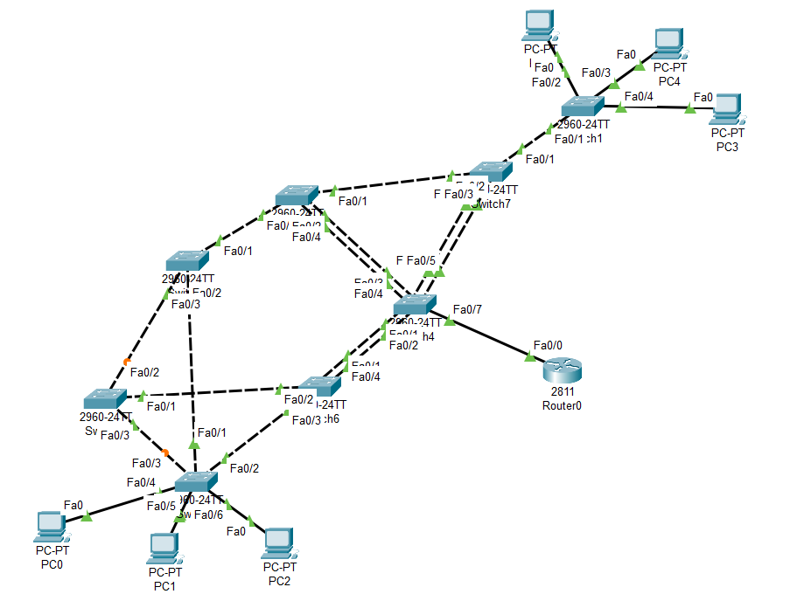
Рисунок 1 – Результат работы

