Container with Most Water

Problem

Input: H:number[] – heights of vertical lines, non-negative

Output: v:number – volume of the largest container formed by two lines and the x-axis

Notes: Each element in H represents a vertical line drawn such that the two endpoints of line i is at (i, H[i ]) and (i, 0).

Examples:

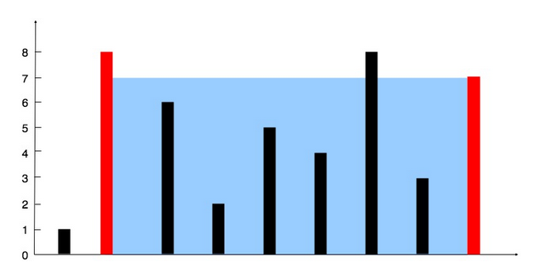

Input: [1, 8, 6, 2, 5, 4, 8, 3, 7]
Output: 49

Solution

The widest container (formed by the first and the last lines) has the biggest potential to be the largest one - it could be built with the smallest line. All the narrower containers require bigger lines to become the largest.
The volume of a container is always limited by the smallest line which forms it. That’s why, once the volume of the widest container is calculated, we exclude the smallest line - no narrower container formed by that line can be bigger.
Once the line is excluded, the next widest container is picked and analyzed the same way until there is no more containers.
The last step is to pick the maximum from the calculated volumes.

Pseudocode:

while left_index < right_index
volume = min(H[left_Index], H[right_index]) * (right_index-left_index);

v = max(volume, v);

if H[left_index] < H[right_index]
left_index++
else
right_index++
end

Time Complexity: O(n)

Space Complexity: O(1)

