Trapping Rain Water

Problem

Input: H:integer[] – heights of vertical bars composed of 1x1 bricks, non-negative

Output: v:integer – total volume of water the bars able to trap after raining

Notes:

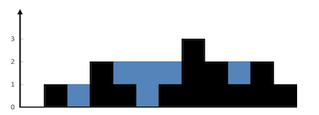

Examples:

Input: H = [0, 1, 0, 2, 1, 0, 1, 3, 2, 1, 2, 1]
Output: v = 6

Solution

A bar traps water only if there exist higher bars surrounding it. The volume of water it traps is limited by the lowest of the highest bars on each side.
The first and the last bars are the initial highest bars surrounding all the other bars. The lower of them sets the initial limit of water.
The next bar to be analyzed is always picked from the end closest to the lower of the current highest bars. If the bar is higher than (or equal to) the lower bar, then it just replaces the lower bar and becomes one of the current highest bars. Otherwise, if the bar is lower than the lower bar, then it traps the volume of water up to the lower bar (the water is guaranteed to be trapped from the right side at least by the other highest bar). Once the bar is analyzed, the cycle continues accumulating the total volume of trapped water. Picking the next bar from the other end wouldn’t work, because we couldn’t make any assumptions about how the water is trapped from the opposite end (since the opposite highest bar is lower).

Pseudocode:

while left_index < right_index
left_max_height = max(left_max_height, H[left_index]);
right_max_height = max(right_max_height, H[right_index]);

if left_max_height > right_max_height
v = v + right_max_height - H[right_index];

right_index--
else
v = v + left_max_height - H[left_index];

left_index++
end

Time Complexity: O(n)

Space Complexity: O(1)

