Assignment: Data Visualization Fundamentals - Tableau (20 points)
Name: Mayukh Tatipamula Score:

Read the brief below. Using Tableau Desktop Profession Edition, complete the questions.

Your company is a small, innovative office supply startup that has broadened into furniture, and is looking to revolutionize how people view and use furniture. Management wants to see how the company did last year and make some decisions about what products to keep along with staffing for busy times of the year.

Installation Setup; two (2) points for proper installation.

Instructions: Use the Excel spreadsheet provided and import the data to Tableau. Complete the tasks below. Upon completion you will submit this word document with your screen shots attached along with your Tableau file (.tbw).

- Open Tableau.
- Import the Excel file – Final_Orders_Clean.xlsx.
- Create an inner join between market_fact table and the rest of the tables as shown below [HINT: Drag and Drop the tables in the Data Source space; ensure you have a Many to Many relationship]

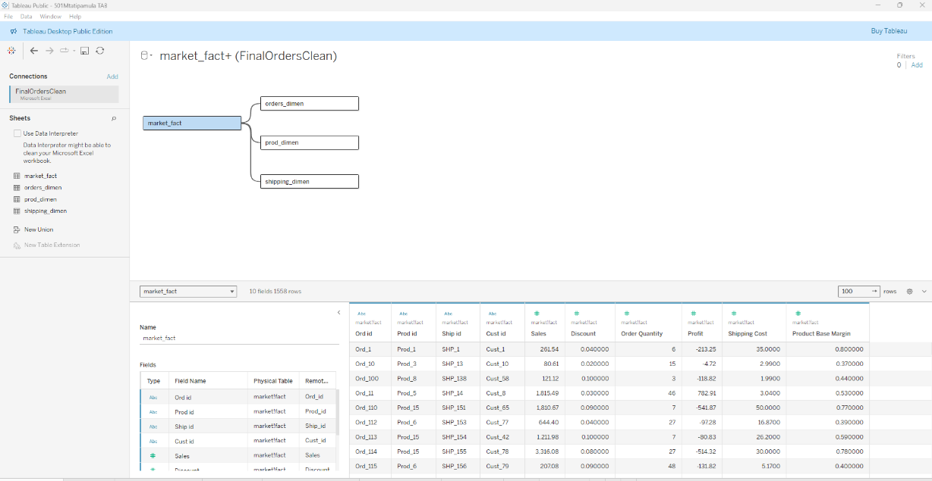
- Double check your join statements to make sure the correct primary key and foreign keys are in place. [HINT: order_id and ord_id]

- Click on “Goto Worksheet” at the bottom to insert a blank worksheet for your questions For each question, take a screen shot of your visualization. Be sure to save your Tableau file and upload the Tableau file along with a document including your screen shots.

Questions; answer all questions and include a screenshot of the corresponding Tableau visualization. Each question answered is worth three (3) points each – 1.5 points for your answer and 1.5 points for the screenshot. Refer to the current syllabus and eLearning announcements for the due date.

Upon completion you will submit this completed Word document and your Tableau workbook via email to john.young@utdallas.edu by the due date set in the syllabus. Ensure your file names are formatted as Section, First Initial, Last Name, TAB; e.g. “501 JYoung TAB.docx.” Failure to follow these directions will result in a zero per the syllabus. Do not send links from One Drive, SharePoint, or any other file sharing technology; send me the actual Word document and Tableau file. If you send me a link instead of the actual files, I will not grade them and you will earn a zero.

DO NOT COPY WORK, SHARE ANSWERS, OR OTHERWISE REPRESENT THE WORK OF SOMEONE ELSE AS YOUR OWN.

- Management wants to see total sales and profit across all product categories and subcategories to determine what to discontinue. Add a new sheet titled Sales & Profit. Required Components: 1) A table with the product categories and subcategories listed. 2) Sales and profit expressed as currency. 3) Color sales and profit with positive values in black and negative values in red. Using the same data, create a horizontal bar chart using squares in lieu of bars. Ensure positive values are shown in black and negative values are shown in red, with each data point labelled as currency. Show both visualizations here and in the Tableau workbook. Based on the data presented, which subcategories are the least profitable and should therefore be discontinued?

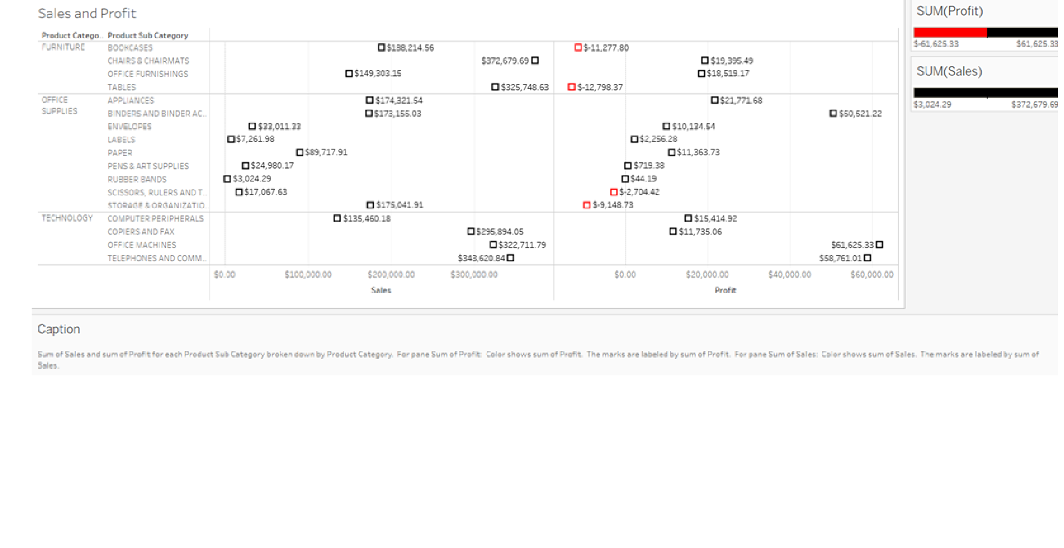
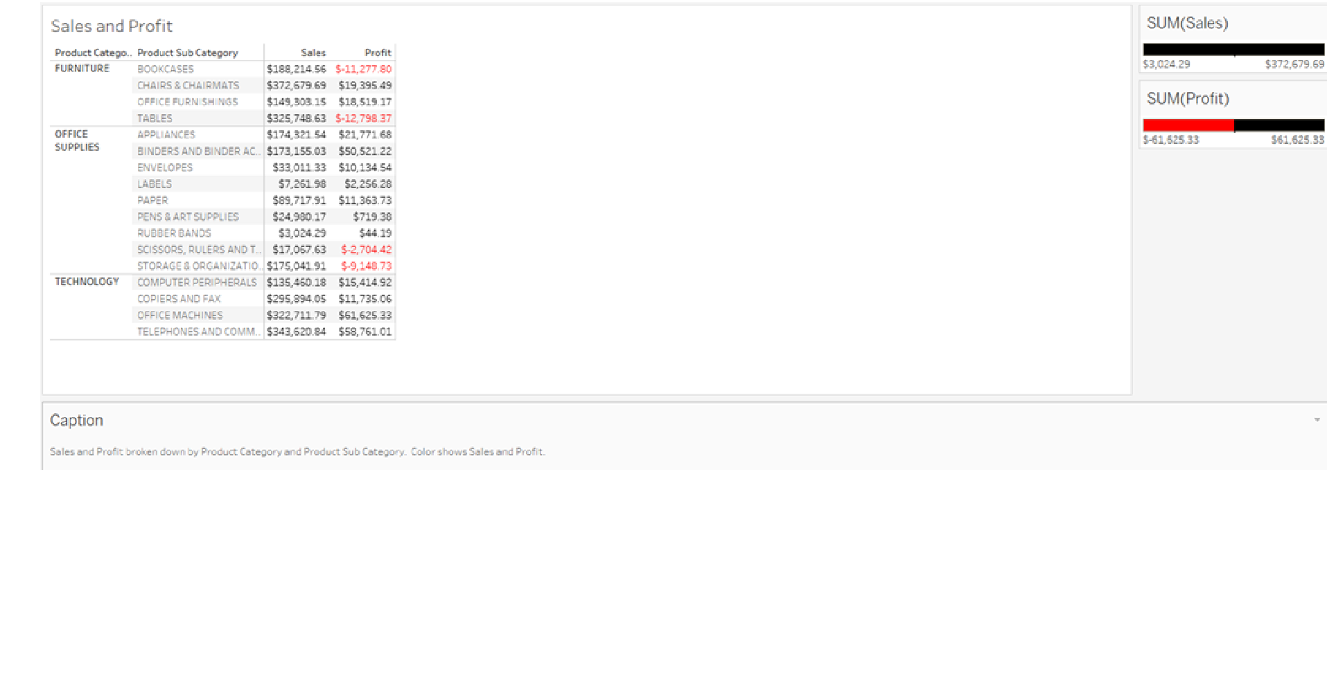
Answer: The least profitable subcategories that should be discontinued are bookcases, tables, scissors, rulers, trimmers, and storage & organization, as these items result in negative profits for the company.

- Management is eager to know the most profitable subcategory per order. Add a new sheet titled Sales & Profitability by Order. Required Components: 1) A tree map with size representing the average order quantity. 2) Color the tree map using a calculated field of sum of profit divided by sum of order quantity, with the darkest color representing the highest profit per order. Use the red gradient for color. 3) Add labels to the tree map representing each subcategory and total sales for each subcategory are expressed as currency. Based on the data presented, which subcategory is the most profitable per order?

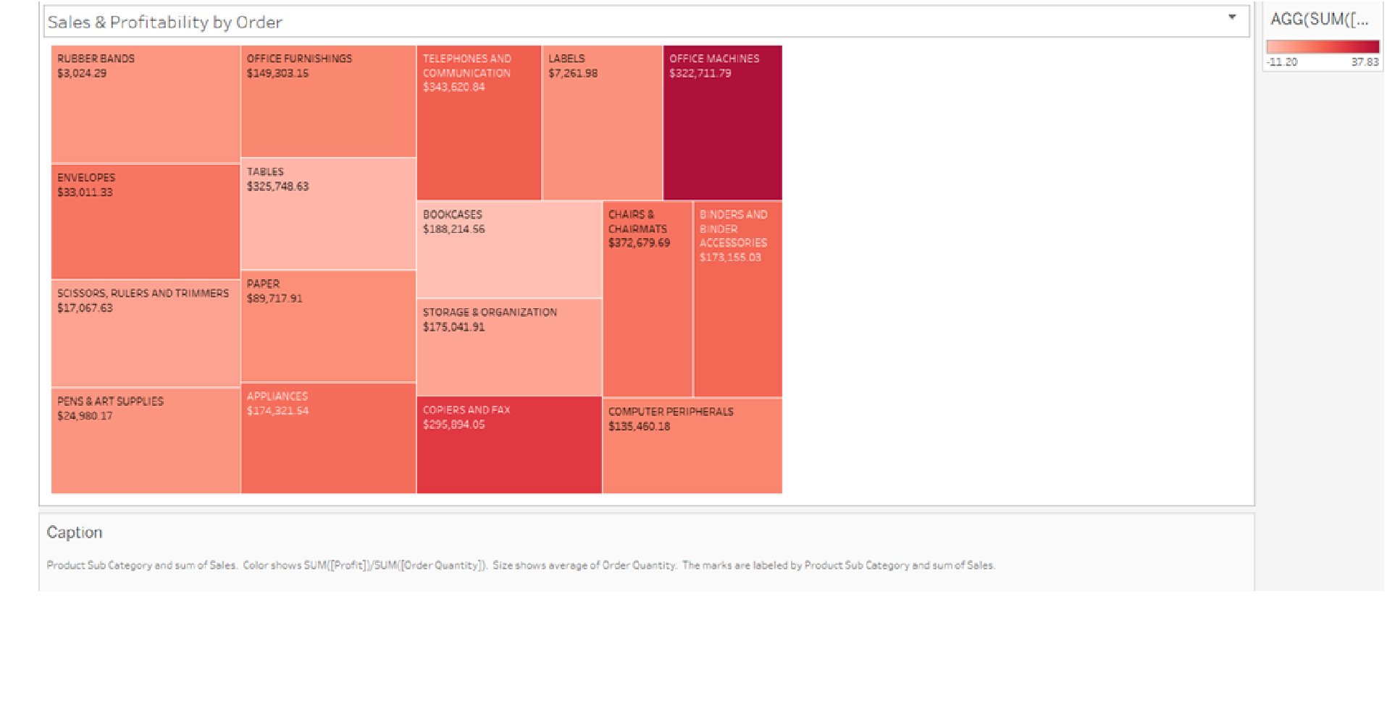
Answer: Based on the data, office machines are the most profitable subcategory per order.

- Historically the company has provided discounts to their top 10 customers in terms of sales. Using packed bubbles, find the top 10 customers. Add a new sheet titled Top 10 Customers. Required Components: 1) Use packed bubbles to display your results. 2) Cust id is represented by color and label. Use a green-gold gradient for the color of the bubbles. 3) Add a filter to filter out the Top 10 customers based on the sum of sales. 4) Display the Cust id, and sum of sales as a currency in the circle with label as to value. Use average sales to determine the bubble size.

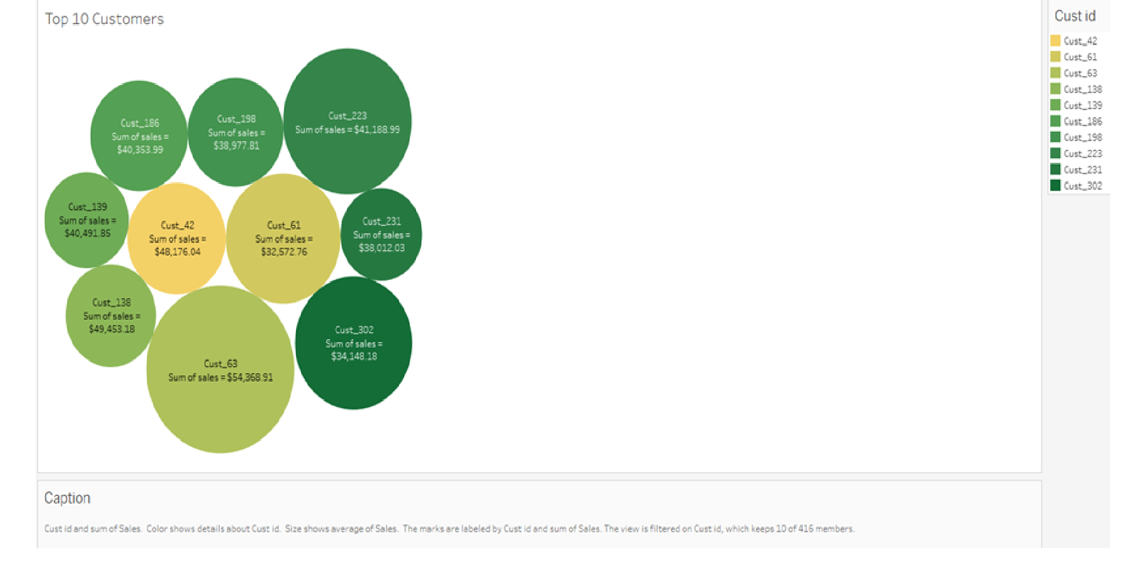

- Management wants to see the proportion of the shipping costs across the three Product Categories. Use a pie chart, display the split of the sum of shipping costs across the categories. Add a new sheet titled Shipping Cost by Product Category. Required Components: 1.) Use a pie chart to display your results. 2.) The angle of the pie chart is dependent on the sum of shipping cost. 3.) Label the sections of the chart with the product category, average shipping cost as currency, and percentage of total. 4) Bold the product category label and change the average shipping cost and percentage font to blue and ensure all values are labeled accordingly, e.g., “average shipping cost: $0.00.” Based on the data presented, which product category has the highest shipping costs? Why? What could be done to reduce shipping costs?

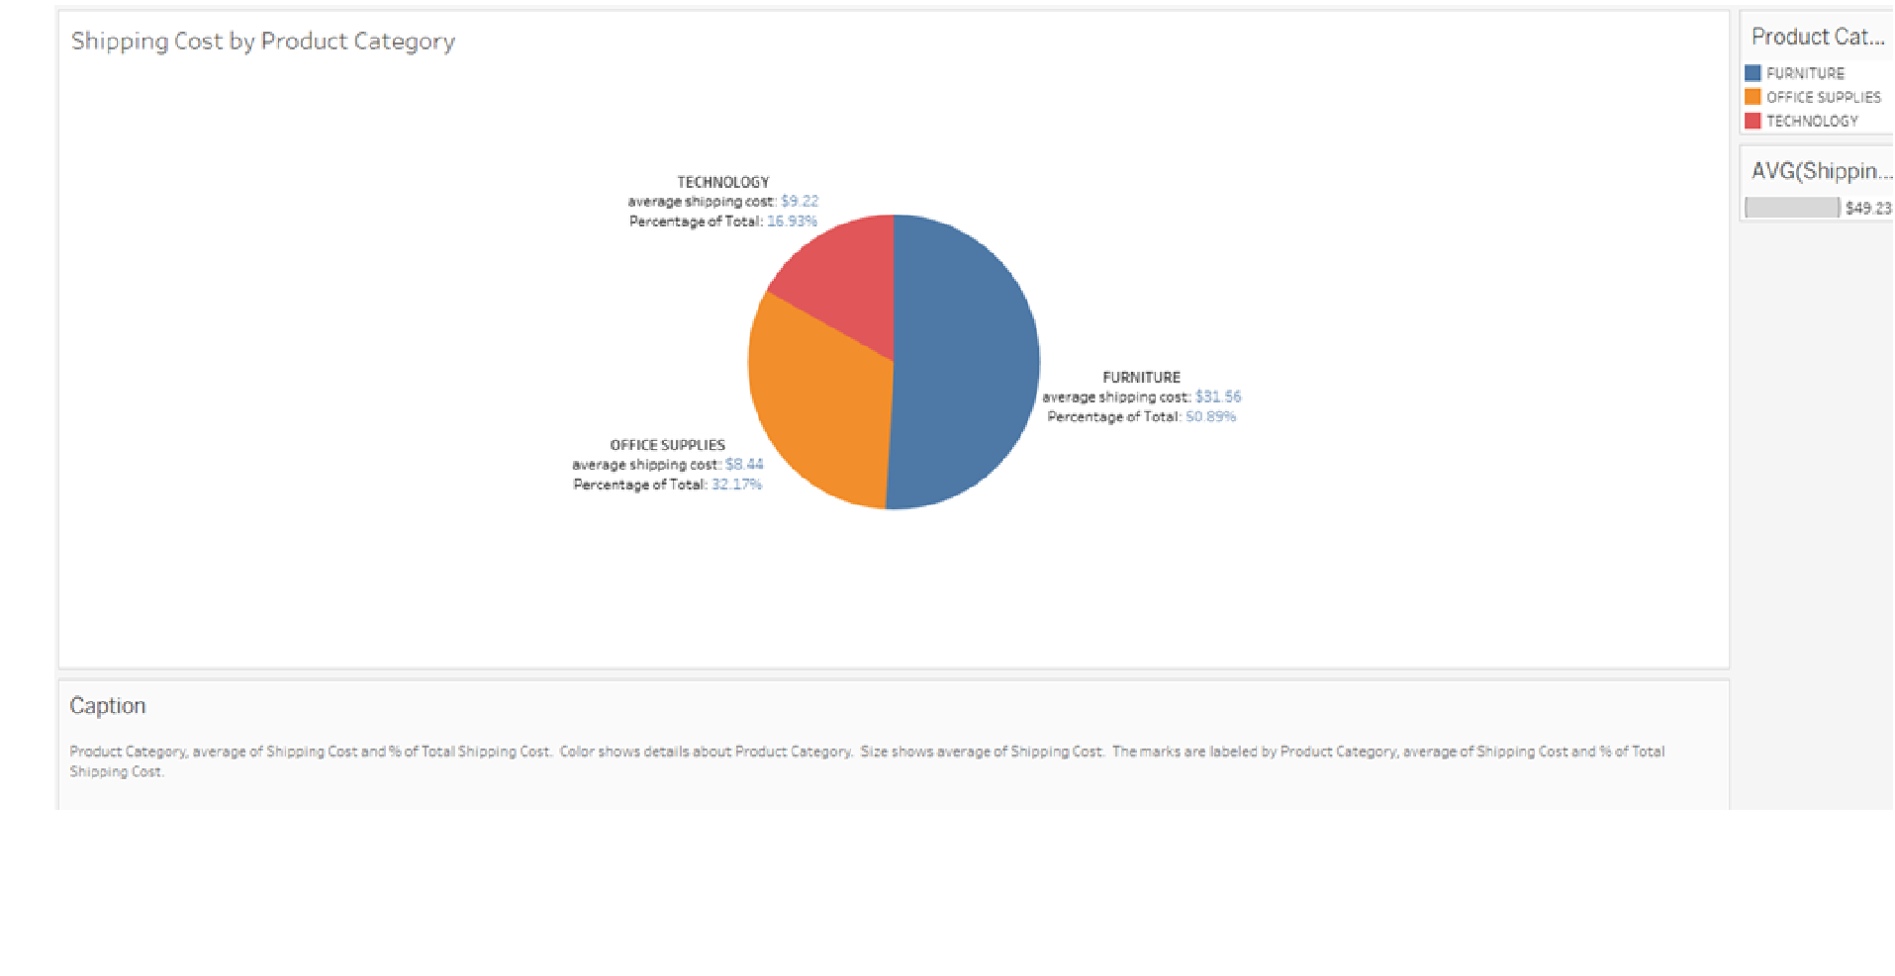
Answer: Based on the data presented, the product category with the highest shipping costs is furniture for two reasons. One reason is that furniture weighs a lot, requires specialized transportation, and has higher freight charges. The second reason is that packaging costs for furniture would be higher to prevent damage. These are three suggestions that we could implement to reduce shipping costs. The first suggestion is to implement flat-pack designs, where we would send a box with all the separate parts and instructions so that the customer can assemble the product independently. The second suggestion is to open regional warehouses to store furniture closer to customers to reduce freight costs. The third suggestion is to offer incentives or discounts for customers to come and pick up large items instead of shipping.

- Management wants to compare product profit and sales by quarter. They want a quick view by each product subcategory. Choose the data visualization to best represent this. Required Components: 1) Use a visualization of your choice. 2) Add labels for sales, profit, and product subcategory; ensure profit and sales are represented as currency. 3.) Add colors.
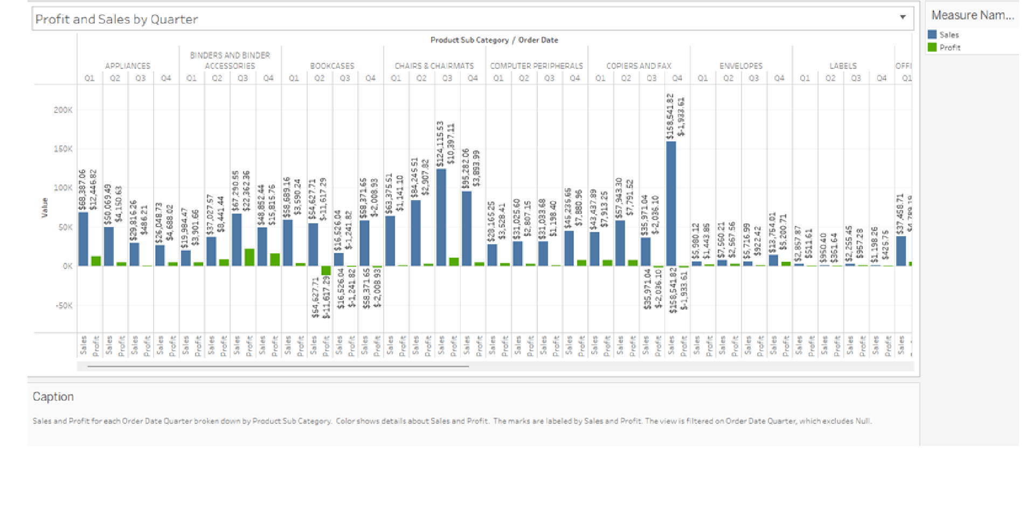
- To make the presentation more appealing, put together your visualizations as a storyboard. Required Components: 1) Create a dashboard titled Sales Dashboard with a logical layout and show a screenshot here. Use only the Sales & Profitability by Order, Top 10 Customers, and Shipping Cost by Product Category visualizations and legend. 2) Create a storyboard. 3) On the storyboard, insert a cover page to highlight what the report is about; the cover page should include your name, date, title of report and a brief description of the analysis. 4) On each page, add text to explain the visualization/findings beyond the intuitively obvious visualization title. Show the dashboard and cover page here as separate images.
The images are on the next page.

