**Introduction**: -

**Purpose**: "Perishables" Management System (at retail stores)

Perishable Management System is an online software application which fulfills the requirement of a typical Perishable stock analysis. It provides the interface to shop-owners/managers in a graphical way to manage the quantity left, decay rate, expiry date, storage conditions like temperature, humidity etc. Also provides the management reports like monthly wastage due to various reasons - due to decay or excess quantity.

**Intended Audience:**

1. Local retail stores/supermarkets
2. Vegetable Shops

**Product Scope:**

The product aims to provide a hassle-free approach to perishable management for store managers, allowing them to maintain product accounts in an efficient and reliable manner while also receiving feedback.

The project's goal is to provide shops with an efficient interface for managing their grocery inventory based on each item sold. The basic idea is that each item is linked to its associated details, which are stored in a database. The system analyses the total sale of perishable goods at the end of each day. The system then compares the current available quantity to the quantity level sold for the day and alerts if the quantity is less.

The product also aims to track the expiration date of perishable goods. If a product is nearing the end of its shelf life, it will notify the manager (admin) of the quantity nearing its expiration date.

**References:**

<https://www.cs.uic.edu/~spurohit/documents/Requirements%20Document.pdf>

<https://opus.govst.edu/cgi/viewcontent.cgi?article=1156&context=capstones>

<https://agritech.tnau.ac.in/govt_schemes_services/pdf/2013/SRS%20Service%207-draft-13-6-13%20(1).pdf>

## **Overall Description:**

1. **Product Perspective:**

The Perishable Management System is a stand-alone product that is not dependent on any other product or system. The product will automate various tasks associated with handling product details, better organizing stored information, and optimum performance, thereby assisting businesses in ensuring the smooth operation of these processes.

Picture: major component of the overall system, subsystem connections and ext interface. – pallavi

1. **Product Functions:**

The main user of our product is the admin/shop-manager and staff.

Administrators must update and monitor the registered product details, add a new product, provide product numbers for all products, assign each product quantity and GST, and so on.

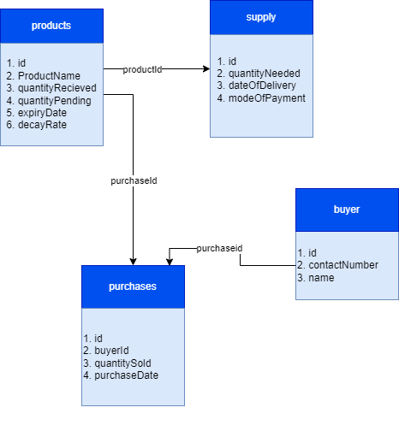

1. **User Classes and Characteristics**

Admin: The admin should be a person familiar with basic database operations like inserting through the click of the mouse. He/She has privileged tasks like adding new items or placing orders for new stock or increasing the price of a stock.

Staff: Staff has the basic operations, like changing quantity available based on sold, marking an item as damaged.

1. **Operating environment**

Our product is an independent web based software which will have a database as a backend.

We will be using a Windows 11 system, 64 bit Operating System, 16GB RAM system, i7 OctaCore processor .

1. **Design and Implementation Constraints**

This software offers security. The login form prevents unauthorized users from gaining access to the system. Only an authorized operator will be granted the ability to modify as needed. This software is also dependable and error-tolerant. The developed system is intended to handle invalid inputs.

**Implementation**

1. The System User Interface is built on Microsoft Visual Studio 2010.
2. The programming is done in Microsoft Visual Studio 2010.
3. **Assumptions and Dependencies**

* We assume that the shop personnel do all the data entry based and the correct values obtained from forms and registers.
* We assume that the computers that will use the software will be part of having the proper platform to run it.
* Staff with administrator access should be careful in deleting or modifying any information knowingly or unknowingly which will lead to inconsistency of the database.
* The end users of this software are assumed to have a basic level of computer knowledge i.e. point and click.

External Interface Requirements

User Interfaces: -

* GUI along with meaningful Frames and Buttons.
* Reports are generated as per the requirement.
* The system shall provide a uniform look and feel between all the web pages.

Software Interfaces

Tech Stack: - MERN Stack

The error messages will come up to let the administrator know that the input provided is not accepted by the database when invalid inputs are submitted to the modules. The system will display a message box prompting the administrator to add all necessary information when the administrator provides incomplete information and attempts to submit the form to store the details in the database.

Communications Interfaces: -

The machine will have to be part of the college Local area Network to access the central database.

or

The e-store system shall use the HTTP protocol for communication over the internet and for the intranet communication will be through TCP/IP protocol suite.

Analysis Models

-Include pertinent analysis models, use case diagrams and if applicable ER diagram- pallavi

System features: -

Some Perishable management software solutions look a lot like inventory management software, but most are oriented more towards Perishable management’s physical and logistical aspects. When considering a PMS, make sure to keep the unique Perishable management system functional requirements of your business in mind and that the features you need are included.

Keeping your PMS requirements and functionality checklist on hand when selecting a solution can also help keep must-have features from being

Other Non-Functional Requirements: -

Performance Requirements: -

It is simple to keep track of records and update them. The section below outlines all the requirements pertaining to the system's performance characteristics.

There are two types of requirements: -

1) Static Requirements

There are no restrictions placed on the execution features of the system.

They are: -

a)Number of Terminals:

The software uses a back end database that will be located on the same system, while the administrative computer will have access to the front end.

b) Number of Users:-

Administrators can be the sole users, but this software can be expanded to include apps for practically all of the organization's workers.

2) Dynamic Requirements: -

These specify constraints on the execution characteristics of the system. They typically include response time and throughout the system. Since these factors are not applicable to the proposed software, it will suffice if the response time is high and the transactions are carried out precisely and quickly.

Safety Requirements: -

b)

c) Functional Requirements: -

Perishable Management System involves the following functions

Staff Registration: -

-PMS provides automatic Staff register number (Staff Id)generation based on a randomization algorithm.

Product Management:

- Easily track product information (sold and available).

-Quickly produce reports for single or multiple sold products.

-Alerts when the product reaches/nears its expiry date.

Security Requirements: -

### **Data Transfer**

* The system shall use secure sockets in all transactions that include any confidential administrator’s information.
* The system shall automatically log out all administrators after a period of inactivity.
* The system shall confirm all transactions with the administrator’s web browser.
* The system shall not leave any cookies on the administrator’s computer containing the user’s password.

**Data Storage**

* The admin’s web browser shall never display an admin's password. It shall always be echoed with special characters representing typed characters.
* The system’s back-end servers shall never display an admin’s password. The admin’s password may be reset but never shown.
* The system’s back-end servers shall only be accessible to authenticated administrators.
* The system’s back-end databases shall be encrypted.

Software Quality Attributes: -

Reliability: -

In the case that the server is down because of a hardware or software issue, the software won't be able to connect to the database.

Availability: -

Only the organization's administrator will have access to the software, and only he will be able to record data regarding the product and the customers. He has the ability to add new items and manage goods, as well as update or remove existing clients.

Security: -

The primary security is covered by the security requirements. Only the administrator and authorized should use the software. The only person with the authority to create new accounts and generate inventory is the administrator. The administrator's login and password are required to access the system, and only authorized users can use them.

Maintainability: -

Backups for databases are available.

Portability: -

The Software is a web-based application and is built in Javascript so it is platform independent and is independent of the operating system.

Business Rules: -

Staff can become admin in case of absence of admin for a long duration.