The Facts and China’s Position on China-US Trade Friction

Information Office of the State Council
The People’s Republic of China

September 2018

CONTENT
Foreword …………………………………………………...…3
I. Mutually-beneficial and win-win cooperation between China and the US in trade and economy…………………………………………………..…..6
II. Clarifications of the facts about China-US trade and economic cooperation ……………………………………..17
III. The trade protectionist practices of the US administration…………………………………………….….41
IV. The trade bullyism practices of the US administration…………………………………………….….52
V. Damage of the improper practices of the US administration to global economy…………...………….…61
VI. China’s position …………………………………..…….67

Foreword
China is the world’s biggest developing country and the United States is the biggest developed country. Trade and economic relations between China and the US are of great significance for the two countries as well as for the stability and development of the world economy.
Since the establishment of diplomatic relations, bilateral trade and economic ties between China and the US have developed steadily. A close partnership has been forged under which interests of the two countries have become closer and wider. Both countries have benefited from this partnership, as has the rest of the world. Since the beginning of the new century in particular, alongside rapid progress in economic globalization, China and the US have observed bilateral treaties and multilateral rules such as the WTO rules, and economic and trade relations have grown deeper and wider. Based on their comparative strengths and the choices of the market, the two countries have built up a mutually beneficial relationship featuring structural synergy and convergence of interests. Close cooperation and economic complementarity between China and the US have boosted economic growth, industrial upgrading and structural optimization in both countries, and at the same time enhanced the efficiency and effectiveness of global value chains, reduced production costs, offered greater product variety, and generated enormous benefit for businesses and consumers in both countries.
China and the US are at different stages of development. They have different economic systems. Therefore some level of trade friction is only natural. The key however lies in how to enhance mutual trust, promote cooperation, and manage differences. In the spirit of equality, rationality, and moving to meet each other halfway, the two countries have set up a number of communication and coordination mechanisms such as the Joint Commission on Commerce and Trade, the Strategic and Economic Dialogue, and the Comprehensive Economic Dialogue. Each has made tremendous efforts to overcome all kinds of obstacles and move economic and trade relations forward, which has served as the ballast and propeller of the overall bilateral relationship.
Since taking office in 2017, the new administration of the US government has trumpeted “America First”. It has abandoned the fundamental norms of mutual respect and equal consultation that guide international relations. Rather, it has brazenly preached unilateralism, protectionism and economic hegemony, making false accusations against many countries and regions - particularly China - intimidating other countries through economic measures such as imposing tariffs, and attempting to impose its own interests on China through extreme pressure.
China has responded from the perspective of the common interests of both parties as well as the world trade order. It is observing the principle of resolving disputes through dialogue and consultation, and answering the US concerns with the greatest level of patience and good faith. The Chinese side has been dealing with these differences with an attitude of seeking common ground while shelving divergence. It has overcome many difficulties and made enormous efforts to stabilize China-US economic and trade relations by holding rounds of discussions with the US side and proposing practical solutions. However the US side has been contradicting itself and constantly challenging China. As a result, trade and economic friction between the two sides has escalated quickly over a short period of time, causing serious damage to the economic and trade relations which have developed over the years through the collective work of the two governments and the two peoples, and posing a grave threat to the multilateral trading system and the principle of free trade.
In order to clarify the facts about China-US economic and trade relations, clarify China’s stance on trade friction with the US, and pursue reasonable solutions, the government of China is publishing this White Paper.

I. Mutually-beneficial and win-win cooperation between China and the US in trade and economy
Economic and trade relations have developed steadily since the establishment of diplomatic ties between China and the US, with fruitful results achieved in trade and investment. China benefits remarkably from the strong synergy, while the US also reaps extensive economic benefits from the opportunities and results generated by China’s growth. It is self-evident that a sound China-US economic and trade relationship is very important for both countries. Cooperation serves the interests of the two sides and conflict can only hurt both.
1. China and the US are important partners for each other in trade in goods.
Two-way trade in goods has grown rapidly. Chinese statistics show that trade in goods between China and the US in 2017 amounted to US$583.7 billion, a 233-fold increase from 1979 when the two countries forged diplomatic ties, as well as a seven-fold increase from 2001 when China joined the World Trade Organization. Currently, the US is China’s biggest export market and sixth biggest source of imports. In 2017, the US took 19% of China’s exports and provided 8% of China’s imports. China is the fastest growing export market for US goods and the biggest source of imports of the United States. In 2017, 8% of US exports went to China.
US exports to China are growing much faster than its global average. Since its accession to the WTO, China has become an important market for US exports, which have grown rapidly. UN statistics indicate that in 2017 US exports of goods to China amounted to US$129.89 billion, a 577% increase from US$19.18 billion in 2001, and far higher than the 112% average growth rate of overall US exports (Chart 1).
Chart 1: US Exports to China Grow Faster than its Global Export Trade (%)
17.20
3.90
24.30
31.90
9.10
21.80
17.20
17.40
-
4.80
31.70
19.60
8.80
14.80
4.20
-
6.50
-
9.10
14.50
-
-6.75
-
-4.94
4.57
12.43
10.58
13.86
11.91
12.13
-
17.97
21.06
15.96
4.26
2.19
2.59
-
7.28
-
3.43
6.6
-
30.00
-
20.00
-
10.00
0.00
10.00
20.00
30.00
40.00
US Export to China
US Global Export
Source: UNCTAD

China is an import market for US goods such as airplanes, agricultural produce, automobiles, and integrated circuits. China represents the No. 1 export market for US airplanes and soybeans, and the No. 2 export market for US automobiles, IC products and cotton. In 2017 China took 57% of US soybean exports, 25% of Boeing aircraft, 20% of automobiles, 14% of ICs and 17% of cotton.
China-US bilateral trade has a strong complementarity. The US stands at the mid-and high-end in global value chains and it exports capital goods and intermediary goods to China. Remaining at the mid-and low-end in global value chains, China mainly exports consumer goods and finished products to the US. The two countries play to their comparative strengths and the two-way trade is highly complementary. In 2017, the top three categories of Chinese exports to the US were:
    - electric machines/electrical products/equipment and components,
    - mechanical apparatus and components, and
    - furniture/bedding/lamps,
which accounted for 53.5% of its total exports to the US. The top three categories of products that China imported from the US were：
- machinery/electric equipment/ components and accessories,
- mechanical apparatus and components, and
- automobile and components and accessories,
which accounted for 31.8% of total import from the US. Machinery and electronic products take a lion’s share of two-way trade, and there is an evident characteristic of intra-industry trade. (Table 1) For most of the hi-tech products that China exports to the US, only labor-intensive processing takes place in China, involving large-scale import of key components and intermediary products as well as international transfer of value.
Table 1: Major China’s imports from and exports to the US (HS 2-digit)
Imports | Share in imports from the US (%) | Exports | Share in exports to the US (%)
Chapter 85 electric motor, electric products, audio-visual equipment and components and accessories | 11.3 | Chapter 85 electric motor, electric products, audio-visual equipment and components and accessories | 24.9
Chapter 84 nuclear reactors, furnaces, mechanical apparatus and components | 10.7 | Chapter 84 nuclear reactor, furnace, mechanical apparatus and components | 21.3
Chapter 87 automobiles and components and accessories, excluding railway cars | 9.8 | Chapter 94 furniture, bedding, lamps and trailer coach | 6.8
Chapter 12 oilseeds, kernels, plants for industrial or pharmaceutical purposes, animal feed | 9.5 | Chapter 95 toys, game or sport articles and components and accessories | 4.3
Chapter 88 aircraft, spacecraft and components | 9.2 | Chapter 61 knitwear, crocheted apparel and accessories | 3.7
Chapter 90 optical, photographic and medical devices and components and accessories | 7.6 | Chapter 39 plastics and plastic articles | 3.6
Chapter27 mineral fuels, mineral oil and products, asphalt, etc. | 4.7 | Chapter 87 automobiles and components and accessories, excluding railway cars | 3.5
Chapter 39 plastics and plastic articles | 4.5 | Chapter 62 non-knit wear, non-crocheted apparels and accessories | 3.3
Source: China Customs

2. Bilateral trade in services is developing quickly.
The US has a highly-advanced and fully-fledged service industry which is very competitive on the international market. Accompanying the growth of the Chinese economy and the improvement of Chinese people’s living standards is an obvious rise in demand for services and rapid growth in bilateral services trade. According to US statistics, two-way trade in services rose from US$24.94 billion in 2007 to US$75.05 billion in 2017. According to MOFCOM, the US was China’s second biggest services trade partner; according to USDOC, China is the third biggest market for US service exports.
The US is the biggest source of China’s deficit in services trade and this deficit has been increasing fast. US statistics show that US service exports to China grew 340% from US$13.14 billion in 2007 to US$57.63 billion in 2017 while its service exports to other countries and regions in the same period grew by 180%. The US surplus with China in services multiplied by a factor of 30 to US 40.2 billion. (Chart 2) At present, the US represents roughly 20% of China’s total deficit in services trade, the biggest source of this deficit. China’s deficit with the US is concentrated in three areas, travel, transport and intellectual property royalties.
Chart 2: US Services Imports from and Exports to China (unit: US$100 mn)
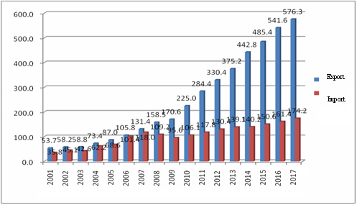
Source: Bureau of Economic Analysis, US DOC

China’s trade deficit with the US in tourism continues to widen. According to the DOC, by 2016 the number of Chinese mainland visitors to the US had been increasing for 13 consecutive years, with double-digit growth in 12 of the 13 years. MOFCOM statistics suggest that in 2017 Chinese visitors going to the US for tourism, education, and medical treatment spent a total of US$51 billion in the US. Among them, 3 million were tourists, who spent as much as US$33 billion while traveling in the US. In education, the US is the largest overseas destination for Chinese students. In 2017, there were around 420,000 Chinese students in the US, contributing some US$18 billion to local revenues. According to US figures, China’s trade deficit with the US in tourism grew from US$430 million in 2006 to US$26.2 billion in 2016, registering an average annual growth of 50.8%.
China’s payments for the use of US intellectual property continues to rise. Chinese statistics indicate that the US is the largest source of intellectual property imports to China. From 2012 to 2016, China imported nearly 28,000 items of intellectual property from the US. China’s payments for US intellectual property doubled in six years from US$3.46 billion in 2011 to US$7.2 billion in 2017. (Chart 3) In breakdown, China’s intellectual property payments to the US accounted for a quarter of its total intellectual property payments to foreign countries.
Chart 3: China’s Payment for the Use of US Intellectual Property
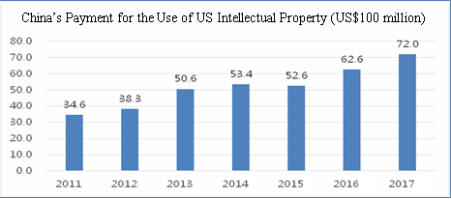
Source: MOFCOM, China

3. China and the US are important investment partners.
The US is a major source of foreign investment for China. According to MOFCOM, by the end of 2017, there were approximately 68,000 US-funded enterprises in China with over US$83 billion in actualized investment. With a rapid increase in direct investment by Chinese enterprises in the US, the latter has become an important destination for Chinese investment. As China’s outbound investment grew, Chinese enterprises’ direct investment in the US rose from US$65 million in 2003 to US$16.98 billion in 2016. According to MOFCOM figures, by the end 2017, the stock of Chinese direct investment in the US amounted to approximately US$67 billion. Meanwhile, China has also made a significant financial investment in the US. According to the US Treasury Department, China held US$1.18 trillion of US treasury bills by the end of May 2018.
4. China and the US have both benefited markedly from trade and economic cooperation.
China and the US have both reaped enormous benefits and created win-win results from trade and economic cooperation.
China-US trade and economic cooperation has promoted economic development in China and improved economic wellbeing. Against the backdrop of economic globalization, strengthening trade and investment cooperation with other countries, including the US, and opening up markets to each other has helped Chinese enterprises integrate into the global industrial chain and value chain, and opened up a huge external market for Chinese economic growth. Thanks to economic development over the past 40 years of reform and opening up, in 2017 China became the world’s largest trader in goods, with US$4.1 trillion of total merchandise imports and exports. It became the second largest trader in services with US$695.68 billion worth of total services imports and exports. And it became the second largest recipient of FDI, with US$136 billion of inward foreign investment. American firms have played an exemplary role in China for their Chinese peers in terms of technological innovation, marketing management, and institutional innovation. They have promoted market competition, improved industry efficiency, and motivated Chinese firms to improve their technology and management. In importing a large number of mechanical and electrical products and agricultural products from the US, China has managed to make up for its own supply deficiencies, and satisfy the demand—especially high-end demand—in various sectors by offering consumers a diversity of choice.
At the same time, the US has gained access to a wide range of business opportunities such as cross-border investment and entry into the China market, which have played a big part in driving economic growth, improving consumer welfare, and upgrading the economic structure in the US.
Trade and economic cooperation has supported US economic growth and lowered US inflation. A joint estimate by the US-China Business Council and Oxford Economics indicated that in 2015 imports from China drove up the US gross domestic product by 0.8 percentage points. Exports to China and two-way investment contributed US$216 billion to America’s GDP, pushing US economic growth rate up by 1.2 percentage points. Value-for-money products from China drove down prices for American consumers, and in 2015 for example, reduced the consumer price index by 1 to 1.5 percentage points. A low inflation environment has created much room for expansionary macroeconomic policies in the US.
Trade and economic cooperation has created a large number of jobs in the US. According to a US-China Business Council estimate, in 2015, US exports to China and US-China two-way investment supported 2.6 million jobs in America.Specifically, Chinese investment covered 46 states of the US, generating for the US more than 140,000 jobs, most of which are in manufacturing.
Trade and economic cooperation has brought real benefits to American consumers. Bilateral trade provides consumers with a broad range of choices, lowers their living costs, and raises the real purchasing power of the American people, especially the low- and middle-income cohort. According to the US-China Business Council, in 2015, trade with China saved every American family US$850 of expenditure each year, which is equivalent to 1.5% of the average household income in the US.
Trade and economic cooperation has created a large number of business opportunities and significant profits for American businesses. With China being a huge and rapidly growing market, trade and economic cooperation between China and the US has created huge business opportunities for American businesses. From the trade perspective, the US-China Business Council 2017 State Export Report found that in 2017, China was one of the top five export markets of goods for 46 states. In 2016 China was one of the top five export markets of services for all 50 states. On average every US farmer exported over US$10,000 of agricultural products to China in 2017. From the investment perspective, according to MOFCOM, in 2015 US firms in China realized approximately US$517 billion of sales revenue and over US$36 billion of profits; in 2016, their sales reached about US$606.8 billion and profits exceeded US$39 billion. For the top three US automakers, their joint ventures in China made a total profit of US$7.44 billion in 2017. In the same year, a total of 3.04 million American passenger vehicles were sold in China, accounting for 12.3% of all passenger vehicles sold in China. General Motors alone has ten joint ventures in China. Its output in China accounted for 40% of its global output. Qualcomm’s income from chip sales and patent royalties in China accounted for 57% of its total revenue. Intel’s revenues in China (including the Hong Kong region) accounted for 23.6% of its total revenue.In the FY 2017, revenues from Greater China accounted for 19.5% of the Apple Inc. total. By January 2017, 13 American banks had subsidiaries or branches and ten American insurance companies had insurance firms in China. Goldman Sachs, American Express, Bank of America, Metlife and other American financial institutions have reaped handsome returns from their strategic investment in Chinese financial institutions. According to China Securities Regulatory Commission, American investment banks were lead underwriters or co-lead underwriters for 70% of the funds raised by Chinese companies in their overseas IPOs and refinancing. US law firms have set up about 120 offices in China.
Trade and economic cooperation has promoted industrial upgrading. In their trade and economic cooperation with China, US multinational companies have sharpened their international competitiveness by combining competitive factors of production in the two countries. For example, iPhones are designed in the US, manufactured and assembled in China, and sold in the world. According to a Goldman Sachs report in 2018, should Apple Inc. relocate all its production and assembly to the US, its product cost would increase by 37%. In technological cooperation, US companies which have sales and investment in China enjoy the benefits of cloud computing and artificial intelligence applied in China, so that American products can better adapt to the changing global market. By manufacturing for US companies, China has enabled the US to invest more money and resources in innovation and management, focus on high-end manufacturing and modern services, and upgrade its industry with more added-value and high technology. This has also helped the US in conserving energy and resources and mitigating pressure in environmental protection at home, making the US more competitive in the world.
In general, China-US trade and economic cooperation is a win-win relationship and by no means a zero-sum game, bringing concrete benefits to US companies and people. Some Americans claim that the United States is “losing” in this relationship, a claim which does not stand up to scrutiny.

II. Clarifications of the facts about China-US trade and economic cooperation
Economic cooperation and trade between the two countries is so huge, substantive and broad-based, with so many players, that it is inevitable for some differences and friction to emerge. The two countries need to take a comprehensive perspective, keep in mind their strategic interests and the international order, properly handle their differences by seeking common ground while shelving differences, and take practical steps to resolve their tensions. However, in its Section 301 report and other ways, the current US administration stigmatizes China by accusing it of “economic aggression”, “unfair trade”, “IPR theft” and “national capitalism”. This is a gross distortion of the facts in China-US trade and economic cooperation. It turns a blind eye to the huge progress in China’s reform and opening-up as well as the dedication and hard work of the Chinese people. This is disrespectful to the Chinese government and people as well as incompatible with the real interests of the American people. It will only aggravate differences and tensions, which in the end will damage the fundamental interests of both countries.
1. The gap in trade in goods alone is not a good indicator of China-US trade and economic cooperation.
An objective understanding and assessment of China-US trade balance calls for comprehensive and in-depth study, rather than a glance at the trade deficit in goods. It is not China’s intention to have a trade surplus. Rather, the ratio of China’s current account surplus to its GDP has declined from 11.3% in 2007 to 1.3% in 2017. The imbalance of trade in goods between China and the US is more of a natural outcome of voluntary choices the US has made in economic structure and market in the light of its comparative strengths. To resolve this issue, both sides need to make concerted efforts in restructuring. The United States turns a blind eye to various factors in its trade and economic cooperation with China, singles out the imbalance of trade in goods, and blames China for the imbalance, which is unfair and unreasonable.
China-US trade and economic cooperation delivers balanced benefits in general. The imbalance of trade in goods between the two countries has evolved over time. From the 1980s to early 1990s, the US ran a surplus in its trade with China; in 1992 China began to run surplus, which has continued to grow.
In today’s world of greater globalization and widespread international production, bilateral trade and economic cooperation already extend beyond trade in goods. Trade in services and sales of local subsidiaries in the host country (local sales in two-way investment) should also be included. If we give full consideration to these three factors—trade in goods, trade in services and sales of local subsidiaries in the host country, trade and economic cooperation delivers balanced benefits in general for China and the United States, with the latter reaping more net benefits. (See Chart 4)According to MOFCOM, the US ran a surplus of US$54.1 billion in trade in services in 2017, indicating its remarkable competitive strength in this area. According to the US Bureau of Economic Analysis (BEA), the sales of US companies in China reached US$481.4 billion in 2015, way higher than the US$25.6 billion sales of Chinese companies in the US, an advantage of US$455.8 billion. US companies enjoy an even bigger advantage in cross-border operations. In June 2018, Deutsche Bank released a report on calculating economic interests between the US and its major trading partners, arguing that, from the perspective of commercial interests, the US has in fact gained more commercial net benefits than China from their two-way trade, given the impact of global operations by multinational corporations on bilateral trade and economic cooperation. According to Deutsche Bank, after contributions from subsidiaries of third countries are taken away, the US enjoyed net benefits of US$20.3 billion in 2017.
Chart 4: China-US Trade and Economic Cooperation Delivers Balanced Benefits in General (2009-2015, unit: US$1 billion)
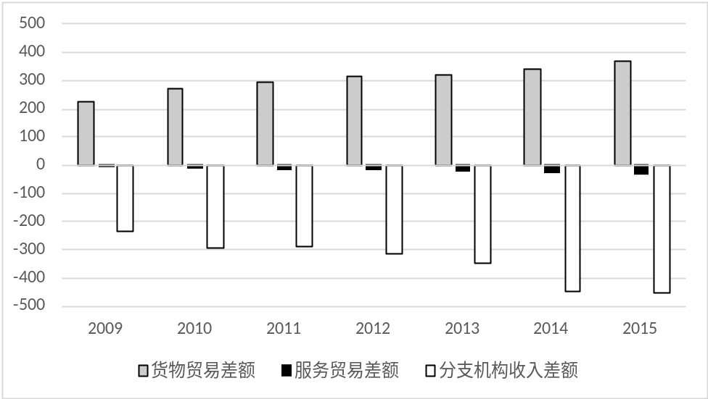
Gap in Trade in Goods
Gap in Trade in Services
Gap in Income by Subsidiaries
Source: Bureau of Economic Analysis (BEA), USDOC.

The gap in China-US trade in goods is a natural outcome of the US economic structure, and a result of the two countries’ comparative strengths and the international division of labor. The persistent and growing gap in trade in goods between the two countries is a result of a number of factors, rather than China’s intent.
First, it is a natural outcome of a low savings rate in the US. From the perspective of national accounts, the balance of a country’s current account is decided by the relationship between savings and investment. The US economy is characterized by low savings and high consumption. Savings have been lower than investment for many years. In the first quarter of 2018, the US net national savings rate was as low as 1.8%. To balance its domestic economy, the US has to attract a large amount of foreign savings by trade deficit. This is the fundamental cause of the US trade deficit over the years. The US began to run trade deficits in its foreign trade in 1971, and by 2017 it was running trade deficits with 102 countries. The US trade deficit is an endogenous, structural and sustained economic phenomenon. The current trade deficit of the US with the rest of the world has shifted among its trading partners and resides with China for the time being.
Second, it is a fair reflection of the complementarity and comparative strengths of Chinese and US industries. In terms of trade mix, China’s trade surplus with the US mainly comes from labor-intensive products and manufactured goods, and its trade deficit with the US lies in capital- and technology-intensive products such as aircraft, integrated circuits, and automobiles, as well as agricultural products. In 2017, China ran a US$16.4 billion trade deficit with the US in agricultural products, accounting for 33% of China’s total trade deficit in the agricultural sector; a US$12.75 billion trade deficit with the US in aircraft, accounting for 60% of China’s total trade deficit in this sector; China also ran a US$11.7 billion deficit in automobile trade with the US. Therefore, the imbalance in trade in goods is a result of voluntary market choices where both countries have played to their industrial competitive strengths.
Third, it is a result of the international division of labor and the changing configuration of production locations by multinational companies. As the global value chain and international division of labor expand, multinational companies have come to establish factories in China to assemble and manufacture products and sell them to the US and the global market, thanks to China’s low production costs, strength in auxiliary production, and reliable infrastructure. When it comes to players in foreign trade, according to China Customs, 59% of China’s trade surplus with the US was contributed by foreign-invested enterprises in China in 2017. In the process of receiving international industrial relocation and joining the Asia-Pacific industrial network, China has, to a large extent, taken over the trade surpluses of Japan, the ROK and other East Asian economies with the US. According to US BEA, the shares of Japan, the ROK and other East Asian Economies in the total US trade deficit have declined from 53.3% in 1990 to 11% in 2017, while China’s trade surplus with the US has risen from 9.4% to 46.3% in the same period. (Chart 5)
Chart 5: How the Regional Components of US Foreign Trade Deficit Changed (1990-2017)
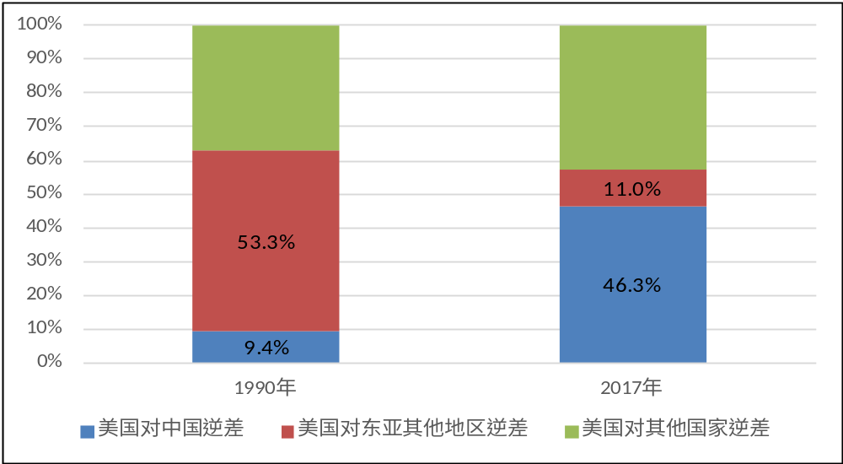
US Deficit with China
US Deficit with Other Regions in East Asia
US Deficit with Other Countries
Source: UN COMTRADEdatabase, Bureau of Economic Analysis, USDOC.

Fourth, this is the consequence of US export control over high-tech products exported to China. The US boasts huge competitive strength in high-tech trade. Yet, haunted by the cold-war mentality, it imposes strict export controls on China, thereby limiting the potential of advantageous US exports, causing significant lost export opportunities, and widening its trade deficit with China. According to a report by the Carnegie Endowment for International Peace in April 2017, if US export controls on China were relaxed to the level of those on Brazil, its deficit could be cut by 24%, and 35% if relaxed to the level of France. Evidently there remains a huge potential to be tapped in high-tech exports to China. If the US had not itself closed the door, it could well have seen its trade deficit reduced.
Fifth, this is the result of the US dollar being a major global currency. The Bretton Woods system established after WWII was based on the US dollar. On the one hand, the US uses its “exorbitant privilege” to levy seignorage on all countries. For the US the cost for printing a hundred-dollar bill is no more than a few cents, but other countries will have to provide real goods and services in exchange for that note. On the other hand, as a major global currency, the US dollar supports global trade settlements, and the US supplies US dollars to the world by way of a deficit. Therefore, beneath the US trade deficit lie profound US interests and the very root of the international currency system.
In addition, US statistics exaggerate its deficit in trade in goods with China. There has been a significant and long-standing statistical divergence between China and the US. In 2017, Chinese statistics recorded a Chinese surplus of US$275.8 billion, while US statistics showed it to be US$395.8 billion, a gap of about US$100 billion. The statistical working group comprising experts from the USDOC and MOFCOM compare every year the statistics from China and the US, and estimate that the US statistics overstate the trade deficit with China by 20% every year. According to statistics from China Customs and the USDOC, the dynamics of and gap between the two statistics have been largely the same over the past decade.(Chart 6) Causes for divergence include differences between CIF and FOB prices, transit trade value-added, direct trade markup, geographical jurisdiction, and shipping time delay.
Chart 6：Bilateral Goods Deficit: China and US Statistics (US$100 million)
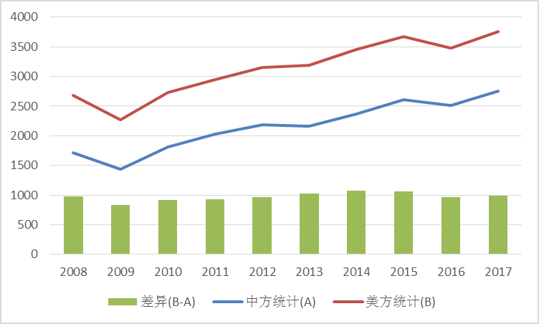
Difference (B-A)
Chinese Statistics
US Statistics
Source: China Customs, Bureau of Economic Analysis, USDOC

If calculated by value added, the deficit would decrease significantly. China’s foreign trade is characterized by large-scale imports and large-scale exports in processing, which applies to its trade with the US as well. According to MOFCOM, by trade methods, 61% of the China-US trade imbalance comes from processing. The value added in China accounts for only a small portion of the total value of many products, while the current approach is to calculate an export by aggregate (total value of goods exported). The WTO and the OECD started to advocate in 2011 a global perspective on production, and proposed to analyze the roles and benefits of all countries participating in the global distribution of labor by the approach of value-added accounting, for which the database WIOD was established. As an example, in 2016 conventional statistics show China’s surplus with the US to be US$250.7 billion. Based on the WIOD database and using the value-added approach, this would become US$139.4 billion, a 44.4% decrease from the aggregate approach.
2. The discussion of fair trade should not be detached from the principle of mutual benefit of the WTO
In recent years, the US has turned away from “free trade” to advocating so-called “fair trade”, to which it has added new meanings. Unlike previous administrations, the incumbent administration emphasizes a “fair trade” that is not based on international rules but “America first”, or the protection of America’s own interests. The core is so-called “reciprocal” opening, an idea of absolute equality, believing that all countries should apply identical tariff levels and provide identical market access in all sectors in their dealings with the US. In the eyes of the US government, the lack of reciprocity in market opening in other markets puts the US in an unfair position, and leads to bilateral trade imbalances. Such a concept of reciprocity is inconsistent with the reciprocal and mutually advantageous principle of the WTO.
The principle of reciprocity of the WTO takes into consideration different development stages by granting special and differential and more favorable treatment to developing members. This arrangement aims to attract new developing members, increase the WTO’s representation and enhance the inclusiveness of the multilateral system, while respecting the right to develop of developing countries and regions. It enshrines the principle of mutual benefit in exchanging present favors for future opening. Developing members that are in the initial stage of development need appropriate protection for their industries to promote sound growth, which will provide more opportunities for developed countries in time. This differential and more favorable treatment is in the long-term interests of all countries and regions, including developed members, and this is genuine global fairness. In 2001, China joined the WTO as a developing member and has been treated as such. It still remains a developing country even after more than a decade of rapid economic development. China’s large population of 1.39 billion dilutes massive economic figures to low levels on a per capita basis. According to IMF statistics, in 2017 the per capita GDP of China was US$8,643, only 14.5% of that of the US, and ranking 71st in the world. By the end of 2017 there were still 30.46 million rural people living in poverty. It is unfair to demand absolute equality in tariffs between China and the US simply on the grounds of China’s economic aggregate and trade volume. The absolute equality approach also violates the MFN and non-discrimination principles of the WTO (Box 1).

Box 1 So-called Reciprocal Opening is not in Line with the Non-Discrimination Principle of the WTO
In the WTO, the reciprocal and mutually advantageous principle (including most-favored nation treatment and national treatment) and the non-discrimination principle are closely linked. The preambles of the Marrakesh Agreement Establishing the World Trade Organization and GATT 1994mention “reciprocal and mutually advantageous arrangements directed to the substantial reduction of tariffs and other barriers to trade and to the elimination of discriminatory treatment in international trade relations”. At its heart is providing MFN treatment to all WTO members and not arbitrarily discriminating against other WTO members. But it is often prone to misunderstanding or abuse, incompatible with the MFN treatment on many occasions and prone to become an excuse for discriminatory treatment. On February 12th, 2018, the US announced for the first time that it was considering reciprocal tariffs on certain products coming into the US, the same as those imposed by the counterpart on the import of the same products from the US. By insisting on absolute equality in treatment regarding a certain product, this idea of reciprocity distorts the mutual benefit principle. The WTO-defined “reciprocal” and the so-called “reciprocal” of the US have different meanings. If reciprocal tariffs were to be implemented on a large scale, it would lead to different tariffs for different countries, deviating from the MFN treatment. And if reciprocal tariffs are imposed on a small number of countries with high tariff rates, it would be tantamount to the US withholding MFN treatment towards these countries.

The reciprocity and mutual benefit principle advocated by the WTO means overall reciprocity and balance of interests in market opening across all the industries of the members, rather than narrowly defined reciprocity of treatment for a specific industry or product. Given the differences in endowment and competitiveness, absolutely reciprocal opening would be virtually impossible, and tariffs in different industries diverge. Even if we follow this absolute reciprocity logic of the US, unfair and non-reciprocal practices are more than common in the US. For example, China’s tariffs on peanuts in the shell, dairy products and trucks are 15%, 12% and 15-25% respectively, while WTO tariff figures show those of the US to be 163.8%, 16% and 25%, all higher than China. (Table 2)

Table 2：Some Tariffs in China and in the US
 | US | China
Trucks | 25% | 15-25%
Dairy Products | 16% | 12%
Peanuts in the Shell | 163.8% | 15%
Shelled Peanuts | 131.8% | 15%
Peanut Butter | 131.8% | 30%
Knitted Shirts | 30% | 16%, 17.5%
Source: China Customs Import and Export Tariff of 2017 and WTO tariff database

China, having fulfilled its WTO commitments, has voluntarily engaged in unilateral tariff reductions to expand market opening. By 2010, all commitments in goods had been fulfilled, with the overall tariff level decreased from 15.3% in 2001 to 9.8%. Yet China did not limit itself to WTO commitments; it has promoted trade and investment liberalization through FTAs, given special treatment in tariffs to LDCs, and significantly reduced import tariffs using provisional tariffs on several occasions. According to the WTO, China’s weighted tariff in 2015 had fallen to 4.4%, significantly lower than that of emerging economies and developing countries such as the Republic of Korea, India and Indonesia, approaching that of the US (2.4%) and the EU (3%). China’s tariffs on agricultural products are lower than the real tariffs of Japan, and lower than those of Australia for non-agricultural goods (Table 3). From the beginning of 2018, China further voluntarily cut the MFN rate on whole vehicles to 15%, and the MFN rate on auto parts from a maximum 25% to 6%. China has reduced import tariffs for 1,449 daily necessities, with the MFN rate down by an average of 55.9%from 15.7% to 6.9%. Currently, China’s overall tariff rate has been reduced to 8%.
Table 3: Trade Weighted Average Tariff Rates of China and Other Countries (%)
 | All | Agro Products | Non-agro Products
Japan | 2.1 | 11.1 | 1.2
The United States | 2.4 | 3.8 | 2.3
The European Union | 3.0 | 7.8 | 2.6
Australia | 4.0 | 2.4 | 4.1
China | 4.4 | 9.7 | 4.0
Republic of Korea | 6.9 | 55.4 | 4.0
Indonesia | 6.8 | 7.8 | 6.7
India | 7.6 | 38.0 | 5.6
Source：WTO tariff database

The idea of “fair trade” and “reciprocal opening up” advocated by the US ignores the existence of objective differences among countries in terms of stage of development, resources, and competitive industries, and ignores developing countries’ right to develop. It will create an impact on the economy and industries of the developing countries, result in broader inequality, and eventually prevent American businesses from expanding their international market share and sharing development opportunities in the developing countries.
Since its accession to the WTO, China has made important contribution to world economic development. Some people think China has taken advantage of its WTO membership while putting other countries at a disadvantage. In fact, after China joined the WTO, it has provided international capital and technologies with low-cost labor and land resources, generating immense production capacity that has promoted the development of global industrial chain and value chain, and world economic growth. In this process, FDI to China has kept on growing, surging from USD46.88 billion in 2001 to USD136.32 billion in 2017, at an annual growth of 6.9%. Multinationals have shared the immense opportunities in China’s economic development. In the meantime, China has paid a high cost in environment and industrial restructuring as its economy grows rapidly.
3. China should not be accused of forced technology transfer as it is against the spirit of contract
Since the adoption of reform and opening up, foreign enterprises have established partnerships with Chinese companies by voluntarily entering into contracts. They transferred production capacity and orders to China of their own volition so as to tap into the emerging market, save production costs, achieve economy of scale, and extend the term of profiting from technologies. These are voluntary behaviors based on business interests. However, it accords with neither historical facts nor the spirit of contract to unjustly label bilateral transactions on a voluntary basis as forced technology transfer simply on the grounds of Chinese firms’ technological advances.
Technology transfer in the course of cooperation between China and developed countries such as the US is voluntary technology transfer and industrial transfer initiated by the enterprises of developed countries keen to maximize their interests. The product life-cycle theory indicates that any kind of product goes through a life-cycle from peak to decline due to application of new technologies. While endeavoring to develop new technologies, multinationals continuously transfer technologies that are either obsolete or standardized to developing countries with a view to extending the term of profiting from old technologies, making room and sparing production factors for R&D and application of new ones, and indirectly sharing R&D costs. Therefore, technology transfer and licensing is a widely-used business cooperation model. Since the 1990s, Microsoft, Intel, Qualcomm, P&G, GE, Lucent, and other American companies have set up R&D facilities in China in a bid to better adapt to and explore the Chinese market. Over the years, American firms in China have earned handsome profits through technology transfer and licensing. They are the largest beneficiary of technological cooperation.
In the process of cooperation, the Chinese government has never introduced policies or practices that force foreign invested enterprises to transfer technology. Technological cooperation and other forms of commercial cooperation between Chinese and foreign businesses are entirely voluntary and bound by contracts. It generates real benefits for companies on both sides. Generally speaking, there are three patterns of technology-related revenues earned by foreign enterprises: (1) one-off transfer through settlement by an agreed price or discounted equity participation; (2) technology-related income that is included in the sales of equipment, components or products; and (3) technology licensing fees. For example a foreign enterprise with a technological advantage sells equipment to a Chinese company short of certain technologies related to the equipment. The Chinese company has to buy technical services and components from the equipment supplier multiple times in the long run. The Chinese company is willing to purchase some of the technologies from the foreign company for a one-off payment. Such requirements for technology transfer are normal price negotiations based on cost-benefit accounting. Such technology fee payments, be they in installments or in a lump-sum, are common practices in international commercial technology trading. It is a complete distortion of the facts that the US administration labels as forced technology transfer the voluntary behaviors of FIEs to partner with Chinese companies, transfer or license technologies, and reap profits together in Chinese market by entering into business contracts.
Besides, equity cooperation in some areas is in line with China’s international obligations and usual practices of many countries, and does not constitute forced technology transfer either. In recent years, China has eased restrictions on foreign equity (See Box 2), and given foreign businesses greater freedom of choice. In this process, equity cooperation between Chinese and foreign enterprises becomes deeper as a result of free choices based on commercial considerations by the two sides.
Box 2 China markedly relaxes market access for foreign investment
China revised the Catalogue for the Guidance of Foreign Investment Industries in 2015 and 2017. Restricted measures have been reduced by 65% to 63 items, and only 28 items are left under the prohibited category. On June 28, 2018, China for the first time published Special Administrative Measures for Foreign Investment Access (Negative List) 2018, reducing restrictions from 63 to 48, and introducing new opening up measures in 22 sectors.
China has notably expanded market access in areas of interest to FIEs. In manufacturing, foreign equity caps will be lifted for the shipbuilding industry, including design, production and repair, and the airplane industry, including trunk airliners, regional jets, utility aircraft, helicopters, drones and lighter-than-air aircraft. In the automobile industry, China will remove foreign equity caps on manufacturing of special-purpose vehicles and new energy vehicles, and phase out those on all automotive ventures over the next five years. In the financial sector, China has lifted foreign equity caps for banks, and raised the cap to 51% for securities, fund management companies, futures and life insurers. All the foreign equity caps in finance will be removed by 2021.
Market opening has attracted more foreign investment into China. On July 10, 2018, Shanghai Municipal government and Tesla signed a memorandum of cooperation which will allow Tesla to wholly own its first super factory built outside of the US, in Shanghai. Foreign financial institutions are also speeding up efforts to explore the Chinese market. Since 2017, 14 foreign institutions such as Fidelity, UBS Asset Management, Man Group, Fullerton, Blackrock, and Schroeder have registered as private securities investment fund managers in China. On June 29, 2018, the world’s largest hedge fund manager, Bridgewater Associates LP, concluded its registration as a private fund manager in China and officially launched its private fund business in the market.
The WTO noted in the report of trade policy review on China that the country remains one of the top foreign investment recipients and its inward FDI has kept rising for many years.

That the US administration accuses China of “stealing” advanced technologies is an insult to China’s efforts to push for scientific and technological advances. The Chinese nation is known for diligence, intelligence, and ingenuity. The Chinese government sets great store by the development of science, technology and education. The progress in science and technology China has made comes from years of implementing a strategy of invigorating the country through science, technology and education and the strategy of innovation-driven development, and from the hard work of the Chinese people, especially scientific workers. Since 2000, the total R&D spend in China has registered an average annual growth rate of close to 20%. In 2017, China spent RMB 1.76 trillion in R&D, second only to the US, accounting for 2.13% of total GDP, and approaching the average level of the OECD countries. China has 2,613 institutions of higher education, 10,900 research institutions of all sorts, and over 6.21 million people engaged in R&D. In 2017, the full-time equivalent of R&D personnel in China reached 4.03 million man-years, of which 77.3% were in enterprises. In the same year, China ranked third after the US and Japan with 113 Chinese enterprises listed among “The 2017 Global Innovation 1000”. According to the “Global Innovation Index 2018” released by WIPO in July 2018, China’s ranking rose from 22ndin 2016 to 17thin 2018. In 2017, patent applications reached 3.698 million in China, of which 1.836 million patents were granted. China’s invention patent applications reached 1.382 million, up by 14.2% year-on-year, ranking 1stin the world for seven years in a row. According to WIPO statistics, China filed 49,000 international patent applications via the Patent Cooperation Treaty (PCT) in 2017, second only to the US. Among the top 50 international patent applicants, ten are Chinese enterprises. As former US Treasury Secretary and renowned American economist Larry Summers once said, “You ask me where China’s technological progress is coming from. It’s coming from terrific entrepreneurs who are getting the benefit of huge government investment in basic science. It’s coming from an educational system that’s privileging excellence, concentrating on science and technology. That’s where their leadership is coming from, not from taking a stake in some US company.”
4. China’s huge efforts and achievements with regard to IPR protection should not be dismissed.
China’s attitude towards IPR protection is clear and firm. It has continued to reinforce protectionthrough legislation, law enforcement and the judiciary, and achieved some notable successes. Official reports by the US administration before 2016 also acknowledged China’s achievements in IPR protection. The China Business Climate Survey Reports by the American Chamber of Commerce in China indicate that, among the main challenges facing its member enterprises in China, IPR infringement has dropped from the 7thbiggest concern in 2011 to 12thin 2018. The recent accusations by the US administration about China’s IPR protection are unrealistic and completely dismissive of China’s tremendous efforts and achievements in this regard.
China has formulated and improved its laws and regulations on IP protection, and enhanced protection of IPR. China built a fully-fledged and high-standard IP legal framework in a relatively short period, compared to the decades or more that developed countries spent setting up similar legal systems. China has put in place a complete regime of IP protection, utilization and administration, spanning laws, planning, policies and enforcement agencies. Dr. Arpad Bogsch, former Director-General of the WIPO, has commented, “China had accomplished all this at a speed unmatched in the history of intellectual property protection.” In 2013, China amended its Trademark Law, setting up a system of punitive damages under which the damages cap is raised from RMB 500,000 to RMB 3 million, thus remarkably enhancing protection. Since the fourth major amendment to Patent Law launched in 2014, China has put forward measures for further strengthening protection of patents such as introducing harsher punishment for infringements, improving the rule of evidence, enhancing administrative protection, and better protecting patents in cyber space. In 2017, China amended the Anti-Unfair Competition Law, which further improves the protection of trade secrets, identifies act of confusion, expands the scope of protection for indications, and ratchets up legal liabilities for illegal acts. On October 1st, 2017, China adopted General Provisions of the Civil Law, which stipulates that “Civil entities enjoy intellectual property rights in accordance with law”, and enhances protection of trade secrets by making them a subject of IP protection.
China has intensified judicial protection for intellectual property and given full play to judicial protection. In 2014, China set up three IP tribunals in Beijing, Shanghai and Guangzhou to handle cross-regional IP cases, including those related to patents. Since 2009, China has established 16 special judicial organs in Tianjin, Nanjing, Suzhou, Wuhan, Xi’an and other cities, effectively enhancing the professional handling of IP cases. Between 2013 and 2017, Chinese courts received 813,564 new IP cases of all sorts, and handled and closed 781,257 cases. In 2017, Chinese courts received 213,480 first-instance cases, and concluded 202,970 cases, up by 46% and 43% from the previous year.More IP cases, especially patent cases, are tried in China than in any other country. China provides equal protection for the legitimate rights and interests of Chinese and foreign interested parties in accordance with law. In 2016, Chinese courts heard and closed 1,667 first-instance cases related to foreign entities and individuals, up by 25.6% year-on-year. (See Box 3) The adjudication period for foreign-related IP cases in China is among the shortest in the world. Beijing IP court processes cases in four months on average. Thanks to its rapid judicial procedure, China is increasingly being selected as the forum of choice for non-Chinese companies to litigate IP disputes, and a significant number of both the plaintiffs and defendants in Beijing IP court are foreigners.

Box 3 Chinese Courts Heard Foreign-related IP Cases
in Accordance with Law

Chinese courts have held open hearings on the “Qiaodan” trademark administrative dispute cases, the Dior trademark dispute cases, and other new types of major and problematic cases in accordance with law. The Supreme People’s Court invited WIPO officers, foreign diplomats in China and relevant parties to observe the hearings. All this shows Chinese courts’ commitment to offering equal protection to Chinese and foreign right holders’ legitimate rights and interests in an open and transparent way, reinforcing judicial protection of IPR, and upholding a market environment that encourages innovation and fair competition.
In 2013, the Shanghai Intermediate People’s Court heard the trade secret misappropriation case lodged by Eli Lilly and Company and Lilly China against Huang Mengwei. The court issued an interlocutory injunction order requiring the defendant to stop infringement actions immediately. In its ruling, the court concluded that the defendant, whose behavior constituted trade secret misappropriation, should bear legal liabilities.

IP administrative authorities have taken protective measures and intensified enforcement in a proactive manner. China adopts a dual-track protection system where IP right holders can seek not only judicial but also administrative protection. The State Intellectual Property Office (SIPO) has established a coordinated system with rapid review, rapid rights verification, and rapid rights protection, and built a nationwide 12330 network that provides assistance in defending rights and accepting reports and complaints. The patent, trademark and copyright authorities have carried out strong and proactive enforcement that has effectively defended the legitimate interests of IP right holders. In November 2011, the State Council published Opinions on Further Cracking Down on IP Infringement and Manufacture and Sales of Counterfeit and Shoddy Products, setting up a national leading group and signaling a normalized mechanism involving 29 governmental departments. In 2018, China reorganized SIPO by retooling the trademark and patent enforcement teams into a comprehensive enforcement team for market regulation, thus integrating and strengthening the power of enforcement.
This intensified IP protection has served as an effective guarantee for foreign businesses to innovate in China. Received foreign invention patent applications grew from 117,464 in 2012 to 135,885 in 2017.Foreign trademark registration applications grew from 95,000 in 2013 to 142,000 in 2017, and trademark extension applications grew from 14,000 to 20,000 in the same period.According to the Peterson Institute, China’s protection of intellectual property is improving. China’s payment of licensing fees and royalties for the use of foreign technology has recorded a four-fold increase over the last decade, reaching US$28.6 billion in 2017 and ranking fourth in the world. In fact, China ranks second globally in the scale of licensing fees paid for technology used within its national borders, second only to the US.
US businesses have benefited hugely from effective IP protection in China. According to US Bureau of Economic Analysis of the DOC, China paid US$7.96 billion in licensing fees to the US in 2016. Statistics from China’s National Copyright Administration, Ministry of Commerce, and State Administration for Market Regulation suggest that from 2012 to 2016, China imported 28,000 copyrights from the US. In terms of trademarks, from 2002 to 2016, the US applied for over 58,000 trademarks transfer in China, making up 4.54% of total transfers. In terms of culture, according to the State Administration of Press, Publication, Radio, Film, and TV, in 2017 China imported 31 American films at a cost of US$650 million.
China’s progress in IP protection has been recognized by the international community. In 2011, China Customs won the National Public Body Award of the Global Anti-Counterfeiting Network. In 2012, the Economic Investigation Bureau of the Ministry of Public Security won the award for Distinguished Contributions to Anti-counterfeiting Enforcement. On 9 May 2011, former US president Obama stated that China had made good progress in IP protection. The US was willing to export more high-tech products to China and other countries in the interests of both sides.In February 2018, GIPC released a report on the International Intellectual Property Index 2018, which maps the national IP environment for 50 surveyed economies with 40 indicators. China ranked 25th, up by 2 places from 2017.
5. The Chinese government’s encouragement to Chinese business to go global should not be distorted as a government attempt to acquire advanced technologies through commercial M&A.
It is consistent with the WTO for the Chinese government to encourage businesses to go global and engage in international economic exchanges and cooperation. As Chinese companies get stronger and the need for resource allocation and market expansion increases, a growing number of firms have started to expand overseas at their own initiative, a trend in line with economic globalization. Like other countries and regions in the world, the Chinese government supports able and competent companies in outbound investment and tapping into international markets, while obeying the laws and regulations of the host countries as well as international rules. The government only provides services that facilitate this outbound investment and cooperation. The arbitrary conclusion of the US that such support is a government act to acquire advanced technologies through commercial M&A is groundless.
In fact, among Chinese investments in the US, those that seek to acquire technology represent a small share. According to the American Enterprise Institute, from 2005 to 2017, of 232 direct investments from China, only 17 involved high-technology, while others were mainly in real-estate, finance and services.
6. China’s subsidy policy complies with WTO rules and should not be attacked.
China conscientiously complies with WTO rules on subsidy policy. As one of the tools to address market failure and imbalanced economic development, subsidies are widely used by many countries and regions, including the US. Since China joined the WTO, we have actively pressed ahead with reform to ensure the compliance of domestic policies, and conscientiously honored the obligations under the WTO Agreement on Subsidies and Countervailing Measures.
China complies with the WTO rules on subsidy transparency. As required, we have regularly notified the WTO of the revision, adjustment and implementation of our domestic laws, regulations and measures. By January 2018, China had submitted thousands of notifications, covering various areas of central and sub-national subsidy policies, agriculture, technical regulations, standards, and IP laws and regulations. In July 2016, in accordance with the relevant rules, the Chinese government notified the WTO of sub-national subsidy policies between 2001 and 2014, covering 100 subsidy policies from 19 provinces and 3 municipalities with independent planning authority. In July 2018 we notified the WTO of the central and sub-national subsidy policies between 2015 and 2016, covering all the provincial level administrative areas for the first time.
China has created a level playing field for the businesses. In recent years, the Chinese government has committed to transforming industrial policies. In June 2016 the State Council released Opinions on Establishing a Fair Competition Examination System in the Building of the Market System, setting out to guarantee rules-based government actions, prohibit new supportive measures that would exclude or impede competition, and filter out and abolish any existing rules and practices that hamper fair competition. In January 2017, the State Council released a Circular on Several Measures on Promoting Further Openness and Active Utilization of Foreign Investment, requiring authorities concerned to carry out a fair competition review in defining foreign investment policies. In June 2018, the State Council released a Circular on Certain Measures for Actively and Effectively Utilizing Foreign Investment to Promote Quality Economic Development, aiming to grant full pre-establishment national treatment on the basis of a negative list, and remove access restrictions on foreign investment in areas outside the list. As required by the Circular, to safeguard the legitimate rights and interests of foreign investors, China has improved the inter-departmental joint meeting mechanism for FIEs to lodge complaints, set up and enhanced the complaint mechanism for FIEs across the country, in order to promptly resolve any unfair treatment of FIEs, and avoid restrictions on the law-based cross-regional operation, movement and deregistration of FIEs.
China’s agricultural industry has become increasingly market-based. In 2015, the NDRC announced the abolition of controlled pricing on tobacco leaves, marking the definitive end to government pricing for agricultural produce. Since 2004, on the basis of market-set price and free circulation, the Chinese government had stepped in to ensure the basic livelihood of farmers by adopting a government purchase system, a backstop in the case of severe oversupply and collapsing prices. In recent years, the Chinese government has stepped up efforts to reform the purchase system by introducing a more market-based price-setting mechanism. (Box 4)
Box 4 Reform of China’s Agricultural Support Policies
Based on the pilot reform between 2014 and 2016, in March 2017 the NDRC and the Ministry of Finance published the Notice on Deepening Reform of Cotton Target Price, adjusting the subsidy policy for Xinjiang cotton target prices and putting a cap on the volume of cotton that qualifies for target price subsidies. The target price-setting period was changed from once a year to once every three years, and thus the cotton subsidy has become a WTO blue box measure.
While China still keeps the minimum purchase price policy for rice and wheat, it has steadily lowered the minimum price in recent years. At the same time, the Chinese government has stepped up the reform of fiscal payment subsidies and stressed the orientation toward green ecology. In May 2015, the Ministry of Finance and the Ministry of Agriculture published Guiding Opinions for Adjusting and Improving the Three Types of Agricultural Subsidies Policies. 80% of agricultural inputs, plus direct subsidy and improved varieties subsidy, are used for farmland protection. The remaining 20% of agricultural inputs plus large-scale farmers’ direct subsidies and increments to the three subsidies are mainly used for establishing and improving the agricultural credit guarantee system.

III. The trade protectionist practices of the US administration

The numerous investment and trade restriction policies and actions adopted by the US that distort market competition, hamper fair trade, and lead to breakdowns in global industrial chains are detrimental to the rules-based multilateral trading system and severely affect the normal development of China-US economic and trade relations.
- Discrimination against foreign products
Many American regulatory policies are clearly self-serving and protectionist as they run counter to the principle of fair competition and discriminate against foreign products. The US directly or indirectly restricts the purchase of products from other countries through legislation, subjecting foreign companies to unfair treatment in the US, with Chinese companies being the main victims.
The US product market falls behind most developed countries and even some developing countries in terms of fair competition. According to the statistics on Indicators of Product Market Regulationreleased by the OECD in 2013, the Netherlands, the UK and Australia were the top three among 35 OECD countries, while the US ranked only 27th, pointing to the many obstacles created by the US market regulatory policies for fair competition in the product market. When the indicators of 12 non-OECD countries were added, the US ranked only 30th among the 47 countries, indicating a product market environment less fair than those of non-OECD countries such as Lithuania, Bulgaria and Malta.
The US is far more discriminatory against foreign products than most developed countries and even some developing countries. According to the ranking of 35 OECD countries on Differential Treatment of Foreign Suppliers, a secondary indicator of the Indicators of Product Market Regulation, the US ranked 32nd among 35 OECD countries in 2013, indicating severe discrimination against foreign countries in its product market. When the indicators of 12 non-OECD countries were added, the US ranked 39th among the 47 countries, with a higher degree of discrimination than such non-OECD countries as Brazil, Bulgaria, Cyprus, India, Indonesia and Romania (Chart 7).

Chart 7: The Extent to Which US Market Regulatory Policies Inhibit Fair Competition in the Product Market
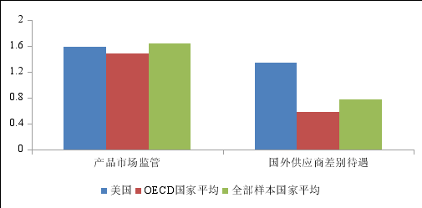
Product Market Regulation
Differential Treatment of Foreign Suppliers
OECD Average
US

Average of All Sampled Countries
Source: OECD, Indicators of Product Market Regulation, 2013

The US, by way of legislation, sets strict requirements on its government departments to “buy American” and imposes discriminatory terms on purchasing foreign products. For example, the Buy American Act stipulates that US federal agencies can only acquire manufactured products made in America and unmanufactured articles that have been mined or produced in America. According to the Code of Laws of the United States of America, an application for a public transport project receiving federal or state funding can be granted only if the steel, iron and manufactured goods used in the project are produced in the US. According to the Agriculture, Rural Development, Food and Drug Administration, and Related Agencies Appropriations Act, none of the funds made available by this Act may be used to procure raw or processed poultry products imported into the US from China for use in the school lunch program, the Child and Adult Care Food Program, the Summer Food Service Program for Children or the school breakfast program. The National Defense Authorization Act prohibits the federal government from procuring telecommunications equipment and services provided by Chinese companies on the grounds of national security.
- Abuse of “National Security Review” as a way to obstruct the normal investment activities of Chinese companies in the US
The US is the first in the world to conduct security reviews on foreign investment. In 1975, the Committee on Foreign Investment in the United States (CFIUS) was established for the specific purpose of monitoring the impact of foreign investment in the US. In 1988, the Exon-Florio Amendment revised the 1950 Defense Production Act by mandating the US President and people with the authority to review foreign takeovers. The Foreign Investment and National Security Act of 2007 expanded CFIUS and broadened its scope of review. The legislation process in the US over the past 50 years shows that the US security review of foreign investment has mainly been characterized by tighter laws, regulations and policies, expanded regulatory teams and scope of reviews, and more recently, intensified screening and restrictions vis-à-vis China.
In practice, the US “national security review” is often based on flimsy evidence and is becoming increasingly stringent. According to CFIUS annual reports to Congress, the Committee reviewed 468 foreign investment transactions from 2005 to 2008, only 37 of which (8 percent) entered the stage of investigation. However, since the Department of the Treasury issued the Regulations Pertaining to Mergers, Acquisitions, and Takeovers by Foreign Personsin 2008, among the 770 cases reviewed between 2009 and 2015, 310 cases – 40 percent of the total – passed on to the stage of investigation, which represents a noticeably sharp rise. In particular, the latest data released in 2015 shows this percentage climbing to an even higher level of 46 percent (Chart 8).

Chart 8 Statistics on Cases Reviewed and Investigated by CFIUS
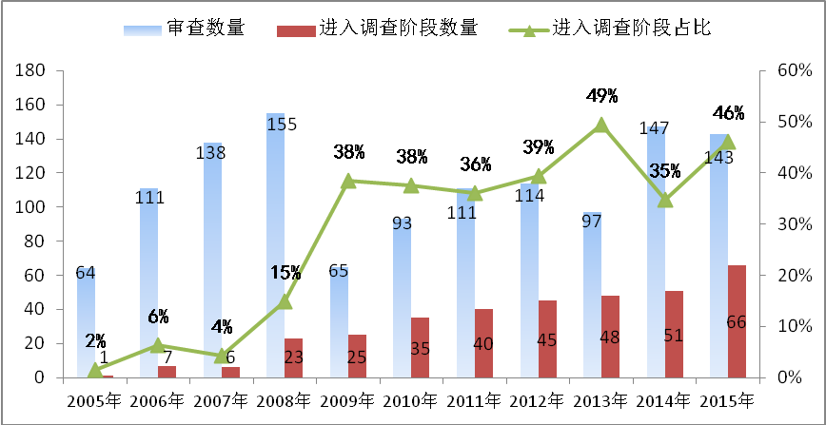
Number of Cases Reviewed
Number of Cases Investigated
Percentage of Investigated Cases
Source: Annual Reports Released by CFIUS

Chinese companies are one of the main targets of the US abuse of national security reviews. Since the establishment of CFIUS, US Presidents vetoed four transactions based on the Committee’s recommendation, all targeting Chinese firms or their related businesses. From 2013 to 2015, CFIUS reviewed in total 387 transactions concerning 39 economies, among which 74 were transactions involving investment from Chinese companies, accounting for 19 percent of the total, the largest share among all countries for three years in a row. The data on Chinese corporate investment being vetoed and blocked by the US (Table 4 and Table 5) shows that CFIUS review of Chinese investment has extended its reach from semiconductors and financial sectors to food processing sectors including swine feed. In addition to an absence of transparency in the review process, excessive discretionary power, and lack of explanations for vetoes, there is an even more serious issue – that normal transactions are being obstructed on the grounds of national security.

Table 4: Overseas Acquisition Transactions with Chinese Investment Vetoed by the US from 1990 to 2018
Year | Buyer | Target | Sector
1990 | China National Aero-Technology Import and Export Corporation (CATIC) | MAMCO (Manufacturer of Aircraft Parts) | Manufacturing
2012 | Ralls, Affiliate of Sany Group | Wind Farm in Oregon | Energy
2016 | Fujian Grand Chip | Aixtron (American Subsidiary of a German Chip Maker) | Semiconductor
2017 | Canyon Bridge | Lattice Semiconductor Corporation from Oregon | Semiconductor

Table 5: Chinese Companies’ Overseas Acquisitions Revoked as a Result of CFIUS Reviews from 2005 to 2018

Year | Buyer | Target | Sector
2005 | CNOOC | Unocal | Energy
2008 | Huawei/Bain | 3Com | Communications
2009 | Northwest Non-Ferrous International Investment Company Ltd | Firstgold Corp. | Energy
2010 | Tangshan Caofeidian Investment Corporation | Emcore | Communications
2010 | Anshan Iron and Steel Group | Steel Development Company | Manufacturing
2010 | Huawei | 3Leaf | Communications
2016 | GSR Ventures | Royal Philips’ Lumileds (US operations included) | Manufacturing
2017 | TCL | MIFI of Novatel Wireless | Communications
2017 | NavInfo, Tencent and GIC | Dutch mapping data provider HERE (US operations included) | Mapping
2017 | HNA Group | Global Eagle Entertainment | Entertainment
2017 | Zhongwang International Group | Aleris | Manufacturing
2018 | Ant Financial | MoneyGram | Finance
2018 | Da BeiNong Group | Waldo Genetics | Agriculture
2018 | BlueFocus Group | Cogint | Internet
2018 | China Heavy Duty Truck Group | UQM | Manufacturing
2018 | HNA Group | Skybridge Capital | Finance

Source: Public Information
The United States is preparing new legislation for more stringent foreign investment security review. On August 13, 2018, the President signed the National Defense Authorization Act for Fiscal Year 2019, part of which is the Foreign Investment Risk Review Modernization Act (FIRRMA), which strengthens the authority of CFIUS, expands the scope of transactions covered, recruits additional staff, establishes the term of “countries of special concern”, and adds additional factors to be considered in reviews. All of this points to a clear trend of tighter investment reviews. In particular, it requests the Department of Commerce to submit a biennial analysis on Chinese investments in the US before 2026..
3. Large subsidies that distort market competition
US governments at federal and sub-national levels provide large subsidies, bailout assistance, and concessional loans to some sectors and companies. Such actions obstruct, to a large extent, fair market competition. According to Good Jobs First, an American organization that tracks subsidies, between 2000 and 2015, the federal government provided at least US$68 billion in grants and special tax credits to businesses, with 582 large companies receiving 67 percent of the total. During the same period, federal agencies gave the private sector hundreds of billions of dollars in loans, loan guarantees, and bailout assistance. A wide range of sectors received government subsidies. Motor vehicles, aerospace and military contracting, electrical and electronic equipment, oil and gas, financial services, chemicals, metals, and retailing and information technologies ranked among the top of the 49 tracked sectors. State and local governments also gave enormous subsidies to companies. The amounts of subsidies at the state level are basically not subject to federal jurisdiction, hence the difficulty in assessing their specific scale and nature. Actual amounts of the state-level subsidies are much higher than the disclosed figures.
In the aviation sector, Boeing has received US$14.5 billion of allocated subsidies from the federal and state/local governments since 2000 and US$73.7 billion of loans, bond financing, venture capital, loan guarantees and bailout assistance from governments at various levels since 2011 (Box 5).

Box 5 EU Challenge to US Civil Aircraft Subsidy
In 2004 and 2005, the EU twice requested consultations with the United States concerning subsidies provided to Boeing. In 2006, the WTO established the DS353 panel. In March 2012, the WTO Appellate Body report affirmed the value of prohibited and/or actionable subsidies granted by NASA, the Department of Defense, the Department of Commerce and other federal departments, and the States of Washington, Kansas and Illinois to Boeing over a long period, in the form of research and development assistance by the federal government and tax credits by governments at other levels, to be at least US$5.3 billion, and called upon the United States to revise its subsidy policy in compliance with WTO agreements. The United States expressed its intention to implement the rulings over a six-month period. In November 2013, the State of Washington revised its local tax legislation and announced an extension of the tax credit policy for domestic aviation companies to keep Boeing assembly lines in the State. The EU made several accusations about the US non-compliance.
On June 9, 2017, the WTO issued a report which ruled that the State of Washington was still providing prohibited subsidies to Boeing. The report confirmed significant lost sales of the A320neo and A320ceo families in the large civil aircraft market and a threat of impedance of exports of A320ceo to markets in the United States and the United Arab Emirates due to the State of Washington’s tax reduction policy for Boeing. The policy violated the US commitment to compliance with the rulings in 2012.

In the automotive industry, the US government at both federal and state levels supports the auto industry with preferential policies and provides key auto companies with large bailouts and disguised subsidies. During the global financial crisis, the US government, with its Automotive Industry Financing Program (AIFP) under the Troubled Asset Relief Program (TAPR), provided key auto companies with nearly US$80 billion of assistance. In 2007, the US Department of Energy, citing Section 136 of the Energy Independence and Security Act of 2007, introduced the Advanced Technology Vehicles Manufacturing Loan Program (ATVM), with authorization from the US Congress, to provide up to US$25 billion in loans. Since 2000, Tesla has received more than US$3.5 billion in subsidies from US federal and state/local governments.
In the field of computer and semiconductor manufacturing, the US has long adopted government-led industrial policies. The US government allocated US$1 billion in the 1980s to SEMATECH to support cutting-edge research, with a view to maintaining America’s leading position in this area and preventing over-reliance on foreign suppliers. Apple’s research and development on nearly all of its products, including the mouse, the display, the operating system, and the touch screen, received support from US government departments, with some of them created directly in labs run by the government. In the military-defense industry, the US has supported related enterprises with preferential taxes, loan guarantees, procurement commitments, etc. Large military-defense enterprises on the brink of bankruptcy have been offered special government loans, restructuring funds, bankruptcy protection, transitional funds, debt relief and other preferential policies. As provided in the 2014 Defense Production Act, “The President may authorize a guaranteeing agency to provide guarantees of loans by private institutions for the purpose of financing any contractor, subcontractor, provider of critical infrastructure, or other person in support of production capabilities or supplies that are deemed by the guaranteeing agency to be necessary to create, maintain, expedite, expand, protect, or restore production and deliveries or services essential to the national defense”. In 2016, Lockheed Martin, the world’s largest military-defense company, obtained US$200 million from the State of Connecticut. In agriculture, high subsidies have long been a policy of the US, the birthplace of the majority of agriculture subsidies in the world. As a result of the WTO Uruguay Round negotiations, the US can give all individual items up to US$ 19.1 billion in amber box subsidies. With abundant financial resources and extensive room for subsidies, the US provides high subsidies for its huge agricultural exports. These subsidies undermine fair international competition and have been repeatedly challenged by other countries, a case in point being the 12-year-long dispute with Brazil over the upland cotton subsidy. In 2014, as part of a major adjustment to its agriculture subsidy policy, the US replaced direct subsidy programs, such as the Counter-cyclical Payment, with the Price Loss Coverage Program and the Agricultural Risk Coverage Program. Simply another form of amber box subsidy, these price-pegged subsidies resulted in a higher level of support. Joseph Glauber, the former chief economist of the US Department of Agriculture, pointed out that these two coverage programs, with reference prices set higher than the target prices of the past, in fact raised the level of subsidy support. According to the Congressional Research Service, the two programs together cost US$10.1 billion in 2015 and US$10.9 billion in 2016. The 2016-2017 support level was higher than before the introduction of the act in 2014. A total of nearly US$15 billion was spent in support of individual items, the highest in nearly a decade. The US also boosted its agricultural exports through various forms of credit guarantee programs. On top of that, the US sent a large volume of the excess farm produce abroad as non-emergency food aid, which led to serious problems of commercial substitution, distorting local agricultural markets in the recipient countries, and undermining the interests of other agricultural exporting countries.
- Use of large-scale non-tariff barriers
While the WTO does not completely prohibit countries from protecting their domestic industries, certain principles must be followed, including lower non-tariff barriers, greater transparency of policies and measures, and a minimal level of trade distortion. The US has put in place a large number of discriminatory non-tariff barriers that are more targeted yet disguised, in an effort to keep specific segments of the domestic market under strict protection. This approach constitutes a notable distortion of the trade order and market environment.

Chart 9: US Non-Tariff Trade Barriers and Its Global Share
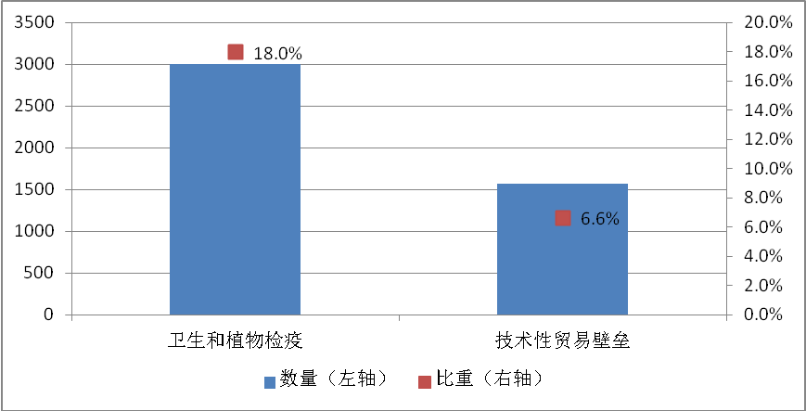
SPS
TBT
Number (Left Axis)
Share
(Right Axis)
Source: WTO Database
According to the WTO, the US has reported 3,004 sanitary and phytosanitary (SPS) measures and 1,574 technical barriers to trade (TBT) measures, accounting for 18 percent and 6.6 percent of the world’s total (Chart 9). As reported in the UNCTAD’s “Analysis of Trade Regulations Data Flags Important New Findings” on June 29, 2018, a tree has to meet 54 SPS requirements before it can be imported into the US. These technical barriers have significantly lowered customs clearance efficiency and raised trade costs.
5. The abuse of trade remedy measures
While the WTO allows the use of trade remedy measures when a member economy finds damage caused to its domestic industries by dumping, subsidy or excessive growth in imports, strict limits and conditions do apply. However, the US has resorted to a huge number of trade remedy measures to protect its domestic industries. Many of these measures target China.
The US is adopting a growing number of trade protectionist measures, whose share of the world’s total is also rising. According to Global Trade Alert, among the 837 new protectionist measures adopted in 2017 worldwide, 143 (or 17.1 percent) were from the US. From January to the end of July in 2018, the US accounted for 33 percent of all protectionist measures in the world (Chart 10).

Chart 10: Additional Trade Protectionist Measures of the US and Their Global Share
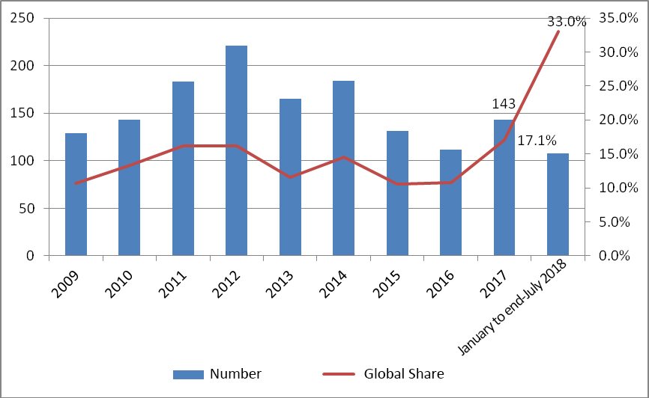
Source: Global Trade Alert
According to the United States International Trade Commission, by July 17, 2018 there were 44 anti-dumping and countervailing measures in effect in the US (Chart 11), among which 58 percent were adopted after the 2008 financial crisis, with China, the EU and Japan as the main targets.

Chart 11: Number of US Anti-dumping and Countervailing Measures Since 2008
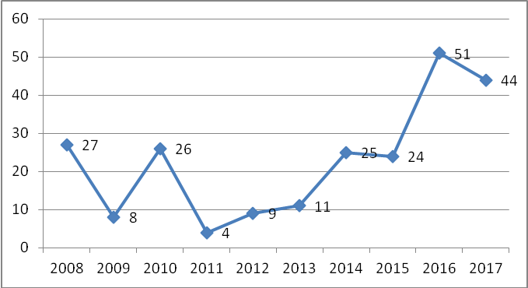
Source: United States International Trade Commission
In anti-dumping investigations, the US has refused to honor its obligation under Article 15 of China’s WTO Accession Protocol and continued to use the surrogate-country approach, citing its domestic law. The Government Accountability Office (GAO) of the US Congress calculated that the rates of anti-dumping duties applied to countries recognized as market economies are notably lower than those applied to non-market economies (NMEs). The average anti-dumping duty imposed by the US on China is 98 percent, while that on market economies is 37 percent. Among the 18 US rulings concerning Chinese products since the start of 2018, 14 had rates of more than 100 percent. Moreover, the US picks surrogate countries rather randomly, making the results of anti-dumping investigations highly unfair and discriminatory for Chinese exporters.

IV. The trade bullyism practices of the US administration

As the key builder of the international economic order and a major participant in the multilateral trading regime after the Second World War, the US should have taken the lead in observing multilateral trade rules and properly handling trade frictions with other WTO members through the dispute settlement system within the WTO framework. This is what the US government explicitly pledged to the international community. However, since taking office, with a narrow focus on “America First”, the new US administration has practiced unilateralism and economic hegemony, abandoned its international commitments, and provoked international trade friction around the world. This has not only undermined the interests of China and other countries, but also jeopardized the international reputation of the US itself. And above all, it has shaken the foundations of the global multilateral trading regime, which will ultimately hurt the long-term interests of the US.
- Unilaterally provoking trade friction on the pretext of US domestic law
Citing industrial injuries and protection of intellectual property rights, the current US administration regularly circumvents the WTO’s dispute settlement system and provokes international trade friction merely using US domestic law as a pretext, initiating a host of investigations under the auspices of Section 232, Section 201 and Section 301. These investigations involve selective use of evidence and arbitrary conclusions. Without WTO authorization, the US has illegally imposed punitive, hefty tariffs on other WTO members, which is a serious breach of the most fundamental and central WTO rules and disciplines, including the most-favored-nation treatment and tariff binding. Such unilateralist actions have harmed the interests of China and other WTO members. More importantly, they have undermined the authority of the WTO and its dispute settlement system, and exposed the multilateral trading system and international trade order to unprecedented risks.
The US administration has conducted Section 232 investigations against the products of multiple countries, abusing the concept of “national security” for trade protectionism. In April 2017, on the basis of Section 232 of its Trade Expansion Act of 1962, the US administration initiated Section 232 investigations against the steel and aluminum products of China and other major economies, citing “national security” reasons. In March 2018, based on the conclusions of these unilateral investigations, the US announced 25 percent tariffs on steel and 10 percent on aluminum imports, incurring widespread opposition and retaliation. On April 5, 2018, China took the lead to bring the case of US Section 232 measures against steel and aluminum to the WTO. Following the US announcement on the resumption of tariffs against EU steel and aluminum products effective from June 1, the EU struck back and appealed to the WTO, charging the US with violation of WTO rules. European Commissioner for Trade Cecilia Malmström said that the US was playing “a dangerous game”, and the EU would be accepting these illegal tariffs if it did not respond. By August 2018, nine WTO members have litigated at the WTO over the Section 232 measures on steel and aluminum. In July 2018, the US administration initiated another round of Section 232 investigations on imported automobiles and auto parts, again on the grounds of “national security”.
It is self-evident that steel and iron are basic raw materials for manufacturing, and automobiles are ordinary consumer goods. It is absurd to link them to “national security”. Chad Bown, senior fellow of the Peterson Institute for International Economics, noted that the capacity utilization rate of the US automobile industry was over 80 percent and about 98 percent of US passenger vehicle imports were from the EU, Japan, Canada, the ROK and Mexico. Therefore, initiating the investigations on the ground that automobile imports impair US national security is baseless. The US administration’s arbitrary expansion of the scope of national security has no theoretical or historical logic. Essentially, it is all about using the executive power of the US President provided for by the relevant sections of certain law to circumvent regular legal restrictions to practice trade protectionism (Box 6).

Box 6 Unilateral actions by the United States have triggered condemnation and countermeasures from multiple countries
In March 2018, pursuant to its Section 232 investigation report, the US administration announced 25 percent tariffs on imports of steel products and 10 percent on aluminum products. On April 2, 2018, in response to the loss caused by the US Section 232 measures, China decided to suspend tariff concessions and impose tariffs on some imports originating in the US. From May 18 to 21, five WTO members – the EU, India, Russia, Japan and Turkey – notified the Council for Trade in Goods and Committee on Safeguards of the WTO about their plans to retaliate in kind on the US measures on steel and aluminum. From June 5 to July 1, Mexico, the EU, Turkey and Canada retaliated against the US Section 232 measures.
On April 5, 2018, China took the lead to initiate a WTO dispute procedure against the US Section 232 measures on steel and aluminum. From May 18 to August 15, India, the EU, Canada, Mexico, Norway, Russia, Switzerland and Turkey initiated dispute procedures over the US Section 232 measures on steel and aluminum under the dispute settlement system of the WTO.

The US has conducted Section 201 investigations against products of multiple countries. In May 2017, on the basis of its Trade Act of 1974, the US initiated Section 201 investigations on imported washing machines and photovoltaic products. In January 2018, it decided to impose a maximum of 50 percent tariffs for three years on washing machines and a maximum of 30 percent tariffs for four years on photovoltaic products. These were the first Section 201 investigations initiated by the US since 2001. As a major source of washing machines imports to the US, the ROK submitted a request for consultations to the WTO in May and announced that it would suspend tariff concessions on some US products as a response to the US imposition of tariffs on its products. On August 14, 2018, China resorted to the WTO dispute settlement system over the Section 201 measures on photovoltaic products.
The US has initiated Section 301 investigation against China. In August 2017, the US initiated a Section 301 investigation against China based on its Trade Act of 1974. A 25 percent tariff was imposed on US$50 billion worth of goods from China in July and August 2018, followed by a continuation of escalating tariff measures. Another tariff of 10 percent on a further US$200 billion worth of China’s exports to the US was imposed from September 24, 2018. A Section 301 investigation is a trade investigation based on relevant provisions of US domestic law. It requests other countries to accept the intellectual property standards and market access requirements of the US, or face retaliatory trade sanctions. Such practice was described as “aggressive unilateralism” as early as in the 1990s.
Historical data show that it is very rare for a Section 301 investigation to be initiated – most cases are settled through consultation. According to a report from the Peterson Institute for International Economics released in March 2018,from 1974 to the present, the US government has conducted 122 such Section 301 investigations, but there has been only one new Section 301 investigation since 2001. In 1994, the US government issued a “Statement of Administrative Action”, stating that the Administration intends to use Section 301 under the WTO rules, and that it would only impose sanctions under Section 301 with authorization from the WTO Dispute Settlement Body (DSB). In 1998, the European Communities filed a case to the WTO DSB against Section 301, and the Panel came to a preliminary finding that in respect of the statutory language, Section 301 is inconsistent with WTO rules. The US government has initiated a Section 301 investigation in the course of its current trade frictions with China, and imposed huge tariffs on Chinese goods in the absence of WTO authorization. These actions have clearly violated its afore-mentioned commitments, and are completely illegal.
2. Baseless accusations against other countries’ industrial policies
As an effective tool to remedy market failures and improve social welfare, industrial policies should not be subject to groundless accusations as long as they are consistent with WTO rules.
The US was among the first to adopt industrial policies. The US rarely acknowledges the adoption of such policies, but its government has in fact undertaken many more industrial policies than the official narrative allows.Ranging from technological innovation incentives and government procurement, through subsidies on specific sectors and companies, to tariff protection and trade agreements, these industrial policies have played a vital role in enhancing the competitive strength of US industries.
To strengthen its global leadership in manufacturing, the US has in recent years formulated a large number of industrial policies. In the 21st century, and in particular over the decade since the outbreak of the international financial crisis, the US has introduced a number of industrial policies including A Framework for Revitalizing American Manufacturing (2009), the United States Manufacturing Enhancement Act of 2010, the Advanced Manufacturing Partnership (2011),A Manufacturing Renaissance: Four Goals for Economic Growth (2011),A National Strategic Plan for Advanced Manufacturing (2012),A Strategy for American Innovation (2011)and the National Network of Manufacturing Innovation: A Preliminary Design (2013). Such plans are also made for key areas such as the Grid Modernization Initiative (2011), the Clean Energy Manufacturing Initiative (2013),A Roadmap for U.S. Robotics – From Internet to Robotics (2013), the Measurement Science Roadmap for Metal-Based Additive Manufacturing (2013), the National Artificial Intelligence Research and Development Strategic Plan (2016) and A National Machine Intelligence Strategy for the United States (2018).
These policies include, among others, specific measures to adjust and improve government investment to scale up input in manufacturing, to increase government procurement of certain products, to provide credit support to export companies to expand global market, and to fund innovation in key areas of manufacturing.
While formulating and promoting its own industrial policies, the US has made unwarranted accusations against other countries’ justified industrial policies. The UNCTAD World Investment Report 2018 pointed out that responding to the opportunities and challenges associated with a new industrial revolution, at least 101 economies across the developed and developing world (accounting for more than 90 percent of global GDP) have adopted formal industrial development strategies over the past 10 years. It was against this backdrop, inspired by US policy papers such as A National Strategic Plan for Advanced Manufacturing and A Strategy for American Innovation, and based on its own national conditions, that China formulated its Made in China 2025 program.
Made in China 2025 is an introductory paper describing a vision, and a market-centered, open and inclusive blueprint for development. The Chinese government has maintained that Made in China 2025 is an open system that is applicable to both domestic and foreign investment. Chinese leaders have stated on several occasions that China welcomes foreign companies to participate in Made in China 2025. China’s State Council released a notice in 2017 on measures to expand opening up and actively utilize foreign investment, which made clear that Made in China 2025 policies apply equally to foreign-invested companies and Chinese companies. The paper was formulated in strict accordance with WTO rules to ensure the relevant policies are legitimate, transparent, fair and non-discriminatory in nature. Many foreign enterprises, including US companies, have participated in programs under Made in China 2025 since its implementation.
3. “Long-arm jurisdiction” and sanctions against other countries based on US domestic laws
“Long-arm jurisdiction” refers to the practice of extending one’s tentacles beyond one’s borders and exercising jurisdiction over foreign entities based on one’s domestic laws. In recent years, the US has been extending its “long-arm jurisdiction” to wider areas including civil torts, financial investment, anti-monopoly, export control and cybersecurity. In international affairs, the US has frequently requested entities or individuals of other countries to obey US domestic laws, otherwise they may face US civil, criminal or trade sanctions at any time.
Take export control as an example. To consolidate its technological advantages, the US has long established an all-round export control system. Through the Export Control Act, the Export Administration Regulations and the International Emergency Economic Powers Act, US exporters or exporting users must apply for export licenses. Foreign buyers are required not to violate restrictive regulations such as those on end-use and end-users, otherwise they will be subject to penalties, including being put in the Entity List which will place them under strict restrictions, or even prohibit them from importing from the US. Statistics show that by August 1, 2018, as many as 1,013 entities from around the world have been put on the Entity List of the US Department of Commerce. This action has undermined not only the interests of companies concerned – including those from the US – but also the development rights of developing countries.
The US is also vigorously reviewing and revising its export control legislation to strengthen its “long-arm jurisdiction”. On August 13, 2018, the US President signed the National Defense Authorization Act 2019, an important part of which is the Export Control Reform Act (ECRA). The ECRA further tightened restrictions on foreign-holding companies, intensified controls on “emerging and basic technologies”, and mandated an inter-agency process to boost law enforcement capabilities. Recently, the Bureau of Industry and Security of the US Department of Commerce added 44 Chinese entities to its Entity List for “acting contrary to the national security or foreign policy interests of the United States”. Such measures create obstacles for Chinese businesses to conduct normal trade and are in fact an extension and upgrading of “long-arm jurisdiction”.
4. Internationalizing domestic issues and politicizing economic and trade issues
The current US administration, in response to domestic political issues, is choosing to internationalize domestic issues and politicize economic and trade issues, and blaming other countries for its own problems.
It has erroneously attributed unemployment caused by domestic policy and institutional flaws to international trade. The US administration has accused other countries of “stealing US jobs through unfair trade”. China, as the biggest source of the US trade deficit, is a convenient primary target. However, statistics from the United Nations show that between 2001 and 2017, China-US trade expanded by a factor of 4.4, and yet unemployment in the US dropped from 5.7 percent to 4.1 percent. In particular, while US imports from China surged from 2009 onward, unemployment in the US saw a steady decline during the same period. The causal relationship between imports of goods and job losses, as claimed by the US administration, does not exist (see Chart 12). A report from the US Congressional Research Service in 2017 reveals that between 2010 and 2015, the number of US manufacturing jobs rose by 6.8 percent even though US imports from China in that sector increased by 32.4 percent.
Chart 12: US Imports of Goods from China and US Unemployment
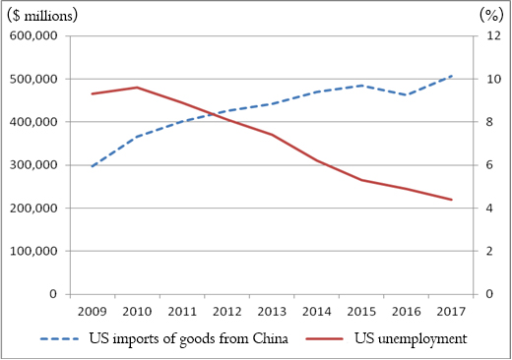
Source: the Bureau of Economic Analysis of the Department of Commerce and the Department of Labor of the United States
In fact, unemployment of some social groups in the US is caused by flaws in domestic economic policy and the absence of proper redistribution and reemployment mechanisms against the backdrop of technological advances and economic restructuring. A study by Ball State University in the State of Indiana finds out that almost 88 percent of the 5.6 million jobs lost in manufacturing in the US between 2000 and 2010 can be attributed to productivity growth. In a market economy where all production factors are in flux, no job lasts forever. The evolution of comparative advantages of the US has had different impacts on job creation in different industries. Decrease of jobs in some industries such as traditional manufacturing is a normal phenomenon in the course of economic development and structural adjustment. The US government should have adapted to the overall trend of economic structural adjustment, taking proactive and effective measures to improve redistribution and reemployment and to help the unemployed find jobs in emerging industries. However, constrained by its traditional distribution mechanism and vested interests, the US government has failed to establish appropriate redistribution and reemployment mechanisms in time. The result has been the build-up of long-standing unemployment among some social groups. This has provided the breeding ground for political populism and isolationism.
The current US administration’s attempt to blame international trade and exporting countries for domestic unemployment is not supported by facts; it aims to deflect public attention in the face of intractable domestic political problems. Without truly resolving its own deep-seated structural problems, the US attempt to bring the manufacturing sector back home through protectionist measures is a completely counter-productive move. This beggar-thy-neighbor and lose-lose approach runs counter to economic rules and will only make the world economy less efficient and trigger opposition from countries around the globe. The US will do as much damage to itself as it will to others.
- The current US administration is violating its own commitments
Respect for rules and contract has been the foundation of the market economy and the international order since the advent of modern times. It makes cooperation between different individuals, groups and countries possible, which is a defining feature of civilized human society. The current US administration has turned its back on universally-recognized and widely-observed norms governing international relations, and made a series of moves in violation of its own commitments. The opportunism of the US toward international relations has been widely challenged and criticized by the international community. The short-sighted actions of the US in pursuit of short-term interests harm its international credibility, and will undermine its international standing and prejudice its strategic interests.
The US administration shows no respect for the sanctity of international agreements and disrupts global governance order. A country should uphold the commitments and agreements it has entered into regardless of government succession. This is essential for a country’s credibility. Exaggerating problems in the multilateral system and differences between countries, the current US administration, unwilling to bear the cost of upholding the international order, has taken a selective approach to international rules. It has withdrawn from international organizations such as UNESCO and the UNHRC, pulled out from the TPP and the Paris Agreement that the previous US administration worked so hard to conclude, and is demanding renegotiation of the North American Free Trade Agreement (NAFTA) and US-Korea Free Trade Agreement.
The global political and economic governance system has only become what it is through constant improvements, starting from the inception of the United Nations (UN), the World Bank, the International Monetary Fund (IMF) and the General Agreement on Tariffs and Trade (GATT). The WTO is an important multilateral trading regime with a total of over 160 members. It is essential to global trade cooperation, and is widely respected and recognized in the world. However, the US frequently violates WTO rules. The number of cases where members requested a suspension of the application of tariff concessions, or suspended tariff concession obligations to the US due to the latter’s failure to comply with the rulings of the DSB, accounted for two thirds of all such cases between 1995 and 2015.
These actions of the US violate international contracts and disrespect its trading partners, and what is more, undermine its credibility as a country. The “Global Risks Report 2018” released by the World Economic Forum pointed out that global risks will intensify in 2018, as the US erodes multilateralism and blocks appointments to the WTO’s appellate body.
The US administration has undermined the market mechanism through direct intervention in business operations. The current US administration has time and again overstepped its purview to directly meddle with market players. For instance, it has demanded that Apple and some other American companies move their overseas factories back to the US, regardless of market rules. The administration has also intimidated and obstructed American companies making investments abroad. For instance, on January 3, 2017, General Motors was threatened with a heavy border tax for continuing to make Chevrolet Cruze models in Mexico. On July 3, 2018, Harley-Davidson was warned not to move part of its operation out of the US. Executives of American companies have been named and shamed on social media, as the administration tightens supervision over normal merger deals under various pretexts.
The US administration has repeatedly backtracked and reneged on its commitments in bilateral trade negotiations. China sets great store by a stable China-US relationship. It has actively responded to the trade concerns of the US, especially since 2017. Multiple rounds of talks have been conducted with the US administration with utmost sincerity and patience, in an effort to narrow differences and solve problems. In response to a strong request from the US, China sent a delegation to the US for trade talks between late February and early March 2018. Yet on April 3, the US announced a 25 percent tariff on a list of Chinese exports worth US$50 billion. Despite this repeated backtracking and in the face of rising demands from the US, China has demonstrated complete sincerity in seeking a negotiated solution, and sat down for earnest consultations with a visiting US delegation in early May. At the US request, China sent another delegation to the US which actively responded to the US concerns in negotiations between 15 and 19 of May. Thanks to the strenuous efforts of both sides, a consensus was reached “not to fight a trade war”, and a joint statement was released on May 19. However, only 10 days later, the US administration tore up the freshly inked joint statement and broke its promise not to engage in a trade war. It bypassed the dispute settlement system of the WTO to announce massive tariffs on Chinese exports, thus unilaterally starting a new phase of conflict (Box 7).

Box 7 The US Tore up the Joint Statement Regarding Trade Consultations Reached with China on May 19, 2018
On May 19, 2018, China and the United States issued a joint statement regarding trade consultations in Washington D.C.
“There was a consensus on taking effective measures to substantially reduce the US’s trade deficit in goods with China. To meet the growing consumption needs of the Chinese people and the need for high-quality economic development, China will significantly increase purchases of US goods and services. This will help support growth and employment in the United States.
Both sides agreed on meaningful increases in US agriculture and energy exports. The United States will send a team to China to work out the details. The delegations also discussed expanding trade in manufactured goods and services. There was consensus on the need to create favorable conditions to increase trade in these areas. Both sides attached paramount importance to intellectual property protection, and agreed to strengthen cooperation. China will advance relevant amendments to its laws and regulations in this area, including the Patent Law. Both sides agreed to encourage two-way investment and to strive to create a fair, level playing field for competition. Both sides agreed to continue to engage at high levels on these issues and to seek to resolve their economic and trade concerns in a proactive manner.”
Yet only 10 days later on May 29, the White House released a statement about imposing tariffs on US$50 billion of imports from China, implementing specific restrictions on Chinese investment in the US, and tightening export controls on China. This is a blatant violation of the consensus the two sides reached on May 19.

V. Damage of the improper practices of the US administration to global economy
The US government has taken extreme trade protectionist measures, which have undermined the international economic order, caused damage to China-US trade and trade relations around the world, disrupted the global value chain and the international division of labor, upset market expectations, and led to violent swings in the international financial and commodity markets. It has become the greatest source of uncertainty and risk for the recovery of the global economy.
- Such measures undermine the multilateral trade rules and the international economic order
In the advance toward civilization, humanity has widely accepted an international governance system based on rules and credibility. Countries, big or small, strong or weak, should respect each other, engage in equal-footed dialogue and jointly safeguard international rules in the spirit of contract. This is fundamental to promoting global trade and investment and boosting global growth. However, the recent steps taken by the US administration that are contrary and even destructive to the existing multilateral trade rules seriously undermine the current international economic order. The US administration has issued open criticisms of the rules and operation mechanism of the WTO on various occasions. It has refused to endorse the multilateral trading system, and at the same time has adopted a negative attitude toward global economic governance, which caused the failure of the APEC Trade Ministers Meetings, in both 2017 and 2018, to reach consensus on supporting the multilateral trading system. In particular, the US administration’s objection to writing “opposition to trade protectionism” into the ministers’ statement was met with opposition from every other APEC member. The US lashed out at the WTO appellate body and repeatedly blocked the appointment procedures of the body, resulting in an understaffed appellate body and pushing the WTO Dispute Settlement Mechanism to the brink of paralysis.
- Such measures obstruct world trade and the recovery of the global economy
As globalization moves forward, the economies of the world are increasingly connected through trade. Trade has become a major engine for global growth. According to the World Bank, the international economy’s dependence on trade rose from 17.5 percent in 1960 to 51.9 percent in 2017 (Chart 13).

Chart 13: World Economy’s Dependence on Trade (1960-2017)
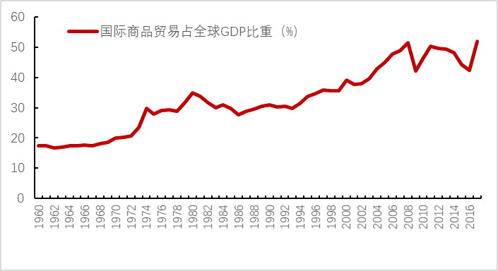
Source: World Bank database
International trade in goods as a share of global GDP (%)
The global economy has just emerged from the shadow of the 2008 global financial crisis and the recovery is yet to be solidly-based. In this context, the US administration’s actions to instigate large-scale trade frictions and impede the flow of world trade will undoubtedly affect the recovery of the global economy. In order to mitigate the protectionist moves of the US, countries are left with no choice but to take countermeasures. This will disrupt the world economic and trade order, and hold back global recovery, damaging the interests of companies and people of all countries and pushing the global economy back into recession (Table 6).
Chart 14: Impact on Trade in the Case of Tariff Increase to Bound Levels
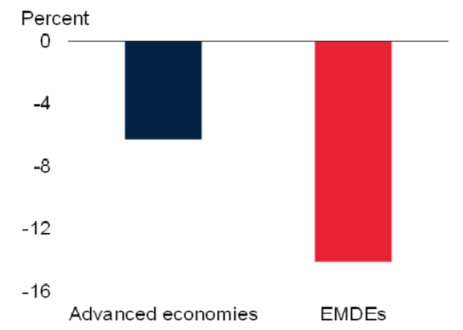
Source: “Global Economic Prospects”, World Bank
According to “Global Economic Prospects” published by the World Bank on June 5, 2018, a broad-based increase in tariffs worldwide would have major adverse consequences, which could translate into a decline in global trade amounting to 9 percent by 2020. The impact would be more severe on emerging markets and developing economies, particularly on those with large trade or financial market linkages with the US (Chart 14). According to WTO Director-General Roberto Azevedo, if tariffs return to the pre-GATT/WTO level, the global economy would contract by 2.5 percent instantly and more than 60 percent of global trade would disappear, creating an impact more serious than that of the 2008 global financial crisis. A trade war is detrimental to all, and particularly to the poor, who could lose 63 percent of their purchasing power. History has proven time and again that trade wars produce no winners and can severely affect world peace and development (Box 8).

Table 6: Impact of Trade Frictions
Provoked by the United States on the Global Economy
Forecast Institutions | Impact of a Trade War on the Global Economy
WTO | If tariffs return to the pre-GATT/WTO level, the global economy would contract by 2.5 percent instantly and more than 60 percent of global trade would disappear.
IMF | An increase in tariffs would slow down global growth by about 0.5 percentage point.
Barclays Capital | Global growth rate would drop by 0.6 percentage point and the global inflation rate would increase by 0.7 percentage point.
Standard & Poor’s | Global growth rate may possibly decline by 1 percentage point.
Bank of England | An increase in tariffs of 10 percent between the US and all its trading partners would take 2.5 percent off US output and 1 percent off global output.
Bank of France | If a country levies a 10 percent extra tariff on imports, the exports of its trading partners would drop by 13 percent to 25 percent.
Sources: WTO, IMF, Barclays Capital, Standard & Poor’s, Bank of England and Bank of France

Box 8: Lessons of the Smoot-Hawley Tariff Act of 1930
In 1930, in the name of protecting the domestic market, President Hoover of the United States signed into law the Smoot-Hawley Tariff Act, which raised tariffs on more than 20,000 imported items and increased the average tariff rate on dutiable imports to nearly 60 percent. The measure stoked much controversy and outcry both inside and outside the country. Domestically, 1028 economists signed a petition expressing their opposition. Internationally, the Act drew fierce criticism from more than 30 countries and many took immediate retaliatory measures. As a result, US imports saw a steep drop by 67 percent from US$4.4 billion in 1929 to US$1.45 billion in 1933, and an even worse plunge of 68 percent in its exports from US$5.16 billion to US$1.65 billion. Both exceeded the 50 percent fall of the US GDP in the same period. Meanwhile, global tariff rates soared, further aggravating the global economic crisis, which became the breeding ground for Hitler’s Nazi rule in Germany and expansionist militarism in Japan. Such lessons from history should never be forgotten, and past tragedies should never be repeated.

3. Impact on the global value chain
In a deeply integrated global economy, countries form a highly efficient global value chain and share in the dividends of economic globalization through division of labor by harnessing their respective strengths in technology, labor and capital. Companies, especially multinational ones, minimize their production costs and raise the quality of their products and services through global allocation of resources, thus achieving a win-win result for themselves and for consumers.
By raising tariffs and erecting trade barriers, the US administration has provoked trade frictions worldwide. US multinationals are being threatened with “traitor” labels and punitive taxes if they do not move their operations back to the US. Such moves will seriously undermine or even break the global value chain, and jeopardize the normal flows of trade and resource allocation across the world. And because of the interconnections between countries through trade and economic links, they will also produce extensive spillovers, and reduce the efficiency of the global economy. For example, sectors such as automobiles, electronics and aircraft are all supported by complex, massive industrial chains. Economies on the supply chain, including Japan, the EU and the ROK, would all be adversely affected by contracting trade. Even US suppliers would not be immune from the subsequent ripple effect. According to the estimates of the Chinese Ministry of Commerce, of the US$34 billion of Chinese products targeted by the first round of US tariff increases, over US$20 billion – nearly 59 percent of the value – are goods produced by companies from the US, the EU, Japan, the ROK and other economies operating in China. Ultimately, companies from all countries on the global industrial chain – including those from the US – would have to pay the price for tariff measures introduced by the US administration.
The “World Economic Outlook” report released by the IMF on April 17, 2018 noted that raising tariffs and non-tariff trade barriers will disrupt the global value chain, slow down the spread of new technologies, and lead to a drop in global productivity and investment. The Peterson Institute for International Economics (PIIE) argued that if the US imposes trade sanctions on China that prompt countermeasures, many countries and regions that export intermediate inputs and raw materials to China will also take a heavy hit.
- Trade protectionism will ultimately hurt US interests
Thanks to economic globalization, economies, particularly the larger ones, are highly interdependent. Ultimately, trade wars unilaterally initiated by the US administration will not only hurt other economies but also undermine US interests.
It will push up manufacturing costs and affect American jobs. A PIIE report contends that since 95 percent of the Chinese products hit by higher tariffs are parts and electronic components used in end products made in the US, raising tariffs on these Chinese products will only damage US businesses. According to the New York Times, electric motors and other components from China are vital to the US boating industry, and it is not easy for importers to find substitutes. Their profit margins are too thin to absorb the cost of 25 percent tariffs, and raising prices would cost them market share. General Electric estimates that new tariffs on imports from China could raise its overall costs by US$300-400 million. General Motors, Ford Motor and Fiat Chrysler Automobiles have lowered their full-year profit forecasts due to escalating tariffs. Mid-Continent, the largest nail manufacturer in the US, said its sales would plummet by 50 percent after it raised prices to cope with its elevated steel costs, and that it laid off 60 of its 500 workers in June and planned to downsize by another 200. Mid-Continent’s problems have already spread downstream. For example, Semo Packaging has started to shed its workforce as a result of fewer orders from Mid-Continent and similar customers. PIIE also projected that raising tariffs on imported automobiles would cause 195,000 US workers to lose their jobs. If other countries retaliate in kind, 624,000 US jobs would be lost.
It will drive up prices in the US and harm consumers. Consumer goods account for a considerable share in the US imports from China. The figure (excluding food and automobiles) stood at 46.6 percent in 2017, according to the Bureau of Economic Analysis of the US Department of Commerce. For many years, the import of inexpensive yet quality products from China has been key to low inflation in the US. The US Association of Equipment Manufacturers has urged the administration not to levy economy-damaging tariffs, as they will only boomerang and increase the tax burden on US consumers. The US National Taxpayers Union warned in an open letter to Congress and President Trump on May 3, 2018 that higher protective duties would increase the prices which domestic consumers would have to pay and few people could hope to gain from such a change. The US Alliance of Automobile Manufacturers concluded in a June report to the government that based on its analysis of 2017 automobile sales figures, a 25 percent tariff on imported automobiles would drive up the average price by US$5,800, thus increasing the cost for US consumers by nearly US$45 billion every year.
It triggers countermeasures from trading partners and will in turn hurt the US economy. The trade war waged by the US administration against China and many other important trading partners has led to countermeasures, and will cause huge losses to some regions, industries and firms in the US. As of the end of July 2018, major US trading partners including China, Canada, Mexico, Russia, the EU and Turkey had all announced countermeasures against US trade protectionism, and had filed lawsuits at the WTO. For example, the Canadian government announced on June 29 a tariff increase on US$12.6 billion of US goods, effective from July 1. The Russian Economy Ministry announced a 25 percent to 40 percent tariff hike on some US products on July 6. As a countermeasure to American duties on European steel and aluminum, the EU raised tariffs on US-made motorcycles from 6 percent to 31 percent.
The US Chamber of Commerce has pointed out that a trade war will hit some American states. For example, Texas could see US$3.9 billion worth of exports targeted by retaliatory tariffs; South Carolina, US$3 billion and Tennessee, US$1.4 billion. The Consumer Choice Center stated that the US government is actually “punishing” American voters with the tariffs it introduced, as over 150,000 jobs in North Carolina and 6,500 workers in South Carolina, both being heavily export-dependent states, will be directly affected by the retaliatory duties. Harley-Davidson Inc., a famous American motorcycle maker, estimated that the EU’s retaliation will cost about US$2,200 per motorcycle shipped to Europe, forecasting US$30 million to US$45 million in costs linked to the EU tariffs for the remainder of 2018. As a response, the company is shifting the production of some bikes overseas.
It erodes investors’ confidence in the American economic environment and results in less net foreign direct investment (FDI) into the United States. As the trade friction escalates, companies feel less confident and more hesitant about investment. Adam S. Posen, President of the Peterson Institute for International Economics, argued that beyond the cost of the trade war, the US government’s policy of “economic nationalism” has taken a toll in another important sphere: net inward investment into the US by multinational corporations – both foreign and American – has fallen almost to zero. This shift of corporate investment away from the US will decrease long-term US income growth, reduce the number of well-paid jobs available, and accelerate the shift of global commerce away from the US. Data from the Bureau of Economic Analysis of the US Department of Commerce show that in the first quarters of 2016 and 2017, the total net FDI inflow was US$146.5 billion and US$89.7 billion. For the same quarter in 2018, the figure was down to US$51.3 billion. This is a result of a general decline in the US attractiveness as a place to make long-term business commitments.

VI. China’s position
Economic globalization is the trend of the times, and peace and development represent the shared aspiration of all peoples. It therefore runs counter to the historical trend when one simply blames economic globalization for the problems in today’s world and one’s domestic development, and attempts to bring the global economy back to the old days of isolation by pursuing trade and investment protectionism. China-US economic and trade ties concern not only the well-being of the peoples of the two countries, but also world peace, prosperity and stability. Cooperation is the only correct option for China and the US, and only a win-win approach will lead to a better future. China’s position is clear, consistent and firm.
1. China is firmly committed to safeguarding its national dignity and core interests.
It is the hope of the government and people of China to promote business cooperation and develop stronger ties with the US. China does not want a trade war, but it is not afraid of one and will fight one if necessary. We have a highly resilient economy, an enormous market, and the hard-working, talented and united Chinese people. We also have the support of all countries in the world that reject protectionism, unilateralism and hegemony. We have the confidence, resolve and capability to meet all risks and challenges. No external factor will hold back China’s development. Meanwhile, the worst-affected Chinese companies and sectors will receive assistance as needed.
China maintains that problems and disputes arising from a fast growing China-US business relationship should be addressed with a positive and cooperative attitude, through bilateral consultation or the WTO dispute settlement mechanism, in a way acceptable to both sides. China has kept the door to negotiations open, but negotiations can only happen when there is mutual respect, equality good faith and credibility. Negotiations cannot be conducted under the threat of tariffs, or at the cost of China’s right to development. We believe that mature political leaders in the US will eventually come back to their senses, see China-US economic and trade relations in an objective and comprehensive light, and redress misguided behaviors in time so that the efforts to resolve the trade friction between the two countries will come back to the right track.
2. China is firmly committed to the sound development of China-US economic and trade relations.
The US and China are the world’s top two economies. Trade friction between the two countries should be properly resolved as it bears on global economic stability and prosperity as well as world peace and development. For China and the US, cooperation can lead to mutual benefits while confrontation will do no good to anyone. The sound and steady development of China-US economic and trade relations is in the fundamental interests of the two peoples and the common interests of people across the globe, and is what the international community expects of us. China would like to work with the US in the same direction, act in a spirit of mutual respect and win-win cooperation, focus on economic and trade cooperation, properly manage economic and trade differences, and make vigorous efforts to foster a new China-US economic and trade order that is balanced, inclusive and mutually beneficial, so as to contribute to the well-being of the two peoples. Under the condition of equality and mutual benefit, China is willing to resume negotiations with the US on a bilateral investment treaty, and launch bilateral FTA negotiations when appropriate.
3. China is firmly committed to the reform and improvement of the multilateral trading system.
The multilateral trading system centered on the WTO is the cornerstone of international trade, and a pillar for the sound and orderly development of global trade. China is firm in observing and upholding the WTO rules. China supports an open, transparent, inclusive and non-discriminatory multilateral trading system, and supports the reform of the global trade statistics system based on the global value chain and value-added in trade. China supports necessary reform of the WTO and firmly opposes unilateralism and protectionism. Committed to pursuing open, integrated and win-win development, China is working to build an open world economy, enhance cooperation within the G20, APEC and other multilateral frameworks, promote trade and investment liberalization and facilitation, and make economic globalization more open, inclusive, balanced and beneficial to all.
4. China is firmly committed to protecting property rights and intellectual property rights (IPR).
China attaches great importance to IPR protection and views it as one of the most important part of the efforts to improve the system for property rights protection. China will keep improving its laws and regulations on IPR protection, enhance the quality and efficiency of IPR reviews, and introduce the system of punitive damage compensation for intentional IPR infringements to significantly raise the cost of law violations. China protects the lawful IPR of foreign businesses in strict accordance with the law, and takes stern measures to address all types of IPR infringement cases. Chinese courts will keep improving the litigation evidence rules for IPR cases, establish a damage compensation system that reflects the value of IPR, strengthen the IPR court system, advance the building of a national-level appeal mechanism for IPR cases, ensure unified judicial criteria, and modernize the IPR adjudication system and capability at a faster pace. China will enhance its cooperation with all countries to protect IPR, and hopes that governments of other countries will also step up their efforts to protect Chinese IPR. China believes that IPR disputes should be resolved through legal means, and opposes trade protectionism pursued by any country in the name of IPR protection.
5. China is firmly committed to protecting the lawful rights and interests of foreign businesses in China.
China is committed to building an open and transparent foreign-related legal system, improving the business environment, and providing better, higher-quality service to businesses from all countries operating and investing in China. China respects international business practices, observes the WTO rules, and treats all businesses registered in China equally. China encourages market entities including foreign businesses to engage in various forms of cooperation, and stands committed to creating a level playing field in the market. The Chinese government pays close attention to the legitimate concerns of foreign investors, and stands ready to respond to and address their specific concerns. China will always protect the lawful rights and interests of foreign investors and foreign-invested businesses, and take firm measures to address violations of their lawful rights and interests in accordance with the law.
6. China is firmly committed to deepening reform and widening opening-up.
Reform and opening-up are China’s basic policies, and provide fundamental driving force for its development. China will not reverse course, but only deepen its reform. China will not close its door to the world, but only open wider. Following the plans made and pace set, China will stay firmly committed to deepening reform and widening opening-up, advance the rule of law across the board, and build a socialist country under the rule of law. The market will play a decisive role in the allocation of resources and the government will play a better role to encourage competition and oppose monopoly. Like other countries, China has the right to choose its own development path, including the economic model, that suits its national reality. As a developing country, China is not perfect, but it is willing to draw on advanced experience and keep improving its systems, institutions and policies through reform and opening-up. China will manage its own affairs well, firmly implement an innovation-driven development strategy, accelerate the pace of modernizing its economy, and pursue economic development with higher quality. China is willing to share with other countries the new opportunities presented by its development. China will adopt policies to promote trade and investment liberalization and facilitation with higher standards, implement the system of pre-establishment national treatment plus a negative list across the board, significantly ease market access, further open up the service sector, further cut tariffs, build a transparent, efficient and fair business environment, develop an open economy at a higher level, and create a more attractive investment environment. In this way, China will share development and prosperity with all countries that aspire to progress.
7. China is firmly committed to mutually beneficial cooperation with other developed and developing countries.
China will work with the EU to expedite and strive for early consensus in the negotiations on the China-EU Investment Agreement, and, on this basis, take the China-EU FTA onto the agenda. China will accelerate negotiations on the China-Japan-ROK Free Trade Area and work for early conclusion of the Regional Comprehensive Economic Partnership (RCEP). China will promote deeper cooperation under the framework of the Belt and Road Initiative based on the principles of consultation, cooperation and benefit for all, and make efforts to achieve policy, infrastructure, trade, financial, and people-to-people connectivity and create new drivers for common development.
8. China is firmly committed to building a community with a shared future for mankind.
Faced with a host of grave challenges to human progress, all countries, particularly major countries, need to shoulder the obligation and responsibility of guiding and promoting international cooperation. Countries should respect each other, engage in discussions as equals, and resolutely reject the Cold War mentality and power politics. Countries should not engage in a zero-sum game that puts one’s self-interest first and sees others’ gains as one’s losses, nor should they follow a hegemonic approach that advocates beggar-thy-neighbor policies and believes in the strong bullying the weak. Instead, countries should manage differences and tensions properly, settle disputes and disagreements through dialogue and consultation, and replace estrangement with exchange, clashes with mutual learning, and superiority with coexistence among civilizations. China will continue to act as a responsible major country, and join every other country in building an open, inclusive, clean and beautiful world that enjoys lasting peace, universal security and common prosperity.
“A just cause enjoys abundant support while an unjust one finds little support.” In a world of increasing uncertainty, instability and insecurity, China will remain true to its original aspiration, follow the trend of the times, shoulder its responsibility for justice, and pursue the greater good. It will unswervingly safeguard the multilateral trading system, press forward with the reform of global governance, promote world peace, contribute to global development, uphold international order, and build a community with a shared future for mankind.

United Nations Commodity Trade Statistics Database.
US China Business Council & Oxford Economics: Understanding the US-China Trade Relation, 2017 Jan.
US China Business Council & Oxford Economics: Understanding the US-China Trade Relation, 2017 Jan.
US-China Business Council & Oxford Economics, Understanding the US- China Trade Relation, 2017 Jan.
China Association of Automobile Manufacturers(http://www.auto-stats.org.cn).
General Motors (http://www.gmchina.com).
Intel Co.(http://www.intel.com).
Apple Inc. (http://www.apple.com).
Research Report on China-US Trade and Economic Relations, page 31, MOFCOM.
Goodman Sachs (http://www.goldmansachs.com), Made in US…..or China? 25 Years Supply Chain Investment at a Cross Roads, May 2017.
Chinese tech isn’t the enemy, Anja Manuel, The Atlantic, Aug 1, 2018.
Deutsche Bank, “Calculating the Economic Interests of the US and its Major Trading Partners”, June 2018.
Carnegie Endowment for International Peace, “Political Barriers in US Exports to China and US-China Trade Deficit”, April 10, 2017.
Barry Eichengreen, 2011, Exorbitant Privilege: The Rise and Fall of the Dollar and the Future of the International Monetary System, Oxford University Press.
National Bureau of Statistics of China.
National Bureau of Statistics of China
Strategy, PWC, The 2017 Global Innovation 1000, 2017.
Cornell University, INSEAD, WIPO, Global Innovation Index 2018, 2018.
National Bureau of Statistics of China, Statistical Communiqué for the People’s Republic of China on the 2017 National Economic and Social Development, published on February 28, 2018.
The State Council Information Office of China, Press Conference on China’s intellectual property rights development in 2017, April 24, 2018.
Larry Summers praises China's state investment in tech, saying it doesn't need to steal from US,CNBC,27June ,2018.
China and the World Trade Organization, June 2018, the State Council Information Office.
Data from the Supreme People’s Court of the PRC.
Status of Protection of Intellectual Property Rights in China 2016, SIPO.
SIPO, Statistics Yearbook 2012, Patent Work and Comprehensive Management Statistics Monthly Report 2017, the figure for 2017 is invention patent applications.
Trademark Office of SAIC, China Trademark Branding Strategy Annual Development Report 2017.
Nicholas R. Lardy, China: Forced Technology Transfer and Theft? , Peterson Institute for International Economics, April 20, 2018.
Official website of the Chinese government (http://www.gov.cn).
American Enterprise Institute (http://www.aei.org), Chinese investment in the US.
Indicators of Product Market Regulation measure the extent to which policy settings promote or inhibit competition in the product market. A higher score indicates greater hindrance. The indicators are computed based on three indicators – state control, barriers to entrepreneurship and barriers to trade and investment. Since 1998, the indicators have been computed every five years – in 1998, 2003, 2008 and 2013. Data were collected through surveys filled in by officials from relevant countries. The statistics cover 35 OECD countries and 12 non-OECD countries. Products covered by the statistics also include some services.
Differential Treatment of Foreign Suppliers is a secondary indicator for barriers to trade and investment in the indicators of product market regulation. It is computed based on the evaluation of restrictions on shipping, land transport and air transport, on foreign professionals, on appeals by foreign entities, on anti-competition behavior, regulatory policy barriers and trade facilitation measures. It reflects the extent to which a country’s market discriminates against foreign products. A higher score indicates greater discrimination.
OECD (http://www.oecd.org).
The White House (http://uscode.house.gov), Buy American Act. The act has also made additional stipulations for waivers.
The White House (http://uscode.house.gov), Buy American Act. The act has also made additional stipulations for waivers.
The US Congress (https://www.congress.gov), Agriculture, Rural Development, Food and Drug Administration, and Related Agencies Appropriations Act.
The US Congress (https://www.congress.gov), National Defense Authorization Act.
The US Congress (https://www.congress.gov), Foreign Investment and National Security Act of 2007.
Based on CFIUS’ annual reports to Congress (https://www.treasury.gov)
The US Department of the Treasury, November 21, 2008.
The US Congress (https://www.congress.gov).
Good jobs first (https://www.goodjobsfirst.org), March 2015.
Good jobs first (https://subsidytracker.goodjobsfirst.org).
Good jobs first (https://subsidytracker.goodjobsfirst.org).
The US Department of the Treasury (https://www.treasury.gov).
The US Department of Energy (https://www.energy.gov).
Good jobs first (https://subsidytracker.goodjobsfirst.org).
Joseph W. Glauber and Patrick Westhoff: “The 2014 Farm Bill and the WTO”, American Journal of Agricultural Economics, 2015.
Randy Schnepf: “Farm Bill Provisions and WTO Compliance”, Congressional Research Service, April 22, 2015.
Randy Schnepf: “Farm Safety-Net Payments Under the 2014 Farm Bill”, Congressional Research Service, August 11, 2017.
The UNCTAD (http://unctad.org ).
“US-China Trade – Eliminating Non-Market Economy Methodology Would Lower Anti-dumping Duties for Some Companies”, a report by the GAO in 2016.
Gary Horlick, deputy assistant secretary of the International Trade Administration of US from 1981-1983, talked about the selection of surrogate countries in a Ways and Means Committee hearing. Horlick described the selection as based on perception. For instance, in a towel case with China, the US listed Pakistan, Thailand, Malaysia, the German Democratic Republic, Colombia and India as surrogate countries, for no apparent reason.
Section 232 investigation is conducted by Department of Commerce on the basis of the authorization by Section 232 of the Trade Expansion Act of 1962 to determine whether the importation of an article in question threatens the national security of the United States. A report is presented to the President within 270 days of initiation. The US President makes a determination on whether to take final measures on the imports concerned within 90 days.
Chad P. Bown@ChadBown, May 27, 2018.
“Section 201” refers to Sections 201-204 of the US Trade Act of 1974. According to the section, the United States International Trade Commission (USITC) initiates global safeguard investigations to determine whether an article is being imported in such increased quantities as to be a substantial cause of serious injury, or the threat thereof, to the domestic industry and presents a report and recommendations to the President within 120 days of initiation. Based on the authorization of law, the President makes a determination on final measures within 140 days of receipt of the USITC report.
“Section 301” refers to Section 301 of the US Trade Act of 1974. According to the Section, the US may initiate investigations against trade practices of other countries it deems “unjustifiable” and negotiate with relevant governments. The President may make a final decision to retaliate through imposing duties or other import restrictions, or suspending relevant agreements.
Peterson Institute for International Economics (https://piie.com): “Rogue 301: Trump to Dust Off another Outdated US Trade Law?”
Robert H. Wade: “The American Paradox: Ideology of Free Markets and the Hidden Practice of Directional Thrust, Cambridge Journal of Economics, May 2017.
The Executive Office of the President of the US, December 2009.
The Executive Office of the President of the US, August 2010.
The Executive Office of the President of the US, June 2011.
The National Association of Manufacturers of the US, December 2011.
The Executive Office of the President of the US and National Science and Technology Council, February 2012.
The Executive Office of the President of the US, 2011.
The Executive Office of the President of the US, National Science and Technology Council, Advanced Manufacturing National Program Office, January 2013
The US Department of Energy, April 2013.
The Office of Science and Technology Policy of USA, March 2013.
The National Institute of Standards and Technology of USA, May 2013.
The National Science and Technology Council, October 2016.
The Center for Strategic and International Studies, March 2018.
Wayne M. Morrison: “China-US Trade Issues”, March 6, 2017, Congressional Research Service.
Ball State University, The Myth and the Reality of Manufacturing in America, June 2015.
Arie Reich: “The effectiveness of the WTO dispute settlement system: A statistical analysis”, Department of Law, European University Institute, November 2017.
Donald J.Trump @realDonaldTrump, January 3, 2017.
Donald J.Trump @realDonaldTrump, July 3, 2018.
CNN News (https://www.cnn.com), April 3, 2018.
Peterson Institute for International Economics (https://piie.com).
Peterson Institute for International Economics (https://piie.com), “Trump, China, and Tariffs: From Soybeans to Semiconductors”, June 18, 2018.
New York Times (https://nytimes.com), “What a Trade War With China Looks Like on the Front Lines”.
Reuters, “Impact of US-China trade tariffs on US companies”, July 30, 2018
Huffington Post (https://www.huffingtonpost.com), “Largest US Nail Manufacturer Could Soon Be Out of Business Because of Trump Tariffs”, June 29, 2018.
Peterson Institute for International Economics (https://piie.com),“Trump's Proposed Auto Tariffs Would Throw US Automakers and Workers Under the Bus”, May 31, 2018.
The US National Taxpayers Union (https://www.ntu.org), May 3, 2018.
The Alliance of Automobile Manufacturers (https://autoalliance.org), “Comments of the Alliance of Automobile Manufacturers on the Section 232 National Security Investigation of Imports of Automobiles, Including Cars, SUVs, Vans and Light Trucks, and Automotive Parts”, June 27, 2018.
NBC News (https://www.nbc.com), July 2, 2018.
The Charlotte Observer (https://www.charlotteobserver.com), “How the Carolinas Could Suffer from Trump’s Tariffs”, June 21, 2018.
Bloomberg (https://www.bloombergquint.com), June 25, 2018.
Adam S. Posen, “The Cost of Trump’s Economic Nationalism: A Loss of Foreign Investment in the United States”, July 24, 2018.

