**The influence of bike sharing on urban traffic**

summary

The problem of this paper is to evaluate quantitatively the impact of shared bicycles on urban traffic and the economic, social and environmental impacts related to urban traffic. To solve this problem, it is necessary to quantitatively analyze the changes of the economic, social and environmental aspects of urban traffic caused by shared bicycle before and after use under the corresponding indicators.

Based on the panel data of New York City from 1993 to 2015, using *BP artificial neural network*, *multiple regression analysis* and other theories, this paper constructs models of travel mode selection, gasoline gas emission reduction and so on, and analyzes the impact of shared bicycles on all *aspects of urban traffic* from a quantitative point of view With the implementation of the project, the number of car trips in New York City decreased in 2015, the use of public transport and cycling increased significantly, and the number of urban employees increased significantly than expected, reducing the emission of air pollution.

**Keyword**：*BP artificial neural network, multiple regression analysis, aspects of urban traffic*

Catalog

**I. Restatement of problems………………………...……………………………..….………….** 3

**II. Analysis of problems ……………………………………………….…….……...** 3

**III. Model hypothesis.………………………………………………….…….…..….** 4

**IV. Symbolic explanation ……….…………………………………….……..……...** 5

**V. Establishment and solution of the model…………………………….…….…...** 6

5.1. The impact of Citibike on society……………………………………….….. 6

5.2. The impact of Citibike on economic…………………………………..……..11

5.2.1. Economic impact on Citibike ..……………………………….…..… 11

5.2.2. Economic impact on membership .…..……………………….…..… 12

5.2.3. Economic impact on society...…………………………………..…….12

5.3. The impact of Citibike on environment..…………………………...………..13

**VI. Model evaluation and improvement …………………………………………...**15

**I. Restatement of problems**

Shared bicycles have changed the urban traffic conditions in many cities, and many large cities have introduced shared bicycles to solve traffic problems. We need to quantitatively assess the impact of shared bicycles on urban traffic, as well as the associated economic, social and environmental impacts. The key to this problem is to establish a reasonable model to predict people’s traffic behav-ior if there is no shared bicycles in a city. For example, comparing all travels using shared bicycles with driving cars is not credible. As an attachment to the paper, we need to submit a formal report to the transportation department on the changes that the shared bicycle caused to the city. You can use data from the citibike in New York, or collect data from other cities.

**II. Analysis of problems**

To analyze the impact of bike sharing project on society, the key is to predict how people's travel structure should evolve if there is no bike sharing project, and then compare and analyze the impact of bike sharing on the travel structure, so as to make basic preparations for the later analysis of its impact on traffic, economy and environment.

The impact of bike sharing on the economy is mainly through the number of trips and the way people travel. From the micro point of view, the number of trips is related to people's economic behaviors such as dining, shopping, tourism and work; from the macro point of view, the way of travel will affect the scale of car sales and the development of public transport system. By analyzing the data of city bicycle users, we analyze the impact of shared bicycle on the economy from three aspects: *city economy*, *membership economy* and *social economy*.

Shared bicycles reduce harmful gas emissions by reducing the use of gasoline in the traffic, which is conducive to resource saving and environmental optimization. It is achieved through two ways: first, shared bicycles reduce the driving of motor vehicles by increasing the riding, directly reducing the consumption of gasoline, and reducing the amount of gasoline can be converted through the mileage of riding; second, shared bicycles change people's willingness to travel, so that For the whole society, public transport consumes less gasoline than private cars, thus reducing the generation of harmful substances. This is the indirect impact of sharing bicycles on the reduction of gasoline, and also the main way of action.

**III. General Assumptions**

(1) After the implementation of bike sharing, the proportion of changes in travel modes inside and outside the central urban area is the same

(2) Travel mode has habit preference, and the travel mode outside the central city will affect the travel mode entering the central city

**IV. Symbolic explanation**

|  |  |
| --- | --- |
| ***Symbol*** | ***Description*** |
| *Y1* | Number of vehicles entering the central urban area (1000 per day) |
| *Y2* | Passenger volume of public transport system entering the central urban area (1000 times per day) |
| *Y3* | Number of rides into the central city (1000 times per day) |
| *X1* | Vehicle travel volume outside the central urban area (1000 per day) |
| *X2* | Passenger volume of public transport system outside the central urban area (1000 per day) |
| *β* | The average fuel consumption of a family car for one mile (kg) |
| *m1* | Increased cycling mileage from bike sharing (miles per day) |
| *m2* | Reduce the driving mileage caused by sharing bicycles (miles per day) |
| *L1* | Average mileage of a ride (miles) |
| *L2* | Average mileage of a car in one trip (miles) |
| *w1* | Bike sharing increases cycling times (1000 per day) |
| *w2* | Reduced car usage due to shared cycling (1000 per day) |
| *Q* | Total reduced gasoline consumption of shared single vehicle project |

**V. Model establishment and solution**

**5.1.** **The impact of Citibike on society**

Because people's travel mode generally has a habit preference, the travel mode in the peripheral area of the central urban area is likely to be the way to enter the central urban area, and there may be a certain connection between the travel structures divided by regions. Based on the above analysis, the number of car trips and public transport trips outside the central urban area are selected as independent variables, and the number of cars entering the central urban area, the number of public transport and the number of cycling are used as dependent variables, respectively. *BP neural network* is used to predict the dependent variables.

By drawing the scatter diagram of *Y*1, *X*1 and *X*2, as shown in Figure 1, there is no obvious linear relationship between them, and the single-layer *BP neural network* can approximate any nonlinear continuous function with any accuracy, so we can use the strong nonlinear mapping ability of *BP neural network* to reflect the comprehensive impact of *X*1 and *X*2 on *Y*1. The high discreteness of sample data will reduce the approximation effect of BP neural network, so interpolation is needed to make the data smoother. The interpolation method is used, with *X*1 as x axis, *X*2 as y axis, and *Y*1, *Y*2 and *Y*3 as z axis respectively. Then use the data after interpolation to train *BP neural network*, and use the network after training to simulate. The simulation situation is shown in Figure 2. As shown in Figure 2, the predicted data are distributed near the fit line and most of the points fall on the line, indicating that the fitting effect is good. The Gaussian distribution of error term is obtained by JB test, which shows that the prediction model has good stability and can predict the data outside the sample.

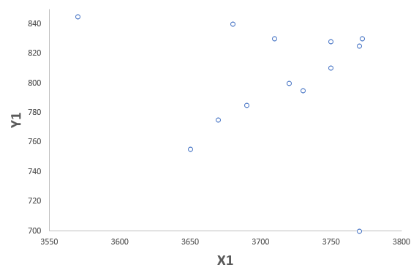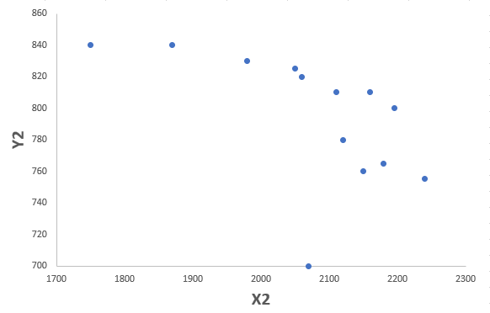

figure 1 Relationship between the number of vehicles entering the central city and the traffic mode of the surrounding areas

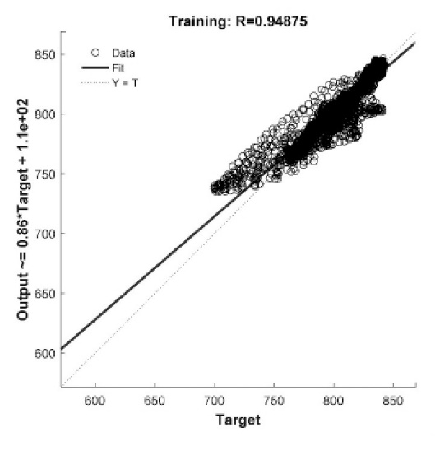

figure 2 Simulation of BP neural network

Using the trained neural network to predict the results, the data in Table 1 is as follows:

Table 1: Analysis table of simulation results of vehicle consumption

|  |  |  |  |  |
| --- | --- | --- | --- | --- |
| **Year** | **Y1** | **simulation result** | **error** | **error *N* *(%)*** |
| 1998 | 842 | 841 | 0.74 | 0 |
| 1999 | 842 | 840 | 2.29 | 0 |
| 2000 | 700 | 738 | 4.39 | 1 |
| 2001 | 700 | 738 | -37.98 | -5 |
| 2002 | 797 | 795 | 1.54 | 0 |
| 2003 | 832 | 802 | 30.16 | 4 |
| 2004 | 825 | 824 | 1.35 | 0 |
| 2005 | 810 | 803 | 6.89 | 1 |
| 2006 | 806 | 803 | 3.35 | 0 |
| 2007 | 795 | 794 | 1.30 | 0 |
| 2008 | 759 | 765 | -6.08 | -1 |
| 2009 | 770 | 773 | -3.25 | 0 |
| 2010 | 776 | 771 | 5.32 | 1 |

Compare the simulation results in Table 1 with the actual data, and get the data comparison as shown in Figure 3 below:

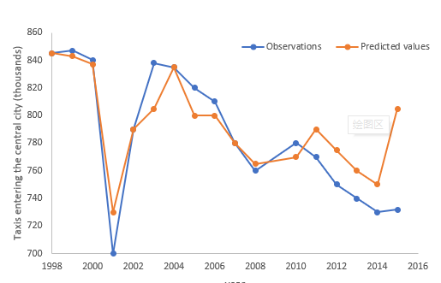

Figure 3 Comparison and analysis diagram of automobile usage prediction model

According to table 1 and figure 3, the predicted number of vehicles entering the central urban area in 2011-2015 is 794, 779, 784, 778 and 800, with the maximum error rate of only 5%. It can be seen directly in Figure 3 that if the shared bicycle plan is not implemented, the vehicle usage should have been on the rise, reaching 800 thousand vehicles per day in 2015, accounting for 20.84% of the total traffic volume; however, in fact, the number of vehicles going to the central urban area is declining year by year, only 731 vehicles per day in 2015, accounting for 19.04% of the total traffic volume, although the vehicle usage is in the total amount of all vehicles However, the proportion of shared bicycles has decreased by 9.4% compared with the theoretical expectation in 2015, which shows that shared bicycles do inhibit the use of automobiles.

Based on the above BP neural network prediction method, the use of public transport system is simulated, and the simulation results are shown in Table 2.

Table 2 Analysis table of simulation results of public transport

|  |  |  |  |  |
| --- | --- | --- | --- | --- |
| **Year** | ***Y*1** | **simulation result** | **error** | **error *N (%)*** |
| 1998 | 2294 | 2303 | -9.29 | -0.41 |
| 1999 | 2431 | 2451 | -19.99 | -0.82 |
| 2000 | 2517 | 2505 | 11.92 | 0.47 |
| 2001 | 2390 | 2423 | -33.03 | -1.38 |
| 2002 | 2441 | 2496 | -54.85 | -2.25 |
| 2003 | 2392 | 2419 | -26.89 | -1.12 |
| 2004 | 2454 | 2421 | 32.70 | 1.33 |
| 2005 | 2472 | 2446 | 26.17 | 1.06 |
| 2006 | 2566 | 2531 | 35.26 | 1.37 |
| 2007 | 2683 | 2647 | 36.05 | 1.34 |
| 2008 | 2743 | 2657 | 85.98 | 3.13 |
| 2009 | 2586 | 2608 | -22.02 | -0.85 |
| 2010 | 2662 | 2663 | -0.57 | -0.02 |

The simulation results in Table 2 are compared with the actual data, as shown in Figure 4:

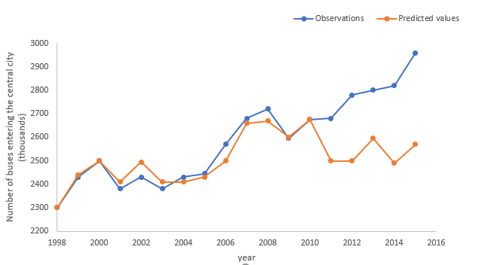

Figure 4 Comparison and analysis of public transport usage prediction models

It is predicted that the usage from 2011 to 2015 will be 2513, 2532, 2582, 2522 and 2546. It can be seen from Figure 4 that, in the absence of a shared bicycle system, the theoretical expectation for the use of public transport system shows a downward trend. In 2015, it dropped to 2546 thousand times per day, which should account for 66.34% of the total traffic volume. However, in fact, the number of public transport to the central city increased significantly. In 2015, the actual value reached 2983 thousand times per day, accounting for 77.71% of the total traffic volume. Its market share in the field of transportation has increased significantly, and its theoretical expected value has also increased by 17.20% compared with its own, which shows that shared bicycles play a very important role in promoting the use of public transport.

In the same way, the simulation data are obtained by simulation of the use of riding, as shown in Table 3 below:

Table 3 Analysis table of simulation results of riding quantity

|  |  |  |  |  |
| --- | --- | --- | --- | --- |
| **year** | ***Y*1** | **simulation result** | **error** | **error *N (%)*** |
| 1998 | 2.8 | 2.8 | 0.01 | 0.49 |
| 1999 | 2.9 | 2.7 | -0.18 | -6.93 |
| 2000 | 2 | 2.2 | -0.20 | -9.83 |
| 2001 | 2.5 | 2.6 | -0.14 | -5.71 |
| 2002 | 3.2 | 3.6 | -0.36 | -11.21 |
| 2003 | 4.4 | 3.8 | 0.58 | 13.22 |
| 2004 | 4.4 | 4.2 | 0.15 | 3.51 |
| 2005 | 4.8 | 4.3 | 0.49 | 10.20 |
| 2006 | 6.6 | 6.3 | 0.29 | 4.35 |
| 2007 | 6.5 | 7.5 | -0.99 | -15.23 |
| 2008 | 8.5 | 8.8 | -0.31 | -3.61 |
| 2009 | 10.9 | 10.5 | 0.40 | 3.65 |
| 2010 | 11.7 | 11.8 | -0.05 | -0.44 |

The simulation results in Table 3 are compared with the actual data, and the results are as follows figure 5:

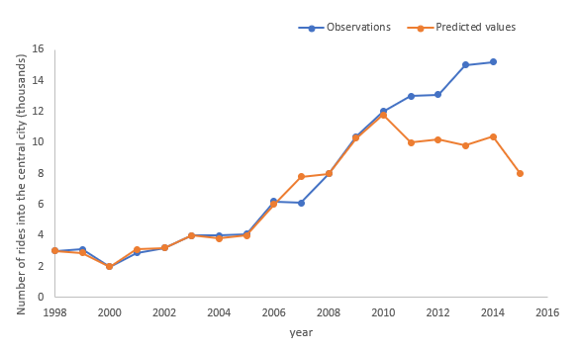

Figure 5 comparative analysis of the prediction model of riding quantity

It is predicted that the usage in 2011-2015 will be 41, 101, 94, 102 and 70. It can be seen from the above figure that, in the absence of shared bicycles, the forecast on the use of cycling shows a downward trend. In 2015, it dropped to 70 thousand times per day, which should account for 0.18% of the total traffic volume. However, in fact, the number of cycling to the central urban area increased steadily. In 2015, the actual value was 154 thousand times per day, accounting for 0.40% of the total public transport volume, which also increased compared with its theoretical expectation The increase of 120% indicates that shared bicycles directly promote the number of riders, which is in line with the expectation of most people.

**5.2.** **The impact of Citibike on economic**

After analyzing the data of Citi bike, we will analyze the impact of bike sharing on the economy from three aspects: *city economy*, *member economy* and *social economy*.

**5.2.1 Economic impact on Citibike**

After corresponding processing of the obtained data, the monthly income of Citigroup in 2013-2018 is obtained, as shown in Figure 6.

Figure 6 Monthly Citi Revenue 2013-2018

It can be seen from Figure 6 that Citigroup's revenue is basically in a stable state, and there is no obvious trend of revenue growth, and the revenue source is all from membership fee, user fee and sponsorship fee.

After integrating the number of temporary members in the data, the number of annual members and the corresponding monthly income, figure 2 is obtained.

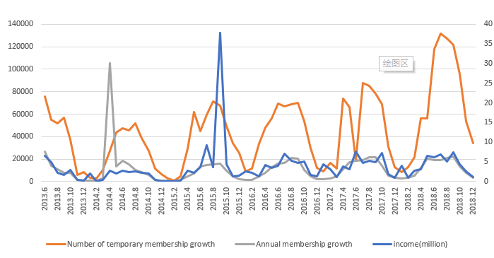

Figure 7 Changes in membership growth and company revenue

It can be seen from Figure 7 that for Citigroup, the growth of temporary members is more conducive to the company's revenue growth and can bring greater benefits than that of annual members.

**5.2.2 Economic impact on membership**

From the perspective of users, this paper compares the travel distance, travel times, travel time, travel speed and cost of shared bicycles and taxis in the city center. For all trips from and to the city center, Citi bike is at least 2 miles faster and $6 cheaper than a taxi. More than two-thirds of taxi trips are entirely in the middle of the city, while for a 1-1.5-mile trip, Citi bikes are generally faster than taxis by more than five minutes, and the price is $11.75 cheaper than ordinary taxis.

**5.2.3 Economic impact on society**

The impact of bike sharing on social economy is selected as five first-class indicators[1] which are: 36% of business income of bicycle manufacturing industry, 21% of business income of bicycle retail industry, 15% of employment rate, 9% of GDP, and 17% of business income of online car Hailing industry. By analyzing the proportion of the above-mentioned income, it can be found that the impact of shared bicycle on the business income of bicycle manufacturing industry is the largest, followed by that of bicycle retail industry, while the impact on the employment rate and GDP is relatively small.

**5.3** **The impact of Citibike on environment**

After the above analysis, the following formula is obtained:

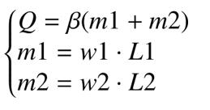 (2)

According to the relevant data, every liter of gasoline burned by an automobile engine will consume 15 liters of fresh air, and exhaust 150-200ml of carbon monoxide (*CO*), 4-8ml of hydrocarbons (*CH*), 4-20ml of nitrogen oxides(*NO*) and other pollutants. Here we take the median value of the range of pollutants generated, i.e. consumption of one liter of gasoline will generate 175ml of *CO*, 6ml of *CH* and 12ml of *NO*, and bring it into the formula(2). The emissions of various pollutants are:

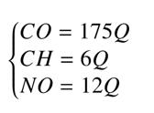

The following results can be obtained by using the data in "Citi Bike &amp; taxis in midtown" of New York mobile bulletin to bring into formula (2)

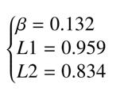

Combined with the solution results of the travel mode selection model, the gasoline consumption reduction is calculated as follows:

Table 7 Gasoline reduction table

|  |  |  |  |  |  |
| --- | --- | --- | --- | --- | --- |
| year | *w*1 | *m*1 | *w*2 | *m2* | *Q(L)* |
| 2011 | 9.13 | 8753.29 | 30.14 | 25134.43 | 4473.18 |
| 2012 | 3.24 | 3104.03 | 28.43 | 23707.17 | 3539.08 |
| 2013 | 5.28 | 5059.60 | 36.76 | 30657.53 | 4714.66 |
| 2014 | 4.80 | 4600.52 | 46.85 | 39069.15 | 5764.40 |
| 2015 | 8.41 | 8064.45 | 68.88 | 57448.51 | 5647.71 |

Taking the results in Table 7 into formula (2), the contribution of shared single vehicle project to the reduction of environmental pollutants in the past five years can be obtained. The results are summarized in Table 8 as follows:

Table 8 Contribution of shared bicycles to the environment (*L*)

|  |  |  |  |
| --- | --- | --- | --- |
| *year* | *CO* | *CH* | *NO* |
| 2011 | 3401 | 116 | 233 |
| 2012 | 3152 | 108 | 216 |
| 2013 | 4107 | 140 | 281 |
| 2015 | 7496 | 257 | 514 |

It can be seen from table 8 that by 2015, the *CO* emissions, *CH* emissions and *NO* emissions of New York City will be reduced by 7496 *L*, 257 *L* and 514 *L* respectively, and the gas emissions will be reduced to alleviate the environmental pollution with a good trend of increasing year by year.

To sum up, first of all, use *BP neural network* to predict the travel mode, describe the travel structure of people assuming that there is no shared bicycle system, and draw a conclusion by comparing with the actual situation: shared bicycle reduces people's willingness to choose car travel, increases the willingness to take public transport tools, the number of rides has a huge rise, and the conclusion is in line with people's expectations. Among them, the actual car travel is 9.4% less than the expected value, the public transport system is 17.2% more, and the number of rides is 120% more than the expected value. The change of the travel structure, that is, the travel mode with less cars and more buses, will obviously reduce traffic congestion and improve road smoothness. Secondly, through the Granger causality test to determine several variables that affect the number of employees, regression analysis is done to quantitatively describe their impact on the number of employees. The results show that: the actual number of employees is 13% more than the theoretical expectation, and the shared bicycle system has played a role in promoting the economy. Finally, based on the analysis of the impact of travel mode on the air environment, taking gasoline as an intermediate variable, we find that the shared bicycle reduces *CO*, *CH* and *NO* by 7496 *L*, 257 *L* and 514 *L* respectively, and this effect is strengthened year by year.

## **VI. Model evaluation and improvement**

When analyzing the social level of shared bicycle, the BP neural network model is used, which is particularly suitable for solving the internal mechanism complex problems, that is, BP neural network has strong nonlinear mapping ability, which is more suitable for solving the complex social level problems, but we can not judge whether the training makes the results accurately reflect the problems.

# References

[1] Chen Yaojun, Yang Yi, sun Zejun, Wang Yunhua. The impact of shared bicycles on the economy, problems and solutions [J / OL]. China business theory, 2018 (20): 31-32 [2019-12-09] in Chinese

[2] Zhu Jiaming, Gu Jianwei, Ling Jiaheng. The impact of shared bicycle on social economy and environment: An Empirical Study Based on panel data of New York City from 1993 to 2015 [J]. Journal of Shandong University of Technology (SOCIAL SCIENCE EDITION), 2019,35 (03): 32-37 in Chinese

# Appendix

|  |  |  |  |  |  |  |  |
| --- | --- | --- | --- | --- | --- | --- | --- |
|  | 临时会员增长数 | 年度会员增长数 | 当前总年度会员量 | 临时会员使用人次 | | 客服电话数 | 电子邮件数 |
| 2013年6月 | 75838 | 26515 | 52130 | 250947 | | 55271 | 13973 |
| 2013年7月 | 55001 | 14185 | 66315 | 193440 | | 49831 | 10726 |
| 2013年8月 | 51637 | 10823 | 77138 | 202563 | | 65798 | 10825 |
| 2013年9月 | 56579 | 8103 | 85241 | 152,800 | | 41807 | 7366 |
| 2013年10月 | 37620 | 7901 | 93142 | 100653 | | 32040 | 5550 |
| 2013年11月 | 5900 | 1813 | 94955 | 44947 | | 18534 | 2805 |
| 2013年12月 | 8217 | 1170 | 96125 | 19754 | | 9866 | 1632 |
| 2014年1月 | 3183 | 1013 | 97138 | 7412 | | 5384 | 1516 |
| 2014年2月 | 2695 | 726 | 97864 | 7247 | | 9979 | 890 |
| 2014年3月 | 10387 | 2736 | 100600 | 23368 | | 15336 | 1274 |
| 2014年4月 | 27512 | 4,767 | 105367 | 63197 | | 8631 | 2016 |
| 2014年5月 | 43878 | 13303 | 105359 | 7979 | | 45997 | 3547 |
| 2014年6月 | 47516 | 18364 | 96318 | 129223 | | 47289 | 3621 |
| 2014年7月 | 45830 | 15359 | 93501 | 129339 | | 39297 | 2738 |
| 2014年8月 | 51744 | 10055 | 93184 | 148422 | | 45566 | 2456 |
| 2014年9月 | 38415 | 8387 | 90879 | 108816 | | 31962 | 2262 |
| 2014年10月 | 27421 | 6043 | 89286 | 77189 | | 19545 | 2627 |
| 2014年11月 | 11566 | 1262 | 88495 | 30909 | | 15034 | 1306 |
| 2014年12月 | 6808 | 702 | 88405 | 17990 | | 10799 | 1101 |
| 2015年1月 | 2506 | 651 | 88010 | 6223 | | 6862 | 1578 |
| 2015年2月 | 1003 | 402 | 87898 | 2345 | | 4646 | 566 |
| 2015年3月 | 4461 | 1589 | 87910 | 11293 | | 11695 | 1513 |
| 2015年4月 | 29251 | 4799 | 86193 | 73516 | | 24534 | 2350 |
| 2015年5月 | 61699 | 7268 | 84335 | 186089 | | 23032 | 2351 |
| 2015年6月 | 44837 | 13528 | 86743 | 130364 | | 17880 | 2371 |
| 2015年7月 | 59660 | 15073 | 80885 | 180277 | | 19803 | 2437 |
| 2015年8月 | 71519 | 15638 | 81406 | 216412 | | 21906 | 3056 |
| 2015年9月 | 67764 | 16081 | 87842 | 210140 | | 32027 | 4052 |
| 2015年10月 | 49605 | 9949 | 90585 | 146508 | | 27575 | 4128 |
| 2015年11月 | 34376 | 4633 | 91901 | 100598 | | 18396 | 2655 |
| 2015年12月 | 25173 | 2221 | 92781 | 67870 | | 14710 | 1892 |
| 2016年1月 | 9200 | 1435 | 93366 | 24453 | | 7990 | 1396 |
| 2016年2月 | 11629 | 1543 | 94324 | 29820 | | 9138 | 313 |
| 2016年3月 | 33844 | 4607 | 97302 | 93233 | | 17796 | 1898 |
| 2016年4月 | 48173 | 7598 | 100171 | 130449 | | 22047 | 2267 |
| 2016年5月 | 56238 | 12791 | 105465 | 175933 | | 25348 | 3008 |
| 2016年6月 | 69231 | 16322 | 108601 | 192211 | | 33496 | 3594 |
| 2016年7月 | 66781 | 16670 | 109961 | 201882 | | 24904 | 3546 |
| 2016年8月 | 68944 | 20884 | 114517 | 218229 | | 27278 | 3346 |
| 2016年9月 | 70320 | 20307 | 118568 | 221215 | | 28537 | 4213 |
| 2016年10月 | 53952 | 10167 | 118950 | 171115 | | 20125 | 4456 |
| 2016年11月 | 29994 | 4939 | 119467 | 85937 | | 15679 | 3414 |
| 2016年12月 | 12497 | 2495 | 119681 | 32525 | | 9475 | 5409 |
| 2017年1月 | 8,803 | 2,353 | 120,460 | 23,016 | | 7,046 | 1,796 |
| 2017年2月 | 16,750 | 2,634 | 121,592 | 42,915 | | 8,512 | 1,648 |
| 2017年3月 | 11,851 | 4,617 | 121,743 | 26,777 | | 7,046 | 1,796 |
| 2017年4月 | 74,065 | 11,019 | 124,450 | 188,840 | | 18,001 | 3,652 |
| 2017年5月 | 66,069 | 17,363 | 128,438 | 189,756 | | 18,192 | 4,211 |
| 2017年6月 | 18,521 | 18,521 | 130,301 | 214,537 | | 19,239 | 3,734 |
| 2017年7月 | 87,507 | 18,968 | 132,265 | 261,743 | | 22,865 | 4,033 |
| 2017年8月 | 85016 | 21699 | 132,679 | 258,006 | | 23835 | 4236 |
| 2017年9月 | 78082 | 21912 | 133944 | 235038 | | 19692 | 3994 |
| 2017年10月 | 68782 | 14049 | 136,499 | 207946 | | 15444 | 7827 |
| 2017年11月 | 31005 | 5636 | 136510 | 90145 | | 10690 | 5261 |
| 2017年12月 | 13160 | 3178 | 136702 | 34609 | | 5568 | 3317 |
| 2018年1月 | 8629 | 3002 | 137003 | 22098 | | 6030 | 2434 |
| 2018年2月 | 12703 | 3388 | 138109 | 33343 | | 6184 | 2,468 |
| 2018年3月 | 21832 | 5323 | 138109 | 59023 | | 6274 | 2158 |
| 2018年4月 | 56165 | 12139 | 140462 | 149283 | | 12655 | 3986 |
| 2018年5月 | 56165 | 20306 | 144,590 | 1242035 | | 20739 | 6640 |
| 2018年6月 | 117680 | 19355 | 146533 | 258213 | | 22760 | 6209 |
| 2018年7月 | 131846 | 19151 | 147040 | 284844 | | 23159 | 7,872 |
| 2018年8月 | 127198 | 20936 | 146567 | 273066 | | 22495 | 6593 |
| 2018年9月 | 121854 | 22516 | 146,437 | 260890 | | 19654 | 6685 |
| 2018年10月 | 95519 | 13569 | 146760 | 193371 | | 17887 | 5979 |
| 2018年11月 | 53455 | 7980 | 147090 | 96224 | | 10878 | 4034 |
| 2018年12月 | 33965 | 3653 | 150743 | 61598 | | 8261 | 2,501 |
|  | 年度会员使用人次 | 当月使用人次 | 平均单次使用时间 | 当月行驶总里程 | 当月抵消(offset)碳排放量（磅） | | | |
| 2013年6月 | 367625 | 618572 | 21.44 | 1684574 | 1,128,665 | | | |
| 2013年7月 | 760432 | 953872 | 18.17 | 1881929 | 1,260,892 | | | |
| 2013年8月 | 906865 | 1109428 | 15.43 | 2165952 | 1,451,188 | | | |
| 2013年9月 | 951,727 | 1104527 |  | 2000200 | 1340134 | | | |
| 2013年10月 | 986517 | 1087170 |  | 1809330 |  | | | |
| 2013年11月 | 656672 | 701619 |  | 1082328 | 562810.56 | | | |
| 2013年12月 | 441117 | 460871 |  | 698298 | 363114.96 | | | |
| 2014年1月 | 305316 | #REF! |  | 456539 | 237400 | | | |
| 2014年2月 | 240105 | #REF! |  | 417577 | 217140 | | | |
| 2014年3月 | 428064 | #REF! |  | 703956 | 366057.15 | | | |
| 2014年4月 | 608429 | #REF! |  | 1231877 | 640575.88 | | | |
| 2014年5月 | 240105 | #REF! |  | 1686310 | 876881.36 | | | |
| 2014年6月 | 906255 | #REF! |  | 1870986 | 972912.72 | | | |
| 2014年7月 | 932040 | #REF! |  | 1850555 | 962288.6 | | | |
| 2014年8月 | 910641 | #REF! |  | 1907282 | 991786.64 | | | |
| 2014年9月 | 943337 | #REF! |  | 1798856 | 935405.12 | | | |
| 2014年10月 | 846989 | #REF! |  | 1496213 | 778030.76 | | | |
| 2014年11月 | 552801 | 583710 |  | 858608 | 446476.16 | | | |
| 2014年12月 | 419466 | #REF! |  | 615387 | 320001 | | | |
| 2015年1月 | 307481 | #REF! |  | 409152 | 212759 | | | |
| 2015年2月 | 207441 | 209795 |  | 276296 | 143673 | | | |
| 2015年3月 | 301422 | 312715 |  | 281461 | 146359.72 | | | |
| 2015年4月 | 632399 | 707915 |  | 1122050 | 146359 | | | |
| 2015年5月 | 853586 | 1039675 |  | 1877843 | 976478 | | | |
| 2015年6月 | 810753 | 941117 |  | 1683557 | 875450 | | | |
| 2015年7月 | 905200 | 1085477 |  | 2016652 | 1048659 | | | |
| 2015年8月 | 948121 | 1164533 |  | 2218900 | 1153828 | | | |
| 2015年9月 | 1079569 | 1289709 |  | 2495965 | 1297902 | | | |
| 2015年10月 | 1065761 | 1212269 |  | 2505898 | 1303067 | | | |
| 2015年11月 | 886661 | 987259 |  | 1096567 | 991415 | | | |
| 2015年12月 | 736242 | 804112 |  | 1500519 | 780270 | | | |
| 2016年1月 | 484935 | 509478 | 12 | 862931 | 448724 | | | |
| 2016年2月 | 531045 | 560865 | 12 | 993521 | 516631 | | | |
| 2016年3月 | 826678 | 919911 | 14 | 1779332 | 925253 | | | |
| 2016年4月 | 882677 | 1013126 | 14 | 2277315 | 1184204 | | | |
| 2016年5月 | 1036409 | 1212342 | 14.81 | 2789146 | 1450356 | | | |
| 2016年6月 | 1268092 | 146033 | 14.71 | 3432044 | 1784663 | | | |
| 2016年7月 | 1177989 | 1379871 | 14.7 | 3264223 | 1697396 | | | |
| 2016年8月 | 1339175 | 1557404 | 14.72 | 3482235 | 1810762 | | | |
| 2016年9月 | 1427310 | 1648525 | 14.73 | 3715405 | 1932011 | | | |
| 2016年10月 | 1402538 | 1573653 | 13.83 | 3359566 | 1746974 | | | |
| 2016年11月 | 1098277 | 1184214 | 13.22 | 2692134 | 1339910 | | | |
| 2016年12月 | 774125 | 806650 | 11.64 | 1732563 | 900933 | | | |
| 2017年1月 | 700,238 | 723,254 | 12 | 1,606,368 | 835,311 | | | |
| 2017年2月 | 740,739 | 783,654 | 12 | 1,987,851 | 1,033,683 | | | |
| 2017年3月 | 695,752 | 722,529 | 11.81 | 1,727,669 | 898,388 | | | |
| 2017年4月 | 1,126,530 | 1,315,370 | 12 | 3,427,151 | 1,782,119 | | | |
| 2017年5月 | 1,333,493 | 1,523,249 | 14 | 3,803,981 | 1,978,070 | | | |
| 2017年6月 | 1,516,618 | 1,731,155 | 15 | 4,126,207 | 2,145,628 | | | |
| 2017年7月 | 1,473,894 | 1,735,637 | 15 | 4,234,279 | 2,201,825 | | | |
| 2017年8月 | 1558376 | 1816382 | 14.88 | 4360292 | 2,267,352 | | | |
| 2017年9月 | 1643120 | 1878158 | 14.5 | 4320996 | 2,246,918 | | | |
| 2017年10月 | 1689364 | 1897310 | 13.9 | 4062340 | 2,112,417 | | | |
| 2017年11月 | 1240486 | 1330631 | 12.6 | 2673757 | 1,390,354 | | | |
| 2017年12月 | 855346 | 889955 | 11.6 | 1814150 | 943,358 | | | |
| 2018年1月 | 696882 | 718980 | 11.3 | 1410002 | 733,201 | | | |
| 2018年2月 | 809754 | 843097 | 11.6 | 1749467 | 909,723 | | | |
| 2018年3月 | 917726 | 976749 | 12 | 2079919 | 1,081,558 | | | |
| 2018年4月 | 1158268 | 1307551 | 13 | 3124193 | 1,624,580 | | | |
| 2018年5月 | 1582441 | 1824476 | 15 | 4438017 | 2,717,882 | | | |
| 2018年6月 | 1694737 | 1952950 | 15 | 3590472 | 2,915,823 | | | |
| 2018年7月 | 1628795 | 1913639 | 15 | 3532821 | 2,868,954 | | | |
| 2018年8月 | 1702825 | 1975891 | 14.3 | 3549619 | 2,807,238 | | | |
| 2018年9月 | 1616389 | 1877279 | 14.3 | 3370028 | 2,740,649 | | | |
| 2018年10月 | 1702031 | 1895402 | 13.24 | 3160086 | 2,565,990 | | | |
| 2018年11月 | 1180064 | 1180064 | 12.3 | 2028127 | 1,628,133 | | | |
| 2018年12月 | 968170 | 1,276,332 | 29.41 | 1829942 | 951,570 | | | |