Project Title
( TWO WAY TRANSLATOR)


BS (SE) Project Report

Submitted by:
MOMINA TARIQ 2227666
SAADIA ALI 2227678
UMMEHANI BAIG 2227703
NEHA TASAWER 2227671
AIMAN YAQOOB 2227613

July 2022

Department of Computer Science and Software Engineering

Jinnah University for Women
5-C Nazimabad, Karachi 74600

Table of Contents

Project Summary 1
Algorithm 2
Project Flow 3
Code Explanation 4
Screenshots 5

Project Summary
- A translation project is a project that deals with the activity of translating.

- The objective of this Python project is to translate a piece of text into another language.

- This project helps in translating the text in other languages easily.

- In this project, a language will be chosen from a list of options in which the text is to be entered, and also the language in which the text is to be translated is also selected from the list of options. After selecting the languages, the translate button will be clicked to translate the text.

- To implement this project, we will use the basic concepts of Python, Tkinter, and googletrans libraries.

- Tkinter is a standard GUI Python library. ttk module gives access to the Tk themed widget set.

- googletrans is a module to translate text. We import the Translator from googletrans, which is used to do translations. We also import LANGUAGES from googletrans which lists all supported languages in a Python dictionary.

- Translation enables communication between people from different regions. It provides meaningful communication from one language to another language.

- It is like a dictionary where we can translate the text.

- Translator made by accessing following steps:

- Installing translate.
- Importing translate and tkinter.
- Initializing window.
- Creating tuple for choosing languages.
- Creating a function for translating the text.
- Choice for input language and the language in which the text is to be translated.
- Input and Output text.

Key functions:
Key function def convert_language () is created for translating the text enter by the user
Key function def file_handling () is created to store data at backend entered by the user and to store translated text after the user entry in a specific file.

GitHub Link:

https://github.com/my-code-of-the-future/two-way-translator

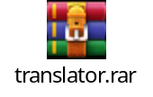

Algorithm
Write the algorithm of your solution with proper indentation. Your algorithm should be a complete solution of your project summary.

STEP 1 :

First installed all the libraries which we used throughout the give program we used following libraries:
1-From google translator import translator
2-From gtts import gTTS
3-From tkinter import
# just like this

from googletrans import Translator
from gtts import gTTS
from tkinter import *

STEP 2 :

After importing all the libraries we use exception handling in our program we use try and except in this, in try portion we write following statements

# for making tkinter window we write

root = tk() # use any variable instead of root

# Then for window title we write

root.title('Translator')

# For window geometry we write

root.geometry ('600x280')
# For background color we write

root.config (bg='black') # here config used to configure the parameters

#For background image we write

my_bg=PhotoImage (file="bg.png")
label_1=Label(root,image=my_bg)

# For position

label_1.place(x=13,y=10)
# For box

e1 =Entry(root,bg='white',fg='black',font=('Arial',23,'bold'))

# For box place

e1.place(x=17,y=20)

STEP 3 :

Now make function and give all the languages which you want to convert

def convert_language():
a1=e1.get ()
t1= Translator ()
t2=click_option.get ()
wr= str(a1)

if t2=="English":
convert="en" # here use any variable instead of covert
elif t2=="Urdu":
convert='ur'
elif t2=='German':
convert='de'
elif t2=='French':
convert='fr'
elif t2=='Spanish':
convert='es'
elif t2=='Hindi':
convert='hi'

STEP 4 :
Now for translating code from one language to another we write

# here in t1 we store translator previously
trans_text=t1.translate (a1, dest=convert)
trans_text=trans_text.text

STEP 5 :
For showing tkinter window we write

ob1= gTTS(text=trans_text ,slow=False ,lang=convert)
label_2.config(text=trans_text)

# For displaying output in string we write

lb=str(trans_text)

STEP 6 :
Now for also using file handling in this program we write

file=open('translator.txt','a')
file.write ('user serached for: ')
file.write (wr)
file.write ('\n')
file.write ('translated text of your desired language is:')
file.write (lb)
file.write ('\n')
file.close()

STEP 7 :
For drop down menu list we write

choices=['English','Urdu','German','French','Spanish','Hindi']
click_option=StringVar()
click_option.set('Select language')

STEP 8 :
For drop down button and for button configure and position we write
list_drop=OptionMenu(root,click_option,*choices)
list_drop.configure(background='black' ='white',font=('Arial',15,'bold'))
list_drop.place(x=370,y=20) ,foreground

STEP 9 :
Now for label_2
# Basically in label_2 we defined that box in which translated text shown
For this we write
label_2=Label(root,text='\t\t\t\t\t\t',bg='black',fg='red'
,font=('Arial',40,'bold'))
label_2.place(x=0,y=120)
label_2=Label(root,text='Translated
text',bg='black',fg='white',font=('Arial',26,'bold'))

# For position

label_2.place(x=180,y=120)

# For font
Button_1=Button(root,text='Translate',bg='#1b03a3',fg='white',
font=('Arial',2,bold'),command=convert_language)

# For position
Button_1.place(x=220,y=200)

# in this statement we close try portion

STEP 10 :
Now we write in exception portion in which we define how to deal
With errors if the following errors occurred in program

# this error occur when executin library, function or string
without quotes (Name error)

except NameError:
print('Name error occured')

# an exception in python that occurs when we try to access
an element from a list or tuple from an index that is not
present in the list (index error)

except IndexError:
print('Index error occured')

# input/output error .It occurs when a file, file path, or
OS operation we're referencing does not exist

except IOError:
print('Index error occured')

# produced by Python when it is translating the source code
into byte code (syntax error)

except SyntaxError:
print('Index error occured')
# raised when the method receives the argument of the
correct data type but an inappropriate value( except value error)

except ValueError:
print('Value error occured')

# programming concept used while writing a code where the
user declares a condition to be true using assert statement prior
to running the module (assertion error)

except AssertionError:
print ('Assertion error occured')

except:
print('Something went wrong please enter the correct value')

STEP 11 :
Now the last step is close the window

root.mainloop ()

Project Flow
Develop a flow chart that depicts your project flow. This should NOT be the exact mapping of algorithm.

Start
Use get method for entry widget and translator() to translate text
Declare a variable click_option equal to StringVariable then use set method to select language
Declare a variable t2 and use the get method for above variable
Import googletrans, gTTS, tkinter
Display main window in variable root , set its geometry, display title and background image
Take text from user in Entry widget
Declare a function name converted_language

True

if t2==english
Convert=’en’

False
if t2==german

True

Convert=’ed’

False
if t2==french

True

Convert=’fr’

False
if t2==spanish

True

Convert=’es’

Declare variable trans_text

Use translate method in trans_text for the text in entry widget where dest=convert

Declare a variable obj1

Use gTTS library in obj1

Open the file or create the file name translator

Store the data of text entered by user and translated text by appending

Close the file

Declare a variable name choices which contain the list of four languages

Declare the variable list_drop for creating dropdown

Using the widget OptionMenu assign in the above variable and using variable choices for list of dropdown

Declare a variable button_1

Using the widget Button in above variable for creating translate button

Close tkinter to display program as :
root.mainloop()

End

Code Explanation

Install Googletrans:

Installation of this package is required before starting the project. Translation of major languages is provided by this package. To install this package run the following command on the command prompt or terminal window.

Install gtts:

Installation of this package is required before starting the project. To install this package run the following command on the command prompt or terminal window.

Importing googletrans, gTTS, tkinter:

- From tkinter import *: The easiest and most effective way to develop GUI applications is using tkinter. * means importing everything from tkinter.
- From googletrans import Translator: This package helps to translate major language
- From gtts import gTTS: gTTS (Google Text-to-Speech)is a Python library and CLI tool to interface with Google Translate text-to-speech API.

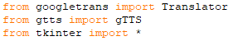

Initializing Windows:

- Tk(): Root window is created with the help of Tk() class.
- title(): It is used to display the title on the top of the root window.
- Geometry():It is used to display window’s length and height.
- Config():It used to display background color of window.
- PhotoImage: Used to siplay the background image of windows.
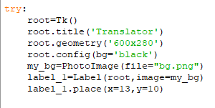

Input Text:
- Entry(): This widget helps to enter or display a single line text on the screen.

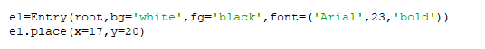

Creating List For choosing Languages:
LanguageChoices is a list that stores four languages from which input language and translated language can be chosen.

Creating A Function For Translating Text:
- Translator(): It helps to translate the text.
- get(): Value of the item is returned with the help of this method.

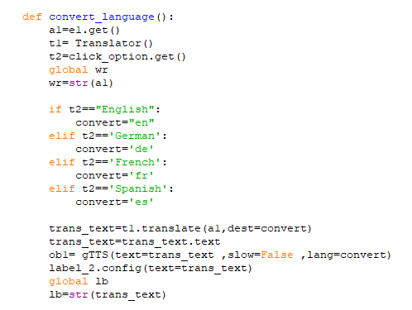

File Handling:
- open(): open the file which exist already or creating the file.
- Write(): To append and store the data of input and output.
- Close(): To close the file properly.

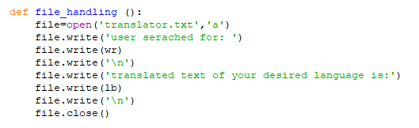

Choice for input language and language in which the text is to be translated:
InputLanguageChoiceMenu provides a choice of input languages. NewLanguageChoiceMenu provides a choice of languages in which translation of text is possible.
- OptionMenu(): It provides the options that are available to the user.
- Label(): This widget helps to implement display boxes where the text can be placed.

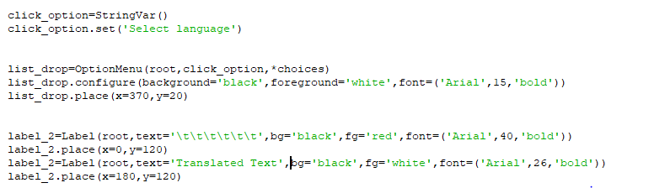

Output Text:
- Button(): This widget creates a button.
- mainloop(): It helps to run the tkinter event loop.

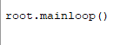

Exception handling:
We use try and except with the exception name if any kind of exception error occur throughout the program.
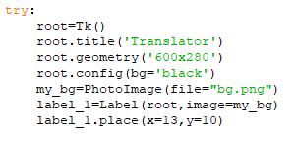
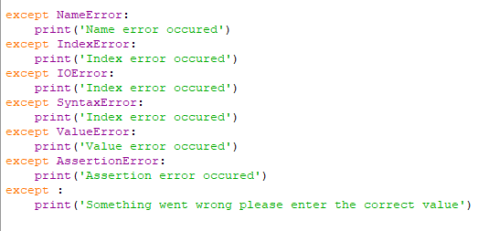

Screenshots

Code:
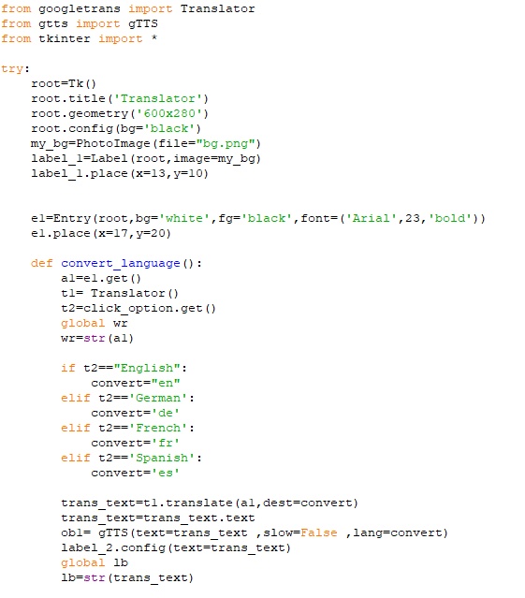
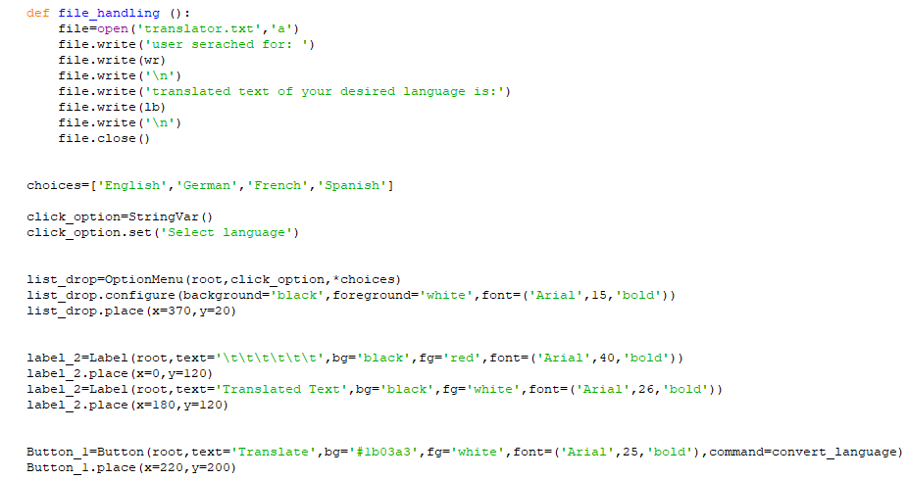
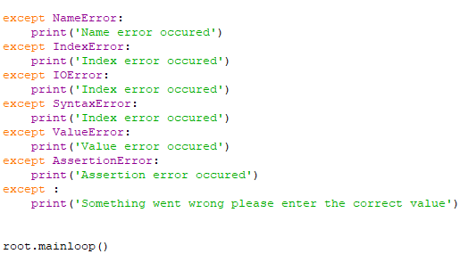

Output:

Translator:

English To German Language:
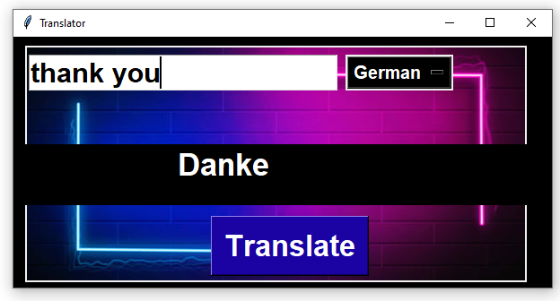

English To French language:

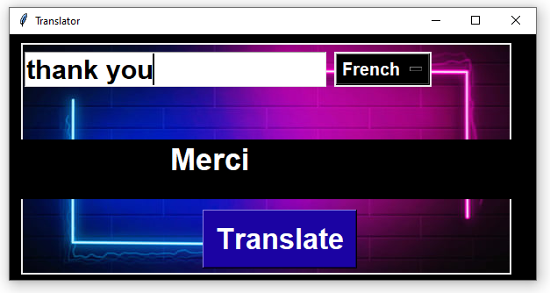

English To Spanish language:

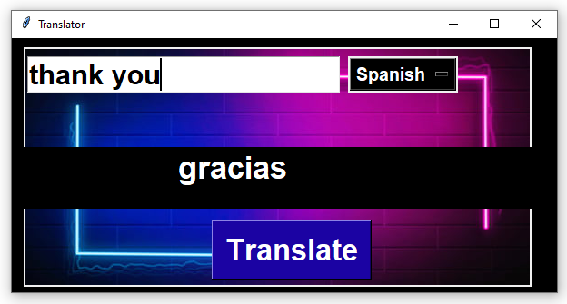

German To English:

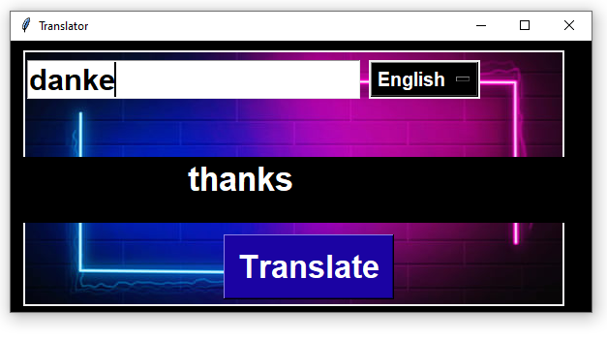

French to Spanish:

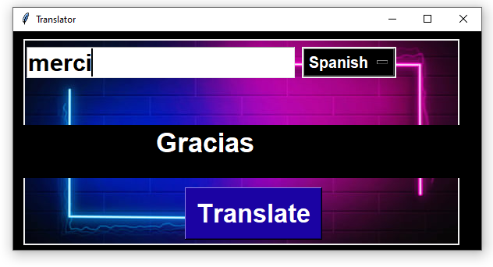

Spanish to German:

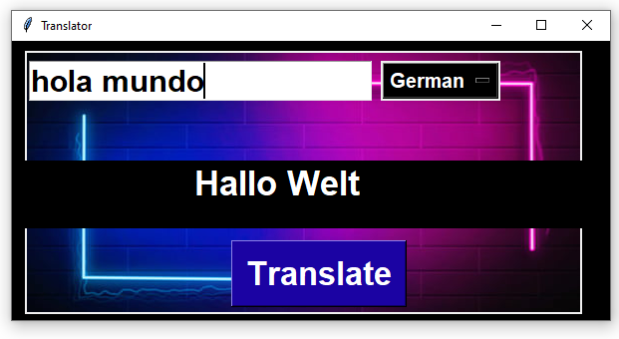

File Handling:

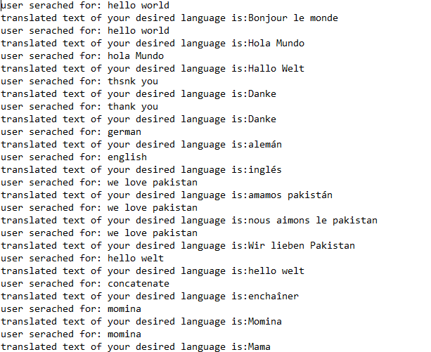
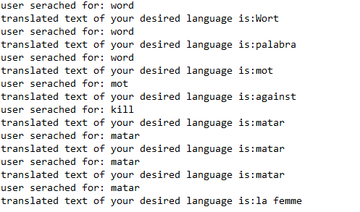

Exception handling:

For NameError:
