**安装与配置 Harbor**

官方文档：

[https://github.com/vmware/harbor/blob/master/docs/installation_guide.md](https://github.com/vmware/harbor/blob/master/docs/installation_guide.md" \t "https://www.jianshu.com/p/_blank)

其他参与：

https://blog.51cto.com/11093860/2117805

<https://www.jianshu.com/p/6ef321f25c16>

https://blog.51cto.com/yanconggod/2104447

1. **Harbor的软硬件要求,详见官方文档**

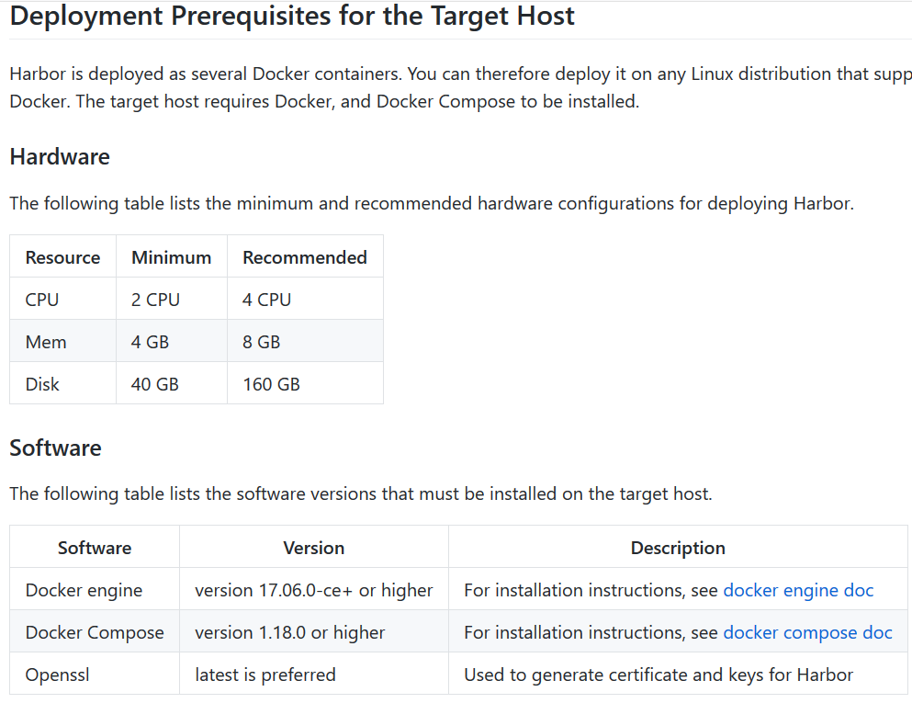

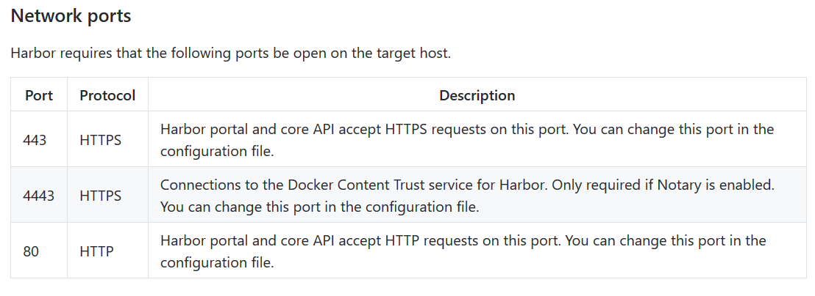

1. **安装Harbor**
2. **Docker安装,见《1-CentOS搭建Docker环境.docx》**
3. **Docker Compose安装**

参与：https://www.jianshu.com/p/f323aa0416da

安装pip

yum -y install epel-release

yum -y install python-pip

确认pip版本

pip --version

更新pip

pip install --upgrade pip

安装docker compose

pip install docker-compose

查看版本

docker-compose version

1. **下载harbor包**

下载包版本选择：https://github.com/goharbor/harbor/releases

在线安装包

wget https://storage.googleapis.com/harbor-releases/release-1.9.0/harbor-online-installer-v1.9.1.tgz

离线包

wget https://storage.googleapis.com/harbor-releases/release-1.9.0/harbor-offline-installer-v1.9.1.tgz