**安装与配置 Harbor**

官方文档：

<https://github.com/vmware/harbor/blob/master/docs/installation_guide.md>

其他参与：

https://blog.51cto.com/11093860/2117805

<https://www.jianshu.com/p/6ef321f25c16>

https://blog.51cto.com/yanconggod/2104447

1. **Harbor的软硬件要求,详见官方文档**

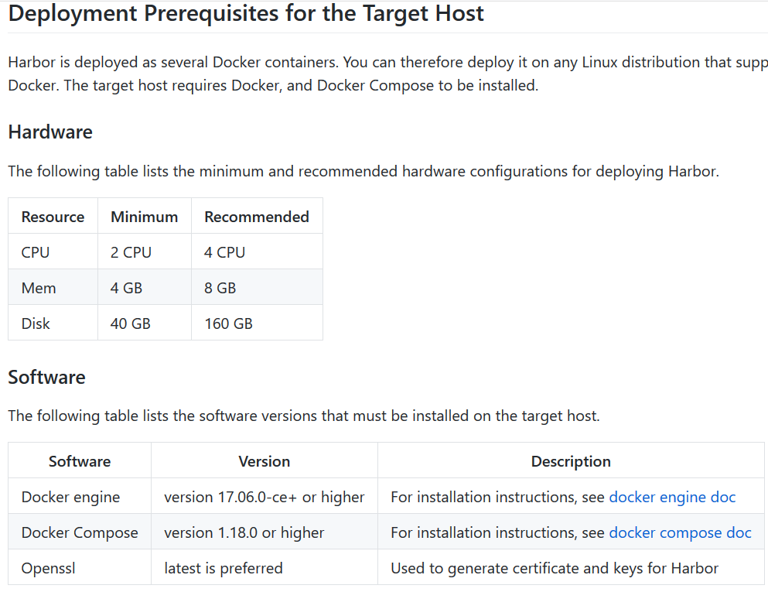

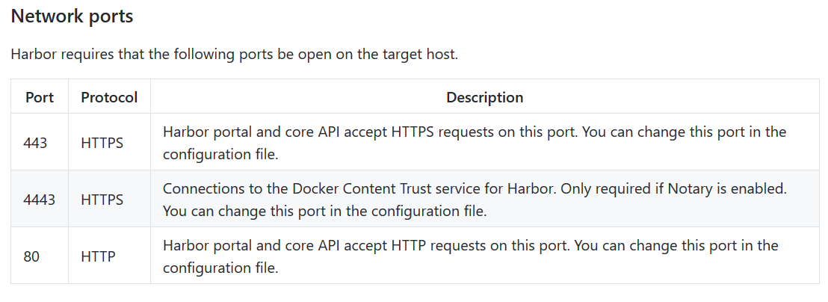

1. **安装Harbor**
2. **Docker安装,见《1-CentOS搭建Docker环境.docx》**
3. **Docker Compose安装**

参与：https://www.jianshu.com/p/f323aa0416da

https://blog.csdn.net/Doudou_Mylove/article/details/102819236

安装pip

yum -y install epel-release

yum -y install python-pip

确认pip版本

pip --version

更新pip

pip install --upgrade pip

安装docker compose

pip install docker-compose

查看版本

docker-compose version

1. **下载harbor包**

下载包版本选择：https://github.com/goharbor/harbor/releases

在线安装包

wget https://storage.googleapis.com/harbor-releases/release-1.9.0/harbor-online-installer-v1.9.1.tgz

离线包

wget https://storage.googleapis.com/harbor-releases/release-1.9.0/harbor-offline-installer-v1.9.1.tgz

**(4)使用离线包**

解压文件

tar zxvf /opt/harbor-offline-installer-v1.9.1.tgz -C /root/harbor

查看文件

ll /root/harbor

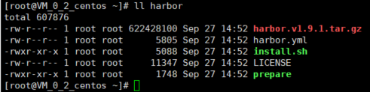

**(5)安装前修改配置**

vim harbor.yml

hostname:此处需要修改为自己的机器ip或者是一个域名。

http->port:配置访问的端口

database: 关于数据库的配置，docker-compose编排中有数据库记录一些相关的数据

data_volume: 数据盘挂载

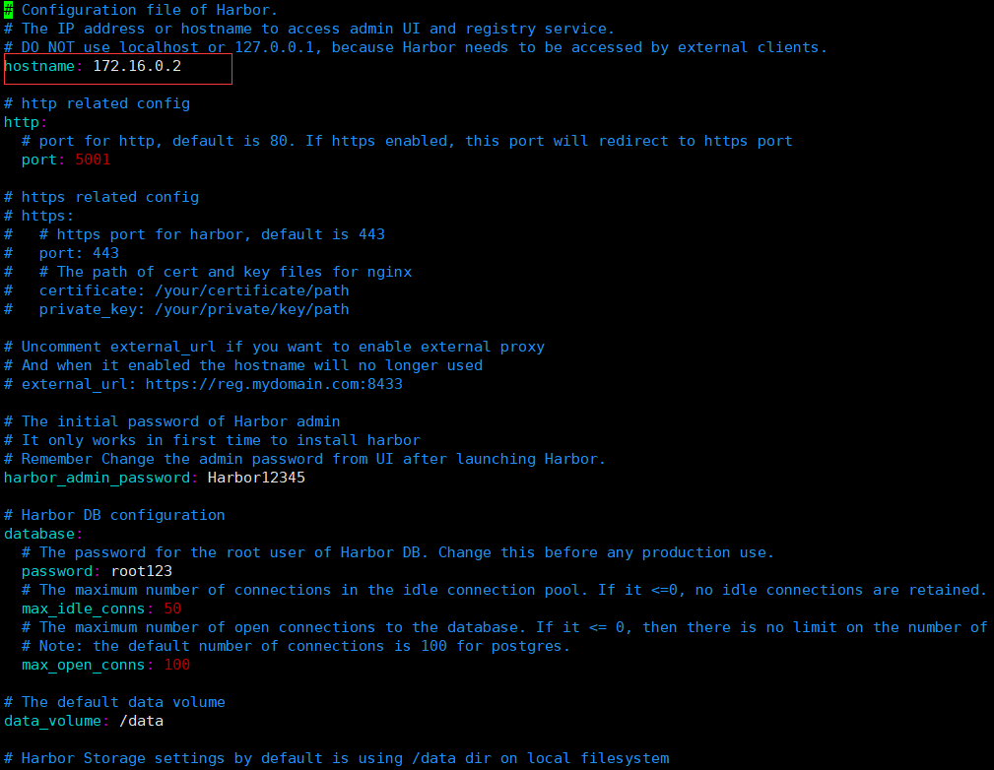

**(6)开始安装**

启动harbor

./prepare

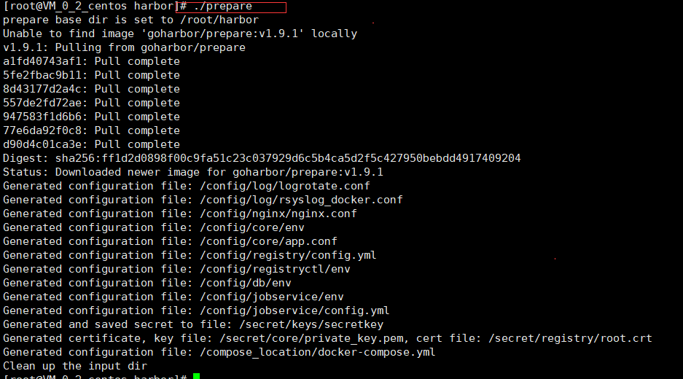

./install.sh

执行如下

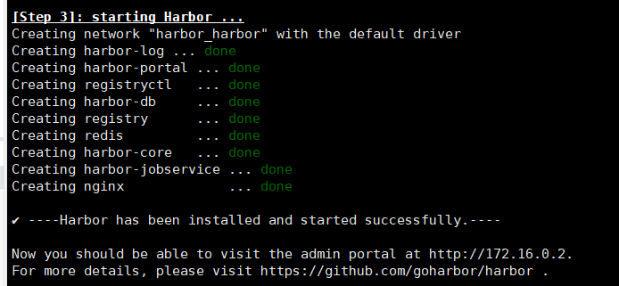

命令行登陆：

[root@k8s-master harbor]# docker login 192.168.2.252:8000

Username: admin

Password:

Error response from daemon: Get https://192.168.2.252:8000/v2/: http: server gave HTTP response to HTTPS client

报错解决如下：

#添加第二行和第三行

vim /etc/docker/daemon.json

{

"exec-opts": ["native.cgroupdriver=systemd"],

"registry-mirrors": [ "https://registry.docker-cn.com"],

"insecure-registries": [ "192.168.2.252:8000"]

}

重启docker:

systemctl daemon-reload

systemctl restart docker

docker start $(docker ps -aq)

登录成功如下：

[root@k8s-master harbor]# docker login 192.168.2.252:8000

Username: admin

Password:

WARNING! Your password will be stored unencrypted in /root/.docker/config.json.

Configure a credential helper to remove this warning. See

https://docs.docker.com/engine/reference/commandline/login/#credentials-store

Login Succeeded