ASSIGNMENT – 1
Q. Create the following tables with the given structures and insert sample data as specified.

1) SALESPEOPLE
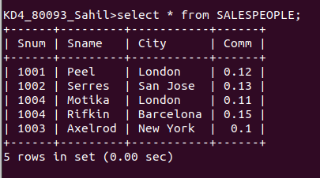
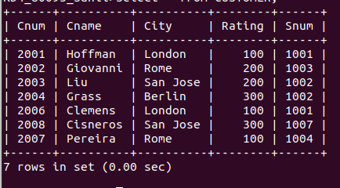
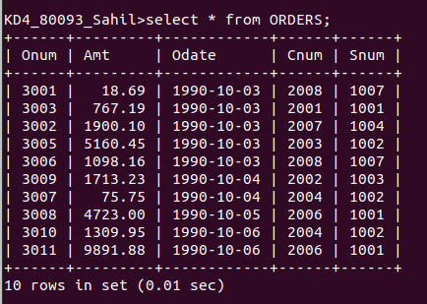
2) CUSTOMERS
3) ORDERS

