MySQl Assignment-11

Q.1 Write a query that uses a subquery to obtain all orders for the customer named Cisneros. Assume you do not know his customer number (cum).
Solve


Q.2 Write query that produces the names and ratings of all customers who have above-average orders.
Solve-
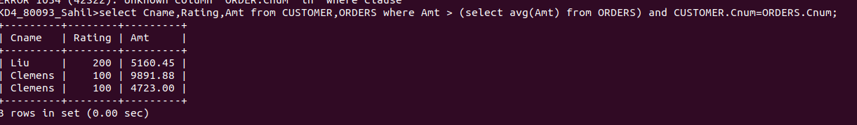

Q.3 Write a query that selects the total amount in orders for each salesperson for whom this total is greater than the amount of the largest order in the table.
Solve-
