MYSQL Assignment -6

Q1) Write two Different queries that would produce all orders taken on October 3rd or 4th ,1990.

Solve :-
1st Queries

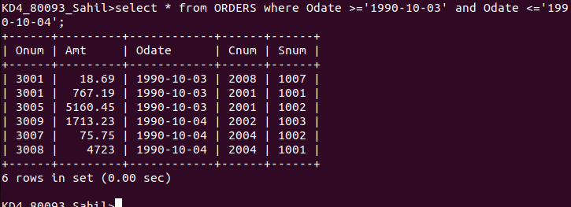
2nd Queries

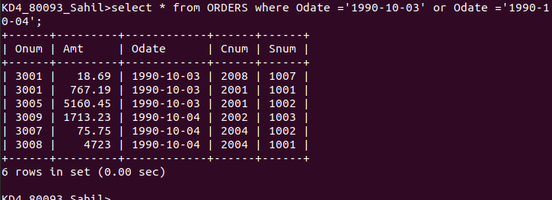

Q2 )
Wrtie a Query that selects all of the Customers serviced by peel or Motika .
-Solve

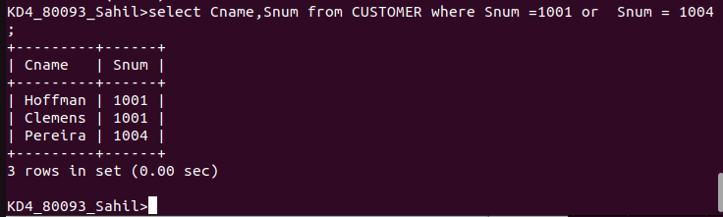

Q3 ) Write a query that will produce all the customers whose names begin with a letter from ‘A’
or ‘G’.

-Solve

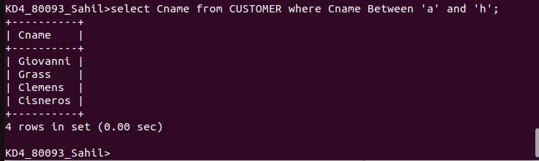

Q4 ) Write a query that selects all customers whose names begins with the letter ‘c’

-Solve
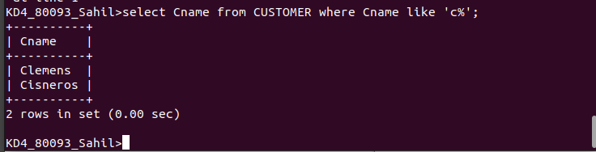

Q5) Write a query that selects all orders expcept those with zeroes or nulls in the amt field.

-Solve
