ASSIGNMENT NO.8
Q.1)
ASSUME EACH SALESPERSON HAS A 12% COMMISION. WRITE A QUERY ON THE ORDERS TABLE THAT WILL PRODUCE THE ORDER NUMBER, THE SALESPERSON NUMBER, AND THE AMOUNT OF THE SALESPERSON’S COMMISION FOR THAT ORDER.
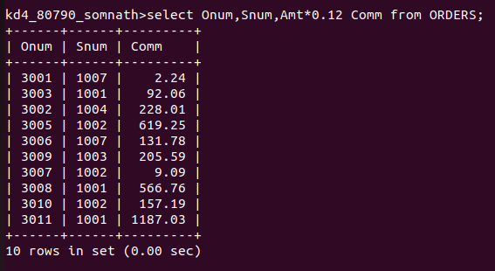
Q.2)
WRITE A QUERY ON THE CUSTOMERS TABLE THAT WILL FIND THE HIGHEST RATING IN EACH CITY. PUT THE OUTPUT IN THIS FORM :
FOR THE CITY (city) , THE HIGHEST RATING IS :
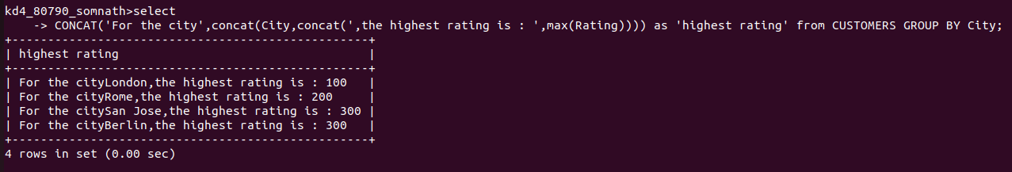
(RATING)

Q.3)
WRITE A QUERY THAT LISTS CUSTOMERS IN DESCENDING ORDER OF RATING. OUTPUT THE RATING FIELD FIRST, FOLLOWED BY THE CUSTOMER’S NAME AND NUMBER
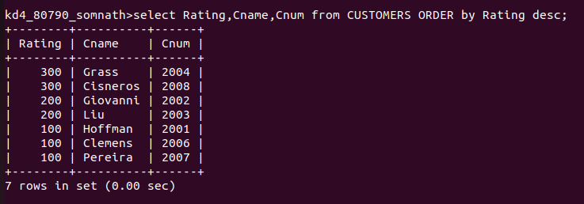

Q.4)
WRITE A QUERY THAT TOTALS THE ORDERS FOR EACH DAY AND PLACES THE RESULTS IN DESCENIDING ORDER.

