ASSIGNMENT NO 11
Q.1)
WRITE A QUERY THAT USES SUB-QUERY TO OBTAIN ALL ORDERS FOR THE CUSTOMERS NAMES “CISNEROS ” . ASSUME YOU DO NOT KNOW HIS CUSTOMER NUMBER(Cnum) .
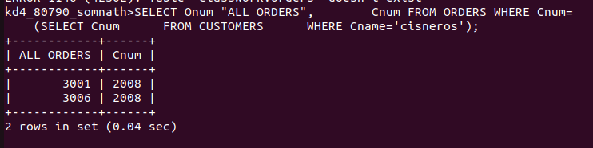

Q.2)
WRITE A QUERY THAT PRODUCES THE NAMES AND RATINGS OF ALL CUSTIMERS WHO HAVE ABOVE AVERAGE ORDERS .

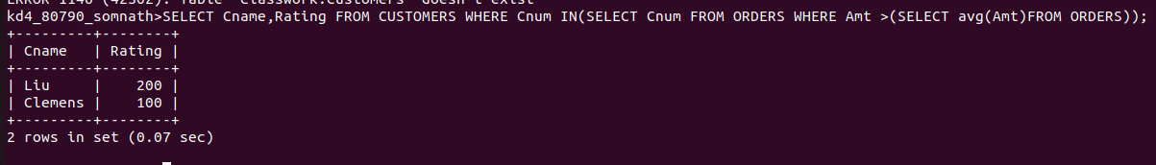

Q.3)
WRITE A QUERY THAT SELECTS THE TOTAL AMOUNT IN ORDERS FOR EACH SALESPERSON FOR WHOM THIS TOTAL IS GREATER THAN THE AMOUNT OF THE LARGEST ORDER IN THE TABLE.

