ASSIGNMENT NO 7
Q.1)
WRITE A QUERY THAT COUNTS ALL ORDERS FOR OCTOMBER 3.
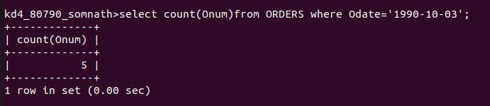
Q.2)
WRITE A QUERY THAT COUNTS THE NUMBER OF DIFFERENT NON-NULL CITY VALUES IN THE CUSTOMERS TABLE.
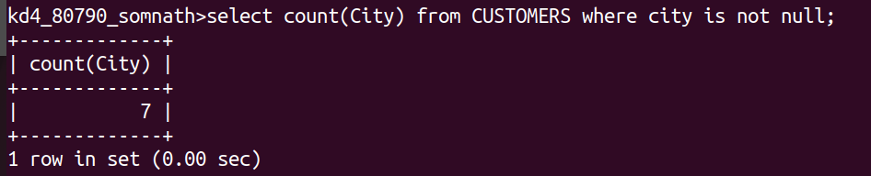

Q.3)
WRITE A QUERY THAT SELECTS EACH CUSTOMER’S SMALLEST ORDER .
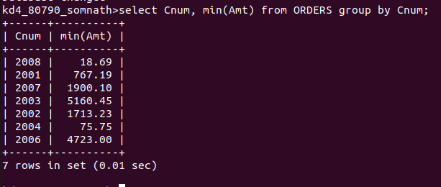

Q.4)
WRITE A QUERY THAT SELECTS THE FIRST CUSTOMER IN ALPHABETICAL ORDER, WHOSE NAME BEGINS WITH G.
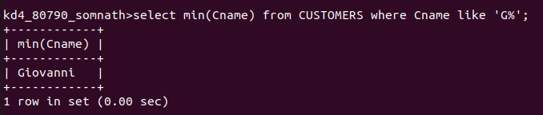

Q.5)
WRITE A QUERY THAT SELECTS THE HIGHEST RATINGS IN EACH CITY.

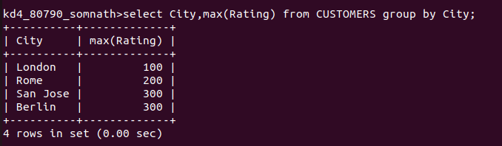
Q.6)
WRITE A QUERY THAT COUNTS THE NUMBER OF SALESPEOPLE REGISTERING ORDERS FOR EACH DAY.(IF A SALESPERSON HAS MORE THAT ONE ORDER ON A GIVENDAY,HE OR SHE SHOULD BE COUNTED ONLY ONCE)
