ASSIGNMENT NO 4

Q.1)
WRITE A SELECT COMMAND THAT PRODUCES THE ORDER NUMBER,AMOUNT,AND DATE FOR ALL ROWS IN THE OREDERS TABLE.

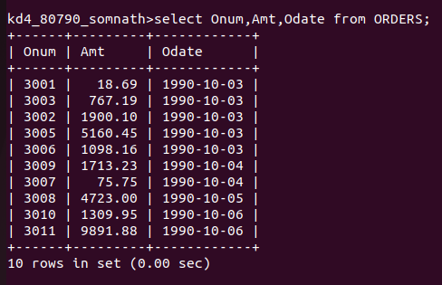

Q.2)
WRITE A QUERY THAT PRODUCES ALL ROWS FROM THE CUSTOMERS TABLE FOR WHICH THE SALESPERSON’S NUMBER IS 1001

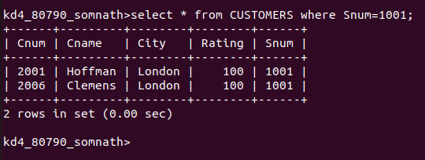

Q3)
WRITE A QUERY THAT DISPLAYS THE SALESPEOPLE TABLE WITH THE COLUMNS IN THE FOLLOWING ORDER: CITY ,SNAME,SNUM,COMM.

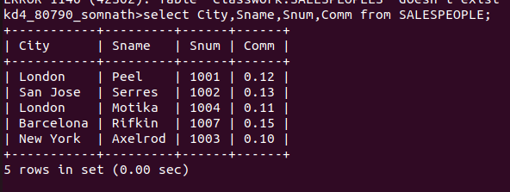
Q4)
WRITE A SELECT COMMAND THAT PRODUCES THE RATING FOLLOWED BY THE NAME OF EACH CUSTOMERS IN SAN JOSE.
