ASSIGNMENT NO.9
Q.1)
WRITE A QUERY THAT LISTS EACH ORDER NUMBER FOLLOWED BY THE NAME OF THE CUSTOMER WHO MADE THE ORDER.
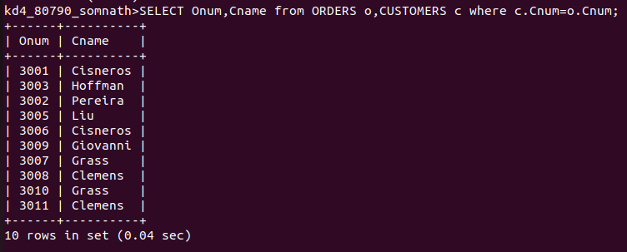
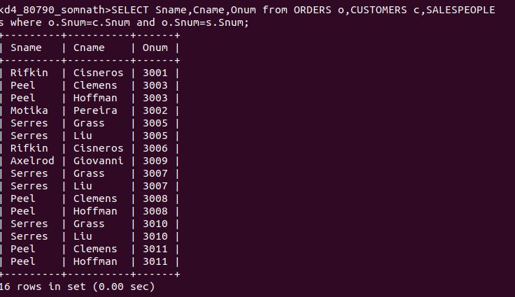
Q.2)
WRITE A QUERY THAT GIVES THE NAMES OF BOTH THE SALESPERSON AND THE CUSTOMER FOR EACH ORDER ALONG WITH THE ORDER NUMBER.

Q.3)
WRITE A QUERY THAT PRODUCES ALL CUSTOMERS SERVICED BY SALESPEOPLE WITH A COMMISION ABOVE .12%. OUTPUT THE CUSTOMER’S NAME , THE SALESPERSON’S NAME AND THE SALESPERSON’S RATE OF COMMISION.
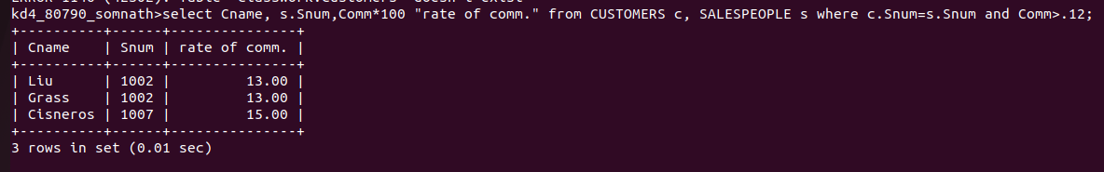
Q.4)
WRITE A QUERY THAT CALCULATES THE AMOUNT OF THE SALESPERSON’S COMMISION ON EACH ORDER BY A CUSTOMER WITH A RATING ABOVE 100.
