ASSIGNMENT NO.12
USING THE OPERATORS IN,ANY,AND ALL
Q.1)
WRITE A QUERY THAT SELECTS ALL CUSTOMERS WHOSE RATINGS ARE EQUAL TO OR GREATER THAN ANY OF 'SERRES'

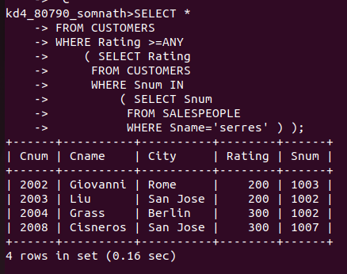

Q.2)
WRITE A QUERY USING ANY OR ALL THAT WILL FIND ALL SALESPEOPLE WHO HAVE NO CUSTOMERS LOCATED IN THEIR CITY.

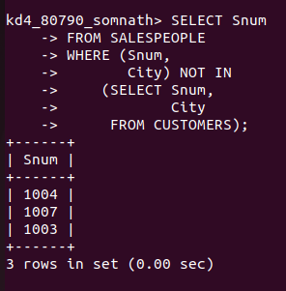

Q.3)
WRITE A QUERY THAT SELECTS ALL ORDERS FOR AMOUNTS GREATER THAN ANY FOR THE CUSTOMERS IN ‘LONDON’
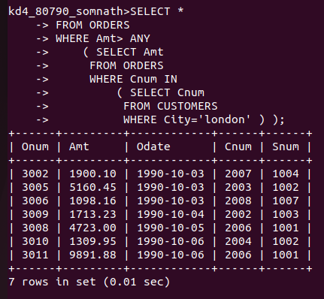

Q.4)
WRITE THE ABOVE QUERY USING MIN OR MAX.
