ASSIGNMENT NO-1
Q. CREATE THE FOLLOWING TABLES WITH THE GIVEN STRUCTURES BAND INSERT SAMPLE DATA AS SPECIFIED:-

A) SALESPEOPLE
B)CUSTOMERS
C)ORDERS

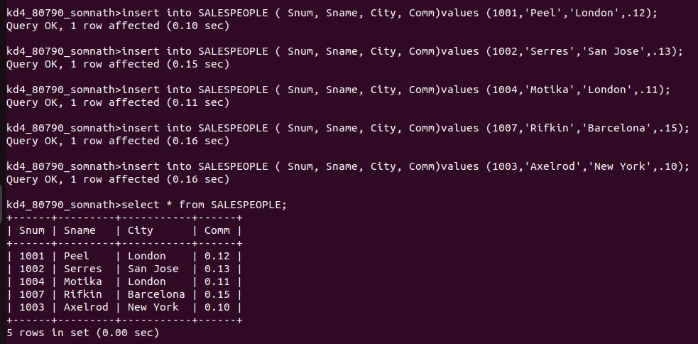
SALES PEOPLE

CUSTOMERS
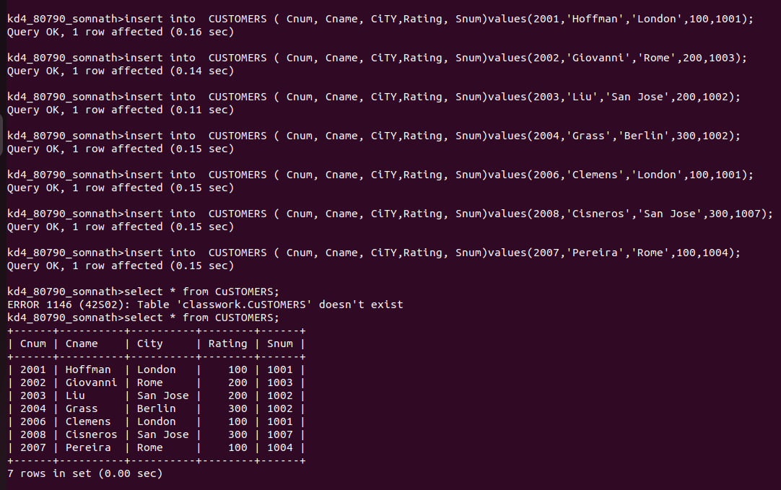
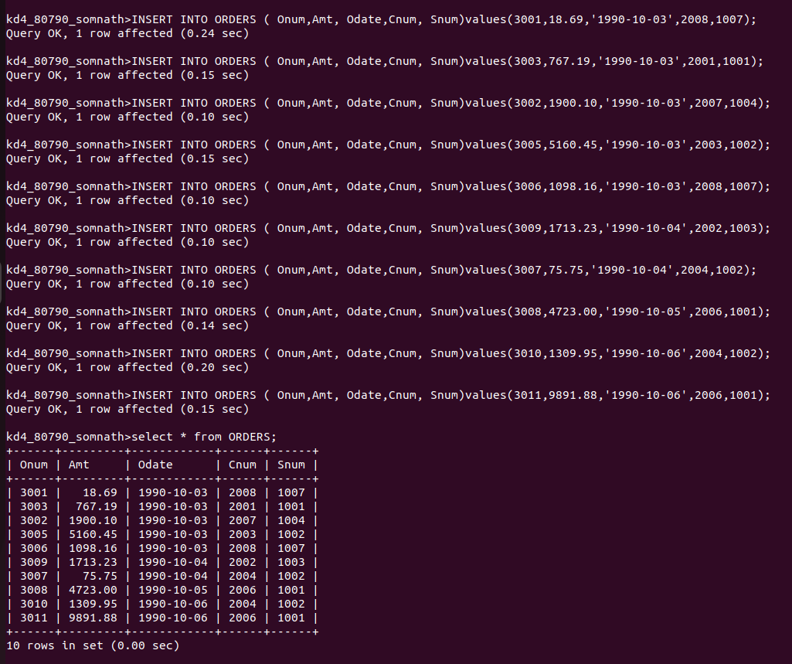
ORDERS

