ASSIGNMENT NO-6
USING SPECIAL OPERATORS IN CONDITIONS
Q.1)
WRITE TWO DIFFERENT QUERIES THAT WOULD PRODUCE ALL ORDERS TAKEN ON OCTOMBER 3rd OR 4th ,1990.
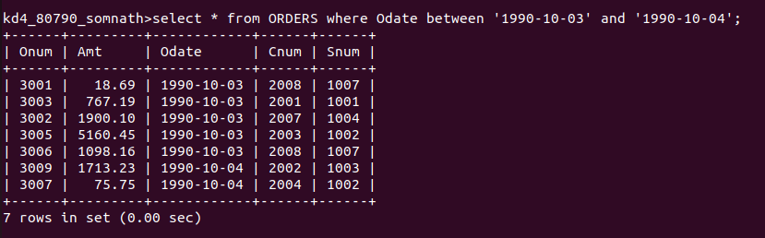
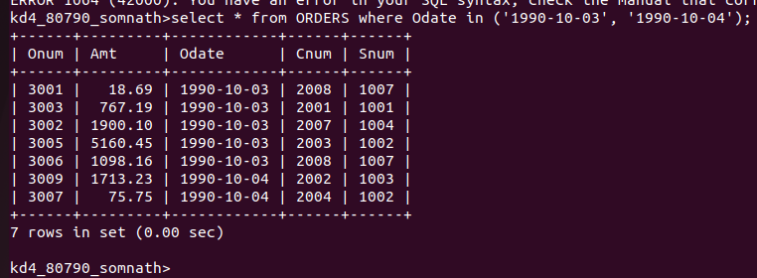

Q.2)
WRITE A QUERY THAT SELECTS ALL OF THE CUSTOMERS SERVICED BY PEEL OR MOTIKA.
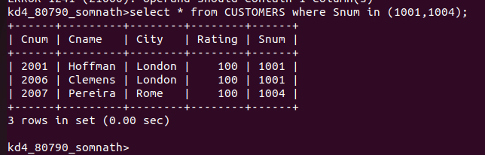
Q.3)
WRITE A QUERY THAT WILL PRODUCE ALL THE CUSTOMERS WHOSE NAMES BEGINS WITH A LETTER FROM `A` TO `G`
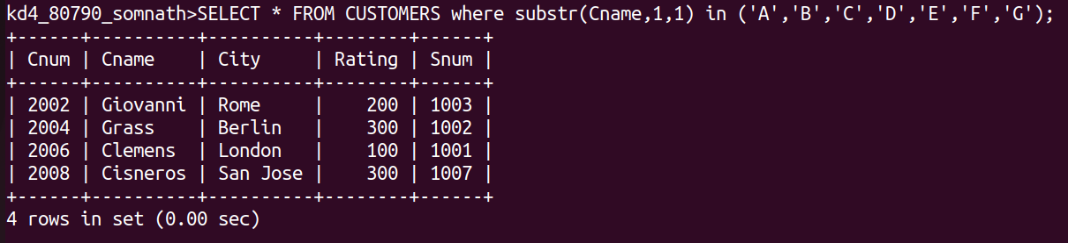

Q.4)
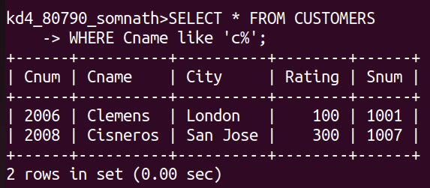
WRITE A QUERY THAT SELECTS ALL CUSTOMERS WHOSE NAMES BEGINS WITH THE LETTER `C`

Q.5)
WRITE A QUERY THAT SELECTS ALL ORDERS ALL ORDERS EXCEPT THOSE WITH ZEROS OR NULLs IN THE Amt FIELD.
