ASSIGNMENT NO-5
Q1)
WRITE A QUERY THAT WILL GIVE YOU ALL ORDERS FOR ORDERS FOR MORE THAN RS. 1,000.
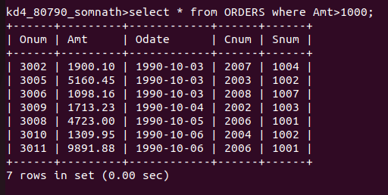

Q2)
WRITE A QUERY THAT WILL GIVE YOU THE NAMES AND CITIES OF ALL SALESPEOPLE IN LONDON WITH A COMMISION ABOVE .10.

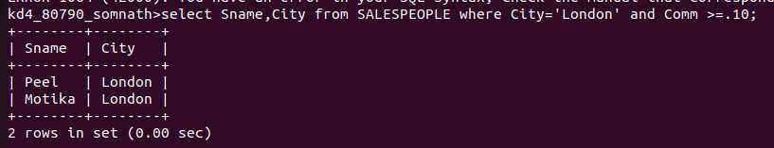

Q.3)
WRITE A QUERY ON THE CUSTOMERS TABLE WHOSE OUTPUT WILL EXCLUDE ALL CUSTOMERS WITH A RATING <=100,UNLESS THEY ARE LOCATED IN ROME.

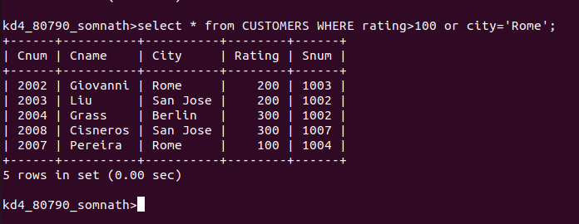

Q4)
WHAT WILL BE THE OUTPUT FROM THE FOLLOWING QUERY?
Select * from Orders where (Amt < 1000 OR
NOT(Odate = ‘1990-10-03’ AND Cnum > 2003));
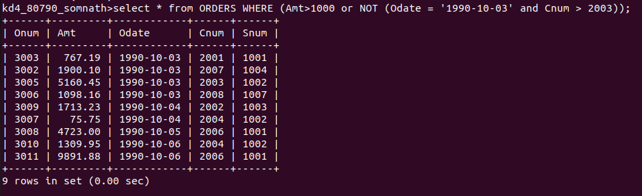

Q5)
WHAT WILL BE THE OUTPUT OF THE FOLLOWING QUERY?
Select * from Orders
Where NOT ((Odate = ‘1990-10-03’ OR Snum >1006) AND Amt >=1500);

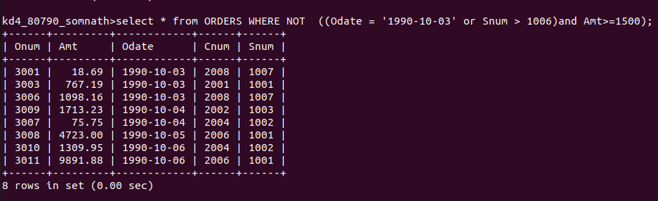

Q.6)
WHAT IS THE SIMPLER WAY TO WRITE THIS QUERY ?
Selec Snum,Sname,City,Comm from Salespeople where (Comm > .12 OR Comm < .14);
