Assignment no 14

1) Write a command that puts the following values , in their given order, into the salespeople table: city- San Jose, name – Blanco, comm – Null, cnum – 1100.

Ans :-
KD4_80099_Jagdish>Mon Sep 18 16:42:35 2023
insert into SALESPEOPLE (city,sname,comm,snum) values ('San Jose','Blanco',null,1100);
Query OK, 1 row affected (0.02 sec)

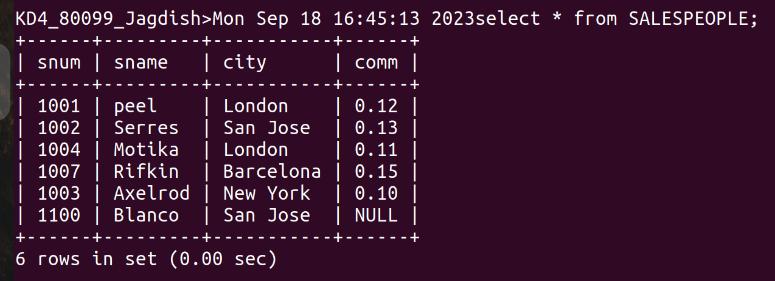
2) Write a command that removes all orders from customer Clemens from the Orders table.

Ans :-
delete from ORDERS where cnum in(select cnum from CUSTOMERS where cname ='Clemens');
Query OK, 2 rows affected (0.01 sec)
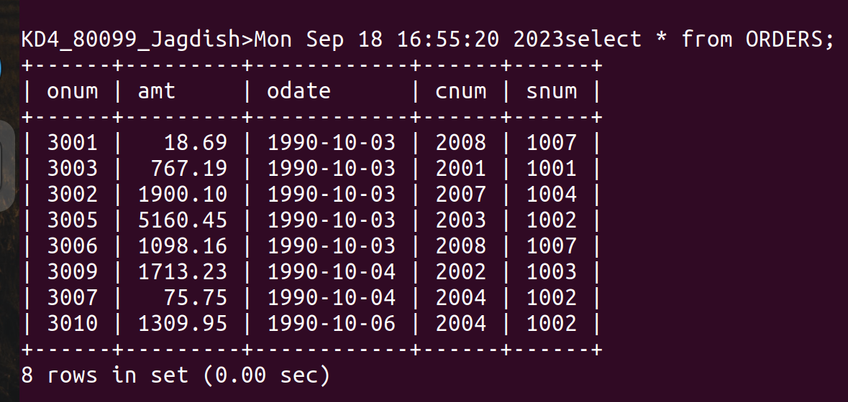
3) Write a command that increases the rating of all customers in Rome by 100.

Ans :-

update CUSTOMERS set rating= rating +100;
Query OK, 7 rows affected (0.01 sec)

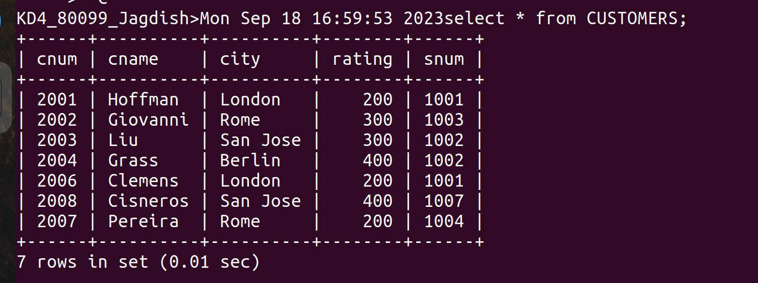
4) Salesperson Serres has left the company. Assign her customers to Motika.

Ans :-

update CUSTOMERS set snum=(select snum from SALESPEOPLE where sname ="Serres") where snum
=(select snum from SALESPEOPLE where sname ='Motika');
Query OK, 1 row affected (0.02 sec)

