Assignment no 11

1) Write a query that uses a subquery to obtain all orders for the customer named Cisneros. Assume you do not know his customer number(Cnum).

Ans:-
select * from ORDERS where cnum=(select cnum from CUSTOMERS where cname="Cisneros");

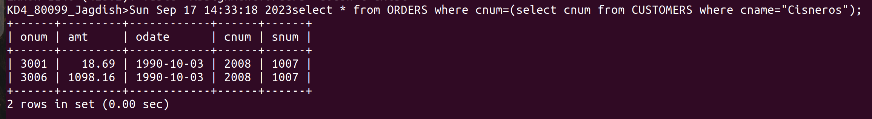
2) Write a query that produces the names and ratings of all customers who have above-average orders.

Ans :-

select cname,rating from ORDERS,CUSTOMERS where CUSTOMERS.cnum=ORDERS.cnum and amt>(select avg(amt) from ORDERS);

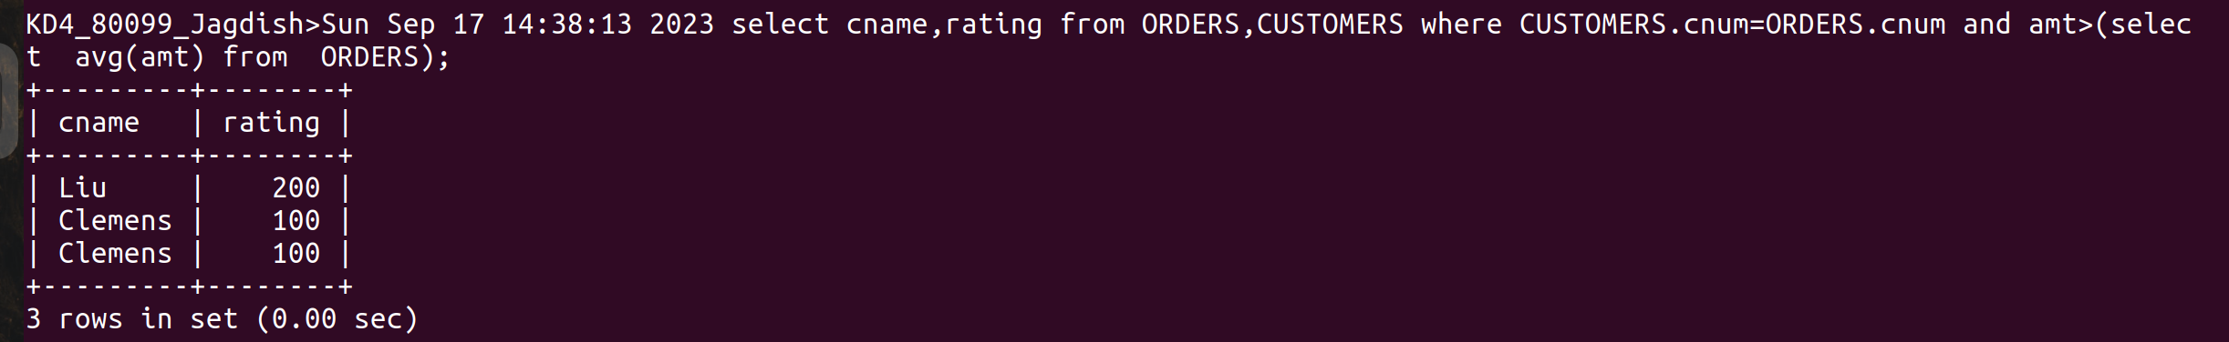
3) Write a query that selects the total amount in orders for each salesperson for whom this total is greater than the amount the largest order in the table.

Ans:-

select snum, sum(amt) from ORDERS group by snum having sum(amt)>(select max(amt) from ORDERS);
