Assignment no 12

1) Write a query that selects all customers whose ratings are equal to or greater than ANY of Serres.

Ans :-
select * from CUSTOMERS where rating >= any(select rating from CUSTOMERS where snum = (sel
ect snum from SALESPEOPLE where sname="Serres"));

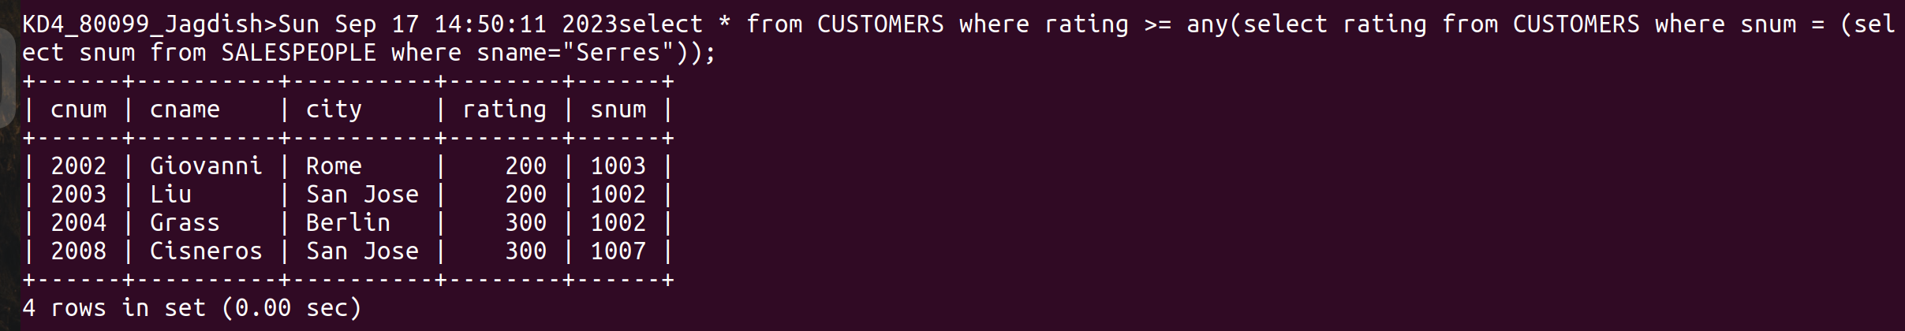
2) Write a query using ANY or ALL that will find all salespeople who have no customers located in their city.

Ans :-
select snum, sname from SALESPEOPLE where (snum ,city) not in (select snum, city from CUSTOMERS);

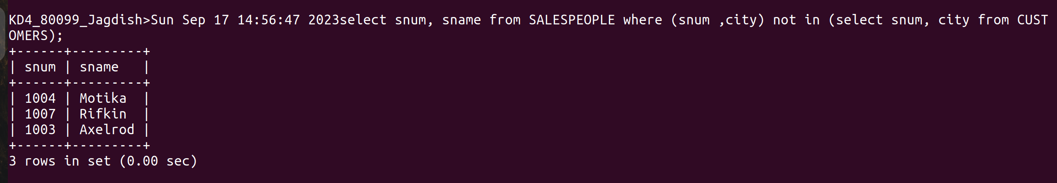
3) Write a query that selects all orders for amounts greater than any for the customers in London.

Ans :-
select * from ORDERS where amt> any (select amt from ORDERS where cnum IN (select cnum fro
m CUSTOMERS where city in('London')));
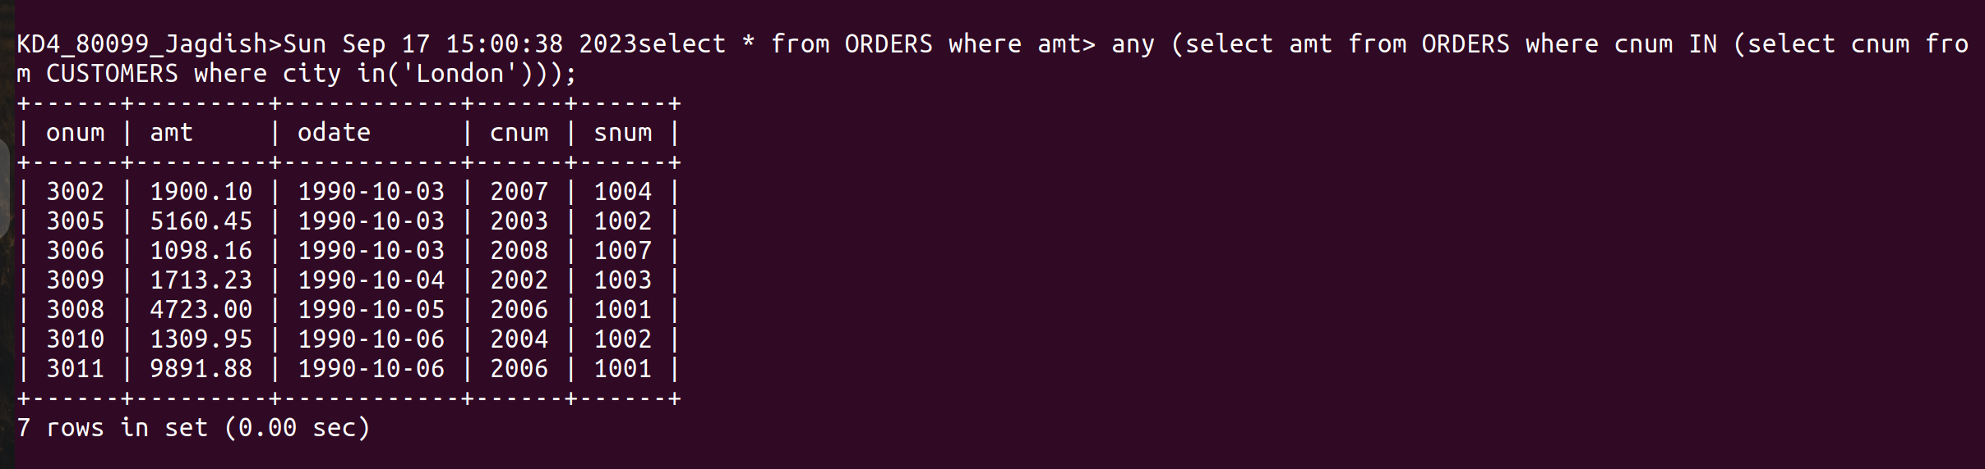
4) Write the above query using MIN or MAX.

Ans :-
select * from ORDERS where amt>(select min(amt) from ORDERS where cnum in (select cnum from CUSTOMERS where city in('London')));

