1) Assume there is a table called Multicust, with all of the same column definitions as Salespeople. Write a command that inserts all salespeople with more than one customer into this table.

Ans :-

create table MULTICUST as select * from SALESPEOPLE where snum in (select snum from CUSTOMERS group by snum having count(snum)>1);

select * from MULTICUST;

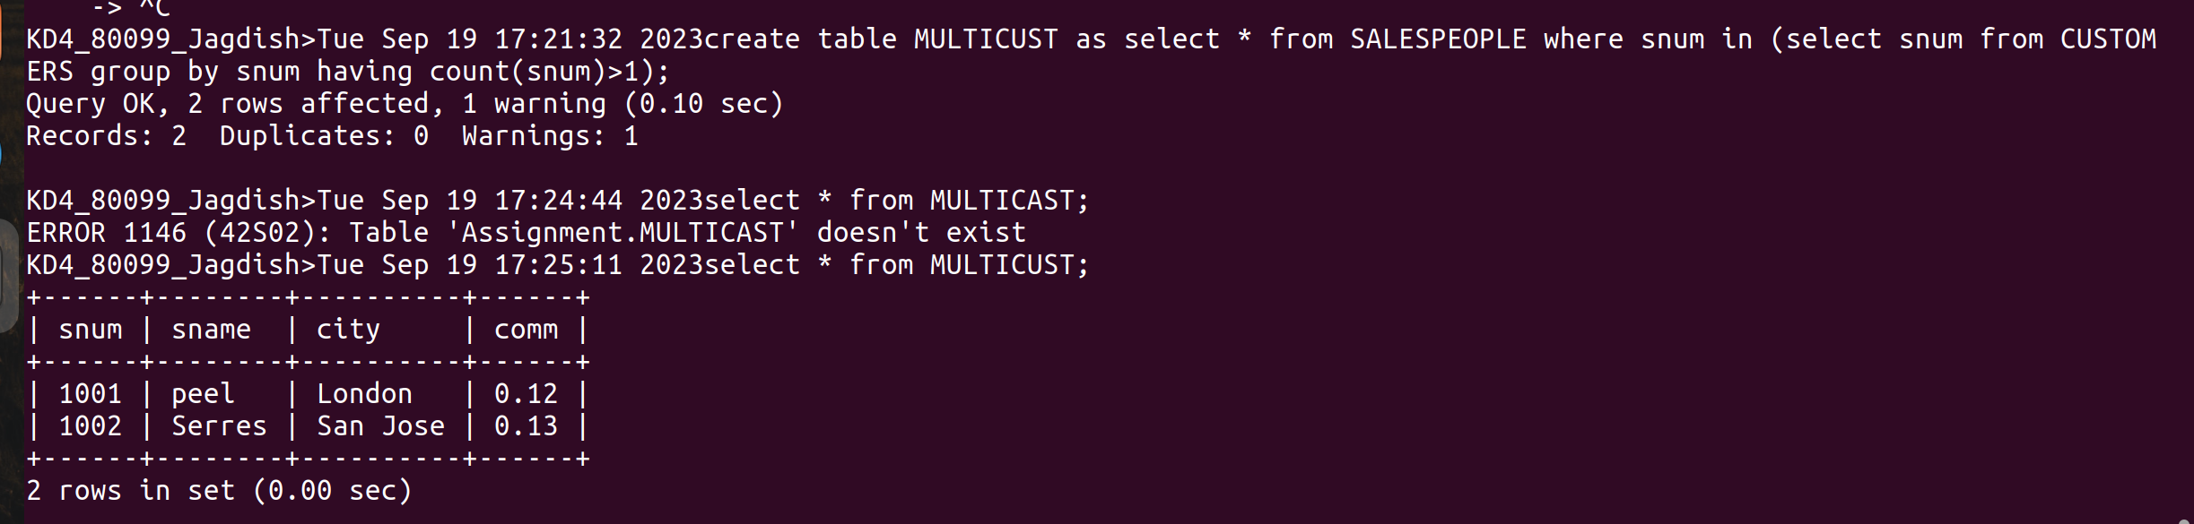
2) Write a command that deletes all customers with no current orders.

Ans :-

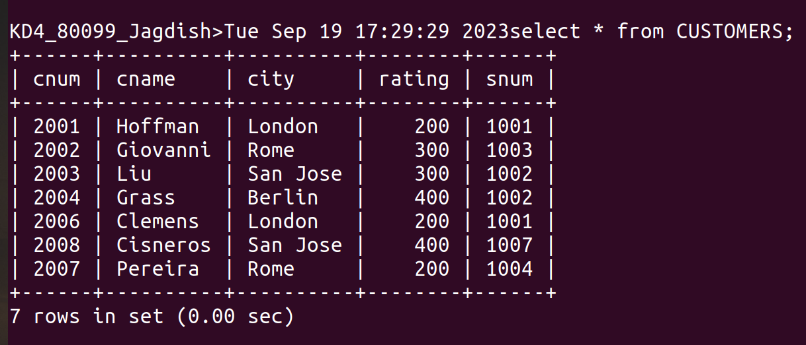
delete from CUSTOMERS where cnum not in (select cnum from ORDERS);

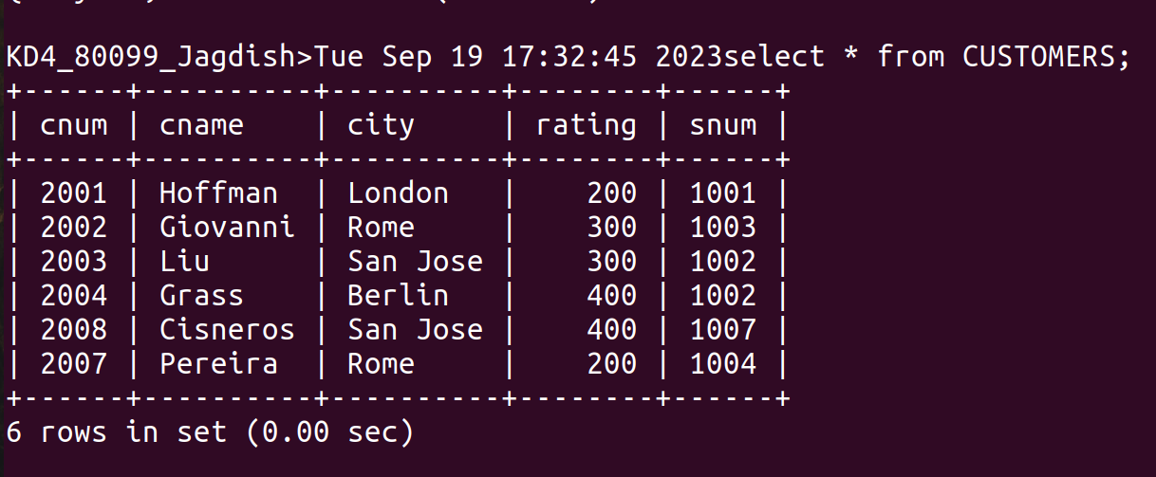
3)Write a command that increases by twenty percent the commissions of all salespeople with total orders above Rs.3000.

Ans :-

update SALESPEOPLE set comm=comm*1.20 where snum in (select snum from ORDERS group by snum having sum(amt)>3000);
