Assignment 7

1) Write a query that counts all orders for Octomber 3 .

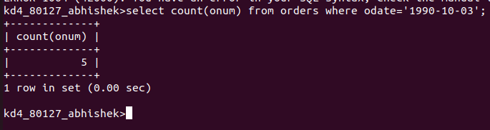

2) Write a query that counts the number of different non-NULL city values in the Customers table .
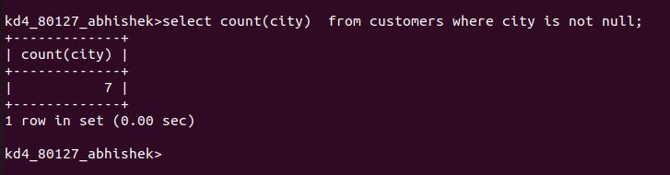

3) Write a query that selects each customers smallest order
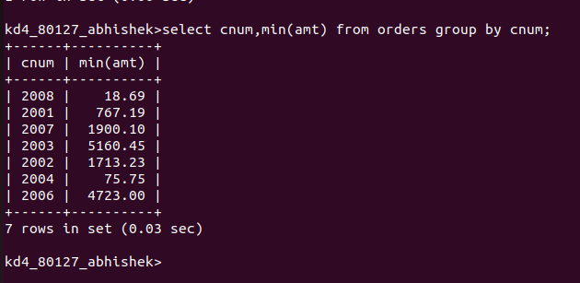

4)Write a query that selects the first customer in alphabetical order ,whose name begins with G .

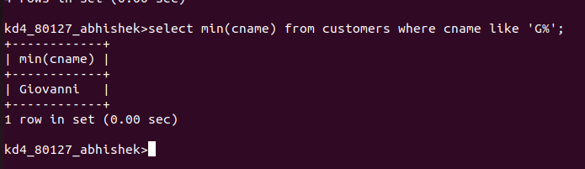

5)Write a query that selects the highest rating in each city .

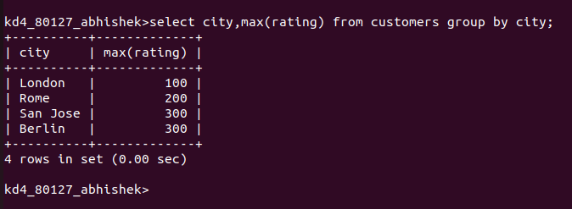
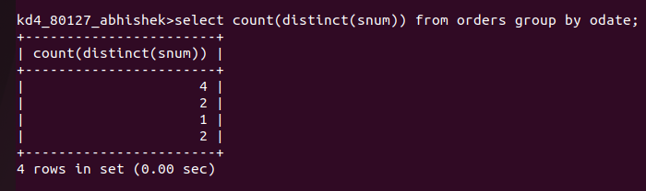
6)Write a query that counts the number of salespeople registering orders for each day.

