ASIGNMENT 11

1)WRITE A QUERY THAT USE A SUBQUERY TO OBTAIN ALL ORDERS FROM THE CUSTOMERS NAME CISNEROS ASSUME YOU DO NOT KNOW HIS USTOMERS NUMBER
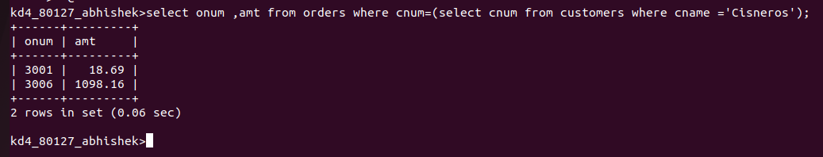

2)WRITE A QUERY THAT PRODUCE THAT NAME AND RATING OF ALL CUSTOMERS WHO HAVE ABOVE AVG ORDERS

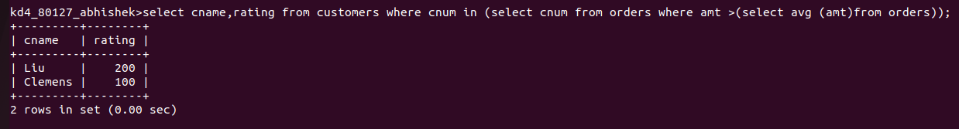

3)WRITE A QUERY THAT SELECT THE TOTAL AMOUNT IN ORDERS FOR ECH SALESPERSON FOR WHOM THIS TOTAL IS GRATER THEN THE AMOUNT OF THE LARGEST ORDERS IN THE TABLE

