Assignment 8

1) Assume each salesperson has a12% commission a query on the orders table that will produce the orders number,the salesperson number,and the amount of the salesperson commision for that order.
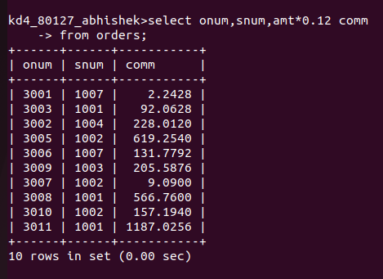

2)Write a query on the Customers table that will find the highest rating in each city.put the output in thise form:
for the city (city),the highest rating is:
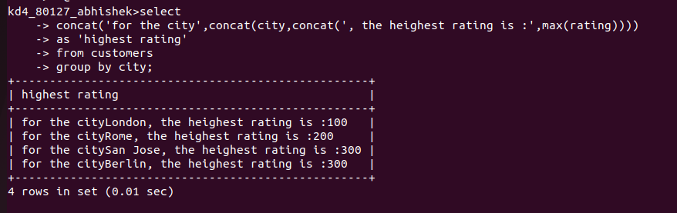

3)Write a query that list customers in descending order of rating.output the rating field first,followed by the customers name and numbers.

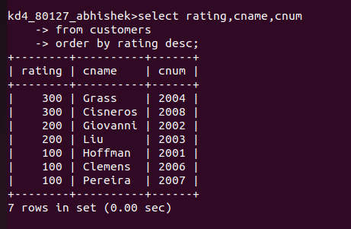

4)Write a query that totals the orders for each day and places the results in descending order.
