Assignment – 6

1) Write two different queries that would produce all orders taken on Octomber 3rd or 4th ,1990 .

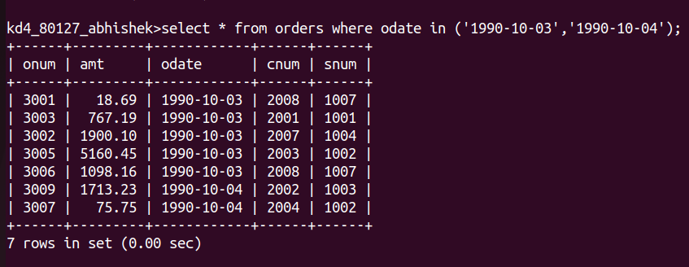

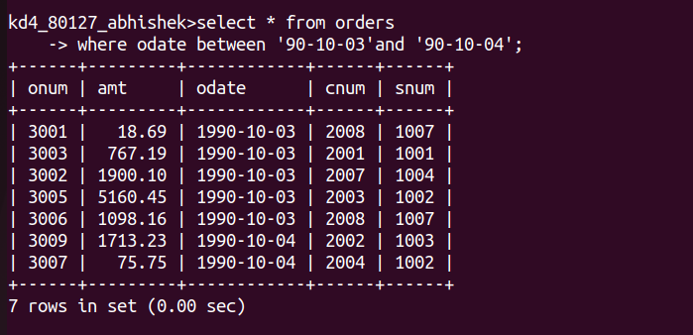

2)Write a query that selects all of the customers serviced by peel or motika .

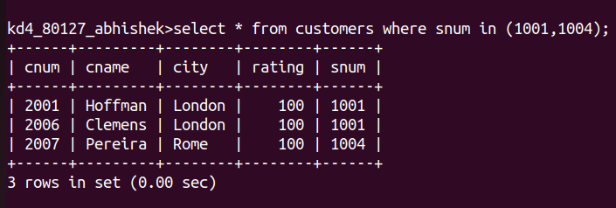

3) write a query that will produce all the customers whose names begin with a letter from ‘A’ to ‘G’.
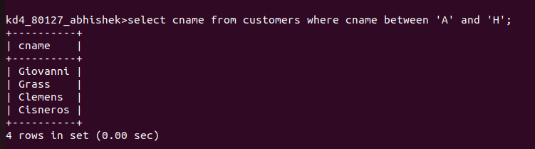

4) Write a query that selects all customers whose names begin with the letter ‘c’.
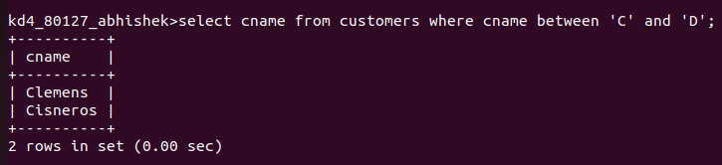

5) Write a query that Selects all orders except those with zeroes or Null in the amt field.

