ASSIGNMENT – 10

Q1) Write a query that produces all pairs of Salespeople who are living inthe same city. Exclude the combinations of salespeople with themselves as well as duplicate rows with order reversed?
Ans-
select X.Sname, Y.Sname
From SALESPEOPLE X, SALESPEOPLE Y
where X.City = Y.City
AND ASCII(X.Sname) < ASCII(Y.Sname);

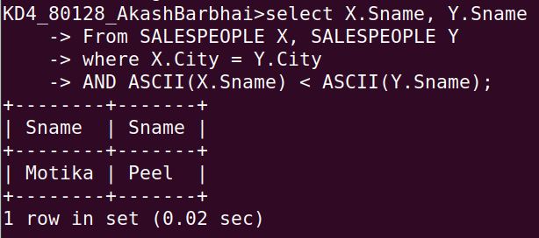

Q2) Write a query that produces the names and cities of all customers with the same rating as Hoffman?
Ans-
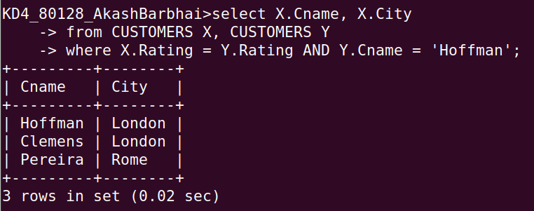
select X.Cname, X.City
-> from CUSTOMERS X, CUSTOMERS Y
-> where X.Rating = Y.Rating AND Y.Cname = 'Hoffman';

